**Konference doktorandů na Vysoké škole finanční a správní 2022**

Prezentace výsledků společenskovědního výzkumu s ekonomickými a finančními efekty (9. ročník)

**Doctoral Students Conference at the University of Finance and Administration 2022**

 Presentation of the results of social science research with economic and financial effects (9th annual conference)

**Ondřej Roubal (ed.)**

**Konference doktorandů na Vysoké škole finanční a správní 2022**

Prezentace výsledků společenskovědního výzkumu s ekonomickými a finančními efekty (9. ročník)

Vysoká škola finanční a správní, Praha, 15. listopadu 2022

**Doctoral Students Conference at the University of Finance and Administration 2022**

Presentation of the results of social science research with economic and financial effects (9th annual conference)

University of Finance and Administration, November 15, 2022

Editor: doc. Mgr. Ondřej Roubal, Ph.D.

Recenzovali:

Ing. Michal Blahout, Ph.D.

Ing. Žaneta Boučková, Ph.D.

Ing. Lenka Farkačová, Ph.D.

Ing. Miroslav Halouzka, CSc.

Ing. Eva Kostikov, Ph.D.

Ing. Jana Kotěšovcová, Ph.D.

Ing. Hana Lipovská, Ph.D.

Ing. Petr Mach, Ph.D.

doc. Ing. Jan Mertl, Ph.D.

doc. Radim Valenčík, CSc.

doc. Mgr. Ing. Petr Wawrosz, Ph.D.

**Vzor citace/pattern quote:**

ROUBAL, Ondřej, ed. *Konference doktorandů na Vysoké škole finanční a správní 2022: Prezentace výsledků společenskovědního výzkumu s ekonomickými a finančními efekty (9. ročník)*. *Doctoral Student Conference at the University of Finance and Administration 2022: Results presentation of social science research with economic and financial effects (9th annual conference).* Praha: Vysoká škola finanční a správní, 2022, xxx s.. SCIENCEpress. ISBN 978-80-7408-189-7 (print) ISBN 978-80-7408-190-3 (online)

Vydalo nakladatelství Vysoké školy finanční a správní, a.s. (University of Finance and Administration)

Estonská 500, 101 00 Praha 10

jako svou 257. publikaci

Edice SCIENCEpress

První vydání

Prepress: VŠFS

Vydavatelský redaktor Mgr. Petr Mach

Tisk dům tisku, s.r.o., Hviezdoslavova 614/16, 400 03 Ústí nad Labem

Tato publikace ani autorské příspěvky neprošly jazykovou úpravou. Za příspěvky odpovídají autoři. Příspěvky prošly oboustranně anonymním recenzním řízením.

Konference byla financována z prostředků, které Vysoká škola finanční a správní obdržela k účelové podpoře specifického vysokoškolského výzkumu na rok 2022.

© Vysoká škola finanční a správní, a.s., 2022

**ISBN 978-80-7408-189-7 (print)**

**ISBN 978-80-7408-190-3 (online)**

Obsah / Table of contents

[Ondřej Roubal   
Úvodní slovo 5](#_Toc121125070)

Introduction 8

[Tobias Bücher   
Impact on Commercial Banks‘ Liquiditiy Risks caused by ECB‘s Negative Interest Rate Policy 11](#_Toc121125072)

[Benedikt Frank   
Current results: Empirical evaluation of the risk of burnout among professionals working in the financial sector 25](#_Toc121125073)

[Alexander Hütteroth   
Correlation between the Fed Pandemic Policy and the S&P 500 Technology Sector Performance 36](#_Toc121125074)

[Robert Laskowski   
Is Amazon exploiting its dominant market position at Corona times? Evidence from office supplies and Stationery in Germany 49](#_Toc121125075)

[Ondřej Málek   
Využití záznamů o pohybu vozidel při správě daní 64](#_Toc121125076)

[Azra Muratovic   
Euro area and its Banking Sector: Perspectives of long‑term Development 74](#_Toc121125077)

[Michael Pirgmann   
Could CBDC be a threat to Monetary Policy? 84](#_Toc121125078)

[Ondřej Ptáček   
Dopad makroekonomického vývoje let 2020–2021 na žádoucí úrokové míry v eurozóně podle Taylorova pravidla 96](#_Toc121125079)

[Bastian Schulz   
The evolution from traditional finance to behavioral finance 109](#_Toc121125080)

[Jiří Slanina   
Analýza statistických závislostí mezi hrubým domácím produktem a mezi trhy autopojištění, pojištění majetku a pojištění odpovědnosti u vybraných evropských zemí 123](#_Toc121125081)

[Moritz Sohns   
Utility indifference pricing in the Heston model: pricing, hedging and shortcomings 133](#_Toc121125082)

[Katrin Steyer   
Public finances in Germany since 2010 - Analysis of the debt ratio 155](#_Toc121125083)

[Dennis C. Tale   
A comparison of the pension systems of Germany and Austria 164](#_Toc121125084)

[Jan Vogt   
Peculiarities in Accounting: The difficulties between recording past transactions and forward looking estimates and the transmission of value through IFRS balance sheets 177](#_Toc121125085)





Ondřej Roubal  
Úvodní slovo

K významným intelektuálním textům posledních let, provokativně inspirujících ekonomické a sociologické směry myšlení, patří kniha *Antifragilita* Nassima Taleba. Zatímco v knize *Černá labuť* jsou Talebovy nekonveční názory a postřehy v podstatě specifickou kritikou moderního myšlení, přehlížejícího velmi nepravděpodobné události a podléhajícího klamu iluzorní bezpečnosti, postavené na kvazi komplexních prediktivních analýzách, stává se antifragilita spíše optimistickým konceptem lidského potenciálu, zvládat bezprecedentní nejistotu budoucích dějů a nepředvídatelných událostí života. Jde o nadějný scénář v podmínkách rizikového a rozkolísaného světa saturovaného nejistotou, v němž roste význam resilience jako formy odolnosti, adaptability a schopnosti regenerace v podobě nejen individuálních psychologicky ukotvených životních strategií, ale i schopnosti komplexních systémů (ekologických, sociálních, ekonomických…), zachovat životaschopnost, přizpůsobit se a obnovit se v různých stavech ohrožení či poškození a zabránit vlastnímu zhroucení. Antifragilita není jen odkazem k samotné resilienci jako adaptivní strategii vzdoru nepříznivých sil, schopnosti překonávat krize, ale navíc tyto krize a destruktivní síly jejich úderu v době rostoucí nejistoty a nepředvídatelnosti, využívat k pozitivním efektům a celkovému prospěchu. Resilience se stává v éře „neviditelných rizik“ Ulricha Becka, „černých labutí“ Nassima Taleba nebo „tekuté modernity“ Zygmunta Baumana, klíčovým modelem života a mechanismem udržitelnosti komplexních systémů živého i neživého světa. Věk nerovnováhy a nejistoty se zřetelně projevuje v posledních letech. Migrační krize, koronavirová pandemie, válka na Ukrajině, energetická krize, ekonomická recese, inflace a v neposlední řadě klimatická změna.

V roce 2021 jsme v době příprav a realizace 8. ročníku Konference doktorandů na Vysoké škole finanční a správní a.s. prožívali zejména koronavirovou pandemii a netušili, že další černou labutí na obzoru bude invaze ruských vojsk na Ukrajinu. A nejen to. Rozkolísaný svět nabízí na přelomu října a listopadu 2022, tedy v době příprav letošního 9. ročníku Konference doktorandů i další události. Zemětřesení v Nepálu o síle 6,6 stupně, následuje zemětřesení v Tichomoří s intenzitou 7,1 stupně, pokračuje zemětřesení ve společnosti Twitter o síle Elona Muska. Nový majitel posílá emailem výpovědi přibližně 3 400 zaměstnanců, dalším zakazuje práci z domova. Meta propouští 11 000 zaměstnanců. V Belgii je generální stávka, v USA kongresové volby a Biden zvažuje další kandidaturu. V Egyptském letovisku Šarm aš-Šajch se koná 27. konference OSN o změně klimatu. Podle generálního tajemníka OSN **Antónia Guterrese nezadržitelně míříme do klimatického pekla. V Pákistánu je postřelen expremiér Chán, v Brazílii se stává prezidentem Lula di Silva. Ve finské vládní koalici se vede spor o práva Sámů. Hackeři napadli teleskop ALMA. V Indii zůstává po zřícení mostu 134 obětí. V Iránu pokračují demonstrace, v Turecku dosahuje meziroční inflace 85 % a během října stoupla inflace v eurozózně k rekordním hodnotám.** V části Berlína se opakují loňské spolkové volby. Růst ekonomiky v EU zpomalil. Schodek veřejných financí v ČR je 4,6 % a Pražanům zdraží teplo o 12 až 15 %.

V takto sociálně, ekonomicky a politicky rozkolísaných časech považuji vědecké konference a další platformy akademických diskuzí a sdílení poznatků za mimořádně potřebné. Jsem přesvědčen o tom, že i letošní 9. ročník Konference doktorandů na VŠFS inspiroval k myšlení a zpřístupnil nové horizonty poznání v sociálně ekonomické a finanční oblasti života společnosti. Podobně jako v minulém roce jsme i letos rozšířili tematický záběr příspěvků doktorandů do oblasti společenských věd, s důrazem na ekonomické a finanční souvislosti výzkumné orientace. Letošní ročník konference byl poprvé realizován ve dvou vědeckých sekcích. První sekce tradičně patřila českým a slovenským doktorandům. Přivítali jsme zde kolegy doktorandy nejen z VŠFS, ale i z IES FSV UK a PF UK. Druhá sekce patřila německým doktorandům VŠFS, vystupujících až na jednu výjimku online v prostředí MS Teams.

Sborník z 9. ročníku Konference doktorandů obsahuje 14 odborných příspěvků, které prošly anonymním recenzním řízením. Tematicky se zaměřují z větší části na oblasti finančního a bankovního sektoru, měnovou politiku, zajímavé jsou například i příspěvky k problému rizik syndromu vyhoření finančních manažerů, dopadů makroekonomického vývoje na úrokové sazby v eurozóně, využití záznamů o pohybu vozidel při správě daní nebo analýza statistických závislostí mezi hrubým domácím produktem a různými trhy pojištění v různých evropských zemích.

Rád bych na tomto místě poděkoval nejen autorům za jejich příspěvky, ale i recenzentům za důkladné posouzení odborné kvality textů. Poděkování patří rovněž moderátorům jednotlivých vědeckých sekcí, prorektorovi VŠFS doc. RNDr. Petrovi Budinskému, CSc., děkanovi FES VŠFS doc. JUDr. Ing. Otakarovi Schlossbergerovi, Ph.D. a vedoucí Katedry financí Ing. Evě Kostikov, Ph.D. Za pečlivou organizátorskou a redakční práci děkuji kolegyni Markétě Holendové z Odboru výzkum a vývoje VŠFS a dále za organizačně technickou podporu patří poděkování Bc. Kamile Procházkové.

Přehled všech dosavadních konferencí, včetně elektronické verze tohoto sborníku příspěvků, naleznou naši čtenáři na internetových stránkách:

https://www.vsfs.cz/konferencedoktorandu/.

Konference byla finančně podpořena ze zdrojů účelové podpory na specifický vysokoškolský výzkum, poskytované Ministerstvem školství, mládeže a tělovýchovy České republiky.

doc. Mgr. Ondřej Roubal, Ph.D.

prorektor pro výzkum a vývoj VŠFS,

odborný garant konference

Introduction

Nassim Taleb's book *Antifragile* is one of the significant intellectual texts of recent years that have provocatively inspired economic and sociological streams of thought. While the unconventional opinions and observations found in Nassim Taleb’s book *Black Swan* essentially constitute a specific criticism of modern thought that overlooks highly improbable events and submits to the chimera of illusory security constructed on quasi-comprehensive predictive analyses, Antifragile has become rather an optimistic concept of humans’ potential to overcome the unprecedented uncertainty of future events and unforeseeable events in life. This involves a hopeful scenario under the conditions of a risk-filled and volatile world saturated with uncertainty, in which the significance of resilience as a form of stamina, adaptability and the ability to regenerate meaning not only individual psychologically embedded life strategies, but also the ability to keep comprehensive systems (ecological, social, economical…) viable, to adapt and to renew oneself under various states of threat or damage and to prevent one’s own collapse are becoming increasingly significant. Antifragile is not simply a reference to resilience itself as an adaptive strategy for resisting unfavourable powers and the ability to overcome a crisis, but also to using these crises and the destructive forces of their impacts in a period of growing uncertainty and unpredictability to positive effect and for the general good. In an era of Ulrich Beck’s “unseen risks”, Nassim Taleb’s “black swans” or Zygmunt Bauman’s “liquid modernity”, resilience has become a key life model and a mechanism for maintaining complex systems in the living and non-living worlds. The age of imbalance and uncertainty has regularly manifested itself in recent years. In the migration crisis, the coronavirus pandemic, the war in Ukraine, the energy crisis, the economic recession, inflation and climate change.

In 2021, we were especially affected by the coronavirus pandemic when preparing and realising the 8th Doctoral Students Conference at the University of Finance and Administration and we had no idea that the next black swan on the horizon would be the invasion of Ukraine by Russian forces. And that is not all. At the turn of October and November 2022, i.e. in the preparation period for this year’s 9th Doctoral Students Conference, the volatile world also offered up a number of other events. A 6.6 magnitude earthquake in Nepal followed by an earthquake in the Pacific with an intensity of 7.1 and then the earthquake at Twitter with the intensity of Elon Musk. The new owner sacked approximately 3400 employees by email and then banned the rest from working at home. Meta sacked 11,000 employees. A general strike in Belgium, congressional elections in the USA and Biden considering running again.  The 27th UN climate change conference took place at Egypt’s Sharm El-Sheikh. According to the UN Secretary General **António Guterres, we are irrevocably heading towards climate hell. Prime Minister Khan was shot in Pakistan and Lula di Silva became the president in Brazil. The governing Finnish coalition was involved in a dispute over the rights of the Sámi people. Hackers attacked the ALMA telescope. 134 victims resulted from the collapse of a bridge in India. Demonstrations continued in Iran, Turkey reached a year-on-year inflation rate of 85% and inflation in the Eurozone reached record values during October. Last year’s elections were repeated in one part of Berlin. The growth in the EU economy slowed down. The deficit in the Czech Republic’s public finances grew to 4.6% and the prices that people in Prague pay for heat rose by 12 to 15%.**

I consider scientific conferences and other platforms of academic discussion and knowledge sharing to be exceptionally necessary in such socially, economically and politically volatile times. I am convinced that this year’s 9th Doctoral Students Conference at the UFA will inspire its participants to think and to open up new horizons of cognition in the socio-economic and financial areas of life and society. As was the case last year, we also expanded the thematic range of the papers presented by the doctoral students this year to include the area of the social sciences with an emphasis on the economic and financial contexts of research orientation. This year’s conference was realised in two scientific sections for the first time. The first section traditionally belonged to Czech and Slovak doctoral students. We invited doctoral colleagues not only from the University of Finance and Administration, but also from the Institute of Economic Studies at the Faculty of Social Sciences at Charles University and the Law Faculty at Charles University. The second section belonged to the German doctoral students at the University of Finance and Administration, who, with one exception, all appeared online using MS Teams.

The publication from the 9th Doctoral Students Conference contains 14 expert papers that have been subjected to an anonymous peer review. They mostly thematically focus on the area of the finance and banking sectors and currency policy, but there are also interesting papers, for example, on the risk of burnout syndrome in financial managers, the impacts of macroeconomic developments on interest rates in the Eurozone, the use of vehicle movement records during tax administration or an analysis of the statistical dependencies between the gross domestic product and various insurance markets in various European countries.

I would not only like to thank the authors for their papers here, but also the reviewers for their thorough assessments of the texts’ expert qualities. Thanks is also due to the moderators of the individual scientific sections, the Vice-rector of the Unversity of Finance and Administration, Associate Professor Dr Petr Budinský CSc., the Dean of the Department of Economics and Management at the Unversity of Finance and Administration, Associate Professor Dr Ing. Otakar Schlossberger, Ph.D., and the Head of the Finance Department, Ing. Eva Kostikov, Ph.D. I would also thank my colleagues Markéta Holendová from the Department of Research and Development at the Unversity of Finance and Administration for her conscientious organisational and editorial work and Bc. Kamila Procházková for her organisation and technical support.

Our readers can find a summary of all the conferences to date, including the electronic version of this publication with the papers, online at

https://www.vsfs.cz/konferencedoktorandu/.

The conference was supported by using objective oriented support for specific university research by the Ministry of Education, Youth and Sport of the Czech Republic.

Assoc. Prof. Mgr. Ondřej Roubal, Ph.D.

Vice-rector for Research and Development

at the University of Finance and Administration,

the conference’s expert guarantor

Tobias Bücher   
Impact on Commercial Banks‘ Liquiditiy Risks caused by ECB‘s Negative Interest Rate Policy

Abstract

ECB’s negative interest rate policy leads to more and more higher liquidity in banks. Higher risks for commercial banks are suspected from this. The hypothesis is, that ECB's Negative interest rate policy leads to significantly higher liquidity risks. The article researches the effects on liquidity risk controlling, supervision and the indeed risk development in banks. Those liquidity risks are typically measured by LCR, NSFR and survival period. The author extends the analyzes carried out by other authors with his own data evaluation in the key figures net liquidity, excess liquidity and LCR as the top liquidity key figure of the banking supervisory authority. Direct effects on commercial banks liquidity risks based on risk models cannot be proven by quantitative research. Qualitative evaluation on the other hand shows increasing risks as a follow of extended maturity transformation and increasing stocks of high risk government bonds. Commercial banks try to buffer those risks by increasing liquidity stocks and emissions of long-term-bonds. Floating above is the threat of the fact that high market liquidity is depended on ECBs low interest policy.

Key words

Banks risks, liquidity risk, Financial Risk and Risk Management, negative interest rate policy

JEL classification

G32

Introduction

ECBs primary goal is price stability in the euro area. To this end, a number of monetary policy measures are carried out, which have a direct influence on market interest rates and indirect influence on the banks' investment and lending rates. In 2014, a negative interest rate was charged for the first time on the deposit facility. So far, there have never been negative interest rates in either the euro area or any of the member states. Therefore, historical or empirical knowledge is also lacking. The European economy becomes more and more dependent on cheap money. Commercial Banks eased up their guidelines for customer loans, to counteract downcreasing profits. This could have an impact on banks main risk types. This article focuses on liquidity risk, cause Negative interest rate policy leads to the fact, that commercial banks are inundated with liquidity. The aim of the contribution is to evaluate, if ECB’s negative interest rate policy (NIRP) leads significantly to increasing liquidity risks in commercial banks.

1 Literature review

1.1 Liquidity Risk Framework

The liquidity risk harbors the risk of own payment obligations at the time not being able to meet the due date (risk of insolvency). (European Central Bank (ECB), 2009) (European Banking Authority (EBA), 2021) (Hellwig, 1994)

In addition to the increase in interest rate risk, the expansion of maturity transformation as a result of the low interest rate level also harbors an increased liquidity risk. An increased call risk may arise with the European commercial banks. Due to the ever lower interest rates, customers have shifted time deposits into sight deposits. This means that the majority of customer deposits can be withdrawn within three months. On the other hand, a large part of the fixed-interest periods of loans is extended in order to obtain a higher interest margin. (European Central Bank (ECB), 2021a)

Figure no. 1: Fixed interest periods for loans to households in Germany for house purchase

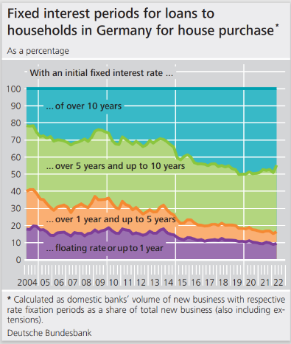

Source: https://www.bundesbank.de/en/statistics/sets-of-indicators/fixed-interest-periods-for-loans-to-households-in-germany-for-house-purchase-622706

Due to the higher elasticity of deposits, an increase in interest rates or the possible passing on of negative deposit interest to customers can result in an increased and uncalculated withdrawal of deposits. However, since these deposits were given out as long-term loans, European commercial banks cannot repay the deposits. As a result, there is an increased liquidity risk for European commercial banks from maturity transformation, which requires assessment and control at all times. This increased liquidity risk contrasts with the positive impact of the low-interest phase. (European Central Bank (ECB), 2021b)

The interest level of the money and interbank market adapts to the general interest rate level. As a result, commercial banks have the opportunity, in addition to the open market transactions at the ECB, to obtain short-term and cheap liquidity on the interbank market. The example of the German commercial banks shows that they operate a long-term liquidity protection in the context of the low-interest phase. In addition to obtaining liquidity from participants in the banking system, German commercial banks have increased the issuance of bank bonds to secure long-term liquidity. Figure 1 shows the average remaining term of existing bank bonds. Since 2013, there has been a significant increase in transit times. For institutions in the German commercial banking sector, this is the highest at around three and a half years. (Guerra, et al., 2022)

1.2 Liquidity risk management

The German commercial banks are therefore reacting to a possible liquidity risk by granting medium-term deposits at favorable conditions and thus increasing the planning reliability of liquidity.

The liquidity risk for European commercial banks is essentially measured using three indicators: LCR, NSFR and survival period.

*Liquidity Coverage Requirement, LCR*

The LCR defines the minimum stock of highly liquid assets that the credit institution defines as a liquid assets reserve to meet net payment obligations over a 30-day period in the event of a severe stress scenario to be able to come. (European Banking Authority (EBA), 2021)

Compliance is regularly checked by the banks and, in many cases, simulated in advance if necessary. Some banks even add additional stress tests to the LCR indicator. According to the current prevailing opinion, this is not necessary. (Guerra, et al., 2022)

The inclusion of highly liquid assets is often criticized. In addition to cash, 100 percent eligible assets include EU government bonds, federal state bonds and government bonds from third countries with the best credit ratings. The criticism is particularly directed at the fact that all EU government bonds are counted at 100%. So also those from countries with a weaker credit rating, such as Greece, Spain or Portugal. (Galletta & Mazzù, 2019) (Saleh & Afifa, 2020)

*Net Stable Funding Ratio, NSFR*

The LCR defines the minimum stock of highly liquid assets, the credit institute as a liquidity reserve to meet net payment obligations over a 30-day period in the event of a severe stress scenario to be able to come. (European Banking Authority (EBA), 2021)

*Survival Period*

With the help of a stress test, the survival period is used to measure the period during which commercial banks remain solvent without being able to obtain liquidity. By comparing the liquidity requirements from stress scenarios with the realizable funding potential, a survival horizon in the event of stress is determined and prepared in the form of a liquidity risk report. Here a new perspective is implemented in the consideration of liquidity risks. In concrete terms, the period means how long the bank can still survive after the occurrence of a stress scenario in relation to the liquidity situation. In some cases, if banks join together to liquidity groups, the determination of the survival period is of a more theoretical nature. (European Central Bank (ECB), 2021b) (Guerra, et al., 2022)

1.2 Qualitative Research of Liquidity Risk

The first negative impact is that the extension of maturity transformation leads to higher liquidity risk. The standing facilities in the euro area have increased on average over the period 2008 to date. The deposit facility and current accounts of commercial banks show an uptrend from 2008 to 2013, then a decline and since 2015 an exponential increase. In the years from 2020 in particular, the curve will be steeper than ever before. As a result, the banks have massive excess liquidity. (Galletta & Mazzù, 2019)

Figure no. 2: Money Markets and the Eurosystem standing facilities (ECB Statistical Data Warehouse, 2021)

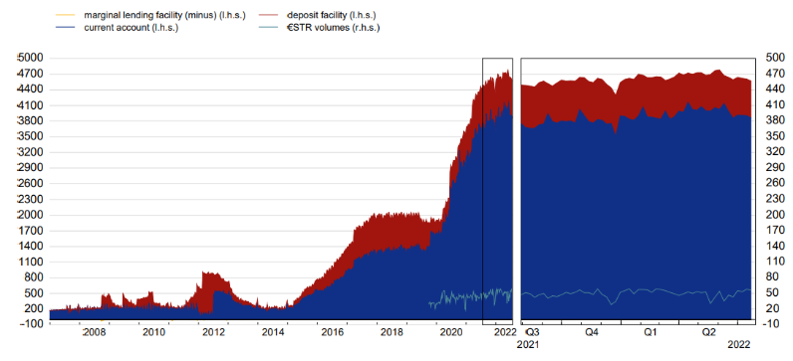

(euro area; EUR billions; last observation: 1 Sep. 2022)

Source: ECB (https://sdw.ecb.europa.eu/servlet/desis?node=1000003327)

A look at the customer deposits to total liabilities over the same period, you can also see a steady increase. What's interesting is, that it grew exponentially over the 12-month period between mid-2014 and mid-2015. The reason is obviously the drop in the deposit facility rate into negative territory. The banks were initially unable to accommodate the excess liquidity in the market as loans, and then also in the long term. While we are seeing nominal credit growth, deposits continue to grow at a faster pace. This is consistent with the chart above showing that the standing facilities have been growing steadily. The result is an income problem that can only be alleviated by expanding maturity transformation. (Jakovicka, 2018)

Figure no. 3: Customer deposits to total liabilities (ECB Statistical Data Warehouse, 2021)

Ein Bild, das Tisch enthält.

Source: ECB (https://sdw.ecb.europa.eu/)

The maturity profile of the banks in the European Union shows a clear reduction in short‑term maturity transformation. The maturity gaps between 1 and 5 years have been steadily decreasing since the financial crisis in 2008. With the drop in the deposit facility rate into negative territory, it is the maturity transformations of up to two years in particular that are once again significantly and significantly reduced. The volume of the two to five-year maturity transformation has remained largely constant in the period between 2014 and today. Since then, however, there has been an increase in maturity transformation in the long-term maturities of 5 to ten years, but above all and significantly over ten years. The banks are therefore prepared to build up maturity transformation risks in this business environment. The reason, as described, is the decline in yields. An attempt is made to stabilize interest income via the longer maturity transformation. This is very risky, since loans are no longer refinanced with matching maturities. If you move in short maturity transformation areas, this is less critical because the interest rate difference is small. With longer maturities, however, the risk increases significantly with a normal steep yield curve. The ECB's NIRP therefore creates significant maturity transformation risks. These will come into play when market interest rates rise. Because then the bank pays a higher interest rate for the short-term procurement of funds than the calculated interest without generating higher income from the loan at the same time, provided that it has issued fixed loan terms. However, the share of variable loans has also decreased in these years, which further increases the risks. This is a problem in Germany in particular, because the proportion of loans with a fixed term is above average here. (Galletta & Mazzù, 2019) (Drehmann & Nikolaou, 2013) (d’Avernas, et al., 2019)

Figure no. 4: Maturity profile of Banks’ outstanding debt securities (ECB Statistical Data Warehouse, 2021)

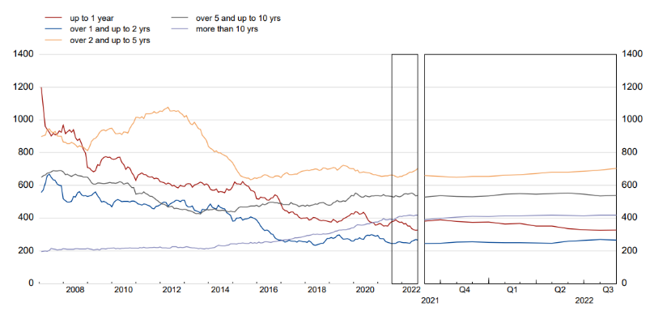

Maturity profile of Banks’ outstanding debt securities (EU27 fixed composition; EUR billions; last observation: Aug. 2022)  
Source: ECB (https://sdw.ecb.europa.eu/reports.do?node=1000003328)

The second negative impact on the banks' liquidity risks results from the restructuring of the proprietary trading portfolio. An increase in government bonds from Greece, Italy, Portugal and Spain can be observed here. The reason is the overvaluation of these bonds in the calculation of the LCR and NSFR. EU bonds, regardless of their creditworthiness, can be counted 100% for the source of funds. This fuels a negative effect: Risk of the national economic crisis being passed on to the EU banks. (d’Avernas, et al., 2019) (Demiralp, et al., 2017)

Figure no. 5: Long-term yield on selected public bonds; December 2021(ECB Statistical Data Warehouse, 2021)

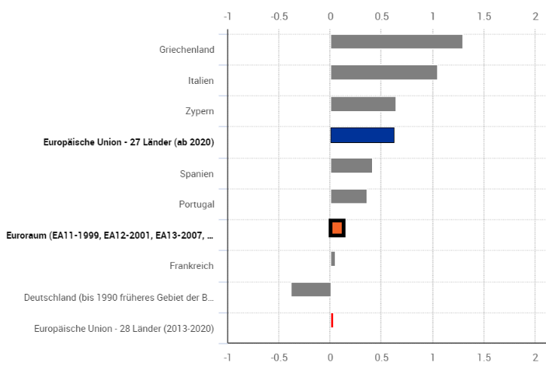

Source: ECB (https://ec.europa.eu/eurostat/databrowser/view/teimf050/default/bar)

The LCR has been increasing consistently since 2020. This would actually indicate reduced liquidity risks. In fact, however, it is apparent that banks overweight bonds with poor credit ratings in their portfolios for controlling reasons. They build up risks instead of reducing them. (Chen, et al., 2021)

Figure no. 6: LCR in EU-27 banks

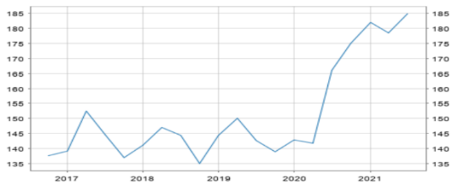

Source: ECB (https://sdw.ecb.europa.eu/)

Figure no. 7: LCR evolution (weighted average)

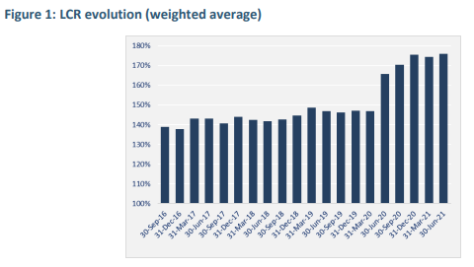

Source: EBA (https://www.eba.europa.eu/sites/default/documents/files/document_library/Publications/Reports/2021/1025522/EBA%20Report%20on%20Liquidity%20Measures%20under%20Article%20509%281%29%20of%20the%20CRR.pdf)

The NSFR ratio also rises, although banks with high LCR does not conclusively have high NSFR ratio. This can be taken as proof that liquidity risks have in fact not been reduced. If this were the case, the banks with high LCR would also have to show a significantly increasing NSFR as they would have to be more resilient to liquidity risk on average. But this is not the case. (Chen, et al., 2021)

Figure no. 8: LCR and NSFR for the sample of banks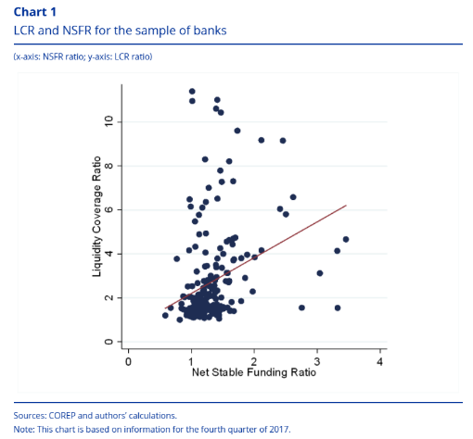

Source: ECB (https://www.bankingsupervision.europa.eu/press/pr/date/2019/html/ssm.pr191007_annex~537c259b6d.en.pdf)

If we look at the survival period at high level in the EU, it shows that 90% of banks report a survival period longer than 2 months, even under the extreme shock scenario.

Figure no. 9: Distribution of EU-27-banks with a survival period <6 months

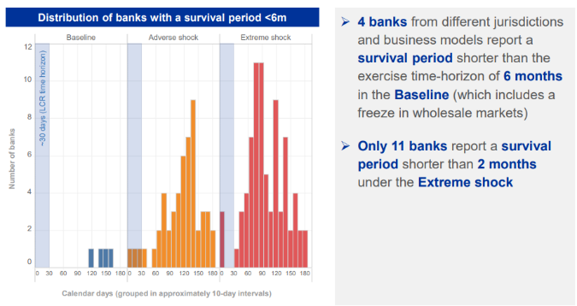

Source: ECB (https://www.bankingsupervision.europa.eu/press/pr/date/2019/html/ssm.pr191007_annex~537c259b6d.en.pdf)

Negative effect number three for liquidity risks is the increasing risk of bank run (cash withdrawal), if customers do not longer accept negative interest rates on their bank accounts. This can be buffered by easy and cheap liquidity procurement by ECB, Interbank Market and Customer Market, as well as by increasing emissions of banks' bonds. However, this risk appears to be more of an additional marginal phenomenon. Such bank runs have not occurred in Europe in the past. They are more of a phenomenon in weak economies. (Drehmann & Nikolaou, 2013)

2 Methodology

In addition to the literature review, in which the key figures LCR, NSFR and survival period observed under fishing law were considered, the author carries out his own data analysis. Data from the ECB was used here. These aggregate the data of all banks in the euro member states. The ECB provides the liquidity indicators net liquidity, excess liquidity and LCR. The hypothesis of this paper is: ECB's NIRP leads to significantly higher liquidity risks. Therefore, a causal relationship between the NIRP and the impact on the liquidity ratios was examined. The NIRP can be easily derived from the deposit facility rate. The rate defines the interest banks receive for depositing money with the central bank overnight. It is the policy rate that has also been lowered into negative territory. Therefore, the correlation between the deposit facility rate and the characteristics net liquidity, excess liquidity and LCR was evaluated over time.

3 Research

The author made a measurement of the significance of NIRP on liquidity risk. The correlation of the deposit facility rate, which is becoming increasingly negative, with the indicators LCR, excess liquidity and net liquidity of the commercial banks was tested. Significant results were obtained here.

Table no. 1: Correlation between deposit facility an liquidity figures

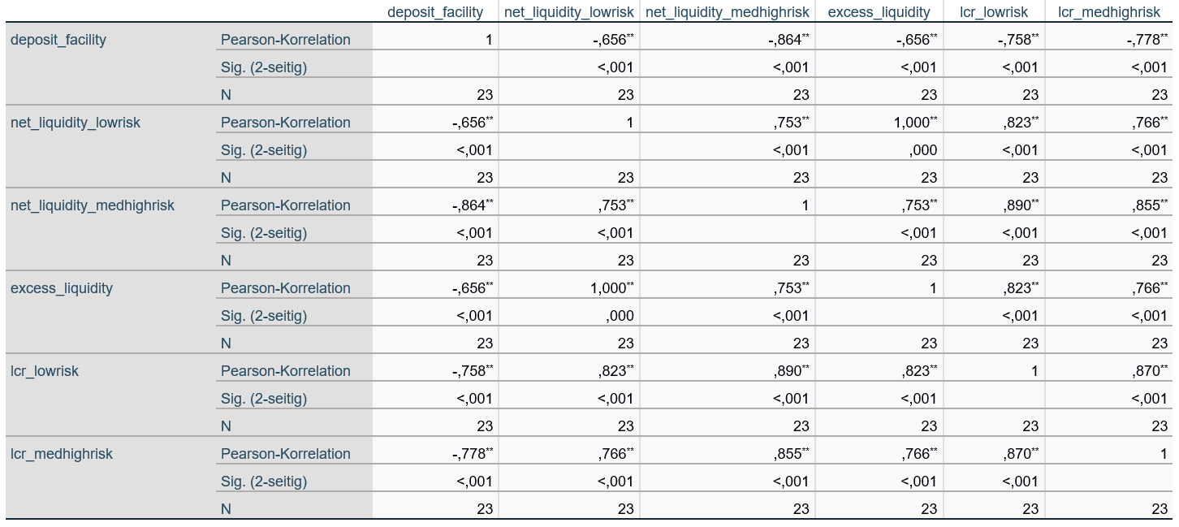

**. The correlation is significant at the 0.01 (2-tailed) level.

Source: Author’s own according to ECBs supervisory and prudential statistics (https://sdw.ecb.europa.eu/browse.do?node=9689366)

The following results are shown for the tested variables: The following results are shown for the tested variables:

*Liquidity Coverage Requirement, LCR*

The LCR of banks with low risk as well as banks with medium and high risk is significantly negatively correlated with the deposit facility rate. This means that the lower the deposit facility rate, the higher the LCR for banks in all risk groups. This is statistical evidence that banks' liquidity is increasing in times of ever lower deposit facility rates. The reason has been described previously: Banks are being inundated with liquidity that they cannot fully lend out. This is a significant problem because while they build liquidity, it is unprofitable. The result is a build-up of maturity transformation and bond buying. The latter is increasingly taking place in poorer credit ratings, also with the intention of increasing overall profitability.

*excess liquidity*

The test for the correlation between deposit facility rate and excess liquidity also shows a significant negative relationship. The interpretation is the same as for the LCR. The increasing reduction in the deposit facility rate leads to a steady build-up of excess liquidity, which cannot be accommodated on the market and therefore accumulates on the bank's ECB account.

*net liquidity*

As the third key figure analyzed, net liquidity also correlates significantly negatively with the deposit facility rate. And this at all banks, both with low, medium and high risks. It is worth noting that the negative correlation is more pronounced for medium-risk and high-risk banks. The reason is the fact that these banks are finding it more difficult to build up further disproportionate risks. As a result, they find it even more difficult than their colleagues from banks with low risks to place liquidity on the credit market. As a result, their net liquidity increases disproportionately.

Overall, banks are increasingly shorting liquidity. This is positive for the liquidity ratios LCR, NSFR and survival period. Initially, more liquid funds also means lower liquidity risks. However, two clearly negative developments can be observed as a result of this shorting of liquidity: The maturity transformation is significantly increased in the long maturity range. In addition, a mismanagement of the inclusion of the European liquidity ratios in combination with the weak earnings of the banks leads to a disproportionate investment by the banks in high-risk bonds from the EU and thus actually to a further build-up of liquidity risks, which are not perceived in a structured manner by the banking supervisory authority. Both do not directly affect the liquidity risks. However, the increased maturity transformation harbors an earnings risk in the event of rising interest rates. And shrinking earnings lead to falling liquidity again. In addition, credit risks are built up as a result of banks investing disproportionately in high-risk bonds. Their potential default thus also indirectly leads to liquidity risks.

4 Discussion

Jakovicka, 2018 goes on to explain that banks are unable to accommodate the excess liquidity in the market as loans. As a result, the key figure customer deposits to total liabilities decreases. Drehmann & Nikolaou, 2013 show that the effect is particularly noticeable in the lending of loans with terms of more than 5 years, which exacerbates the effect of increasing risks.

The author comes to the same conclusions when analyzing the LCR and the excess liquidity. Liquidity is increasingly being built up on paper, which apparently reduces liquidity risks. In fact, all external sources and the author are of the opinion that the structure of the maturity transformation builds up massive risks, which can materialize in the event of an interest rate rise, as we are currently experiencing. As the author shows on the basis of the net liquidity, this risk increases for banks with already high credit risks, since they are even more difficult to channel the excess liquidity into the market.

The external source analysis by d'Avernas, et al., 2019 and Demiralp, et al., 2017 also shows increasing risks in the proprietary trading portfolio. An increase in government bonds from Greece, Italy, Portugal and Spain can be observed here. The reason for this is the disproportionate preference given to these bonds when calculating the LCR. Here, too, liquidity risks will build up in the background, so they will be disguised. The author cannot contribute his own data analysis for this, as there is no raw data from the ECB.

A limitation of the study is that the aggregated data of all ECB member banks is very rough. Individual countries may have different risks because national banking regulators apply stricter standards. There is also a high degree of heterogeneity within the states in terms of the banks' business models and banks' risk tolerance.

In addition, the actual liquidity risks from the emerging maturity transformation and the overweighting of countries with weaker credit ratings can only be predicted in the event of a rise in interest rates. There is no historical data for comparison as there has never been a period of negative interest rates in the EU.

Nevertheless, the study has the potential to evaluate and name risks that are building up in the background. Further dedicated research based on different countries and bank business models would be very interesting.

Conclusion

The hypothesis as to whether the ECB's NIRP leads to significantly higher liquidity risks cannot therefore be confirmed using statistical measurement methods. The liquidity of the banks has increased with the increasingly negative deposit facility rate and is evidently showing us increasingly decreasing liquidity risks.

However, it must be stated that the liquidity risks are actually increasing far beyond the measurement by the banking supervisory authority. This fact cannot be ignored and should question the effectiveness of the control of the current measurement methods.

Literature

1. d’AVERNAS, Adrien, VANDEWEYER, Quentin and PARIES, Matthieu Durracq. Unconventional Monetary Policy and Funding Liquidity Risk. *Social Science Research Network*. 2019, pp. 1-54. ISSN 0378-4266.
2. CHEN, Wei-Da, CHEN, Yehning and HUANG, Shu-Chun. Liquidity risk and bank performance during financial crises. *Journal of Financial Stability*. Vol. 56, 2008. pp. 1‑24. ISSN 1572-3089.
3. DEMIRALP, Selva, EISENSCHMIDT, Jens and VLASSOPOULOS, Thomas. Negative interest rates, excess liquidity and bank business models: Banks' reaction to unconventional monetary policy in the euro area. (L. I. Economics, Ed.) *Econstar Working Paper.* No. 1708, 2017.
4. DREHMANN, Matthias and NIKOLAU, Kleopatra. Funding liquidity risk: Definition and measurement. *Journal of Banking & Finance*. Vol. 37, 2013. pp. 2173-2182. ISSN 0378-4266.
5. EUROPEAN BANKING AUTHORITY (EBA). New Bank Liquidity Rules: Dangers Ahead - A Position Paper by EBA’s Banking Stakeholder Group. *European Banking Authority (EBA).* [online]. June 2021. [cit. 2022-10-03]. Available at: https://www.eba.europa.eu/sites/default/documents/files/documents/10180/807776/e2086633-7538-4e2e-ad2e-11c78a61c3c8/20121002_BSG_Liquidity_Paper_incl_amendment.pdf?retry=1
6. EUROPEAN CENTRAL BANK (ECB). Liquidity Risk Concepts - Definitions and Interactions. *Working Paper Series* - No. 1008. [online] 2009. [cit. 2022-10-03]. Available at: https://www.ecb.europa.eu/pub/pdf/scpwps/ecbwp1008.pdf
7. EUROPEAN CENTRAL BANK (ECB). Monetary policy decisions. *Euroepan central bank.* [online]. 2021. [cit. 2021-12-20]. Available at: https://www.ecb.europa.eu/press/pressconf/shared/pdf/ecb.ds211216.en.pdf
8. EUROPEAN CENTRAL BANK (ECB). Asset purchase programmes. *Euroepan central bank.* [online]. 2021. [cit. 2021-12-20]. Available at: https://www.ecb.europa.eu/mopo/implement/app/html/index.en.html
9. ECB STATISTICAL DATA WAREHOUSE. Balance of payments. *ECB Statistical Data Warehouse.* [online]. 2021. [cit. 2021-08-12] Available at: https://www.ecb.europa.eu/stats/balance_of_payments_and_external/eer/html/index.en.html
10. GALLETTA, Simona and MAZZU, Sebastiano. Liquidity Risk Drivers and Bank Business Models. (MDPI, ed.) *Risks*. 2019. pp. 1-14. ISSN 2227-9091
11. GUERRA, Pedro, CASTELLI, Mauro and CORTE-REAL, Nadine. Machine learning for liquidity risk modelling: A supervisory perspective. *Economic Analysis and Policy*. Vol. 74, 2022. pp. 175-187. ISSN 0313-5926
12. HELLWIG, Martin. Liquidity Provision, Banking, and the Allocation of Interest Rate Risk. *European Economic Review*. Vol. 38, issue 7, 1994. pp. 1363-1389. ISSN 0014-2921
13. JAKOVICKA, Julia. Overview of the activities of the Money Market and Money and Liquidity Division. *European Central Bank Frankfurt*, Germany. [online]. 2018. [cit. 2022-10-03]. Available at: https://www.ecb.europa.eu/pub/conferences/shared/pdf/20180709_ecb_central_banking_seminar/2018-07-12_Overview_of_the_activities_of_the_Money_Market_and_Liquidity_Division_-_Jakovicka.pdf
14. SALEH, Isam and AFIFA, Malik Abu. The effect of credit risk, liquidity risk and bank capital on bank profitability: Evidence from an emerging market. *Cogent Economics & Finance*. 2020. pp. 1-18. ISSN 2332-2039

Contact

Tobias Bücher

University of Finance and Administration

Rathausplatz 5B

65205 Wiesbaden

Germany

t.buecher@gmx.de

Benedikt Frank  
Current results: Empirical evaluation of the risk of burnout among professionals working in the financial sector

Abstract

A world that is becoming ever faster, driven by globalisation and digital networking, creates a feeling of being overwhelmed for many people. The aim of the present work in its actual status quo is to enable a more detailed interpretation of the expected and unexpected effects of burnout – especially in the financial sector. This is because the financial sector is often associated with high levels of workload and performance pressure, and can accordingly be a breeding ground for burnout. This paper uses an analysis of existing literature through literature research to manifest a current scientific status and serve as a basis for subsequent quantitative and qualitative follow-up studies.

Key words

Burnout, economic costs, financial sector, mental illness

JEL classification

E24, H51, I15, I31

Introduction

The term burnout, whose scientific basis and origin of the term comes from, among other things, reactor technology and the medical field, acquires its current meaning, which is well known to the general public, primarily from the accumulation of symptoms such as emotional exhaustion, depersonalisation and reduced personal performance (Maslach, 1976). In principle, however, it is difficult to give a generally valid definition of the clinical picture of burnout, as the existing concretisations are too general or, in contrast, too specific explanations and a uniform definition of occupational burnout could not be defined for a long time (Guseva et al., 2020; Maslach, 1982).

Due to the hardship of an unambiguous definition, in colloquial language there is often an equation with an excess of stress and burnout (Hillert & Marwitz, 2006). The term cannot be used synonymously for work stress, fatigue, alienation or depression (Iacovides et al., 2003).

Nevertheless, psychosocial stress, for example, is an important driver of burnout (Von Känel, 2006). Especially the financial industries seem to be closely interwoven with a high workload, which can end in burnout.

Therefore, this scientific project should give insights and a more detailed interpretation of the expected and unexpected effects of burnout with focus on the financial sector. This is conducted by analysing existing scientific studies through literature research, the results could afterwards serve as a basis for quantitative and qualitative consequential studies.

1 Burnout and the financial sector

This research project is particularly dealing with the evaluation of the risk of burnout among professionals working in the financial sector. Finally, it is a matter of making assumptions from the research results as to how employees, particularly from the financial sector, can behave preventively. For example, the aim is to reduce the long-term sickness-related absences of these people and thus, from the perspective of the companies concerned, reduce costs (Schweifer-Winkler, 2013). This includes, for example, fluctuation-related costs such as severance payments, early retirement or absences from work, which can be reduced by early detection of burnout and appropriate countermeasures. Reduced work performance or increased error rates may also be prevented (Burisch, 2003).

First of all, it is important to describe how the financial sector can be defined as such and thus to develop appropriate framework conditions.

Containment of the financial sector, areas of responsibility and challenges

There is often no clear reference to a unified definition of the financial sector on which this term is based. So, this economic sector is frequently equated with the banking sector. In a broader definition, however, the financial sector includes not only banks and insurance companies but also pension and investment funds and other financial service providers, such as credit card companies (Hemmelgarn, 2011).

With transfer to the field of activity of the financial services, it can be said that these include of the subsequent offerings (Eurostat European Commission, 2013):

1. financial intermediation (containing insurance and pension services);
2. financial auxiliary services; and
3. different other types of financial services.

Financial intermediation is the provision of financial risks and the transformation of liquidity. Organisations involved in these operations receive money by taking deposits and creating bills, bonds, and other securities, for example. These resources, as well as their own, are used by businesses to purchase financial assets by making loans to others and acquiring bills, bonds, or other securities. Insurance and pension services are examples of financial intermediation. Risk management and liquidity conversion are aided by auxiliary financial activities. Financial auxiliaries function on purpose of other divisions and do not expose themselves to financial liabilities or financial assets as element of an intermediation service. Other financial services involve stock and bond market analysis, security services such as preserving valuable jewellery and sensitive papers, and trading services such as foreign exchange trading and stocks trading. Because of the strict oversight of those services, financial companies provide practically entirely of them. For example, if a merchant wants to give credit to its consumers, the loan is normally provided by a financial company affiliate of the retailer or some other specialized financial institution (Eurostat European Commission, 2013).

In view of the past decade and the accompanying changes in the financial sector, this industry faces challenges, particularly as a result of emerging crises as the great financial crisis in the late 2000s or the Corona pandemic. For example, it has to be adapted, especially due to business models that are partly geared to short-term profits, and further consolidation in the market is to be expected. However, the author of this dissertation wants to mention, that there is hope that the multitude of reforms in the area of financial supervision and regulation could positively change the stability and efficiency of the market.

The following additional challenges for the financial sector can be identified as a result of constant change, particularly due to technological development. So, for example, Blockchain technology, which is still in its infancy and faces technological, economic, and regulatory complications, has the potential to transform many elements of the financial services sector and the wider economy. Furthermore, new methods of transferring money and risk are evolving, acting as a driver for shift for established financial sector organisations. These technologies have the potential to boost automation within organisations while also broadening financial access. Nevertheless, the technology's social and technological infrastructure remains severely undeveloped. If it is to live up to any of its promises, it must solve several technological problems, including productivity, scalability, confidentiality, protection, interoperability, and governance (Casey et al., 2018).

Burnout risk in the work environment and the financial sector

In order to provide a subsequent link between burnout and the financial sector, it is first helpful to focus on the assessment of the risk of burnout among employees overall on the basis of the following figures. In this regard, an increased risk can be observed among them. In general, a study of Banerjee et al. (2017) with over 700 participants from 41 European countries came to the conclusion that, for example, 71 percent of European oncologists, in example cancer doctors, show clear signs of burnout even at the age of up to 40. Country-specific distinctions could also be made in this regard. For example, the burnout rate of the respondents was significantly higher in Central Europe, at 84 percent, than in the northern parts of Europe, at 52 percent. Depersonalization, for example, also found a clear differentiation between male and female participants. Thus, at 60 percent, significantly more men were subject to this factor than women at 45 percent. In addition, the young age group of 26 to 30-year-olds in particular suffered from reduced performance due to possible burnout symptoms. The MBI measuring instrument used for this purpose was extended by additional questions on working methods and lifestyle factors (Banerjee et al., 2017).

With a particular focus on the financial sector, similar results as mentioned above were recorded among bankers. For example, in a study of participants under 30 with at least five to seven years of work experience, 67 percent of both male and female respondents said they go to the office even when they feel sick. Similarly, 76 percent of participants confirmed that their workload has increased significantly during the past few years, and 38 percent of men as well as 30 percent of women also take work home with them from time to time, thus shifting professional activity to leisure time. Furthermore, slightly more than half (52 percent) of the respondents answered that they know people from their professional or private environment who have been affected by burnout. It is also more significant that 10 percent of the participants answered in the affirmative to the question about their own experience of burnout syndrome, and thus describe themselves as having been burned out at some time in their lives when they were under 30 years old. Another 10 percent of the women and 5 percent of the men also suspect burnout in themselves (Brunner & Andersen, 2005). Although it is not possible to diagnose a definite illness by means of a simple anonymous survey, the results, due to their unambiguousness and the subjects' own assessment, give a tendency that burnout is present even in a young section of the population. In general, Dias and Angélico (2018) identified in comparison of fourteen studies on burnout syndrome in bank employees that individuals who worked forty hours or more a week and had immediate contact with clients were the most impacted by the disease.

Subsequent and additional to this, Dursun and Aytac (2014) mention, that the service industry could be seen as one of the fastest expanding economic sectors. However, for workers in this industry, the high amount of client engagement may be the source of unfavourable outcomes such as hostility of customers, which can have serious consequences for an individual's health and safety. Whereas employees in nearly every industry are at danger of being subjected to hostile conduct, the risk is substantially higher for those in this sector. In the banking area, the high amount of engagement with consumers increases the danger of exposure to aggressive attitude for personnel in this field. As a result, according to the findings of Dursun and Aytac (2014), verbal abuse significantly enhanced the emotional exhaustion and depersonalization levels of bank employees and therefore the risk of suffering a burnout.

Another example from the financial industry is credit analysts, who are individuals engaged by an organization to assess the creditworthiness of current and potential customers. Job burnout, as example, might be one factor influencing carelessness while analysing a credit application. Moreover, a significant number of debtors and credit applications might raise workload and job burnout for analysts. Research from Damayanti (2019) found out, that significant work engagement between workers and their jobs can reduce occupational exhaustion. Work engagement might be viewed in this sense as a situation in which employees find it simpler to manage work relationships and stress on the job. So, it is all about having good thinking and enthusiasm, determination, and absorption.

Furthermore, research from Guo (2020) investigated the health, psychological contract, and job burnout of company managers from various industries, as well as their correlation. The findings revealed, for example, that the directors of companies from the financial, commerce and manufacturing area had comparatively poor mental health. Aside from a general reciprocal promotion link of organisation executives' mental health and psychological contract situation, the study discovered that the level of mental wellbeing and occupational burnout, as well as the level of psychological contract and job burnout, were mutually limiting.

Job stress as a critical influencing factor in financial sectors

In order to have a better understanding of burnout risk in the financial industry, it is worthwhile to look at studies that examined workplace stress and burnout in the banking industry, among other things, as an additional element of examination. The aims of research from Khattak et al. (2011), for example, were to detect the stress and burnout among bank personnel caused by changing working practices, fast expansion, globalization, and liberalisation. The findings confirmed what one may assume intuitively in terms of the causes creating stress and leading to burnouts. As a result, unfavourable attitudes about the volume of work, prolonged operating hours, technical issues at work, inadequate pay, insufficient time for family, and employment anxieties at home are important stressors in banks. It is important to keep in mind that the primary source of stress is the job, as well as the synchronization of family and work life. The majority of employees appear to be influenced by the excessive workload and the lengthening of working hours. The extended work schedule prevents them from relaxing, adequately caring for their family, and enjoying time with them. The results suggest that the employer should investigate these stressors, which might have major long-term consequences for the banking industry. The findings indicate that these possible causes of stress are contributing to burnout. Long days at work cause excessive exhaustion and backache, resulting in physical burnout among banking industry personnel. Following that, the extended working hours take them away from their families and social lives throughout the day. Moreover, bankers' jobs include constant connection with consumers and statistics. These variables generate emotional tiredness in banking industry personnel, resulting in headaches and sleep disturbances. As a consequence, these stress factors contribute to psychological burnout in bankers. In general, the nature of the job in the banking industry has a substantial impact on workplace stress and burnout. Negative attitudes regarding the organisation's structure, job aspects, work relationships, and the family-work interface are all possible origins of stress for bank workers (Khattak et al., 2011).

According the research from Khattak et al. (2011), there is a considerable positive association between all factors of stress and each type of burnout. As a result, it is apparent that increased stress in the banking industry will result in a higher degree of burnout. All stress factors except work environment are indicators of burnout; nevertheless, in the banking industry, job, family, and work interface are the key determinants of burnout.

Changing market variables drive stress

In conclusion, there arises the question of why today's workplace in the financial sector, and by way of representation the banking environment, seems to be a major source of stress for employees in general. Globalization and the new economy have resulted in substantial changes in work structure and operation. Several signs of this evolvement can be found in the banking sector, including mass layoffs, acquisitions and collapses, digital technology, outsourcing, business re-engineering with reduced hierarchical levels, job uncertainty, increased contention due to the entry of more private banks, and multifunctional responsibilities. According to recent studies, these symptoms are associated with high levels of stress among bank personnel (Petarli et al., 2015, Neelamegam & Asrafi, 2010, Giorgi et al., 2017). The needs of labour in the banking industry necessitate continual amendment and upgrading of abilities, as well as training, to keep up with new forms of work organisation, and this element may be a cause of additional stress (Giga & Hoel, 2003). Thus, it can be said that in the banking sector, and by extension in the financial sector, stress is a major factor that can act as an influence or trigger of burnout, as mentioned above.

As a result of the aforementioned factors, it is possible to assume that banking sector employees, and hence related to the financial industry, are under stress, regardless of their job description. As a consequence, decreasing employee workload through suitable division of labour or expanding the amount of workers is critical. The stress caused by overwork can be lessened if banking work is done in shifts. Employees' technological difficulties at work appear to be the result of the absence of training, therefore communication technology practices might be advised. Ultimately, inadequate income tension requires an acceptable wage structure, and to resolve stress produced by a shortage of available time for family and job issues at home, hours worked, and job demand must be examined (Khattak et al., 2011).

In summary, it can be seen that burnout can have a variety of personal as well as external influences, but the one thing that unites them is that it usually involves an individual at risk under dangerous environmental conditions. However, it is significant that this disease does not occur exclusively in people who have spent many years in the profession, but does not even shy away from relatively young workers. Thus, it is all the more necessary to have a correct and early diagnosis, as well as an effective and individually tailored method of treatment.

2 Methodological approach

The main methodology used in this paper has been literature review and an analysis of existing scientific burnout studies.

The literature search is the search for scientific literature on the corresponding topic. In the process, reference is made to existing scientific information. Since new keywords have to be researched again throughout the writing process, the literature investigation runs through the entire writing process. For the present literature research, two methods were basically used in order to be able to benefit from both approaches. The unsystematic literature search is suitable for an overview of a topic. The systematic literature search could be utilised in parallel and as a supplement to search for specific literature. In the non-systematic literature search approach, bibliographies of other works are examined to find literature on the topic to be worked on. A relevant source is searched for and its literature references are analysed for other suitable references. The sources found in this way are then examined for further relevant literature. With the help of a systematic literature search, all relevant publications can be filtered out of a large number of scientific publications. In this method, search terms were determined, a literature review was conducted, search results were analysed, a literature selection was made, and a documentation was prepared.

Subsequent follow-up studies to this paper, which aim to examine possible further approaches by means of data to be collected, can make use of quantitative and qualitative methods. A possible quantitative methodology aims to analyse the influence of burnout on companies operating in the financial sector via a questionnaire. Furthermore, another qualitative study creates an interview questionnaire to collect further additional data.

Conclusion

The aim of the present work in its actual status quo is to enable a more detailed interpretation of the expected and unexpected effects of burnout through literature review – especially in the financial sector. Further information and insights will hopefully be found after the empirical part of the addressed work can be completed in subsequent quantitative and qualitative studies. What can be said at this stage is that due to the hardship of an unambiguous definition, in colloquial language there is often an equation with an excess of stress and burnout

Furthermore, especially the financial industries seem to be closely interwoven with a high workload, which can end in burnout. In view of the past decade and the accompanying changes in the financial sector, this industry faces challenges, particularly as a result of emerging crises as the great financial crisis in the late 2000s or the Corona pandemic.

So, challenges for the financial sector can be identified as a result of constant change, particularly due to technological development.

Moreover, findings confirmed what one may assume intuitively in terms of the causes creating stress and leading to burnouts. As a result, unfavourable attitudes about the volume of work, prolonged operating hours, technical issues at work, inadequate pay, insufficient time for family, and employment anxieties at home are important stressors in banks.

According the research from Khattak et al. (2011), there is a considerable positive association between all factors of stress and each type of burnout. As a result, it is apparent that increased stress in the banking industry will result in a higher degree of burnout. All stress factors except work environment are indicators of burnout; nevertheless, in the banking industry, job, family, and work interface are the key determinants of burnout.

Literature

1. BANERJEE, Susana, CALIFANO, Raffaele, CORRAL, Jesus, DE AZAMBUJA, Evandro, DE MATTOS-ARRUDA, Letticia, GUARNERI, Valentina, et al. Professional burnout in European young oncologists: results of the European Society for Medical Oncology (ESMO). *Young Oncologists Committee Burnout Survey*. Vol 28, no. 7, 2017. pp. 1590–1596. Available at: doi: 10.1093/annonc/mdx196
2. BRUNNER, Wolfgang and ANDERSEN, Thomas. *Das Burnout-Syndrom bei jungen Bankern und wie es sich vermeiden lässt.* Berlin: Berliner Institut für Bankunternehmensführung, 2005.
3. BURISCH, Matthias. *Das Burnout-Syndrom*. Berlin: Springer-Verlag, 2003. ISBN [3540574026](https://www.booklooker.de/B%C3%BCcher/Angebote/isbn=3540574026?zid=1l1hg3kthku5fr45ut7nj8eh42)
4. CASEY, Michael, CRANE, Jonah, GENSLER, Gary, JOHNSON, Simon and NARULA, Neha. *The Impact of Blockchain Technology on Finance: A Catalyst for Change.* Geneva: International Center for Monetary and Banking Studies, 2018.
5. DAMAYANTI, Ni Nyoman Sri Rahayu. The effect of work engagement and self-efficacy on job burnout of credit analyst. *International Journal of Applied Business & International Management.* Vol. 4, no. 3. 2019. pp 113–120. ISSN 2614-7432. Available at: DOI:[10.32535/ijabim.v4i3.689](http://dx.doi.org/10.32535/ijabim.v4i3.689)
6. DIAS, Felipe Silva ano ANGELICO, Antonio Paulo. Burnout Syndrome in Bank Employees: A Literature Review. *Trends in Psychology.* Vol. 26, no. 1, 2018. pp. 31‑46. ISSN 1413-389X. Available at: DOI:[10.9788/TP2018.1-02En](http://dx.doi.org/10.9788/TP2018.1-02En)
7. DURSUN, Salih and AYTAC, Serpil. The Effect of Customer Aggression on Burnout. *Academic Journal of Interdisciplinary Studies.* Vol. 3, no. 4, 2014. pp. 369–372. Available at: DOI:[10.5901/ajis.2014.v3n4p369](http://dx.doi.org/10.5901/ajis.2014.v3n4p369)
8. EUROSTAT EUROPEAN COMMISSION. *European system of account ESA 2010*. Luxembourg: Publications Office of the European Union, 2013. ISBN 978-92-79-31242-7. Available at: doi:10.2785/16644
9. GIGA, Sabir I. and HOEL, Helge. *Violence and stress at work in financial services.* Geneva: International Labor Office, 2003. Available at: https://www.researchgate.net/publication/254406982_Violence_and_stress_at_work_in_financial_services
10. GIORGI, Gabriele, ARCANGELI, Giulio, PERMINIENE, Milda, LORINI, Chiara, ARIZA-MONTES, Antonio, FIZ-PEREZ, Javier, DI FABIO, Annamaria and MUCCI, Nicola. Work-related stress in the banking sector: A review of incidence, correlated factors, and major consequences. *Frontiers in Psychology.* Vol. 8, 2017. Available at: doi: 10.3389/fpsyg.2017.02166
11. GUO, Xiaona. Relationship between mental health, psychological contract and job burnout of enterprise managers. *Revista Argentina de Clínica Psicológica*. Vol. 29, no. 2, 2020. pp 724–730. Available at: DOI: 10.24205/03276716.2020.302
12. GUSEVA, Canu Irina, MARCA, Sandy Carla, DELL´ORO, Francesca, BALAZS, Adam, BERGAMASCHI, Enrico, BESSE, Christine, BIANCHI, Renzo, BISLIMOVSKA, Jovanka, KOSCEC, Bjelajac Adrijana, BUGGE, Merete et al. Harmonized definition of occupational burnout: A systematic review, semantic analysis, and Delphi consensus in 29 countries. *Scandinavian Journal of Work, Environment & Health*.Vol. 47, no. 2, 2020. pp 95–107. Available at: doi: 10.5271/sjweh.3935
13. HEMMELGARN, Thomas. *Steuern und Abgaben im Finanzsektor. Abgabenrechtliche Regulierung und neue Finanzmarktsteuern in der Europäischen Union.* Berlin: Institut Finanzen und Steuern, 2011. ISBN 978-3-89737-012-8
14. HILLERT, Andreas and MARWITZ, Michael. *Die Burnout-Epidemie oder brennt die Leistungsgesellschaft aus?* München: C. H. Beck, 2006. ISBN 9783406535895.
15. IACOVIDES, Apostolos, FOUNTOULAKIS, Konstantinos, KAPRINIS, Stergios and KAPRINIS, George. The relationship between job stress, burnout and clinical depression. *Journal of Affective Disorders.* Vol. 75, no. 3, 2003. pp 209–221. Available at: doi: 10.1016/s0165-0327(02)00101-5
16. KHATTAK, Jamshed, KHAN, Muhammad, HAQ, Ayaz Ul, ARIF, Muhammad and MINHAS, Amjad Ali. Occupational stress and burnout in Pakistan’s banking sector. *African Journal of Business Management*, Vol. 5, no. 3, 2011. pp 810–817. Available at: https://www.researchgate.net/publication/265579525_Occupational_stress_and_burnout_in_Pakistan's_banking_sector
17. MASLACH, Christina. *Burnout – The Cost of Caring*. Englewood Cliffs, N.J.: Prentice-Hall, 1982. ISBN 978-1883536350
18. MASLACH, Christina. Burned out. *Human Behaviour*. Vol. 5, no. 9, 1976. pp 16–22.
19. NEELAMEGAM, Ramesh and ASRAFI, S. Work Stress Among Employees of Dindigul District Central Cooperative Bank, Tamil Nadu: A Study. *Journal of Management Research*. Vol. 9, no. 5, 2010. pp. 57–69. Available at: https://papers.ssrn.com/sol3/papers.cfm?abstract_id=1631709
20. PETARLI, Gleda Blaser, ZANDONADE, Eliana, SALAROLI, Luciane Bresciani and BISSOLI, Nazare Souza. Assessment of occupational stress and associated factors among bank employees in Vitoria, State of Espírito Santo, Brazil. *Ciência & Saúde Coletiva*. Vol. 20, no. 12, 2015. pp. 3925–3934. ISSN 1678-4561.
21. SCHWEIFER-WINKLER, Brigitte. *Burnout im Unternehmen - Ursachenforschung, Folgen und Lösungsansätze*. Hamburg: Diplomica Verlag GmbH, 2013. ISBN 9783842848665.
22. VON KÄNEL, Roland. Psychosomatische Medizin in der Grundversorgung. *Schweizerische Rundschau für Medizin Praxis.* Vol. 95, 2006. pp. 311–320.

Contact

Benedikt Frank, M.Sc.

University of Finance and Administration

Herzog-Heinrich-Str. 37

80336 Munich

Germany

benfrank92@gmx.de

Alexander Hütteroth  
Correlation between the Fed Pandemic Policy and the S&P 500 Technology Sector Performance

Abstract

The technology sector weighting for the S&P 500 Index has reached a weight of more than a quarter end of 2021. At the same time inflation fears drove U.S. treasury yields significantly beginning of 2022. This paper analyzes the prevailing view that this has a negative effect on technology stocks performance and that these are affected by interest rate hikes. The performance of the S&P500 and S&P 500 ex information & technology & communication services vs. U.S. interest rates from 2020 to 2021 and for 2022 is examined. The assumption is that the outperformance of the S&P 500 technology sector was based on the Fed policy and there will be a mean-reversion process with a regime shift. Furthermore, the hypothesis that the higher interest rates at the end of the pandemic the higher the mean reversion process is discussed. Finally, research on other sectors and Euro Stoxx 600 is recommended.

Key words

S&P 500, technology sector, mean reversion, interest rates

JEL Classification

F30

Introduction

In 2022 the interest rate environment globally changed after the Covid 19 pandemic with rising rates based on increased inflation. With this regime shift of central banks the prevailing scientific opinion is that this environment weighs on technology stocks and that this sector is particularly affected by rate hikes (Ghosh et al 2022). The logic behind this theory is that bond yields are more attractive with rising interest rates than stocks and with lower risk. This effect affects the global stock market. However, future cash inflows also lose value in the case of stronger growing companies. Due to higher interest rates, discounted cash value decreases. In addition, it becomes more expensive for companies, to finance themselves with debt (Motley Fool 2021). The high inflation drove U.S. government bond yields whereupon equity markets around the world lost value, led by U.S. tech stocks. The key 10-year U.S. government bond rate at times exceeded several new highs in 2022. However, since inflation reduces the real interest rate, many bond investors sold their exposure. The dynamic was mainly triggered by increased bond yields which are similar like the average dividend yield in the S&P 500 index. The new regime hit tech stocks particularly hard, expressed by drops in the Nasdaq (Gupta 2022). After all, the high valuations of most tech companies are based less on current dividends than on the hope of reaping high returns in the future. If these earnings are discounted to the present, values are significantly lower with higher actuarial interest rates. Although fundamental data of the companies had not changed, the basis for calculation, the interest rate, melted away. The effects of the discounted cash flow method are particularly strong for technology stocks (Heyden 2021). Traditional companies, such as utilities or consumer goods, are less affected by this mechanism. Banks are among the winners in this environment as well, as higher interest rates again create more scope for interest rate margins (Sullivan 2022). This results in the aim to examine the hypothesis that the higher the interests at the end of the pandemic the higher the mean reversion process for the highly capitalized S&P 500 technology sector. In this paper, the performance of the S&P500 is compared with the S&P 500 ex information & technology & communication services vs. U.S. interest rate policy during th  pandemic from 2020 – 2021 and for the regime shift of the central bank in 2022 is analyzed. In the first step the performance impact on the highly capitalized technology sector of the S&P 500 is examined. Important findings are, that the performance of the S&P 500 is higher during the pandemic and lower after the central bank regime shift in 2022 than for the S&P 500 ex information & technology & communication but there is no linear correlation between U.S. interest rates and the performance of S&P 500 and S&P 500 ex information & technology & communication services from 2020 to 2021. Chapter four of the paper examines a potential correlation between interest rate hikes and S&P sector performance. To account for the potential interest rate sensitivity the paper looks at the distribution of performance data. Finally, the question whether there is a mean reversion process for the S&P 500 technology sector is answered via a regression analysis for performance and interest rate data. Chapter five concludes with the findings.

1 U.S. Interest rate impact on S&P 500 performance

For this paper the performance data of the S&P 500 is compared with the S&P 500 ex information & technology & communication for two phases of Fed policy, during the pandemic from 2020 to 2021 and for the regime shift from January 2022 until July 2022.

1.1 2020 to 2022

The following figure illustrates the historical U.S. interest rates for a 5 Year period. The data shows the massive decrease in interest rates beginning of the pandemic and the regime shift of the Fed with increasing inflation beginning of 2022. Based on this, the performance of the S&P 500 is analyzed for these two phases in the following chapters of this paper.

Figure No. 1: 5 Years U.S. interest rate

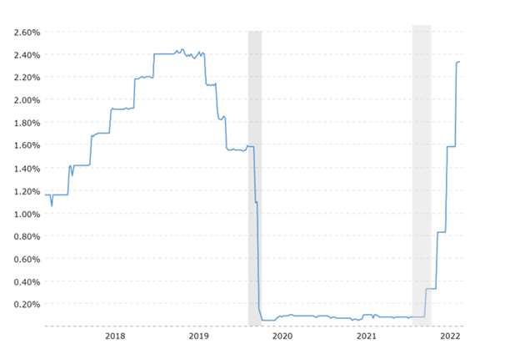

Source: macrotrends

Official S&P performance data shows that the performance of the S&P 500 is higher during the pandemic and lower after the central bank regime shift in 2022 (tradingview 2022)

Figure No. 2: S&P 500 performance from Jan 2020 to July 2022

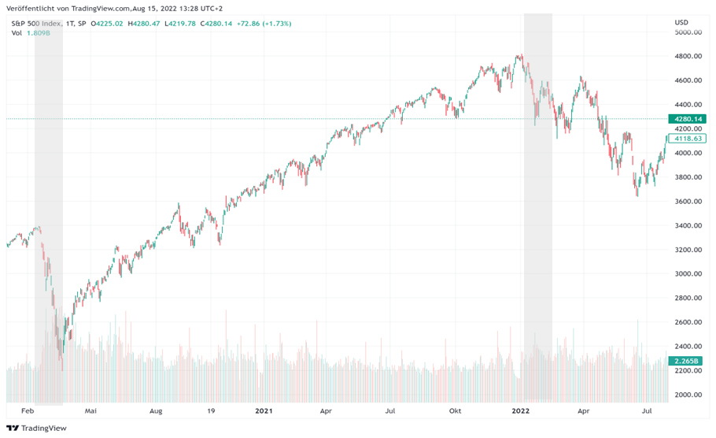

Source: TradingView

Dow Jones Market Data evaluated the five most recent rate hike cycles to show stock market returns in these periods. The analysis illustrates that during these periods, the S&P 500 only declined during one rate hike cycle.

Table No. 1: Rate hike cycles from 1994 to 2019

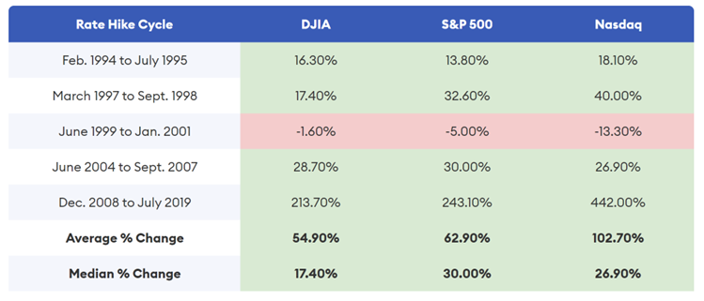

Source: Dow Jones Market Data

In the next step the sector exposure is reviewed with the help of a historical flow charts for the S&P 500 to identify the sector performance for the two periods investigated.

Figure No. 3: S&P 500 sector exposure as of March 2022

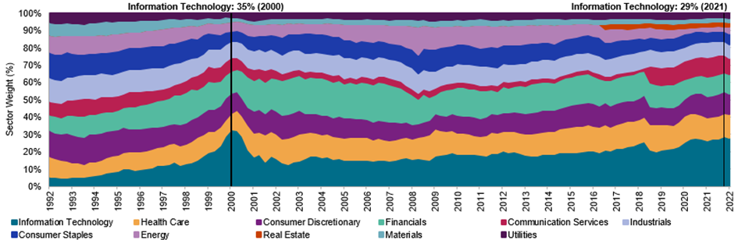

Source: S&P Dow Jones Indices LLC

The chart of figure 4 shows a sector exposure of 29 percent for the information and technology sector in 2021 which raises the question of the performance contribution during the pandemic and after the regime shift in 2022. Therefore, the sector performance breakdown during the pandemic from 2020 to 2021 and for the regime shift of the central bank in 2022 is evaluated based on S&P data in the next step.

Table No. 2: S&P 500 sector performance from 2020 to July 2022



Source: S&P Dow Jones Indices LLC

Figure 5 illustrates the significant performance contribution of the technology and communication services sector during the pandemic in 2020 and 2021. Furthermore, the data shows a significant underperformance of both sectors after the Fed regime shift in 2022. Based on the sector performance data the following hypotheses are defined:

H1: The performance of the S&P 500 is higher during the pandemic and lower after the central bank regime shift in 2022 than for the S&P 500 ex information & technology & communication.

H2: There is a high correlation between U.S. interest rates and the performance of S&P 500 and S&P 500 ex information & technology & communication services.

H3: There is a mean reversion process with a regime shift of U.S. interest rate policy after the pandemic.

For further research the following descriptive statistical methods are used to evaluate a potential correlation between the Fed pandemic policy and the S&P 500 technology sector performance:

1. Distribution: mean, variance, quartile

2. Boxplot: density distribution and median

3. Histogram: performance distribution

4. Simple regression and Pearson correlation: potential correlation between interest rates and performance

2 Chapter

There are several indicators for a potential correlation between Fed interest rate hikes and S&P sector performance discussed in the previous chapter. Based on these, the daily performance of the S&P 500 and S&P 500 ex information & technology & communication services is analysed in this chapter for a potential correlation. The S&P 500 without technology sectors does not include companies like Apple, Microsoft and Alphabet and is therefore used as comparative. Both indices are defined as dependent variables and interest rates as independent variable with the following parameter:

Table No. 3: Examination Parameters



Source: Author’s own according to S&P data

2.1 Distribution

In the first step the performance distribution is plotted against the interest rates for the pandemic period for 505 data points.

Figure No.5: S&P 500 vs. S&P 500 excl. INFT & TELS from 2020 to 2021

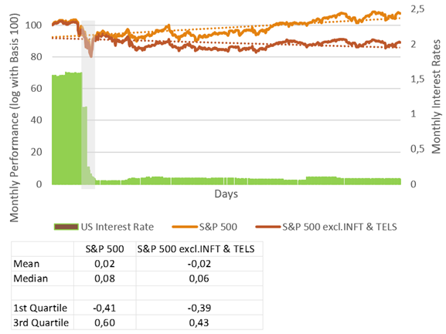

Source: Author’s own according to S&P data

In addition, the performance distribution is plotted against the interest rates for the Fed regime shift for 144 data points.

Figure No.5: S&P 500 vs. S&P 500 excl. INFT & TELS from January to July 2022

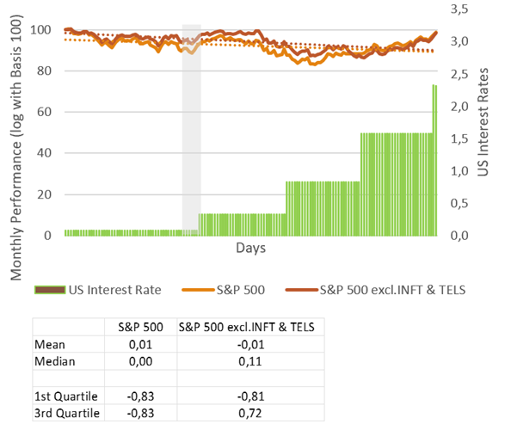

Source: Author’s own according to S&P data

The data shows higher performance for the S&P 500 during the pandemic and lower performance after the central bank regime shift in 2022 than for the S&P 500 ex information & technology & communication which confirms H1.

2.2 Boxplot

In the next step, Boxplots charts are used for the same evaluation periods to confirm the results of the distribution charts.

Figure No. 6: S&P 500 vs. S&P 500 excl. INFT & TELS from 2020 to 2021

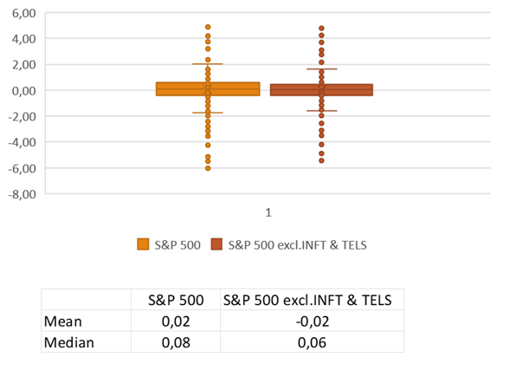

Source: Author’s own according to S&P data

The boxplot chart for the pandemic period shows a similar result as the distribution chart. The slightly higher median confirms the higher performance for the S&P 500 during the pandemic than for the S&P 500 ex information & technology & communication.

Figure No. 7: S&P 500 vs. S&P 500 excl. INFT & TELS from January to July 2022

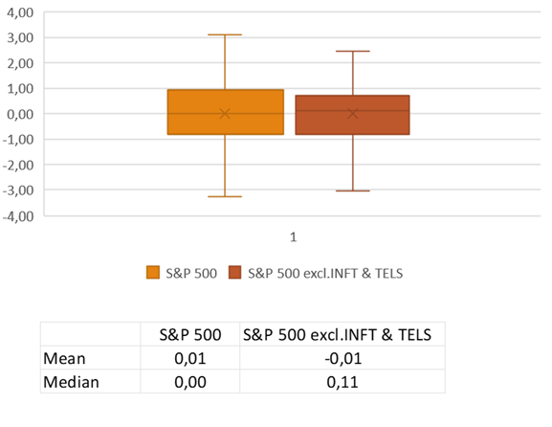

Source: Author’s own according to S&P data

The boxplot chart for the Fed regime shift period shows a median for the S&P 500 ex information & technology & communication which confirms a higher performance than for the S&P 500. The results of the distribution data raise H2 if there is a high correlation between U.S. interest rates and the performance of S&P 500 and S&P 500 ex information & technology & communication services.

2.3 Regression and Correlation Analysis

H2 will be answered with the help of a regression analysis and Pearson correlation for the index and Fed interest rate data. Data points and periods are the same as for the distribution and boxplot analysis. In the first step, a simple regression analysis for the pandemic observation is conducted with 505 data points.

Table No.4: S&P 500 & S&P 500 excl. INFT & TELS vs. U.S. interest rates from 2020 to 2021

 

Source: Author’s own according to S&P data

The regression analysis shows that there is no linear correlation between U.S. interest rates and the performance of S&P 500 and S&P 500 ex information & technology & communication services from 2020 to 2021.

In the second step a simple regression analysis for the Fed regime shift period is conducted with 144 data points.

Table No.5: S&P 500 & S&P 500 excl. INFT & TELS vs. U.S. interest rates from Jan to July 2022

 

Source: Author’s own according to S&P data

The result shows that there is a low linear correlation between U.S. interest rates and the performance of S&P 500 and S&P 500 ex information & technology & communication services in 2022. In the next step, Pearson correlation analysis for the pandemic observation is conducted with 505 data points.

Table No.6: S&P 500 & S&P 500 excl. INFT & TELS vs. U.S. interest rates from 2020 to 2021

|  |  |  |
| --- | --- | --- |
| **Pearson Correlation** |  |  |
|  | S&P 500 | S&P 500 excl. Tech |
| r | -0,049817 | -0,053862 |
| N | 505 | 505 |
| T | -1,118666 | -1,209762 |
| DF | 503 | 503 |
| p | 0,263816 | 0,226938 |

Source: Author’s own according to S&P data

The Pearson correlation shows for both indices values of 0 and indicates no correlation between U.S. interest rates and the performance of S&P 500 and S&P 500 ex information & technology & communication services from 2020 to 2021. The p-values for both analyses indicate no significance for the correlation values.

In the second step a Pearson correlation analysis for the Fed regime shift period is conducted with 144 data points.

Table No.7: S&P 500 & S&P 500 excl. INFT & TELS vs. U.S. interest rates from Jan to July 2022

|  |  |  |
| --- | --- | --- |
| **Pearson Correlation** |  |  |
|  | S&P 500 | S&P 500 excl. Tech |
| r | 0,153308 | 0,151592 |
| N | 144 | 144 |
| T | 1,848734 | 1,827553 |
| DF | 142 | 142 |
| p | 0,066576 | 0,068209 |

Source: Author’s own according to S&P data

The findings show that there is no correlation between U.S. interest rates and the performance of S&P 500 and S&P 500 ex information & technology & communication services in 2022. The p-values for both analyses indicate significance for the correlation values.

Therefore, it can be determined, that is no mean reversion process for the S&P 500 technology sector with the regime shift of the Fed after the pandemic

Conclusion

This paper shows the different sensitivity of S&P 500 sectors during the Covid19 pandemic from 2020 to 2021 and after the Fed regime shift in 2022. The technology sector contributed significantly to the positive performance in the low interest rate environment and led the negative contribution after raising interest rates beginning of 2022.

The main reason for this development is rising U.S. government bond rates and the effects of the discounted cash flow method on the highly capitalized U.S. technology sector. Interestingly, the performance of the S&P 500 is in fact higher during the pandemic and lower after the central bank regime shift in 2022 than for the S&P 500 ex information & technology & communication. But the regression analysis of this paper shows that that there is no linear correlation between U.S. interest rates and the performance of the technology sector and proves that that there is no mean reversion process until July 2022.

Therefore, the aim of this paper results in the important conclusion that the hypothesis that the higher the interests at the end of the pandemic the higher the mean reversion process for the highly capitalized S&P 500 technology sector is wrong.

Since traditional companies, such as utilities or consumer goods and banks, are less affected by the mechanism of discounted cash flow this paper expresses further dedicated research on other sectors of the S&P 500.

The paper also recommends conducting research on the Euro Stoxx 600 sectors to analyze a potential correlation with the EZB interest rates the performance in comparison to the Fed impact.

Literature

1. GHOSH, Indradip et al. *Fed to raise rates three times this year to tame unruly inflation.* [online]. 20. 01. 2022 [cit. 2022-10-25]. Available from: https://www.reuters.com/business/fed-raise-rates-three-times-this-year-tame-unruly-inflation-2022-01-20/
2. MOTLEY, FOOL. *Die Panik um Zinserhöhungen bei US-Technologieaktien ist übertrieben.* [online]. 08. 05. 2021 [cit. 2022-10-25]. Available from: https://www.onvista.de/news/die-panik-um-zinserhoehungen-bei-us-technologieaktien-ist-uebertrieben-454436806
3. GUPTA, Kriti. *Big Tech and Interest Rates Are Starting to Move in Unison Again.* [online]. 26. 01. 2022 [cit. 2022-10-25]. Available from: https://www.bloomberg.com/news/articles/2022-01-26/big-tech-and-interest-rates-are-starting-to-move-in-unison-again
4. HEYDEN, Manuel: *Diese Folgen hat der Preisdruck für Tech-Aktien*. [online]. 16. 03. 2021 [cit. 2022-10-25]. Available from: https://www.dasinvestment.com/diese-folgen-hat-der-preisdruck-fuer-tech-aktien/
5. SULLIVAN, Bob: *How Does The Stock Market Perform When Interest Rates Rise?* [online]. 23. 06. 2022 [cit. 2022-10-25]. Forbes (2022). Available from: https://www.forbes.com/advisor/investing/how-interest-rates-affect-stock-market/

Contact

Alexander Hütteroth

University of Finance and Administration

Parsevalstraße 5

60486 Frankfurt am Main

Germany

Alexander_Huetteroth@web.de

Robert Laskowski  
Is Amazon exploiting its dominant market position at Corona times? Evidence from office supplies and Stationery in Germany

Abstract

The purpose of the paper is to prove that Amazon exploited its dominant market position at pandemic times in 2020 and 2021 in Germany to increase prices and returns. In the period 2019 to 2021, the purchase and sales prices, as well as Amazon's buy box rate of approximately 10,000 items in the office and stationery category were recorded and evaluated. It was found that the sales prices increased by approximately 4% more during the pandemic period than the purchase prices during the same period. The federal government's temporary VAT reduction from 19% to 16% in the second half of 2020 was passed on to customers by Amazon. In addition, VAT increases in January 2021 were not exploited for a hidden price increase by Amazon. Rather, the observed price increases of 8% to 15% in 2021 is due to the increase in Amazon's purchase prices and the VAT adjustment in January 2021. The Amazon Buy Box ratio fell from an average of 75% to as low as 56.7% during the first government lockdown due to a demand shock, but was recovered by Amazon in subsequent months through price discounts and the sacrifice of its own profit margin of over 5% on the previous year. On average for the year, Amazon Buy Box ratios remained almost the same as in the previous year and the second pandemic year. The events of the first lockdown are compared with further restrictions in the pandemic, whereby a drop in the Buy Box quota could not be determined again.

Keywords

Inflation, online price index, Amazon, online trade, purchase price, buy box

JEL classification

E30, E31, O12

Introduction

What´s happened in Germany during Covid-19

With the onset of the Corona pandemic in early 2020, drastic government requirements and restrictions were implemented to contain the virus in Germany (Räker et all, 2021). Among other things, curfews were imposed, brick-and-mortar stores were closed, students and parents were forced to home-school and work from home, and the VAT rate was temporarily reduced to stimulate the economy. While brick-and-mortar retail was propped up and saved with stop-gap aid, online retail experienced an explosion in demand. By 2021, one in seven euros in retail was already spent online, representing growth on 2019 of over 43% (Online Monitor, 2021). Above all, however, the tech and online giant Amazon benefited from the state-imposed shop closures of stationary retail. In 2020 and 2021 alone, Amazon Germany increased net sales to €32.6 billion. In the year before the Corona pandemic, it was still 19.9 billion euros (amazon.com, INC, 2021). Online retail experienced a veritable demand shock during the lockdowns. Online retail sales skyrocketed, led by the industry leader Amazon. Anyone who did not have an Amazon account before then had to create one now at the latest.

Demand determines supply. If more and more people demand goods online, the supply or the offer price will also increase. Since today's online market is only limited by a few large companies, such as Amazon, Otto, Zalando and Ebay, the increasing demand was only served by a few online shops. This created a strong channelling of demand to a few providers, which suggests a price increase due to a dominant market position.

Amazon, how it works

Amazon has set out to sell everything except guns and live animals (Jeff Bezos, 2015). Amazon is an online shop and marketplace that sells virtually everything in various product categories. To ensure low prices, Amazon scans the entire online market using its own scraping systems to look for the best deals on an item. Once the best price or offer has been found in another online shop, this offer is posted or undercut on its own website, with the aim of always offering the customer the best price (Cavallo, 2018). Thus, prices in online retail are generally very volatile. The retail giant Amazon acts as both a seller and a marketplace on its website. As a seller, Amazon mostly buys the goods directly from the manufacturer in order to resell them to the consumer on its own behalf and account on the website. However, Amazon also functions as a marketplace where other online sellers can offer goods. Other sellers have the opportunity to sell products on Amazon that Amazon itself also sells. Amazon has no direct influence on the sales prices of the other marketplace participants. Each seller of goods must determine his own selling price. Finally, there is one offer from Amazon directly and many more from other sellers. The consumer is free to choose from whom he buys a product. However, Amazon already places the best offer for the consumer in the Buy Box. The Buy Box is a synonym for the best offer in terms of price and shipping costs, which Amazon connects to the buy button of the item. With this principle, Amazon creates a competition on its own website. With the battle of all sellers for the Buy Box, the best possible offer from price and shipping costs is determined for the consumer.

1 Research Question

The aim of this paper is to find out how office and stationery prices on Amazon.co.uk have changed in times of pandemic from 2019 to 2021 and how the Amazon Buy Box ratio has changed during this period.

A key question arises for this research: is Amazon exploiting its dominant market position in times of government-imposed shop closures of brick-and-mortar retailers? Further, subordinate research questions arise that will be answered in this paper: How did Amazon consumer prices in the office and stationery category change between January 2019 and December 2021 due to government restrictions and requirements? Did Amazon fully pass on the VAT reduction to the customer or was there a hidden price increase, if applicable? Did Amazon use the VAT increase at the end of 2021 to raise consumer prices by more than the VAT rate? What Buy Box behaviour can be demonstrated?

2 Research hypothesis

The shop closures of brick-and-mortar retailers shifted shopper demand to online retail in one fell swoop, resulting in a demand shock. The hypothesis of the paper is that Amazon exploited its market position during the Corona pandemic, especially in 2020 and 2021, to maximise market share and profits. It is suspected that Amazon raised prices and occupied the buy box more than in times before the pandemic by suspending or adjusting some of the automatic price adjustment. Amazon's share price alone suggests this. It climbed from USD 93.75 in January 2020 to USD 166.72 in December 2021 (google.com/finance, 2022).

3 Data and Methods

Using a modern web scraping method, the daily prices and the buy box situation could be recorded on www.amazon.de. The daily monitoring of prices makes it possible to find out what direct and indirect influence the government restrictions within the Corona Pandemic had on prices and the Buy Box in 2020 and 2021. The changes in the VAT rate in the second half of 2020 are more likely to have a direct impact on price. Whereas the lockdowns and shop closures had more of an indirect impact on sales prices, purchase prices and the Amazon Buy Box. In addition, by monitoring both price levels, it is possible to find out how Amazon's margin changed during the monitoring period.

This study has the following data on a daily basis from 9,977 items from 17 different brands in the office and stationery sector (pens, paper, staplers, scissors, writing pads, etc.) in the period 01.01.2019 to 31.12.2021 (appendix, table 1):

* Amazon Purchase Price (AZN PP)
* Amazon Gross Sales Price incl. VAT (AMZ RP)
* Amazon Net Profit Margin (Net PPM)
* Amazon Buy Box Quote per Month (AMZBB)

The purchase price of an item from Amazon can only be changed by a supplier. This is usually negotiated with Amazon and is almost stable for one year. It describes the actual cost price for Amazon of a product. Downstream remuneration or discounts are not included. Amazon and suppliers usually negotiate downstream purchasing and invoicing conditions once a year. It must be assumed that downstream conditions have changed during the data records, which also has a direct influence on Amazon's profitability. The sales and purchase price are therefore not the only variables influencing Amazon's net profitability (Net-PPM). The Amazon Net Profit Margin (Net-PPM) is an index figure provided by Amazon to the supplier on a weekly basis. It is intended to show how profitable an item is for Amazon when Amazon itself has taken over the Buy Box. The Amazon gross selling price including VAT is the price at which Amazon offers a product on the marketplace. The Amazon market price does not necessarily have to be the price with which Amazon wins the Buy Box over other sellers. The Amazon price therefore does not necessarily represent the price at which the customer purchases an item. Therefore, the Amazon buy box ratio is an important indicator that should show how much Amazon itself occupies the buy box.

The methodological approach for the study is as follows. In order to minimise errors in the raw data or measurement errors, the data was trimmed. If prices deviate more than 80% downwards or 400% upwards from the previous daily price, this figure is not used in the calculation. Guidance is provided by a published study by Hansen (2020), who has already undertaken a study of online prices to investigate the dynamic pricing of online shops. An item must have at least ten data points per month to be considered in the study. It is possible that Amazon did not offer individual items for certain periods of time, resulting in missing sales price data (RP). The same logic is used for the purchase price data (PP) to ensure data quality. Then the daily prices are aggregated to an arthritic average price per month. The monthly Amazon Buy Box quota is calculated using the quotient of the number of days Amazon itself occupied the Buy Box and the number of days in a month. The data series starts with January 2019 compared to January 2020, at which point there are only 1,812 valid data points out of the total number of items to 6,649 invalid ones. This ratio shifts to 5,117 valid and 3,096 invalid data points by December 2021 compared to December 2020. Only the AZN Net PPM is only available for 2020 and 2021, so the change could only be measured in 2021. In the end, however, the Amazon Net-PPM is only intended to confirm or invalidate the theory put forward. The sample is checked to see to what extent it is representative. It is assumed that the basic quantity of products in the office and stationery category is not determined and cannot be narrowed down. Thus, the simplified formula for calculating the sample size can be used. To ensure that the sample contains the true value even in the worst case, the sample size is forced to its maximum with π = 0.5. The π-value can be between 0% and 100% and is usually not known in advance of a sample investigation. With π = 0.5, it is ensured that the equation for determining the sample with π(1 - π) obtains its maximum. If π = 0 and π = 1, the sample would be n = 0. To ensure a high confidence level of the sample of at least 99%, z = 2.58 is set. The z-value was determined using the z-value table of the standard normal distribution.

Confidence level: z-value table

90% 🡪 1,65 95% 🡪 1,96 99% 🡪 2,58

A margin of error (1) of maximum 3.03% is allowed with the sample size of 1.812 measurements (2). A margin of error of only 1.8% is achieved with the sample size of 5.117 measurements (3).

$E=z*\sqrt{\frac{π\left(1-π\right)}{n}}$ (1)

n = sample size, π = proportion of the characteristic in the population, z = width of the confidence interval, E = margin of error

$E=2.58*\sqrt{\frac{0,5\left(1-0.5\right)}{1,812}}=0.0303$ (with the smallest sample size, n=1,812) (2)

$E=2.58*\sqrt{\frac{0.5\left(1-0.5\right)}{5,117}}=0.0180$ (with the largest sample size, n=5,117) (3)

Thus, it can be concluded that the sample of at least 1,812 items is representative at all times with a probability of 99% and a margin of error of 3.03%.

The price changes of products are measured against the respective month of the previous year. Just as with the inflation comparison, the average monthly price of the current month is compared with the same month of the previous year. If data from the previous year is not available, this item is not taken into account for the current month. This means that an item can only be considered in the study if a reliable value of the current month and the previous month is available. However, this method reduces the sample considerably.

The changes t-1 and t of the Amazon purchase prices and Amazon sales prices of overlapping products are compared. These are products that can show a valid value in both months. We calculate an index (PPI) for the purchase price changes (4) and an index (RPI) for the Amazon selling price changes (5). Then, the average of the monthly price indices is calculated to determine a price change at the category level, analogous to inflation (appendix, tables 2, 3). Thus, the inflation or inflation of the existing basket of goods is calculated based on the correspondence of the price data to the previous month. Finally, the indices are compared to test the hypothesis. The Laspeyres index formula is used for the calculations of the online price index, which is also used in the calculation of the consumer price index and the Harmonised Index of Consumer Prices in Germany (Camba-Mendez et al., 2002).

Calculation Purchase price inflation (PPI):

$PPI =\sum_{t=0}^{t}{\frac{{PP}_{t}-{PP}_{t-1}}{{PP}_{t-1}}}$ (4)

t = period month, t-1 = same month, previous year, PPI = purchase price inflation, PP = purchase price

Calculation Amazon retail price inflation (RPI):

$RPI=\sum_{t=0}^{t}{\frac{{RP}_{t}-{RP}_{t-1}}{{RP}_{t-1}}}$ (5)

t = period month, t-1 = same month, previous year, RPI = retail price inflation, RP = Amazon retail price

Calculation monthly Buy Box quota (BBQ):

$BBQ=\frac{ADB}{DpM}$ (6)

BBQ = buy box quota, ADB = days when Amazon on buy box, DpM = days per month

The monthly Buy Box quota per item is calculated from the number of days on which Amazon itself was in the Buy Box (ADB) in relation to the number of days in a month (6). The total Buy Box quota per month is calculated from the average of all Buy Box quotas per article and month.

Calculation Change Amazon pure profit margin (CnetPPM):

$CnetPPM={netPPM}_{t}-{netPPM}_{t-1}$ (7)

t = period month, t-1 = same month, previous year, CnetPPM = change Amazon Net-PPM to previous year, netPPM = pure profit margin by Amazon

The change in Amazon's net profit margin is calculated with a simple subtraction of the net PPM from the current year and the net PPM from the previous year (7). The change in net profit margin per month will be used at the end of the study to strengthen or refute the findings. margin per month will be used at the end of the study to strengthen or refute the findings (appendix, table 4).

4 Results

The examination of the results only partially confirms the hypothesis, but nevertheless allows for very interesting findings. Amazon's annual average buy box rate is around 75% (appendix, figure 1). Only in March and April 2020 does the Amazon buy box rate collapse to 56.73%, leading to a real buy box crash. This is due to the first lockdown in the course of fighting the pandemic, starting on 22 March 2020. The closure of brick-and-mortar retail led to a demand shock in online retail. Amazon, which turns over nearly every second euro in online retail (Online Monitor, 2021), was now sold out of many items and had to let other sellers in the marketplace take the buy box. Amazon first had to get new goods again, which, according to experience, takes ten days. Already in May '20 Amazon reached a Buy Box value of 75% again. In the following months Amazon seems to make up for the lost Buy Box shares. By December '20 Amazon significantly increases its own Buy Box quota with an average of 79.97% in the second half of the year. The Buy Box ratio reaches its peak with over 84% in August'20. At the end of 2021 Amazon again reached an average annual value of 75.83%. It is also interesting that the event of the buy box crash was not diagnosed again for the second state lockdown in November and December 2020. Thus, it can be stated that Amazon was now better prepared for upcoming restrictions and requirements by the German government and had sufficient goods in stock.

The Buy Box analysis helps to understand the context of Amazon price changes. In the sample of up to 5,117 valid prices, the changes in Amazon purchase price increases only diverge significantly from sales price increases in the second half of 2021. While Amazon was still lowering prices and foregoing margins in 2020, prices were significantly increased in 2021. The diagnosed price reduction from June to December 2020 correlates with Amazon's increased Buy Box share. Namely, to make up for the lost Buy Box shares, Amazon had to lower prices to win its own Buy Box on the marketplace. The price reduction on Amazon's part was not seen again in the course of the second lockdown, as Amazon now had no need to regain lost Buy Box shares (appendix, figure 2).

The government-imposed VAT cut from 19% to 16% to activate consumption from July'20 to December'20 had an additional effect on Amazon's price. At the end of the day, it can be said that Amazon passed on the 3% VAT cut to stimulate consumption to its customers. The real effect of the VAT cut on consumer prices is only 2.52%. In August'20 and September'20, the negative inflation of Amazon prices reaches its peak. Price reductions of up to 5.5% in August'20 and 7.63% in September'20 compared to the previous year are recorded. These significant price reductions correlate with Amazon Buy Box share. Amazon wants to win back lost Buy Box shares and has to lower prices to do so. The higher the Buy Box ratio, the lower the Amazon prices. In January '21 the VAT was raised again to the old rate of 19%. In the same month, Amazon sales prices jumped by 10.36% compared to the same month of the previous year. This price jump was driven by increased purchase prices, which were raised significantly by 8.5% in January. Amazon usually negotiates new prices and conditions with its suppliers for the coming year, which then become effective for invoicing at the beginning of a new year. The standard deviation of purchase price inflation of up to 52.45% indicates a high dispersion of price data in 2021. Compared to the 2020 standard deviation of 5% on average, this means that few products have been significantly increased. The VAT effect does not yet have an impact on inflation at this point. Approx. 3% Amazon increases the sales price without influence of any other measurable effect in this study. Compared to the inflation of the Federal Statistical Office in the category SEA-VPI-No.0954 stationery and drawing materials (appendix, table 5), the inflation for January'21 is only 1.7% (Destatis, 2022).

In the second half of 2021, the VAT effect of the previous year comes into play. While the effect had a negative impact on inflation and the Amazon price in the previous year, it is now responsible for a positive effect of 2.52%. The increased purchase price of 9.06% explains a further part of the calculated sales price increase on the part of Amazon, but not the entire increase of 14.03% in July 2021. The average inflation of the purchase price from July to December 2021 is 9.05%. The average inflation of the retail price is 14.40%. The VAT effect is 2.52%. This means that Amazon's prices increased by 2.83% without the influence of VAT and the purchase price increase.

Compared to the official inflation rate of the Federal Statistical Office of the 3rd Stella level (SEA-VPI-Nr.0954), the inflation of the Amazon sales price is higher. Run Amazon sales price analysis, inflation is determined to be as high as 15.89% in October 2021. The Federal Statistical Office has determined an inflation of only 4% in the same period. Recording the year‑on-year change in Net PPM, which hovers around zero with the exception of April 2021, confirms the finding that Amazon must have given up margins in the previous year in an attempt to restore the Buy Box ratio. April 2021 is diagnosed as a single significant year‑on-year increase in net profit margin of 5.48%, but this does not reflect a trend. The jump in the net profit margin is not due to an increased selling price and decreased buying prices in 2021. The cause of the changes therefore lies in the previous year. Amazon can logically only calculate a margin if an item has also been sold. Since Amazon was sold out of many items in March and April 2020, no profit margin could be achieved and calculated. Deviations in the AZN-Net PPM of up to 1% upwards and downwards compared to the same month of the previous year are quite common in the market. It therefore refutes the hypothesis that Amazon exploited its market position at pandemic times to maximise profits to the detriment of consumers.

Conclusion

Amazon first significantly lowered prices in the office and stationery category within the Corona pandemic in 2020 compared to the prevailing expectations in Germany and then significantly increased them in 2021. With the first lockdown imposed by the federal government and the associated blanket closure of stationary retail, online retail and Amazon in particular is experiencing a demand shock. Amazon came under pressure on its own marketplace due to an increased sell-out situation. Amazon lost significant share in Bux Box in March '20 and April '20. As a result, Amazon's selling prices rose in the same month, as goods were scarce and the battle for the Buy Box was literally suspended. Sooner or later, everyone who still had goods won the Buy Box and could sell their items. When Amazon and all other marketplace participants had stocked up again with sufficient goods in May '20, the battle for the Buy Box could start again. In order to correct the Buy Box situation, Amazon lowered prices significantly in the following months of the same year in order to win back the lost Buy Box shares. Thus, Amazon price inflation rates ranked well below the official inflation rate of the German Federal Statistical Office at the comparable Stellar level. The significant reduction in Amazon sales prices also shows that the Amazon algorithm seems to have targets that predominantly have to be achieved, even if it means giving up one's own margins. This is particularly noticeable in the jump in profit margin in March'21 compared to the same month last year. Since the jump in profits cannot be attributed to increased sales prices or reduced purchase prices, one can assume that the profit margin in March'20 must have been very low. In this specific case, it was more important for Amazon to somehow react to the lost buy box quotas than to secure its own margins. The reduction in VAT from July'20 to December'20 had an additional effect on prices. It can be stated that Amazon passed on the VAT advantage to its customers and did not exploit its dominant market position in the first pandemic year.

A significant influence on the price increase in the second pandemic year was primarily the purchase price increase and the VAT increase from January'21. Beyond these influencing factors, a maximum price deviation between purchase and sales prices - adjusted for the VAT effect - of up to 4% in October'21 could be determined, but this does not necessarily have to be due to Amazon's dominant market position, as no significant increase in Amazon's net profit margin could be determined in the same period. It is much more likely that the price increase is due to higher energy and logistics costs, which have increased sharply in times of the pandemic. A clear advantage for Amazon based on the available data cannot be ascertained in the second pandemic year either.

The described effect from the restrictions and limitations on public life from the first lockdown could not be determined again for the second lockdown in November and December 2020. Amazon learned from the first lockdown and was prepared for the next wave of demand. Even the international logistics shock when the cargo ship Evergiven blocked the Suez Canal for several days in March 2021 had no measurable impact on prices.

While the inflation of Amazon sales prices in 2020 is still well below the inflation of the German Federal Statistical Office and in 2021 well above it, and considering that every fifth euro (excluding food) is already spent online, the calculated inflation of the Amazon sales price should rather go hand in hand with the official inflation. Other research can follow this theory.

References

1. AMAZON. *Amazon INC. FORM 10-KFor the Fiscal Year, 2022,* Ended December 31, 2021, Amazon.com. [online]. 2021. [cit. 2022-08-09]. Available at: https://sec.report/Document/0001018724-22-000005/
2. CAMBA-MENDEZ, Gonzalo; GASPAR, Vito; WYNNE, Mark. *Measurement issues in european consumer price indices and the conceptual framework of the HICP*. European Central Bank, 2002. ISBN 92-9181-306-0
3. CAVALLO, Alberto. More Amazon effects: online competition and pricing behaviors. *NBER Working Paper* No. 25138, 2018.
4. GOOGLE.DE/FINANCE, *NASDAQ: AMZN Stock Value 2017-2022*, [online]. 2021. [cit. 2022-08-09]. Available at: https://www.google.com/finance/quote/AMZN:NASDAQ?hl=de&window=5Y
5. HANDELSVERBAND DEUTSCHLAND e.V. *Online Monitor* *2021*. Einzelhandel.de [online]. 2021. [cit. 2022-08-09]. Available at: https://einzelhandel.de/index.php?option=com_attachments&task=download&id=10572
6. HANSEN, Malte. Dynamische Preissetzung im Onlinehandel: zur langfristigen Anwendung von automatisierter Preiserhebung. *WISTA-Wirtschaft und Statistik*, 2020, 72. Jg., Nr. 3, S. 14-23. ISSN 1619-2907
7. RÄKER, Miriam; KLAUBER, Jürgen; SCHWINGER, Antje. Pflegerische Versorgung in der ersten Welle der COVID-19-Pandemie. In: *Pflege-Report 2021*. Springer, Berlin, Heidelberg, 2021. pp. 33-58. ISBN 978-3-662-63106-5. Available at: https://link.springer.com/content/pdf/10.1007/978-3-662-63107-2.pdf
8. STATISTISCHES BUNDESAMT. *Verbraucherpreisindizes für Deutschland*. *Monatsbericht Februar 2022.* Destatis.de [online]. 2022. [cit. 2022-08-09] Art.No.: 2170700221024. Available at: https://www-genesis.destatis.de/genesis/online?operation=abruftabelleBearbeiten&levelindex=1&levelid=1664258539836&auswahloperation=abruftabelleAuspraegungAuswaehlen&auswahlverzeichnis=ordnungsstruktur&auswahlziel=werteabruf&code=61111-0004&auswahltext=&werteabruf=Werteabruf

Contact

Robert Laskowski

University of Finance and Administration

Sandstraße 74 b

09114 Chemnitz

Germany

[rlaskowski@amvisor.com](mailto:rlaskowski@amvisor.com)

Appendix

Table no. 1: Data collection scheme: daily Amazon purchase price, daily Amazon retail price, daily Amazon buy box and daily Amazon net pure margin per week



Source: own research

Table no. 2: Amazon purchase price inflation with valid sample size, median, standard deviation, range and percentiles 25, 50 and 75.



Source: own research

Table no. 3: Amazon retail price Inflation with valid sample size, median, standard deviation, range and percentiles 25, 50 and 75.



Source: own research

Table no. 4: Change AZN-Net-PPM compared to the same month of the previous year with valid sample size, median, standard deviation, range and percentiles 25, 50 and 75.



Source: own research

Figure no. 1: Amazon buy box quota month by month from Jan´2019 to Dec 2021.

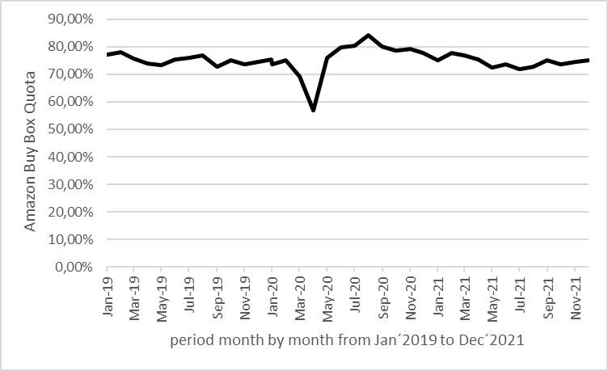

Source: own research

Figure no. 2: Comparison of German Federal Statistical Inflation with Amazon retail price index, Amazon purchase price index and Amazon net pure profit margin in the period January 2020 to December 2021

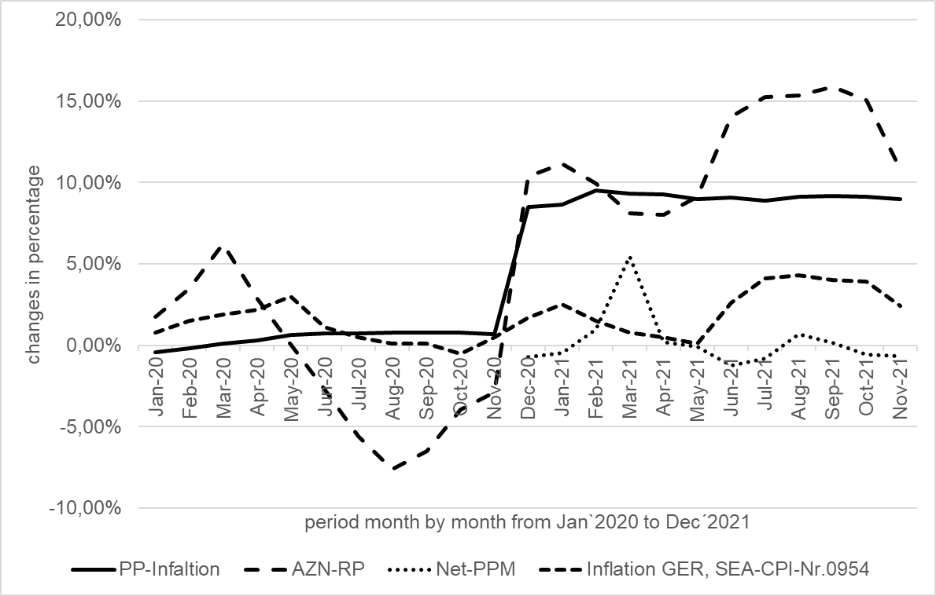

Source: own research

Table no. 5: German Federal Statistical Office 3rd Stellar Level Inflation from January 2020 to December 2021 for the Goods Class Stationery and Drawing Materials (SEA CPI No. 0954).

|  |  |  |  |  |  |  |  |  |  |  |  |
| --- | --- | --- | --- | --- | --- | --- | --- | --- | --- | --- | --- |
| **Jan-20** | **Feb-20** | **Mar-20** | **Apr-20** | **May-20** | **Jun-20** | **Jul-20** | **Aug-20** | **Sep-20** | **Oct-20** | **Nov-20** | **Dec-20** |
| 1.70 | 0.80 | 1.50 | 1.90 | 2.20 | 3.00 | 1.10 | 0.50 | 0.10 | 0.10 | -0.50 | 0.50 |

|  |  |  |  |  |  |  |  |  |  |  |  |
| --- | --- | --- | --- | --- | --- | --- | --- | --- | --- | --- | --- |
| **Jan-21** | **Feb-21** | **Mar-21** | **Apr-21** | **May-21** | **Jun-21** | **Jul-21** | **Aug-21** | **Sep-21** | **Oct-21** | **Nov-21** | **Dec-21** |
| 1.70 | 2.50 | 1.50 | 0.80 | 0.50 | 0.10 | 2.60 | 4.10 | 4.30 | 4.00 | 3.90 | 2.40 |

Source: own research

Ondřej Málek  
Využití záznamů o pohybu vozidel při správě daní

Abstrakt

Nejvyšší správní soud se v rámci své rozhodovací praxe opakovaně zabývá pravomocí správce daně požadovat poskytnutí informací zjištěných jinými orgány veřejné moci za účelem správy daní. Rozhodovací praxe se již ustálila na závěru, že je možné požadovat poskytnutí informací od policie, a to i z trestních spisů. V jednom z nedávných rozsudků pak Nejvyšší správní soud posuzoval možnost poskytování záznamů o pohybu vozidel ze systému Automatické kontroly vozidel provozovaném policií správcům daně. Tento rozsudek se objevil i v neodborných médiích, přičemž byl některými prezentován jako překvapivý a zavádějící plošné sledování správci daně. Příspěvek hodnotí význam tohoto rozsudku, zabývá se otázkou, zda byl skutečně tak překvapivým, a nabízí úvahu nad dalším možným vývojem rozsahu požadovaných informací ve vztahu k závěrům rozsudku.

Klíčová slova

Dokazování, správa daní, správce daně, systém Automatické kontroly vozidel, kniha jízd

Klasifikace JEL

K34, H20, H26

Úvod

Činnost a pravomoc správce daně je ve svém jádru vymezena cílem samotné správy daní. Ten je normován § 1 odst. 2 daňového řádu, dle kterého jde o postup, jehož cílem je správné zajištění a stanovení daní a zabezpečení jejich úhrady. Tento postulát je společně se základními zásadami správy daní[1] významným interpretačním korektivem (Lichnovský/Ondrýsek, 2021, s. 2) celé procesní úpravy správy daní. K dosahování tohoto cíle je správce daně nadát pravomocí (a povinností) vyhledávat důkazní prostředky, a to i bez součinnosti s daňovým subjektem. Takto stanovený cíl správy daní však správce daně současně omezuje v jeho vyhledávací činnosti, neboť limitem vyhledávací činnosti je zákonné vymezení cíle správy daní obsažené v § 1 odst. 2 daňového řádu (Baxa, 2011, s. 420), a to bez ohledu na to, zda má obstarávaný důkazní prostředek svědčit ve prospěch či neprospěch daňového subjektu (Lichnovský/Ondrýsek, 2021, s. 308).

Při vyhledávání důkazních prostředků je správce daně mimo jiné oprávněn požadovat poskytnutí široké škály informací od jiných orgánů veřejné moci a osob. Rozsah tohoto oprávnění a možný dopad do použitelnosti takto získaného důkazního prostředku jsou opakovaně posuzovány Nejvyšším správním soudem. V nedávném rozsudku ze dne 21. 7. 2022, č. j. 9 Afs 147/2020-34 se Nejvyšší správní soud zabýval možností požadovat poskytnutí informací o pohybu vozidel zaznamenaných policií v systému Automatické kontroly vozidel.

Cílem příspěvku je zhodnotit význam tohoto rozsudku, klade si otázku, zda byl rozsudek skutečně tak překvapivým, a nabízí úvahu nad dalším možným vývojem rozsahu požadovaných informací a nástrojů získání informací významných pro správu daní v kontextu právě tohoto rozsudku.

1 Informační povinnost osob a orgánů veřejné moci vůči správci daně

1.1 Pravomoc policie zaznamenávat pohyb vozidel

Zaznamenávání pohybu vozidel (i osob) může ze své podstaty zasahovat hned do několika základních práv, a to zejména ve vztahu k ochraně osobnosti. Mimo jiné jde o záruku nedotknutelnosti osoby a jejího soukromí dle čl. 7 odst. 1 Listiny základních práv a svobod, popřípadě právo na respektování soukromého a rodinného života dle čl. 8 Úmluvy o ochraně lidských práv a základních svobod (EÚLP). Tato ochrana však není absolutní, a proto například čl. 8 odst. 2 EÚLP stanoví, že státní orgán do výkonu tohoto práva v zásadě nemůže zasahovat, a to s výjimkou případů, kdy je to v souladu se zákonem a je to nezbytné v demokratické společnosti v zájmu národní bezpečnosti, veřejné bezpečnosti, hospodářského blahobytu země, ochrany pořádku a předcházení zločinnosti, ochrany zdraví nebo morálky nebo ochrany práv a svobod jiných (Pavlíček, 2011, s. 518). Na toto ústavně právní zakotvení a mezinárodně právní závazek navazují normy jednoduchého vnitrostátního práva, jejichž základ lze nalézt v občanském zákoníku.

Ochrana práva na podobu vychází v § 84 občanského zákoníku z principu svolení, tj. že zachytit podobu člověka tak, aby podle zobrazení bylo možné určit jeho totožnost[2], lze pouze s jeho svolením. Jednou z výjimek z tohoto pravidla je zákonná úřední licence dle § 88 občanského zákoníku. Základem této výjimky je existence zvláštního zákona (nikoliv předpisu nižší právní síly), na jehož základě dochází k úřednímu pořízení podoby (Melzer/Tégl, 2013, s. 560-561). Tento zvláštní zákon pak současně musí vymezit rozsah výjimky dle § 88 pro konkrétní okruh situací (Knap, 2004, s. 114).

Této úřední licence využívá ustanovení § 62 odst. 1 zákona o Policii České republiky, dle kterého policie může, je-li to nezbytné pro plnění jejích úkolů, pořizovat zvukové, obrazové nebo jiné záznamy osob a věcí nacházejících se na místech veřejně přístupných a zvukové, obrazové nebo jiné záznamy o průběhu úkonu. Obdobně jako v případě právní úpravy daňového řádu i zde dochází k limitaci účelem takového jednání orgánu veřejné moci. Jde tedy o limitaci dle § 2 zákona o Policii České republiky, který pojímá úkoly policie coby služby veřejnosti, a to za účelem ochrany bezpečnosti osob a majetku a veřejného pořádku, předcházení trestné činnosti, plnění úkolů podle trestního řádu a dalších úkolů na úseku vnitřního pořádku a bezpečnosti.

Kromě pořizování záznamů osob však policie může pořizovat i záznamy míst veřejně přístupných, které se žádným způsobem netýkají fyzických osob, žádným způsobem nezasahují do práva na ochranu jejich osobnosti a neobsahují ani osobní údaje. V takovém případě však nedochází k výkonu úřední licence dle § 88 občanského zákoníku a policie je pořizuje v rozsahu obecných oprávnění, která náleží každému (Vangeli, 2014, s. 255). Takový záznam však policií může být využit pouze pro potřeby plnění zákonem stanovených úkolů. Pokud je pak takové využití primárně preemptivní, nevylučuje to záznam z jeho použitelnosti coby důkazu v trestním[3] nebo jiném řízení, neboť byl pořízen v souladu se zákonným zmocněním (Vangeli, 2014, s. 256), a to ať již došlo k využití úřední licence ve vztahu k podobě člověka, nebo jde o záznam nedotýkající se osobnostních práv konkrétního jedince. Není pak ani rozhodné, zda byl záznam pořízen z místa veřejně přístupného, nebo z místa neveřejného, zjevně či utajeně (Šteinbach, 2019, s. 152).

Současná doba umožňuje pořídit záznamy i automatizovaně a hromadně. I pořízení takovýchto záznamů je pak pokryto § 62 odst. 1 zákona o Polici České republiky. Ta má však, v případě, že systém sama provozuje, povinnost informovat o této skutečnosti veřejnost. Podle ustanovení § 62 odst. 2 zákona o Policii České republiky, platí, že zřídí-li stálé automatické technické systémy k pořizování záznamů podle odst. 1, vhodným způsobem o tom uveřejní informaci. Toto ustanovení se však již neuplatní v případě systémů, které sama neprovozuje, ale má k záznamům v nich přístup. V takovém případě tuto informaci zveřejní provozovatel zařízení (Šteinbach, 2019, s. 154).

Jedním ze systémů, který policie provozuje dle § 62 zákona o Policii České republiky je systém Automatické kontroly vozidle (AKV). V rámci něj dochází k „zaznamenání údaje o registrační značce motorového vozidla, přičemž spolu s ním jsou dále uchovávány údaje o čase a prostoru zaznamenání konkrétní registrační značky“[4] a nahodile může docházet i k zachycení podoby osob při pořízení fotografie vozidla kamerou. Tyto informace jsou pak zaznamenávány v rámci preemptivní činnosti policie bez toho, aby byla známa konkrétní souvislost s úkoly policie.

1.2 Informační povinnost ve správě daní

Informační povinnost při správě daní není pouze jednosměrná ve směru od správce daně, ale i ve směru opačném – správce daně je oprávněn požadovat od orgánů veřejné moci či osob poskytnutí informací. Normativní vyjádření informační povinnosti vůči správci daně je primárně obsaženo v § 57 daňového řádu, přičemž v obecné rovině má správce daně požadovat informace od osob a orgánů veřejné moci, které splňují alespoň jeden z kvalifikačních znaků taxativně vymezených pod písmeny a) až d) prvého odstavce (Lichnovský/Ondrýsek, 2021, s. 236), tedy [a)] vedou evidenci osob nebo věcí, [b)] poskytují plnění, které je předmětem daně, [c)] provádějí řízení v případech, jejichž předmět podléhá daňové povinnosti, nebo [d)] zpracovávají jiné údaje nezbytné pro správu daní.

Ustanovení § 57 odst. 1 daňového řádu okruh orgánů veřejné moci či osob, které na vyžádání poskytují informace, nijak dále nekonkretizuje a jako obecné ustanovení tak dopadá na všechny orgány veřejné moci či osoby (Baxa, 2011, s. 321). Toto obecné ustanovení § 57 odst. 1 daňového řádu však neprolamuje mlčenlivost uloženou zvláštními právními předpisy. Ta je prolomena pouze v některých případech, a to primárně dle § 57 odst. 2 a § 57 a daňového řádu. Tyto výjimky jsou však vymezeny taxativně, a to jak co do okruhu osob s informační povinností, tak do rozsahu poskytovaných informací.[5]

Patrně nejširší oprávnění pro získávání informací pro správu daní dává § 57 odst. 1 písm. d) daňového řádu, neboť zákonodárce vymezil tyto orgány veřejné moci a osoby jako ty, které „zpracovávají jiné údaje nezbytné pro správu daní.“ Šíře této pravomoci si jsou správci daní vědomi a pokoušejí se ji i hojně využívat.

Nejvyšší správní soud se ve své rozhodovací praxi věnoval mimo jiné i otázce, zda je orgánem veřejné moci pro potřeby § 57 daňového řádu policie. Opakovaně přitom uzavřel, že tomu tak je a správce daně je oprávněn požadovat poskytnutí informací od policie, je-li tím sledován cíl daní, tj. správné zjištění a stanovení daně a zabezpečení její úhrady. Může přitom jít i o informace z trestních spisů, což se uplatní zejména, jde-li o trestní řízení vedené v souvislosti s daňovou povinností prověřovanou správcem daně.[6]

2 Využití záznamů o pohybu vozidel správcem daně

2.1 Zpochybění knihy jízd

Předmětem sporu mezi plátcem DPH a správcem daně, který vyústil v rozsudku ze dne 21. 7. 2022, č. j. 9 Afs 147-2020-34, byl uplatněný nárok na odpočet daně na vstupu z pořízení automobilu pro potřeby podnikání plátce. Ten plátce daně uplatnil dle jeho tvrzení v souladu s § 72 zákona o DPH. Správce daně ovšem zahájil postup k odstranění pochybností mimo jiné ohledně oprávněnosti deklarovaného nároku na odpočet daně na vstupu z pořízení automobilu. Plátce daně předložil v reakci na výzvu k odstranění pochybností knihu jízd za období od 7. 7. 2015 do 11. 3. 2016 a daňový doklad k pořízení automobilu.

Správce daně v rámci prověřování oprávněnosti uplatněného nároku vyzval prodejce automobilu k poskytnutí údajů a listin souvisejících s příslušným automobilem. Z reakce prodejce a předložených listin (předávacího protokolu) zjistil, že k předání vozidla došlo dne 15. 7. 2015. Byl tak založen rozpor, kdy plátce deklaroval používání automobilu v době, kdy dle prodejce ještě nedošlo k jeho předání, a plátce jej tak neměl mít ve své dispozici.

V rámci dalšího prověřování pak správce daně vydal výzvu dle § 57 odst. 2 písm. d) daňového řádu s žádostí o poskytnutí informací o pohybu motorového vozidla vybrané registrační značky za období uvedené v knize jízd. Policie tyto záznamy poskytla, načež správce daně zjistil, že poloha vozidla dle záznamů v knize jízd neodpovídá poloze vozidla jak je zaznamenána policií v systému Automatické kontroly vozidel.

Na podkladě těchto rozporů, tj. nesouladu zjištěného data předání a záznamů o pohybu vozidla s knihou jízd, správce daně dospěl k závěru, že plátce daně neustál své důkazní břemeno a neprokázal splnění věcných podmínek nároku na odpočet daně dle § 72 zákona o DPH. Platební výměr na DPH vyšel z těchto kontrolních zjištění a oproti tvrzení plátce daně jej správce daně vyměřil bez přiznání odpočtu daně z pořízeného automobilu.

2.2 Skutečně přelomové rozhodnutí?

O rozsudku informovala běžná média (Štuková, 2022; Pokorný, 2022; Divinová, 2022), přičemž (patrně) v honbě za lákavým titulkem se bylo možné dočíst, že „Velký bratr dohlédne i na knihu jízd. Policie smí dávat data“ či že „Finanční úřady mají novou zbraň, mohou použít záběry silničních kamer“. Šlo však skutečně o takto překvapivý a senzační závěr?

V prvé řadě je nutné podotknout, že systém Automatické kontroly vozidel v současné době funguje již více než 15 let. Nejde tak o nástroj nijak nový – naopak je policí využíván již po značnou dobu. Je ovšem pravdou, že rozsudek byl prvním případem, kdy Nejvyšší správní soud posuzoval, zda je na základě § 57 odst. 1 písm. d) daňového řádu možné poskytnutí i informací získaných a evidovaných v systému Automatické kontroly vozidel.

V tomto kontextu však rozsudek nelze hodnotit jako jakkoliv překvapivý. Nejvyšší soud ve své rozhodovací praxi již dříve potvrdil, že policie je orgánem veřejné moci ve smyslu § 57 odst. 1 daňového řádu a správce daně po ní může požadovat poskytnutí informací i z trestních spisů, u kterých lze usuzovat na potenciálně značný zásah do soukromí osob, zúčastněných na trestním řízení. Argumentem *a maiori ad minus* tak je možné říci, že je-li možné požadovat poskytnutí informací v řízení, u kterého je značný zájem na jeho neveřejnosti a ochraně osob na řízení zúčastněných, tím spíše bude možné požadovat poskytnutí informací, které se ještě ani žádného konkrétního (trestního) řízení nedotýkají a jsou shromažďovány v rámci preemptivních aktivit policie. Konečně pak šlo o informaci již shromážděné policií, nikoliv nově vytvořené či získané policí na pokyn správcem daně.

Rozsudek každopádně poskytuje cenný vhled do praktik správců daně (bez ohledu na to jak jsou skutečně rozšířeny a využívány), neboť doposud nebylo veřejně známo, že by správci daně využívali údaje pořízení policí v rámci systému Automatické kontroly vozidel ve správě daní.[7]

Soudím, že při opatření důkazních prostředků pro zjištění pohybu vozidel se dnes nabízí více a více možností automatického zaznamenávání pohybu vozidel.

Může jít například o využití záznamů při snímání státních poznávacích značek za účelem zjištění informací o platnosti elektronické dálniční známky. Dle informací zveřejněných Státním fondem dopravní infastruktury však jsou SPZ v rámci kontroly zaplacení poplatku uloženy v informačním systému po dobu 24 hodin.[8] V úvahu tak připadají pouze záznamy, které byly předány přestupkovému orgánu v případě, kdy bylo zjištěno, že poplatek uhrazen nebyl. Ty jsou totiž dále zpracovávány a uchovávány přestupkovým orgánem pro potřeby přestupkového řízení.

Obdobnou situaci pak může představovat ověřování platnosti parkovacích oprávnění. Ze zásad zpracování osobních údajů v rámci správy pozemních komunikací, zejména zón placeného stání, v Praze[9] plyne, že je pořízen fotozáznam vozidla, jeho identifikační údaje, údaje o čase a místě stání vozidla, výjimečně/nahodile záznamy vyskytujících se osob a údaje o parkovacím oprávnění. Doba uchování záznamů v případě, kdy neexistuje podezření na přestupek proti regulaci zón placeného stání (tj. je zjištěno, že vozidlo má příslušné oprávnění), je v délce 7 dní od zápisu údaje do centrálního informačního systému zón placeného stání v hlavním městě Praze. V případě, že existuje podezření na spáchaný přestupek, dochází k předání údajů Městské policii hlavního města Prahy, přičemž zásady zpracování osobních údajů v takovém případě neinformují o žádné lhůtě, po kterou dochází k uchování příslušného záznamu.

Z délky trvání uchování záznamu, a to jak u kontroly u elektronických dálničních známek, tak u kontroly parkovacích oprávnění, plyne, že uchování údajů v případě, kdy neexistuje podezření na spáchání přestupku, je limitována na dobu řádově dnů. Po uplynutí této doby dochází ke smazání těchto záznamů a nelze tak předpokládat jejich další poskytnutí správci daně, neboť daňové povinnosti bývají zpravidla zkoumány zpětně a nikoliv průběžným a opakovanym dotazováním širokého spektra subjektů potenciálně disponujících informacemi potřebnými pro správu daní. Jiná situace ovšem nastává v případě, kdy existuje podezření na spáchaný přestupek, neboť záznam o vozidle a jeho poloze je předán přestupkovému orgánu, který jej následně bude uchovávat v souvislosti s řešenou přestupkovou agendou. V těchto případech by tedy bylo možné, aby správce daně využil svého oprávnění dle § 57 daňového řádu, a požadoval poskytnutí například záznamů o spáchaných přestupcích v souvislosti s absencí parkovacího oprávnění v zónách placeného stání. Oproti získání dat ze systému Automatické kontroly vozidel by však šance získat informace mohla být spíše náhodná, resp. výtěžnost tohoto zdroje by byla výrazně limitována, a to pouze na situace, kdy u vozidla nebyl zaplacen příslušný poplatek, a věc byla předána přestupkovému orgánu. K výraznému nárůstu záznamů o poloze vozidel by však mohlo dojít v případě, kdy by některý z těchto existujících systémů byl v budoucnu napojen na systém Automatické kontroly vozidel.

Závěr

Rozsudek Nejvyššího správního soudu blíže rozebraný v tomto příspěvku nelze považovat za tak přelomový, jak mohlo být prezentováno v neodborných zdrojích. Rozhodnutí nezavádí žádné doposud neexistující plošné sledování, existenci Velkého Bratra či přímý přístup správců daně do systému Automatické kontroly vozidel. V kontextu intepretace oprávnění správce daně k vyžadování splnění informační povinnosti od orgánů veřejné moci a osob bylo celkem předvídatelné, že Nejvyšší správní soud potvrdí zákonnost výzvy stran dožádaného subjektu a požadovaných informací. Rozsudek tak navazuje na řadu rozhodnutí potvrzující velké možnosti § 57 daňového řádu.

Nelze však odhlédnout od vzrůstající míry monitorování a zaznamenávání informací v rámci automatizovaných systémů provozovaných orgány veřejné moci. Proto může za jistých okolností připadat v úvahu i využití údajů z kontroly platnosti elektronických dálničních známek či parkovacích oprávnění. Tato využitelnost se však nyní v zásadě omezuje na situace, kdy z tohoto monitorování bylo zjištěno podezření na spáchání přestupku. V opačném případě jsou záznamy evidovány v řádu dnů. Do budoucna však lze zcela jistě uvažovat o tom, že bude dále docházet k rozšiřování a propojování těchto systémů. Systém Automatické kontroly vozidel by tak mohl začít využívat záznamy z jiných systémů automatické kontroly (například kontroly elektronických dálničních známek) a tím rozšířit okruh monitorovaných vozidel.

V kontextu cílů tohoto příspěvku tak lze konstatovat, že rozsudek nelze považovat za nijak překvapivý, neboť navazuje na judikaturní linku Nejvyššího soudu. Lze však uvažovat o tom, že dojde k rozšiřování systémů automaticky monitorujících polohu vozidel, čímž dojde k rozšíření informačních zdrojů správců daně využitelných dle § 57 daňového řádu.

Dedikace

Tento výstup vznikl v rámci projektu Specifického vysokoškolského výzkumu č. 260 493 s názvem „*Vývoj finančněprávní a trestněprávní regulace pod vlivem normotvorby Evropské unie*” řešeného na Univerzitě Karlově, Právnické fakultě, v letech 2020–2022.

Literatura

1. BAXA, Josef, et al. *Daňový řád. Komentář. I. díl*. Praha: Wolters Kluwer, 2011. ISBN 978-80-7357-564-9.
2. DIVINOVÁ, Jana. Velký bratr dohlédne i na knihu jízd. Policie smí dávat data. *peníze.cz* [online]. 8. 8. 2022 [cit. 9. 10. 2022]. Dostupné z: <https://www.penize.cz/dane/435847-velky-bratr-dohledne-i-na-knihu-jizd-policie-smi-davat-data>.
3. KNAP, Karel, et al. *Ochrana osobnosti podle občanského práva*. Praha: Linde, 2004. ISBN 80-7201-484-6.
4. LICHNOVSKÝ, Ondřej a ONDRÝSEK, Roman, et al. *Daňový řád. Komentář*. Praha: C. H. Beck, 2021. ISBN 978-80-7400-838-2.
5. MELZER, Filip, TÉGL, Petr, et al. *Občanský zákoník – velký komentář. Svazek I. § 1-117.* Praha: Leges, 2013. ISBN 978-80-87576-73-1.
6. PAVLÍČEK, Václav. *Ústavní právo a státověda*. Praha: Leges, 2011. ISBN 978-80-87212-90-5.
7. POKORNÝ, Marek. Auto mám jen k práci, tvrdil finančnímu úřadu. Ten si od policie vyžádal data z kamer a neuznal odpočet DPH. *Hospodářské noviny* [online]. 8. 8. 2022 [cit. 9. 10. 2022]. Dostupné z: <https://archiv.hn.cz/c1-67100580-auto-mam-jen-k-praci-tvrdil-financnimu-uradu-ten-si-od-policie-vyzadal-data-z-kamer-a-neuznal-odpocet-dph>.
8. Policie České republiky. Automatická kontrola vozidel. *policie.cz* [online]. 25. 5. 2015 [cit. 9. 10. 2022]. Dostupné z: <https://www.policie.cz/clanek/automaticka-kontrola-vozidel.aspx>.
9. ŠTEINBACH Miroslav, et al. *Zákon o Policii České republiky. Komentář*. Praha: Wolters Kluwer, 2019. ISBN 978-80-7598-194-3.
10. ŠTUKOVÁ, Karolína. Finanční úřady mají novou zbraň, mohou použít záběry silničních kamer. *Seznam Zpr*ávy [online]. 11. 8. 2022 [cit. 9. 10. 2022]. Dostupné z: <https://www.seznamzpravy.cz/clanek/ekonomika-finance-dane-financni-urady-maji-novou-zbran-mohou-pouzit-zabery-silnicnich-kamer-211315>.
11. VANGELI, Benedikt. *Zákon o Policii České republiky*. Praha: C. H. Beck, 2014. ISBN 978-80-7400-543-5.
12. GDPR a osobní údaje. *edalnice.cz* [online]. 2022 [cit. 30. 9. 2022]. Dostupné z: <https://edalnice.cz/gdpr-a-osobni-udaje/index.html>
13. Zásady zpracování osobních údajů. *Parkujvklidu.cz* [online]. 1. 9. 2021 [cit. 30. 9. 2022]. Dostupné z: <https://www.parkujvklidu.cz/wp-content/uploads/2021/09/2021-09-01_Zasady-zpracovani-osobnich-udaju_TSK_ZPS.pdf>
14. Nález Ústavního soudu ze dne 11. 12. 1996, sp. zn. I. ÚS 116/96.
15. Rozsudek Nejvyššího soudu ze dne 12. 10. 2006, sp. zn. 30 Cdo 2232/2006.
16. Rozsudek Nejvyššího správního soudu ze dne 25. 10. 2016, č. j. 4 Afs 177/2016 – 35.
17. Usnesení Nejvyššího soudu ze dne 25.1.2017, sp. zn. 4 Tdo 8/2017.
18. Rozsudek Nejvyššího správního soudu ze dne 2. 8. 2017, č. j. 4 Afs 58/2017 – 78.
19. Rozsudek Nejvyššího správního soudu ze dne 21. 7. 2022, č. j. 9 Afs 147-2020 – 34,

Kontakt

Mgr. Ondřej Málek

Univerzita Karlova, Právnická fakulta

Katedra finančního práva a finanční vědy

nám. Curieových 901/7

116 40 Praha 1

Česká republika

malek@prf.cuni.cz

Azra Muratovic  
Euro area and its Banking Sector: Perspectives of long‑term Development

Abstract

The path of the banking system from national level to global players being interconnected through the market integration has been a long journey and is still going on. The paper provides a historic overview of the monetary integration process but also the current status of the banking levels. It is supposed to show the need, the causes for the establishment of additional institutions in order to maintain the stability within the integration process. Also it shows why the necessity occurred to introduce new institutions like the Banking and Capital Market Unions. The aim of the paper is to present briefly the monetary integration process and everything it has brought with it. We have seen that the banking efficiency has been improved anyway as the market has become more stabilized. Although the banking market has slightly changed in its composition due to the global environment, it has remained rather stable during the financial and Covid crises.

Key words

Banking sector, monetary union, banking and capital market union, banking efficiency

JEL classification

G20, H12, F62, E52

Introduction

Monetary integration has been one important element and driving force in this process, but by far not the only one. Others include the emergence of the Euromarkets in the 1950s and 1960s, regional exchange-rate arrangements, individual countries' financial liberalization efforts and the EU Single Market program. Additionally, the monetary integration process has caused the implementation and establishment of the EU Banking Union and European Capital Market Union. Beside, not all influences were policy induced. At times, market forces played a decisive role. The paper intends to provide a historic overview of the monetary integration process but also the current status of the banking levels. It is supposed to show the need, the causes for the establishment of additional institutions in order to maintain the stability within the integration process.

1 Monetary Integration

On 24 April 1972, EEC central-bank governors concluded the 'Basel Agreement', creating a mechanism called the ‘Snake in the tunnel’. Under this mechanism, Member States' currencies could fluctuate (like a snake) within narrow limits against the dollar (the tunnel) and central banks could buy and sell European currencies, provided that they remained within the fluctuation margin of 2.25%. The original participants in the mechanism were France, Germany, Italy, Luxembourg and the Netherlands. Denmark, Norway and the United Kingdom joined shortly afterwards. (European Parliament, 2015)

The introductory rudiments of EMS were the description of the European Currency Unit (ECU) as a handbasket of public currencies and an Exchange Rate Mechanism (ERM), which set an exchange rate towards the ECU for each sharing currency. On the base of those' central' rates, bilateral rates were also established among Member States. The system also included a preventative tool to avoid breaking the set exchange rates. The early times of the EMS saw modest results. According to experts, the turning point came in 1983 when the' French government decided to follow a franc stronghold policy, in which financial policy nearly followed that of the German government and came decreasingly request acquainted.' (Solomon, 1999) By committing to EMS discipline, France and other affectation-prone countries achieved a reduction in affectation and their interest rates gathered to a lower position. (European Parliament, 2015)

1.1 Towards an Economic and Monetary Union

Despite these stabilization efforts, the destabilizing effects of deregulating international financial capital movements under the Single European Act, and the diverging national monetary and fiscal policies of EMS members such as the UK and reunified Germany. combined with uncertainties related to the ratification of the Maastricht Treaty, led to increasing market speculation, culminating in a currency crisis during 1992-93, forcing some Member States (the UK and Italy) to leave the ERM and some others (Spain and Portugal) to devaluate their currency. This move, as well as the positive result of the second referendum in Denmark (after the Edinburgh Agreement and its opt-out from the EMU) eased tensions and the project went forward with the creation of the European Monetary Institute, charged with ensuring the coordination of Member States' monetary policies and providing surveillance. (Chang, 2009)

Going further, the Cannes European Council in June 1995 confirmed that the year 1999 would be the starting date for the Economic and Monetary Union and European leaders at the Madrid European Council in December decided to name the new European currency the 'euro'. With the date for the launch of the EMU approaching, public skepticism towards monetary integration grew, especially in Member States with strong currencies, like Germany, which were concerned about maintaining price stability. At the same time, other countries such as France and Spain were more concerned about growth than price stability. This led the European leaders' meeting in Dublin in December 1996 to propose a Stability and Growth Pact, which was a compromise between a German proposal for the creation of a Stability Pact – which would maintain convergence obligations after Member States joined the euro area – and the French, Spanish and Italian concerns that excessive focus on budgetary discipline would be at the expense of growth. (Chang, 2009)

In June 1997, the European Council adopted a Resolution to set up an exchange rate mechanism after the creation of the euro area in 1999. This mechanism, called 'ERM II' because it essentially replaced the ERM mechanism of the EMS, fixed the exchange rate of non-euro area Member States against the euro and allowed it to fluctuate only within set limits, to ensure that exchange rate fluctuations between them would not impact on the economic stability of the single market. Meanwhile, the Member States considerably increased their efforts towards convergence: whereas in 1997 only Finland, Luxembourg and Portugal had achieved all the convergence criteria, by May 1998, the Council decided that 11 Member States satisfied the necessary conditions. Finally, in July 2000, the Council agreed that Greece also fulfilled the convergence criteria – although it needed to continue the intensive structural reforms undertaken – and could therefore adopt the single currency. (Chang, 2009)

1.2 The euro area before and after the crisis

The years between the introduction of the euro and the global financial crisis are generally considered as a positive period for euro-area economies. According to (Mongelli et al., 2008), the value of imports and exports of goods within the euro area increased from 26% of GDP in 1998, to 33% of GDP in 2007. In the same period, intra euro area services trade also went up, from 5% to 7% of GDP. Baldwin, Skudelny and Taglioni (2008) found that the EMU had a significant impact on trade flows with non-EMU countries: third countries traded up to 27% more with EMU countries since the creation of EMU. Inflation rates dropped and converged among euro-area countries. (OECD, 2005) Mongelli and Wyplosz (2006) observed that this price stability benefited consumers and companies. Moreover, low interest rates have lowered the cost of servicing high public debts. Mongelli et al. (2008) notes that EMU has been associated with 'a substantial increase in cross-border financial integration across the euro area' which in turn, 'has stimulated financial development (...), through the lowering of transactions costs and the expansion in the volumes of financial assets'.

Euro area Member States and institutions are fighting the crisis on different fronts: economic governance was strengthened through a number of initiatives; at the same time, facilities and mechanisms were created to provide assistance and support to Member States in financial difficulties and a Banking Union was founded, to restore financial stability in the euro area, through a safer financial sector and a better integrated banking system; finally, non-standard monetary policy measures were introduced, to maintain price stability, stabilize the financial situation and limit financial contagion to the real economy. Thus, financial system collapse was avoided, while foundations were laid for the sector's long-term stability.

2 European Banking Union and Capital Market Union

As mentioned above, the process of monetary integration has caused the establishment of the banking and capital market unions.

The need for a banking union emerged from the financial crisis of 2008 and the subsequent sovereign debt crisis. It became clear that, especially in a monetary union such as the euro area, problems caused by close links between public sector finances and the banking sector can easily spill over national borders and cause financial distress in other EU countries.

The purpose of the banking union is to make european banking more: transparent by consistently applying common rules and administrative standards for supervision, recovery and resolution of banks; unified by treating national and cross-border banking activities equally and by delinking the financial health of banks from the countries in which they are located; and safer by intervening early if banks face problems in order to help prevent them from failing, and – if necessary – by resolving banks efficiently. (ECB, 2022)

The other establishment that emerged from the monetary process and due the recent crises is the capital markets union.

The capital markets union (CMU) is a plan to create a single market for capital. The aim is to get money – investments and savings – flowing across the EU so that it can benefit consumers, investors and companies, regardless of where they are located.

A capital markets union will (1) provide businesses with a greater choice of funding at lower costs and provide SMEs in particular with the financing they need; (2) support the economic recovery post-Covid-19 and create jobs; (3) offer new opportunities for savers and investors; (4) create a more inclusive and resilient economy; (5) help Europe deliver its new green deal and digital agenda; (6) reinforce the EU’s global competitiveness and autonomy and (7) make the financial system more resilient so it can better adapt to the UK’s departure from the EU. (European Commission, 2021)

2.1. The Costs and Benefits of Monetary Union

The traditional optimum currency area literature identified the elimination of transactions costs and the trade-creating effects of lower exchange rate variability as being the principal benefits of extending the domain of a single currency. The cost, of course, is the loss of the exchange rate instrument as a means of responding to disturbances that affect different regions differently.

In an exceptionally thorough and professional study of the consequences of monetary union, the Commission of the European Communities has attempted to quantify these costs and benefits and has also identified other ways in which monetary union can have an impact on national economies. The Commission study identifies 16 different mechanisms by which economic and monetary union can affect economic performance. These mechanisms are grouped under five main headings. The Commission wisely does not attempt to arrive at a “bottom line” that provides a quantified balance of benefits versus costs. The tone of the report, however, is that the benefits are greater than the earlier literature has suggested, and the costs much smaller and transitory. Moreover, since many benefits accrue at the conclusion of the transition process, the advantages of rapid progress are overwhelming. (ECB, 2022)

Since its establishment, the European Union has progressively made a series of reforms in order to improve the integration of European financial markets. The banking sector is one of the most important aspects not only of the financial markets, but also of the economy, as it is the main channel through which enterprises are financed. European integration was expected to contribute to a more efficient banking sector (European Central Bank, 2005). Thus, the banking industry experienced profound changes and reforms aiming at fostering integration of banking services across the E.U. Nonetheless, European banking integration still confronts certain obstacles as European member-countries have different national characteristics and legal systems, which means that complete banking integration is not yet close to being achieved (Weill, 2009; Matousek et al., 2015; Kalemli-Ozcan et al., 2008; Stavaarek et al., 2012).

The introduction of the common currency (the euro) represents one of the most important steps towards banking sector integration and this analysis aims at testing the hypothesis that an advanced level of financial integration is associated with higher convergence of efficiency in banking.

For instance, Casu and Molyneux (2003) apply a nonparametric D.E.A approach and a Tobit regression approach for European Union banks, throughout the period 1993–1997 and proved that the differences in the efficiency of the sample are mainly attributed mainly to country-specific factors. Kolia and Papadopoulos (2020a) investigate the relationship among capital, risk and efficiency in the Eurozone and the US banking systems and take into consideration environmental variables.

The basis for regulation of the banking industry is the interest to protect consumers and the systemic risks in the banking market. Because of informational asymmetries, consumers are not able to assess the safety and soundness of financial institutions which therefore requires official intervention and regulation (Dewatripont and Tirole 1995). Moreover, banks are seen as being particularly prone to systemic risk and vulnerable to contagion, for instance, in the form of fast-spreading bank-runs leading to sector-wide illiquidity and (if unchecked) bankruptcy. Thus, individual crisis-prevention entails sizable positive externalities, while much of the associated effort takes the form of private costs.

As a consequence, supervision and regulation is needed to ensure prudential banking and sufficient risk reduction efforts at the bank level (De Bandt and Hartmann, 2000). Besides regulation and monitoring a safety net is provided by Lender-of-Last-Resort, often assumed to be the central bank, which should intervene in case of a systemic crisis and lend to those banks which are temporarily illiquid (Goodhart and Huang 1999, Giannini 1999).

In 2010, the European Banking Authority (EBA) has been established by the European Parliament, replacing the Committee of European Banking Supervisors (CEBS). It is a regulatory body that strives to maintain financial stability throughout the European Union’s (EU) banking industry.

2.2 Current Challenges

In the words of Jean Monnet, one of the EU’s founding fathers: “People only accept change when they are faced with necessity, and only recognize necessity when a crisis is upon them.”

In the past couple of years, the EU has experienced a wide series of different challenges: inflation and recession, Brexit, the coronavirus and now the Russian invasion of Ukraine. The effects of the financial crisis on the EU were on of the first threats to the EU stability. The monetary union as conceived by the Maastricht Treaty previously had been a not finished project lacking adequate mechanisms for financial solidarity among member states in cases of emergencies. When the output of the U.S. sub-prime mortgage crisis hit EU, Europe’s financial system came close to collapse. But the impact of the crisis was uneven among the EU member states. Southern European members for example, suffered a great deal more than others. They not only fell into a deep recession but also had to implement harsh monetary and fiscal policies imposed by Northern European members as the condition for the bailouts they received.

Instead of a “break-up”, the EU members came up with a healing plan which included emergency funding programs, fiscal policy amendments and the act of bond purchase programs conducted by the European Central Bank. Herewith, the EU proved that its togetherness was a stronger crises-coping-mechanism than an individual member-per-member response would have been.

With the Russian invasion on Ukraine, not only a breach of international law has been undergone, but also has most of the European gas supply been interrupted. As energy prices increased, the whole supply-chain became costlier. A major increase in inflation has been noticed since February 2022.

According to the International Monetary Fund (IMF), this winter, more than half of the countries in the euro area will experience technical recessions. (IMF, 2022) And while inflation is projected to decline next year, it will stay significantly above central bank objectives of 2 percent, at about 6 percent and 12 percent, respectively, in advanced and emerging European economies. Additionally to the inflation and recession, the budget deficit in some EU countries has been noticeably increased. The highest deficits were recorded in Malta (-8.0%), Greece (-7.4%), Latvia (-7.3%), Italy (-7.2%), Romania (-7.1%), Spain (-6.9%), Hungary (‑6.8%), France (-6.5%) and Slovakia (-6.2%). (Trading Economics, 2022)

Conclusion

The paper provided a brief insight into the monetary integration process over the past decades, what has caused it and where we are now.

Contradictory to the expectations prior to the financial crisis 2007/08 where the banking efficiency has been focused on, the paper shows that the establishment of the European banking and Capital Market Unions have been prioritized, as the banking stability has now gained more weight. The paper did not cover a great piece of the financial crises as this was not the topic – but was mentioned as the course of the integration has been changed due to it.

Due to the unfortunate and unexpected events of the Covid 19 Virus Crisis and the recent Russian-Ukrainian conflict, the Eurozone has entered new challenges. Inflation, Recession and budget deficits are the new tasks on the agenda.

We have seen that the banking efficiency has been improved anyway as the market has become more stabilized. Although the banking market has slightly changed in its composition due to the global environment, it has remained rather stable during the financial and Covid crises. Another trigger however have been the arising energy shortage/inflation crises which are still present – their consequences are still being measured and dealt with in a fiscal policy-amendment matter, proving again the importance of highly stable and functioning institutions.

Literature:

1. BALDWIN, Richard, Di NINO, Virginia, FONTAGNE, Lionel, De SANTIS, Robert and TAGLIONI, Daria. *Study on the Impact of the Euro on Trade and Foreign Direct Investment*.” Brussels: European Commission, 2008. ISBN 978-92-79-08246-7
2. CASU, Barbara and GIRARDONE, Claudia. *Integration and efficiency convergence in EU banking markets.* Omega. Volume 38, Issue 5, 2010. ISSN 0305-0483
3. CHANG, Michele. *Monetary integration in the European Union*. Palgrave Macmillan. New York, 2010. ISBN 9780230542853
4. De BANDT, Olivier and HARTMANN, Philipp, Systemic Risk: A Survey. *European Central Bank Working Paper Series.* No. 35, 2000. ISSN 1561-0810. Available at: <http://dx.doi.org/10.2139/ssrn.258430>
5. DEWATRIPONT, Mathias and TIROLE, Jean. The Economics of Career Concerns, Part I: Comparing Information Structures. *The Review of Economic Studies.* Vol. 66, Issue 1, 1999. pp. 183–198, <https://doi.org/10.1111/1467-937X.00084>
6. EUROPEAN CENTRAL BANK. *EU Banking Structures.* Frankfurt: European Central Bank, 2006. ISSN 1830-1878
7. EUROPEAN CENTRAL BANK. *Banking union.* Banking Supervision [online]. 2022. Available at: https://www.bankingsupervision.europa.eu/about/bankingunion/html/index.en.html
8. EUROPEAN COMMISSION. *Capital Markets Union: Commission proposes new measures to boost Europe's capital markets.* [online]. 2021-11-25. Avaliable at: https://ec.europa.eu/commission/presscorner/detail/en/ip_21_6251
9. GIANNINI, Curzio. “Enemy of None but a Common Friend of All?”: An International Perspective on the Lender-of-Last Resort Function. *Princeton Essays in International Finance*. No. 214, 1999. ISBN 0881651273
10. GOODHART, Charles and HUANG, Haizhou. The Lender of Last Resort. *Economic Notes*. Vol. 29, no. 5, 1999. pp. 1-11. ISSN 0378-4266, Available at: <https://ideas.repec.org/a/eee/jbfina/v29y2005i5p1059-1082.html>
11. KAMMER, Alfred. Europe Must Address a Toxic Mix of High Inflation and Flagging Growth. *IMF BLOG.* [online] 2022-10-23. Availabla at: https://www.imf.org/en/Blogs/Articles/2022/10/23/europe-must-address-a-toxic-mix-of-high-inflation-and-flagging-growth
12. KALEMLI-OZCAN, Sebnem, Simone MANGANELLI, Elias PAPAIOANNOU and José-Luis PEYDRÓ. Financial integration, macroeconomic volatility and risk sharing – the role of the monetary union. In: NOBLET, Gilles a Frank SMETS, MAĆKOWIAK, Bartosz a Francesco Paolo MONGELLI, ed. *The Euro at Ten: Lessons and Challenges. Fifth ECB Central Banking Conference (13-14 November 2008)*. Frankfurt am Main: European Central Bank, 2009, s. 116-155. ISBN 978-92-899-0375-2 (print), 978-92-899-0376-9 (online). Available at: https://www.ecb.europa.eu/pub/pdf/other/euroattenen2009en.pdf?6ca2c8ad670dc32eecd6ba34120c80b5
13. KOLIA, Loukia and PAPADOPOULOS, Simeon. A comparative analysis of the relationship among capital, risk and efficiency in the Eurozone and the U.S. banking institutions. *Risk Governance and Control: Financial Markets and Institutions*, Vol. 10, no. 2, 2020. pp. 8-20. ISSN: 2077-4303
14. MAĆKOWIAK, Bartosz, Francesco Paolo MONGELLI, Gilles NOBELT a Frank SMETS, ed. *The Euro at Ten: Lessons and Challenges. Fifth ECB Central Banking Conference (13-14 November 2008)*. Frankfurt am Main: European Central Bank, 2009. ISBN ISBN 978-92-899-0376-9.
15. MATOUSEK, Roman, RUGHOO, Aarti, SARANTIS, Nicholas and ASSAF, George A. Bank performance and convergence during the financial crisis: evidence from the ‘old’ European Union and Eurozone. *Journal of Banking and Finance.* Vol. 52, 2015. pp. 208-216. Available at: <https://ideas.repec.org/a/eee/jbfina/v52y2015icp208-216.html>
16. MONGELLI, Francesco (2005). What Is European Economic and Monetary Union (EMU) Telling us about the Optimum Currency Area Properties? *Journal of Common Market Studies.* Vol. 43, no. 3, 2005. pp. 607-635. ISSN 1468-5965. Available at: <https://papers.ssrn.com/sol3/papers.cfm?abstract_id=786108>
17. ORGANISATION FOR ECONOMIC COOPERATION AND DEVELOPMENT. *Economic Policy Reforms: Going for Growth.* Vol. 1. Paris: OECD, 2005. Available at: <https://read.oecd-ilibrary.org/economics/economic-policy-reforms-2005_growth-2005-en#page1>
18. SOLOMON, Richard. (1999). The Birth of the Euro and Its Effects. *The Brown Journal of World Affairs.* Vol. 6, No. 2, 1999. pp. 141-148. ISSN: 10800786
19. TRADING ECONOMICS (2022). Euro Area government Budget. [online] 2022. Available at: [Euro Area Government Budget - 2022 Data - 2023 Forecast - 1995-2021 Historical (tradingeconomics.com)](https://tradingeconomics.com/euro-area/government-budget)
20. WEILL, Laurent. (2009). Convergence in banking efficiency across European countries. *Journal of International Financial Markets, Institutions & Money*. Vol. 19, no. 5, 2009. pp. 818-833. ISSN 1042-4431. Available at: <https://www.sciencedirect.com/science/article/abs/pii/S1042443109000298>

Contact

Azra Muratovic

Europa-Allee 138

60486 Frankfurt am Main

Germany

Azra_Muratovic@live.com

Michael Pirgmann   
Could CBDC be a threat to Monetary Policy?

Abstract

Central Banks are generally exposed to the Effective Lower Bound (ELB) problem when conduction Monetary Policy (MP). It is not possible for a central bank (CB) to perform MP with negative interest rates over a significant period because market participants would convert their deposits into cash if costs for conversion, storage and insurance would be lower than costs for their remunerated deposits. With many CB contemplating Central Bank Digital Currencies (CBDC), this paper discusses the effects for MP under the restriction of the ELB. Under the assumption that the CB will implement a non-remunerated tier for CBDC to provide market participants with a cash like means of payment, it can be assumed that the ELB will increase from currently approximately -1% with only cash in existence, closer to zero when implementing CBDC. This is due to the lower costs of exchange, holdings and insurance when shifting deposits into a non-renumerated tier of CBDC instead of converting into cash in times of negative interest rates. Implementation of a tier of non-remunerated CBDC creates a significant “extra buffer” for market participants with a large destabilizing effect for MP which a CB needs to consider when performing MP at the ELB.

Keywords

Monetary Policy, Effective Lower Bound, Cryptocurrencies, CBDC

JEL Classification

E41, E42, E43, E52, E58

Introduction

At present, cash is used in the bulk of all payments on a global scale (Bilotta and Botti, 2021). Despite this, there is evidence that the shares of cash payments are declining, and have done so for the past twenty years, promoting the notion of a cash-free society (Engert and Fung, 2017).

In the wake of the Global Financial Crisis of 2008 and the following years and the rising distrust in the financial system, an individual with the pseudonym Satoshi Nakamoto released a white paper introducing the concept of the first decentralised cryptocurrency (Nakamoto, 2008). Later that year, Nakamoto started the first version of the bitcoin network. Since then Bitcoin and other cryptocurrencies attracted increasing attention from investors and other market participants (Bouri *et al.*, 2017). Latest, since Meta (f. k. a. Facebook) planned to issue a stablecoin as its own proprietary currency (Bindseil, 2020; Sandner *et al.*, 2020) the interest by the public for cryptocurrencies in general is steadily increasing (Barotini and Holden, 2019). Today there are more than 10.000 different cryptocurrencies which most of them experiencing high volatility (Statista, 2022).

Compared to traditional assets and currencies, cryptocurrencies show some advantages for market participants. They have the potential to lower transaction costs because no middleman is needed. This also leads to a higher level of security since there is no single point of failure, and all transactions are transparent and immutable on an open distributed ledger based on the blockchain technology. Also, they are decentralised and therefore not controlled by a higher regulatory (Stefanoski *et al.*, 2020).

With the increasing interest by the public in cryptocurrencies which are not backed by any central authority, and large social networks like Facebook planning to issue stablecoins (Bindseil, 2020; Sandner *et al.*, 2020), central banks have begun contemplating about issuing Central Bank Digital Currencies as an additional means of payment since the mid-2010s (Barotini and Holden, 2019). It is notable, that cryptocurrencies and CBDC are a subset of digital currencies and might have a similar technological foundation. But CBDC are not necessarily based on the blockchain or distributed ledger technology like it is common for cryptocurrencies. A survey by Barotini and Holden, which was performed in 2018 among central banks (of which 63 central banks have replied, which together represent close to 80% of the world´s population and more than 90% of its economic output) has shown, that around 70% of the central banks are currently conducting conceptual and theoretical research about the implementation of CBDC. Among motivations like safe and efficient payments as well as financial inclusion, the main motivation for the central banks to consider CBDC is financial stability and monetary policy implementations (Barotini and Holden, 2019).

The Bank of England which spearheaded exploring CBDCs, took the first steps toward the development of its own CBDC as early as 2014, though, it is currently not planned to issue a CBDC (Kumhof and Noone, 2018; Klein, Groß and Sandner, 2020). The Bahamas was one of the first regions to declare the initiation of its own CBDC, the Sand Dollar which is a crypto token representative of the Bahamian Dollar (Alonso, Jorge-Vazquez and Forradellas, 2021). China orchestrated studies into their own CBDC in 2019 and concluded their tests in April 2020, after which the pilot was spread to nine Chinese cities. The Central Bank of Uruguay (CBU) finished a pilot project in 2018 as a segment of a wider government scheme to promote financial inclusion. The CBU distributed and circulated twenty million e-peso and is currently in the process of evaluating to issue the digital currency. Transactions were made instantaneously using a peer-to-peer verification system but in the absence of a blockchain (Alonso, Jorge-Vazquez and Forradellas, 2021). More recently, the European Central Bank (ECB) announced its intentions to amplify its efforts on the development of a Digital Euro (ECB, 2020; Passacantando, 2021).

It is discussed very controversial how a CBDC should look like. Different options for its architecture have been contemplated. Whether it shall bear an interest or not or whether it should be a full replacement for cash is a topic for ongoing discussions as well as the way of distribution and implementation. Either solution has a different impact on the financial market which needs to be carefully looked at.

For the MP, especially the existence of an ELB - due to cash being a remedy for market participants when exposed to low or negative nominal interest rates - needs to be considered when making decisions about the design of a CBDC. The ELB problem can be a serious threat to economies. To archive a desired price stability target, a CB can stimulate the economy by lowering the real interest rate and create more attractive conditions for investments. The real interest rate is equal to the nominal interest rate set by the CB (and other monetary policy measures), adjusted by the inflation rate. With the ELB in place, a CB has only limited options when the nominal interest rate is already at its lowest level and an economy needs further stimulus.

There is a lack in the literature of what the implications on MP at the ELB are, when implementing a non-remunerated CBDC tier.

The aim of the contribution is to answer the research question of how the effect on MP at the ELB can be evaluated when CBDC is introduced as a convenient and safe alternative to cash.

This paper is organized as follows: In the first chapter the CBDC is described with the relevant architectural features for contemplating the ELB problem. After that, the ELB problem in general will be outlined in the second chapter, before discussing the implications of a tiered non-remunerated CBDC on MP at the ELB. This paper will be summarized, and the research question will be answered in the concluding last chapter.

1 Central Bank Digital Currencies

CBDC is only a recent concept but there are global efforts being undertaken by central banks to investigate a potential implementation of CBDCs (Bordo and Levin, 2017; Auer, Cornelli and Frost, 2020). However, a monetary authority with an implemented CBDC had not previously existed, and a predominant reason for this is that the technology with the potential to make it a robust solution has not existed until recently (Barrdear and Kumhof, 2017). In most cases, CBDC is contemplated as an addition to cash and not thought of as a replacement of such. (Beniak, 2019). Despite this, some researchers examined the possibility of a full replacement of cash, leaving CBDC the only remaining currency in place (Bordo and Levin, 2017).

It is important to note, that CBDC is a risk free liability of the CB, which would be backed by assets (Panetta, 2021). Besides overnight deposits and bank notes, a CBDC could be seen as the third form of base money (Bindseil, 2020).

Whether a CBDC should be interest-bearing or non-interest-bearing is discussed controversial. With an interest-bearing CBDC, the CB could set the interest to a positive or negative rate, based on the economic situation. Either at their discretion, or under a rule-based approach (Pfister, 2020). An interest-bearing CBDC would give the central banks a tool to react flexible to economic circumstances and stimulate the economy with negative interest rates. But the stimulation would be limited as an interest-bearing CBDC would also impose the ELB problem as market participants would exchange their CBDC to banknotes like they would do with deposits in extended times of negative deposit interest rates.

A non-interest-bearing CBDC would be neutral to the economy and could be seen like cash nowadays. But if the interest rate trends towards zero or even into the negative area, it would impose an ELB effect, as market participants would change their deposits into banknotes and non-remunerated CBDC. An unrestricted and non-remunerated CBDC would set the ELB to zero, making it impossible for the CB to impose negative interest rates at all.

In case of the Digital Euro e.g., it has not been decided yet whether the DE shall be interest-bearing or non-interest bearing. The ECB is contemplating a remuneration for the DE due to monetary policy options (ECB, 2020). But, if the ECB would introduce a remunerated DE, a system with multiple tiers could be implemented. Bindseil and Panetta (2020) propose a two-tier system and suggest remunerating each tier differently. The so-called retail-tier would be zero-remunerated and would allow private households to use it as means of payment for their daily life just like cash. The authors propose that this tier shall never have a negative interest rate and that the quantity needs to be limited, for example to EUR 3,000 per user. The second tier would begin above the first tier´s limit and could be unlimited but remunerated. The interest rate for the second tier could be negative when MP decisions make it necessary, and vice versa (Bindseil and Panetta, 2020).

With such a system the ECB could set different interest rates to different user groups such as private households, large institutions, commercial banks, or foreigners and adjust the attractiveness of the DE. So, it would give the ECB an instrument to influence money flows and consequently support the commercial banking sector (Bindseil, 2020).

Also, with a multi-tiered CBDC, certain user groups could be excluded, e. g. individuals or companies from certain jurisdictions or countries (ECB, 2020). But, if at all feasible from a technical and political perspective, such regulation of excluding certain user groups would cause major friction and a competitive disadvantage for market participants and the DE per se (Ferrari and Mehl, 2021).

To summarize this point, a multi-tiered system with at least one remunerated and one non-remunerated tier as an equivalent to cash nowadays can be expected to have a high acceptance among the public. Such a system can also have advantages for the CB regarding efficiently performing monetary policy. Hence, the following considerations are under the assumption, that a non-remunerated tier is part of an implemented CBDC.

2 The Effective Lower Bound

The existence of non-renumerated cash constraints central banks to impose their policy interest rates significantly below zero. Assumed, that the negative policy rate would be transmitted via the banking system to market participants, they would convert their deposits into the paper form of the currency to avoid higher costs. This restraint is referred to as the “zero lower bound” (ZLB) or “effective lower bound” (ELB), to reflect that converting and holding the currency comes at a cost. Hence, the ELB actually lies at a point below zero, where the costs of negative interest rates are equal to the costs of exchange, storage and insurance of cash or CBDC.

How far below zero the ELB could be, is an ongoing discussion among economists. The empirical findings of Witmer and Yang consider that the ELB can be negative due to the costs of insuring, storing and transporting of physical banknotes and coins (Witmer and Yang, 2016). Other economists conclude that the effective lower bound is at around -1% (Witmer and Yang, 2016; De Fiore and Tristani, 2018; Ciżkowicz, Rzońca and Torój, 2019). The Czech National Bank calculated the threshold for the short term nominal interest rate in a corridor of -2% to -0,4%, with the mean at approximately -1% (Kolcunová and Havránek, 2018).

Also, it is to note that there are other factors besides the nominal interest rate that influence the ELB such as the time frame over which the negative interest rates are imposed. The interest rate must be limited by the ELB for a longer time span while they could be lowered for one quarter without a great effect on the ELB (Swanson, 2018).

But how negative could the interest rate be if the ELB was removed? Theoretically, there is no limit. When the Global Financial Crisis hit the US, e. g. the simulations by the Fed staff indicated in June of 2009, that the policy rate should ideally be set to -8% (FOMC, 2015; Nelson, 2021).

3. Monetary Policy at the ELB

To understand the impact of the ELB on MP by the CB, MP effects need to be considered when being already at the ELB with the nominal interest rate at a point where the CB is no longer able to decrease the policy rate any further without causing the market participants to start converting their deposits into cash.

A simplified description of the MP shows how the CB reacts to economic conditions. The measures of MP can either be a set mechanism in a rule-based regime (e.g., the Taylor-rule), or the CB can just set the nominal interest rate at an elected rate when it is in a discretionary system (Pfister, 2020). The form of the MP curve is depending on the Fisher equation. According to the Fisher equation (*r = i – π*), the real interest rate *r* is equal to the nominal interest rate *i* minus the (expected) inflation rate *π*. Again, the MP is not only depending on the policy rate but is describing policy measures at a whole with the nominal interest rate being the primary conventional policy tool for most economies to reach the desired inflation rate.

As shown in figure 1, to archive the goal of the CB to stimulate or slow down the economy, the CB will define a target inflation rate which is shown in figure 1 as *πB*. Thus, the CB will perform measures to adjust the real interest rate by setting the policy rate and e. g. by changing the minimum reserves or engage in open market operations. These measures are intended to either stimulate or slow down the economy by setting the real interest rate at a level, so that the target inflation can be archived, thus giving the MP curve it´s upward sloping form. For example, if inflation is decreasing from our target level *πB* towards *πA*, the CB is going to want to decrease the real interest rate to stimulate the economy and move the target price level back to *πB*. Thus, the CB is going to decrease *i* by a certain factor, which will result in moving down the MP curve from point *B* to *A*. So, the CB will attempt to lower the real interest rate to *rA*, which is supposed to stimulate the economy in the next period and move back up the MP curve to the target inflation.

Vice versa, if the CB is afraid, that the economy is getting too strong and that the inflation will increase above *πB*, the CB would increase *i* to lift the real interest rate and slow down the economy.

Fig. 1: Monetary Policy at the Effective Lower Bound with and without Central Bank Digital Currency

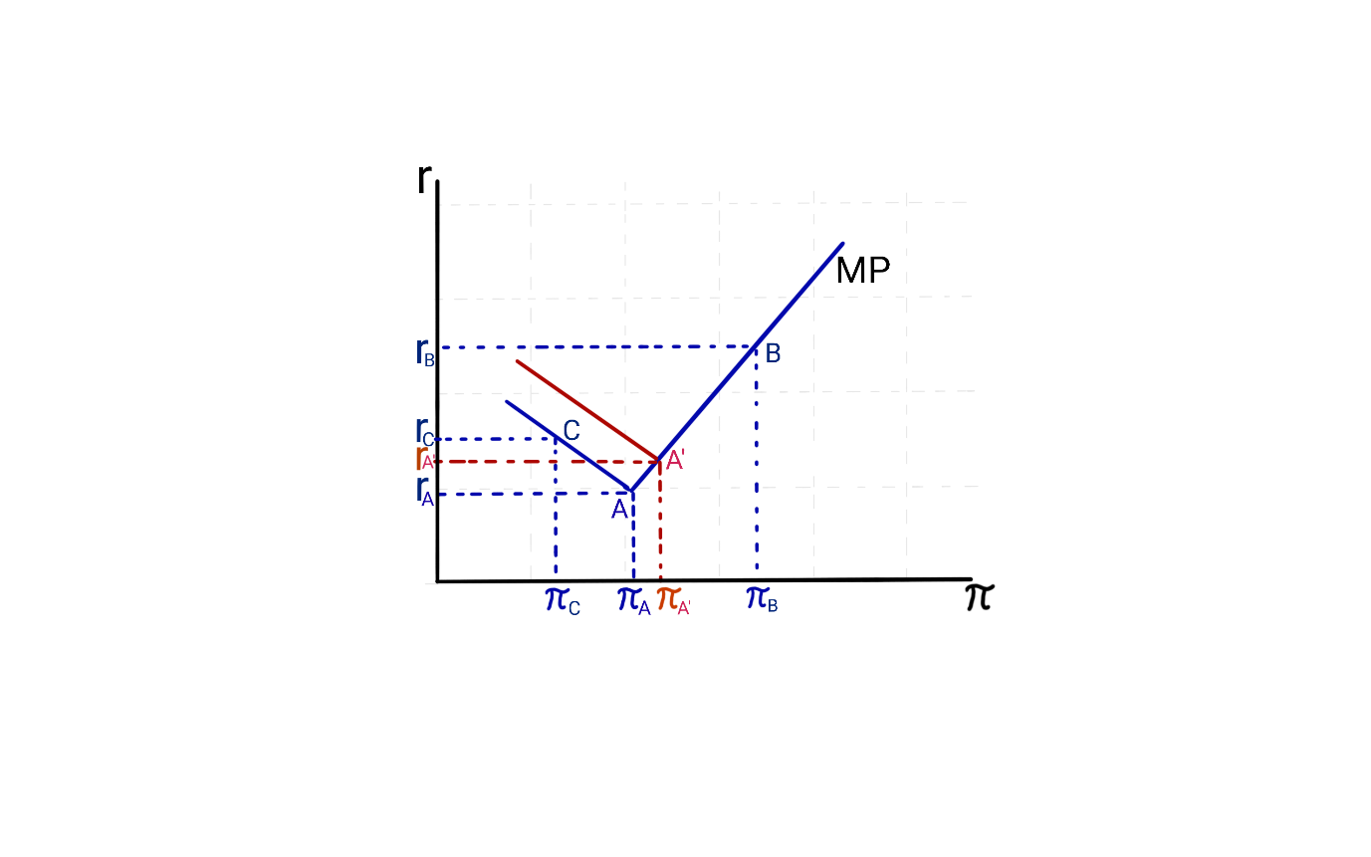  
Source: Author´s own

It is important to note, that the shape of the MP curve changes when we are in point *A* at the ELB, so *i* is already at its lowest level possible. If inflation inclines towards *πC*, then the CB can no longer reduce *i* to decrease the real interest rate. Hence, according to the Fisher Equation the real interest rate is actually moving up again to point *C*, thus, resulting in the descending inflation rate being fully reflected in rising real interest rates instead of the desired decreasing real interest rate. The higher real interest rates will lead to lower investments, which will slow down the economy even further. Thus, this could lead to a deflationary downward spiral which can only be approached with drastic uncommon MP measures.

4 Monetary Policy at the ELB with CBDC

When CBDC is intended to be implemented as an alternative to cash, the CB would need to provide market participants with a non-renumerated (limited or unlimited) tier of CBDC. The CBDC would be the third liability on the CB balance sheet, besides reserves and cash. Also, the CBDC would need to be perfectly elastically available at a zero interest rate and agents must be able to decide between CBDC, cash and reserves (Meaning et al., 2021).

The reason for the lower bound being below zero is, that market participants have opportunity costs for exchanging and storing cash. The higher these costs for cash are, the lower the interest rates could be set by the CB, without triggering a wide conversion from deposits to cash (Witmer and Yang, 2016). The costs for exchanging and holding CBDC can be expected to be closed to zero, allowing a frictionless and cheap conversion from deposits into CBDC. Also, as the CBDC will be held in some sort of cryptographically secured wallet, the holding and insurance cost can be expected to be neglectable. Another advantage for CBDC-users is, that it will be safe central bank money, and, opposed to deposits at commercial banks, without any bankruptcy risk of the issuer. So, in times of financial stress, it can be anticipated that market participants will distrust the banking sector and would seek a more secure way of holding their values. They would seek for CBDC as a second form of central bank money which – besides cash – would be widely accessible, but without the costs involved of holding physical coins and banknotes (Meaning *et al.*, 2021). Obviously, these in and outflows from deposits into CBDC and back, could destabilise the banking sector which would need to be compensated by the CB. This could even create a bank-run on CBDC much sooner than what could be experienced in the past with bank-runs on physical cash. But opposed to a bank-run on a commercial bank where the amount of cash is limited, the CB must allow the stock of CBDC to increase. This either means a decline of reserves or an expansion of the monetary base (Meaning *et al.*, 2021).

So, it can be seen in figure 1 that the real interest rate is increasing again in point *A* when inflation falls, due to the ELB. The ELB is expected to move from being effectively below zero when cash is in place, towards an interest rate of zero when opportunity costs of exchanging and holding value in form of CBDC declines to zero. Hence, the turning point on the MP curve - where the real interest rate would rise again when the inflation rate declines further - would lie higher on the MP-curve in point *A’*.

This results in a situation where the CB would need to implement unconventional MP measures - besides decreasing the policy rate - much sooner than nowadays, where the only remedy from negative interest rates is cash. What can be misinterpreted as a small shift, would actually be a potential volume equal to the aggregated non-remunerated tiered amount of CBDC for all market participants. Even a low amount for a remunerated tier, e. g. like EUR 3,000 as it is suggested by Bindseil for the Digital Euro (Bindseil, 2020), would result in a significant extra buffer for the market participants to escape from negative interest rates. In economies like the US or Europe with more than 300 million individuals and a large commercial and public sector, these small amounts would add up to billions of US-Dollars and Euros and would have the ability to destabilise monetary policy.

Conclusion

The ELB, in general, is a non-remunerated cash problem and would not exist if non-interest-bearing bank notes would not exist (Agarwal and Kimball, 2015). Some researchers propose the removal of cash parallel to implementing a remunerated CBDC to solve the problem (Bordo and Levin, 2017). These measures would make MP much more efficient and high negative interest rates possible to effectively break through todays ELB (Lilley *et al.*, 2019). However, it is unlikely that cash will be removed or fully replaced with a CBDC which would allow renumeration anytime soon. Instead, an implementation of CBDC in parallel to the existence of cash is likely. (Engert and Fung, 2017).

This paper shows that implementing a CBDC with a non-remunerated tier could influence the efficiency of performing MP for CB negatively. The conversion and holding of deposits of CBDC would come at a much lower cost for market participants than the exchange to banknotes and coins. Hence, as costs for exchange, holding and insuring values in CBDC compared to banknotes decrease, the ELB, which is experienced to be at roughly -1% nowadays, is expected to rise closer to zero. Implementing a non-remunerated tier for CBDC would create an extra buffer for market participants to escape negative interest rates. Even small amounts, e. g. like EUR 3,000 suggested by Bindseil (Bindseil, 2020) for the Digital Euro, would add up to large sums over an economy as a whole and could easily reach billions of USD or EUR. These in- and outflows of deposits in the banking sector could destabilise the banking sector (Meaning *et al.*, 2021) as well as making MP less efficient.

This paper is intended as an early step in the research of the effect on Monetary Policy at the ELB when non-remunerated CBDC was to be implemented to a certain extent.

Questions remain unanswered and should be a topic for further research. Since the ELB is an aggregate function and assumed to be the same for all market participants, it could make sense to take a more differentiated approach to the opportunity costs for exchanging and holding money for different user groups. E. g., understanding the ELB from private household versus larger corporation could help setting the remuneration for different tiers differently to increase the efficiency of MP and diminish disintermediation of the banking sector.

Significant theoretical and empirical research is suggested on this topic in the near future to avoid unforeseen problems on monetary policy when considering a non-renumerated tiered CBDC.

Abbreviations

CB - Central Bank

CBDC - Central Bank Digital Currency

ECB - European Central Bank

ELB - Effective Lower Bound

FED - Federal Reserve Bank

DLT - Distributed Ledger Technology

MP - Monetary Policy

ZLB - Zero Lower Bound

References

1. AGARWAL, Ruchir and Miles KIMBALL. Breaking Through the Zero Lower Bound. *IMF Working Papers* [online]. Vol. 15, no. 224, 2015. ISSN 1018-5941. Available at: doi:10.5089/9781513567327.001
2. ALONSO, Sergio Luis Náñez, JORGE-VAZQUEZ, Javier and FORRADELLAS, Ricardo Francisco Reierl. Central banks digital currency: Detection of optimal countries for the implementation of a CBDC and the implication for payment industry open innovation. *Journal of Open Innovation: Technology, Market, and Complexity* [online]. Vol. 7, no. 1, 2021. pp. 1–23. ISSN 21998531. Available at: doi:10.3390/joitmc7010072
3. AUER, Raphael, CORNELLI, Giulio and FROST, Jon. Rise of the Central Bank Digital Currencies: Drivers, Approaches and Technologies. *CESifo Working Paper*. No. 8655, 2020.
4. BAROTINI, Christian and HOLDEN, Henry. Proceeding with caution - a survey on central bank digital currency. *BIS Papers* [online]. No. 101, 2019. pp. 1–15. ISSN 1682-7651. Available at: www.bis.org
5. BARRDEAR, John and KUMHOF, Michael. The Macroeconomics of Central Bank Issued Digital Currencies. *SSRN Electronic Journal* [online]. No. 605, 2017. ISSN 1556-5068. Available at: doi:10.2139/ssrn.2811208
6. BENIAK, Patrycja. Central bank digital currency and monetary policy: a literature review. *MPRA Paper* [online]. No. 96663, 2019. Available at: https://ideas.repec.org/p/pra/mprapa/96663.html
7. BILOTTA, Nicola and BOTTI, Fabrizio. *The (Near) Future of Central Bank Digital Currencies*. Bern: Peter Lang, 2021. ISBN 9783034342759.
8. BINDSEIL, Ulrich. *Tiered CBDC and the financial system*. Frankfurt am Main: European Central Bank, 2020. ISBN 9789289939942. Dostupné z: doi:10.2866/134524
9. BINDSEIL, Ulrich and PANETTA, Fabio. Central bank digital currency remuneration in a world with low or negative nominal interest rates*. VOXEU CEPR Policy Portal* [online]. 2020. [cit. 2022‑04‑02]. Available at: https://voxeu.org/article/cbdc-remuneration-world-low-or-negative-nominal-interest-rates
10. BORDO, Michael D. amd LEVIN, Andrew T. Central Bank Digital Currency and the Future of Monetary Policy. *National Bureau of Economic Research.* [online]. 2017. Available at: http://www.nber.org/papers/w23711
11. BOURI, Elie, GUPTA, Rangan, TIWARI, Aviral Kumar and ROUBAUD, David. Does Bitcoin hedge global uncertainty? Evidence from wavelet-based quantile-in-quantile regressions. *Finance Research Letters.* Vol. 23, 2017. Pp. 87–95. ISSN 15446123. Available at: doi:10.1016/j.frl.2017.02.009
12. CIŻKOWICZ, Piotr, RZOŃCA, Andrzej and TORÓJ, Andrzej. In Search of an Appropriate Lower Bound. The Zero Lower Bound vs. the Positive Lower Bound under Discretion and Commitment. *German Economic Review*. Vol. 20, no. 4, 2019. Pp. e1028–e1053. ISSN 14680475. Available at: doi:10.1111/geer.12203
13. DE FIORE, Fiorella and TRISTANI, Oreste. 2018. (Un)conventional policy and the effective lower bound. *Working Paper Series.* No. 2183, 2018.Available at: doi:10.2866/219561
14. ECB. *Report on a digital euro.* [online]. 2020. Dostupné z: https://www.ecb.europa.eu/
15. ENGERT, Walter and FUNG, Ben. Central Bank Digital Currency: Motivations and Implications. *Staff Discussion Paper*. No. 2017-16, 2017. pp. 1–30. ISSN 1914-0568. Available at: https://www.bankofcanada.ca/2017/11/staff-discussion-paper-2017-16/
16. FERRARI, Massimo and MEHL, Arnaud. *(B) Central bank digital currency and global currencies* [online] 2021. [cit. 2021-06-07]. Available at: https://www.ecb.europa.eu/pub/ire/html/ecb.ire202106~a058f84c61.en.html#toc2
17. FOMC. Monetary Policy Alternatives. *FOMC Bluebook* [online]. 2009. Available at: <https://www.federalreserve.gov/monetarypolicy/files/FOMC20090624bluebook20090618.pdf>
18. KLEIN, Manuel, GROSS ,Jonas and SANDNER, Philipp. The Digital Euro and the Role of DLT for Central Bank Digital Currencies. *Franfurt School Blockchain Center Working Paper* [online]. May 2020. [cit. 2021-02-12]. Available at: https://www.researchgate.net/publication/341354711_The_Digital_Euro_and_the_Role_of_DLT_for_Central_Bank_Digital_Currencies
19. KOLCUNOVÁ, Dominika and HAVRÁNEK, Tomáš. Estimating the Effective Lower Bound on the Czech National Bank’s Policy Rate. *Review*. Vol. 85, no. 6, 2018. Available at: doi:10.20955/r.85.67
20. KUMHOF, Michael and NOONE, Clare. Central Bank Digital Currencies - Design Principles and Balance Sheet Implications. *Bank of England Working Paper*. No. 725, 2018. ISSN 1556-5068. Available at: doi:10.2139/ssrn.3180713
21. LILLEY, Andrew a Kenneth ROGOFF*. The Case for Implementing Effective Negative Interest Rate Policy*, [online]. 2019. Available at: https://ssrn.com/abstract=3427388
22. MEANING, Jack, DYSON, Ben, BARKER, James and CLAYTON,Emily. Broadening narrow money: Monetary policy with a central bank digital currency. Vol. 17 no. 2, 2021. pp. 1–42. ISSN 18157556. Available at: doi:10.2139/ssrn.3180720
23. NAKAMOTO, Satoshi. 2008. Bitcoin Whitepaper. *Artificial Life*. Vol. 23, no. 4, 2008. pp. 552–557. ISSN 15309185 Available at: doi:10.1162/ARTL_a_00247
24. NELSON, Bill. *The Benefits and Costs of a Central Bank Digital Currency for Monetary Policy - Bank Policy Institute* [online]. 2021. [cit. 2022-03-30]. Available at: <https://bpi.com/the-benefits-and-costs-of-a-central-bank-digital-currency-for-monetary-policy>
25. [25] PANETTA, Fabio. Evolution or revolution ? The impact of a digital euro on the financial system. *Brugel* [online]. 2021. 1–14. Available at: https://www.ecb.europa.eu/press/key/date/2021/html/ecb.sp210210~a1665d3188.en.html
26. PASSACANTANDO, Franco. Could a digital currency strengthen the euro? *Policy Brief*. No. 9/2021, 2021. Available at: https://sep.luiss.it/wp-content/uploads/2022/09/PB9.21-Could-a-digital-currency-strengthen-the-euro.pdf
27. PFISTER, Christian. Retail CBDC Remuneration: The Sign Matters. *SUERF Policy Note*. No. 205, 2020. Available at: www.suerf.org/policynotes
28. SANDNER, Philipp, GROSS, Jonas, GRALE, Lena and SCHULDEN, Philipp. The Digital Programmable Euro, Libra and CBDC: Implications for European Banks. EBA Policy Research Workshop: New technologies in the banking sector – impacts, risks, and opportunities, 2020. Available at: doi:10.2139/ssrn.3663142
29. STATISTA. Number of crypto coins 2013-2022. *Statista*. [online] 2022 [cit. 2022-03-15]. Available at: https://www.statista.com/statistics/863917/number-crypto-coins-tokens/
30. STEFANOSKI, Darko, SAHIN, Orkan, BANUSCH, Benjamin, FUCHS, Stephanie, ANDERMATT, Silvan and QUERTRAMP, Alexandra. Tokenization of Assets. *Ey* [online]. Vol. 1, 2020. Available at: https://assets.ey.com/content/dam/ey-sites/ey-com/en_ch/topics/blockchain/ey-tokenization-of-assets-broschure-final.pdf
31. SWANSON, Eric T. The federal reserve is not very constrained by the lower bound on nominal interest rates. *Brookings Papers on Economic Activity*. 2018. pp. 555–572. ISSN 15334465. Available at: doi:10.1353/eca.2018.0015
32. WITMER, Jonathan and YANG, Jing, 2016. Estimating Canada’s Effective Lower Bound. *Bank of Canada Review*. Vol. 2016, 2016. pp. 3–14. Available at: https://www.bankofcanada.ca/wp-content/uploads/2016/05/boc-review-spring16-witmer.pdf

Contact

Michael Pirgmann

University for Finance and Administration

Ballindamm 15

20095 Hamburg / Germany

37328@mail.vsfs.cz

Ondřej Ptáček  
Dopad makroekonomického vývoje let 2020–2021 na žádoucí úrokové míry v eurozóně podle Taylorova pravidla

Abstrakt

Příspěvek má za cíl zjistit, do jaké míry makroekonomický vývoj v Evropě let 2020–2021 ovlivnil žádoucí úrokové sazby stanovené na základě Taylorova pravidla z pohledu zemí, které přijaly společnou měnu euro, a pro srovnání též České republiky. Evropská centrální banka stanovuje jednotné úrokové sazby platné v celé eurozóně, avšak mezi jejími členy přetrvávají makroekonomické rozdíly, tudíž vyhlašované sazby ECB nemusí dle Taylorova pravidla vyhovovat všem členským zemím eurozóny. Korelační analýza ukázala na datech 14 zemí eurozóny a České republiky za období 2003–2021, že korelace taylorovských úrokových měr zemí eurozóny se střední hodnotou taylorovských úrokových měr za celou eurozónu byla povětšinou i při zahrnutí pandemických let 2020–2021 velmi vysoká, zatímco základní sazby ECB v období 2003–2021 většinou méně odpovídaly potřebám úrokových měr jednotlivých zemí eurozóny nebo tento vztah nebyl statisticky signifikantní.

Klíčová slova

Taylorovo pravidlo, měnová politika, Evropská centrální banka, eurozóna, COVID-19

Klasifikace JEL

O11, G21

Úvod

Cílem příspěvku je provést komparaci teoretické úrokové sazby členských zemí eurozóny vypočtené podle Taylorova pravidla se skutečně vyhlašovanými krátkodobými úrokovými sazbami ECB s přihlédnutím k makroekonomickému vývoji let 2020–2021.

Tento příspěvek rozšiřuje dílčí výzkum z let 2019–2020 viz Ptáček (2020), a to jak z pohledu délky časové řady, kdy byla navíc zahrnuta data za roky 2020 a 2021, tak z pohledu zaměření. Původní článek identifikoval odchylky úrokových měr dle Taylorova pravidla jednotlivých ekonomik eurozóny od skutečně vyhlašovaných úrokových sazeb ECB. Tento příspěvek je rozšířen o diskusi na téma dopadu makroekonomického vývoje let 2020–2021 na žádoucí úrokové míry v eurozóně podle Taylorova pravidla zemí eurozóny.

První část příspěvku se věnuje definici Taylorova pravidla, popisuje způsob rozhodování ECB o výši klíčových úrokových sazeb a uvádí související přehled literatury. Druhá část příspěvku představuje metodologii a data. Třetí část obsahuje výsledky a diskusi k provedené statistické analýze. Poslední část příspěvku shrnuje jeho závěry.

1 Teoretická východiska

Autor Taylorova pravidla John B. Taylor se řadí do proudu nových keynesiánců, kteří rozpracovali keynesiánskou teorii za existence racionálních očekávání. V 70. letech společně s Edmundem S. Phelpsem obhajoval keynesiánské pojetí měnové politiky v prostředí racionálních očekávání za předpokladu mzdových a cenových strnulostí. Také vytvořil model tzv. střídavých kontraktů, na kterém ukázal, jak odbory vyjednávají mzdu při zahrnutí racionálních očekávání.

V 90. letech proslul zejména formulací tzv. Taylorova pravidla, které představuje zjednodušené vodítko pro stanovení a změnu krátkodobých úrokových sazeb centrální banky na základě mezery hrubého domácího produktu (HDP) a míry inflace. Taylor (1993) říká, že si lze v dynamickém prostředí tržní ekonomiky jen těžko představit jednoduché pravidlo, podle kterého by se mohla řídit měnová politika, poukazuje však na to, že jeho pravidlo poskytuje poměrně věrné odhady skutečných úrokových sazeb vyhlašovaných Fed.

Taylor představil jednoduché pravidlo, podle kterého by měla centrální banka systematicky upravovat úrokové sazby s ohledem na vývoj inflace a makroekonomické aktivity. Taylorovo pravidlo předpokládá, že centrální banky by při stanovování krátkodobé nominální úrokové sazby *it* v čase *t* měly vycházet z inflačního cíle formulovaného jako  a dlouhodobé rovnovážné reálné úrokové míry , přičemž reagují na aktuálně dosahovanou odchylku od inflačního cíle o velikosti  a mezeru produktu  , které váží koeficienty *a𝜋* a *ay*. Taylorovo pravidlo lze shrnout do následujícího vzorce:

(1) 

Z Taylorova pravidla vyplývá, že v případě růstu inflace o jeden procentní bod nad inflační cíl by měla nominální úroková míra vzrůst o více než jeden procentní bod a v případě mezery HDP ve výši 1 % by nominální úroková míra měla klesnout o méně než jeden procentní bod. Následování pravidla proto v průměru vede k relativně vyšším úrokovým sazbám, tedy spíše restriktivní měnové politice. Taylor (1993) doporučuje udržovat krátkodobé úrokové sazby Fed okolo 4 %, což odpovídá hodnotám parametrů *a𝜋*=0,5 a *ay*=0,5 za předpokladu plnění 2% inflačního cíle a ekonomice blízko stálého stavu s růstem reálného produktu 2,2 %.

Od doby formulace pravidla vznikla celá řada studií, které empiricky testují, zda rozhodnutí centrálních bank o výši klíčových úrokových sazeb toto pravidlo následují, nebo nikoliv. Clarida et al. (2000) poukazuje na to, že v 90. letech centrální banky v podstatě Taylorovo pravidlo následovaly, zatímco např. v době inflační spirály 70. let se chovaly odlišně. Taylor (2009a) a Taylor (2009b) kritizoval měnovou politiku v období před krizí jako příliš uvolněnou, když podle něj nízké úrokové sazby umožnily vznik bubliny na hypotečním trhu.

Řada studií se, podobně jako tento příspěvek, také specificky věnuje Taylorovu pravidlu v eurozóně, např. Gerlach-Kristen (2003). Brancaccio et al. (2015) dochází k závěru, že spíše než toto pravidlo jsou pro eurozónu využitelné postkeynesiánské modely. Rubio a Carrasco-Gallego (2016) na svém modelu ukazují, jak společná měnová politika přispěla k růstu cen nemovitostí před krizí let 2008 a 2009.

Jak uvádí Goodhart et al. (2020), více než dekádu trvající politika negativních úrokových měr (NIRP)[10] v eurozóně vedla v reálné ekonomice zejména k nárůstu zadluženosti, k vyhledávání rizikovějších aktiv ke zhodnocení úspor a ke snížení ziskovosti bank.

Altavilla et al. (2019) oproti tomu argumentuje, že konvenční měnová politika může zůstat efektivní i v prostředí NIRP. Banky v dobré kondici, které negativní úrokové sazby centrální banky přenášejí na klientská depozita, nezaznamenaly snížení objemu úvěrů. Nedochází podle něj tedy k narušení transmisního mechanismu měnové politiky, neboť s každým dalším poklesem úrokových sazeb docházelo ke zvyšování objemu úvěrů. Firmy s vysokým podílem oběžných aktiv se v prostředí NIRP vyhýbají držbě hotovosti a zvyšují investice do movitých i nemovitých aktiv stejně jako v prostředí konvenční měnové politiky. Ampudia et al. (2018) poukazují na dopady NIRP na cenu akcií, potažmo kapitál, bank. Podle nich neočekávaný pokles základních sazeb ECB o 25 bodů v průměru znamenal zvýšení cen akcií bank o 1 %. Tento efekt byl silnější v době krize a posupně slábl s poklesem sazeb. V případě záporných sazeb již tento vliv byl pro cenu akcií bank škodlivý. Tento dopad je větší v případě bank, které se více ve své struktuře pasiv spoléhají na depozita.

Oproti předešlým článkům zaměřeným na podobné téma došlo k doplnění časové řady o roky 2019–2021 a analýze související změny v dlouhodobém vývoji. Nelze přitom pominout makroekonomické turbulence v době pandemie COVID-19 let 2020–2021, které samozřejmě mohly mít významný dopad na výši a soulad žádoucích i reálných úrokových měr v eurozóně. Proto zkoumáme odděleně časové řady 2003–2019 a 2003–2021. Časovou řadu 2020–2021 nezkoumáme samostatně pro malý počet pozorování, neboť v případě některých ukazatelů nemáme k dispozici čtvrtletní data (např. o velikosti mezery reálného produktu), ale pouze roční.

2 Metodologie a data

Metodologie je založena na výpočtu žádoucí úrokové sazby podle Taylorova pravidla, viz Taylor (1993) pro jednotlivé země eurozóny a eurozónu jako celek a následné korelační analýze. Pro výpočet žádoucích úrokových sazeb dle Taylorova pravidla byla použita data z OECD Economic Outlook No. 110 – December 2021 (OECD, 2021), konkrétně mezera produktu, deflátor HDP a dlouhodobá úroková míra, přičemž byla použita časová řada let 2003–2021. Čtvrtletní data nebyla k dispozici v případě mezery produktu, a proto jsme se soustředili výhradně na analýzu ročních pozorování.

V naší analýze jsou použita data OECD, která jsou snadno dostupná a zároveň jsou postavena na srovnatelné metodické bázi mezi jednotlivými zeměmi.

Mezeru produktu měří OECD jako odchylku skutečné úrovně reálného HDP od odhadované výše potenciálního reálného HDP. Metodické poznámky v OECD (2022) uvádějí, že potenciální produkt je odhadován na základě dat o zásobě kapitálu, celkové produktivitě faktorů a potenciální zaměstnanosti, která je částečně odvislá od odhadů strukturální míry nezaměstnanosti (NAIRU). V případě některých zemí, kde tato data nejsou k dispozici, je potenciální produkt odhadnut pomocí filtrovaných hodnot trendu reálného HDP.

Taylor (1993) používá pro odhad dlouhodobé rovnovážné reálné úrokové míry konstantu 2 % p.a. pro vyspělé ekonomiky, který přebírá např. též Gerlach-Kristen (2003) a další autoři.

Míra inflace je odhadována pomocí deflátoru HDP, který je měřen jako index tržních cen zboží a služeb vstupujícího do výpočtu HDP (viz OECD, 2021). Jak již bylo uvedeno výše, za inflační cíl je považována meziroční míra inflace ve výši 2 %.

Hodnoty dalších parametrů byly zvoleny v souladu s Taylor (1993), tedy *a𝜋* = 0,5 a *ay* = 0,5. Jedná se o parametry, které vycházely z empirických dat o ekonomice Spojených států amerických, což může ovlivnit výsledky analýzy.

Eurozóna v současnosti zahrnuje celkem 17 zemí, z nichž je analyzováno 14: Německo, Francie, Belgie, Nizozemí, Lucembursko, Itálie, Rakousko, Španělsko, Portugalsko, Řecko, Irsko, Finsko, Slovensko a Slovinsko.

Ze zemí eurozóny nejsou v databázi OECD k dispozici data za všechny členské země měnové unie nebo nejsou k dispozici za celou zkoumanou časovou řadu. Z důvodů chybějících dat byly z analýzy vyřazeny Malta, Kypr, Estonsko, Litva a Lotyšsko. Např. Estonsko dle metodické poznámky v OECD (2019) nevydává desetileté vládní dluhopisy, a proto nebylo možné srovnatelnou metodikou stanovit dlouhodobou úrokovou míru. Malta a Kypr nejsou členy OECD, a proto pro ně nejsou k dispozici relevantní data. Jedná se zároveň o pět nejmenších ekonomik eurozóny z hlediska absolutní výše HDP v paritě kupní síly podle údajů z databáze Eurostat. V případě Slovinska a Slovenska je potřeba mít na paměti, že tyto země vstoupily do eurozóny v roce 2007, resp. 2009, a tudíž nebyly jejími členy po celé sledované období, což může mít vliv na výsledky analýzy pro tyto dvě země.

Z důvodu zajištění robustnosti analýzy na základě meziročních vstupních dat preferujeme maximální dostupnou délku časové řady. Pro všechny potřebné vstupní indikátory a zkoumané země i eurozónu jako celek je v databázi OECD Economic Outlook No. 110 – December 2021 (OECD, 2021) k dispozici časová řada 2003–2021 a odhad pro roky 2022 a 2023. Na vhodných místech doplňujeme také srovnávací údaje za Českou republiku, která není součástí eurozóny, avšak v eurozóně se nachází řada zemí jejích klíčových obchodních partnerů.

Data o krátkodobých úrokových sazbách ECB za období 2003–2021 byla získána z databáze ECB[11]. ECB stanovuje několik klíčových úrokových sazeb, konkrétně sazby pro Deposit facility, Main refinancing operations (fix a float) a Marginal lending facility. Pro srovnávací analýzu byly vybrány úrokové sazby Marginal Lending Facility a Deposit facility, které jsou používány pro overnight kredity, resp. vklady. Pro účely této analýzy pracujeme se středovou úrokovou sazbou získanou jako aritmetický průměr sazeb Marginal Lending Facility a Deposit facility – dále označováno též jako „ECB mean rate“. Data z databáze ECB poskytující údaje o datech rozhodnutí Rady guvernérů ECB o změně úrokových sazeb a jejich výši byla převedena na roční bázi, a to poměrně podle počtu dnů v daném roce, po které byly v platnosti dané sazby.

Poté byl proveden test stacionarity všech 17 časových řad (Taylorovy úrokové sazby pro 14 zemí eurozóny, eurozónu jako celek, Českou republiku a ECB mean rate). Zvoleny byly rozšířený Dickey-Fullerův test a také Phillips-Perronův test jednotkového kořene, který je vhodný pro data obsahující strukturální zlom, viz Choi (2001). Počet zpoždění byl nastaven na dva dle doporučení Schwarzova informačního kritéria. Výsledky testů a informace o následné transformaci dat jsou uvedeny v další části článku.

Následně byla provedena analýza těsnosti závislosti mezi krátkodobými úrokovými sazbami ECB a v časových řadách pomocí Pearsonova korelačního koeficientu, jehož významnost byla testována pomocí střední chyby korelačního koeficientu a t-testu, přičemž výsledné hodnoty t-testu byly porovnány s hodnotou t-rozdělení pro n-1 stupňů volnosti na 5%, 1% a 0,5% hladině významnosti.

Na závěr byl proveden kontrolní dvojvýběrový párový t-test na shodu průměrů ECB mean rate s úrokovými sazbami dle Taylorova pravidla. Nejprve byly zjištěny odchylky řad úrokových měr podle Taylorova pravidla od ECB mean rate v absolutní hodnotě, dále průměr a rozptyl těchto odchylek a výsledné hodnoty t-testu byly porovnány s hodnotou t-rozdělení pro n-1 stupňů volnosti, a to opět pro 5% a 1% hladinu významnosti.

Ekonometrické výpočty byly provedeny pomocí software eViews.

3 Výsledky

3.1 Taylorovo pravidlo a měnová politika ECB

Z výchozích dat byly nejprve vypočítány úrokové sazby dle Taylorova pravidla pro čtrnáct zemí eurozóny, eurozónu jako celek a Českou republiku. Výsledek je zachycen na obr. 1 níže, kde je pro porovnání červeně zvýrazněna křivka úrokové sazby dle Taylorova pravidla v eurozóně a černě křivka krátkodobé úrokové sazby ECB (označena jako „ECB mean rate“).

Obrázek č. 1: Úrokové sazby dle Taylorova pravidla ve 14 zemích eurozóny a České republice v porovnání se skutečnými krátkodobými úrokovými sazbami ECB,  
2003–2021

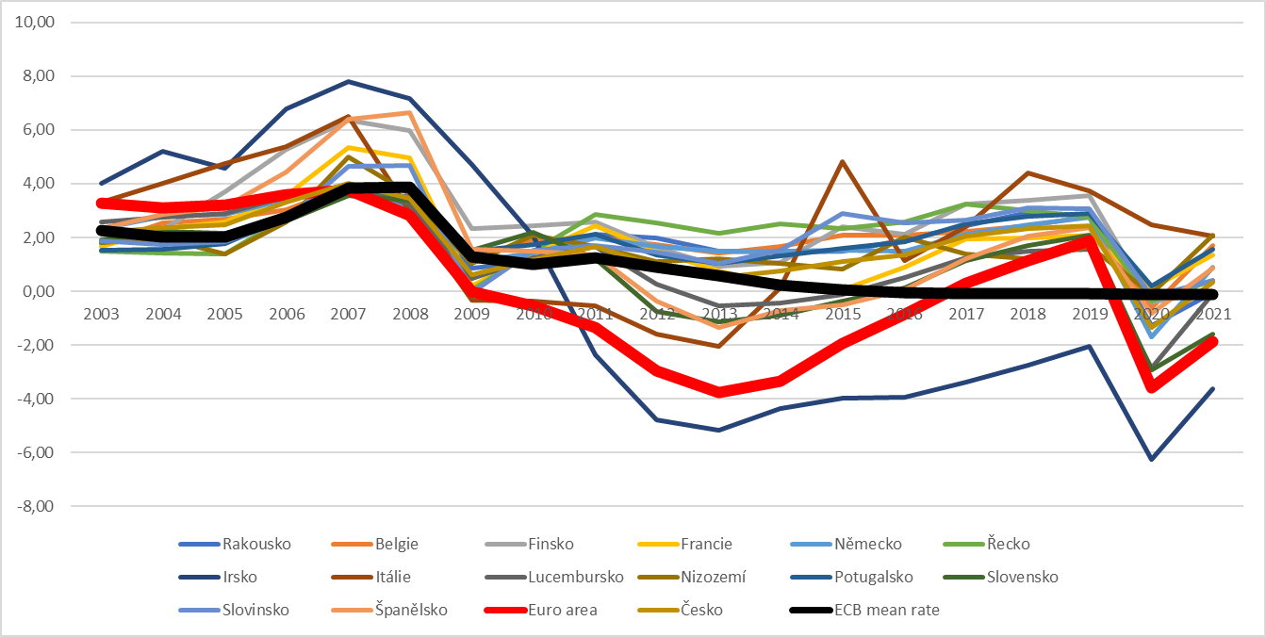

Zdroj: vlastní zpracování podle údajů OECD (2021)

Dále jsme se v souladu s představenou metodikou soustředili na meziroční pohled na data. Z grafu i z obecného makroekonomického vývoje jsou patrna minimálně čtyři období, která jsou uvedena nebo ukončena strukturálními zlomy. Jak je patrné i z obrázku č. 1, hodnota úrokové sazby dle Taylorova pravidla pro země eurozóny[12] nejprve rostl do roku 2007 na hodnotu 3,79 % a po „zubu“ v období krize vykazoval setrvalý růst od dna roku 2013 ve výši -3,77 %, a to až na hodnotu 1,89 % v roce 2019. Rok 2020 znamenal očekávatelný náhlý pád v důsledku makroekonomických turbulencí až na ‑3,60 %, tedy na úroveň podobnou době dluhové krize eurozóny v letech 2012-2013. Rok 2021 znamenal jen korekci na stále záporných -1,88 %.

Jednotlivé časové řady byly před provedením korelační analýzy testovány na stacionaritu pomocí rozšířeného Dickey-Fullerova testu. Pro všechny řady byly hodnoty t-statistiky v absolutní hodnotě vyšší, než kritické hodnoty testové statistiky na 1% hladině významnosti, resp. p hodnota byla u všech řad vyšší než 0,01, a proto nebyla zamítnuta nulová hypotéza o tom, že jednotlivé řady mají jednotkový kořen. Všechny použité časové řady lze proto považovat za nestacionární a bylo nutné je pro další analýzu transformovat do diferencí. Stacionaritu se podařilo u všech časových řad uspokojivě (na 1% hladině významnosti) odstranit až po transformaci do druhých diferencí a vynecháním trendu a konstanty z rovnic. Pro zvýšení jistoty o stacionaritě použitých časových řad ve druhých diferencích byl proto proveden ještě Phillips-Perronův test. Phillips-Perronův test dokáže pracovat s daty obsahujícími strukturální zlomy. Z obrázku č. 1 je patrné, že použité časové řady obsahují většinou minimálně jeden zlom v době finanční krize mezi lety 2008 a 2009. Phillips-Perronův test vedl u všech časových řad ve druhých diferencích k zamítnutí nulové hypotézy o existenci jednotkového kořene bez zahrnutí trendu a konstanty. Žádná časová řada nebyla na základě testu stacionarity z další analýzy vyřazena, všechny však byly analyzovány ve druhých diferencích.

Dále již byly spočítány hodnoty Pearsonova korelačního koeficientu pro zjištění těsnosti závislosti mezi krátkodobými úrokovými sazbami ECB 2021 a úrokovou sazbou zemí eurozóny dle Taylorova pravidla v období 2003–2019 a 2003–2021. Pouze pět korelačních koeficientů obstálo v kontrolním t-testu alespoň na 5% hladině významnosti v případě časové řady   
2003–2021, tedy zahrnující též období pandemie COVID‑19. V případě předchozího výzkumu, který sledoval vývoj v letech 2003–2018, přitom nebyly signifikantní pouze dvě časové řady z 16.

Zcela jiné výsledky však přinese pohled na těsnost závislosti mezi jednotlivými zeměmi a časovou řadou Euro area, která zobrazuje hypotetické taylorovské úrokové míry za celou eurozónu. Všechny sledované časové řady (včetně Česka) dosáhly za období 2003–2021 hodnoty korelačního koeficientu nad 0,93 s výjimkou Francie (0,86), Irska (0,77) a Nizozemí (0,78), naměřená hodnota Itálie 0,29 nebyla signifikantní. Znamená to tedy, že korelace žádoucích taylorovských úrokových měr zemí eurozóny se střední hodnotou taylorovských úrokových měr za celou eurozónu byla povětšinou i při zahrnutí pandemických let 2020–2021 velmi vysoká, zatímco základní sazby ECB v období 2003–2021 většinou méně odpovídaly potřebám úrokových měr jednotlivých zemí eurozóny nebo tento vztah nebyl statisticky signifikantní.

Značné zlepšení výsledků ve smyslu zvýšení signifikance přineslo odebrání posledních dvou pandemických let 2020–2021 z časových řad, kdy až na výjimky byla těsnost závislosti vyhodnocena jako signifikantní minimálně na 1% hladině významnosti. V případě Nizozemí byla těsnost závislosti prokázána jako signifikantní na 5% hladině významnosti, v případě časových řad Itálie a Irska signifikance nebyla prokázána.

Nejvyšší těsnost závislosti a tedy sladění „domácí“ taylorovské úrokové míry se skutečně vyhlašovanými sazbami ECB mean rate prokázalo Rakousko, Francie, Portugalsko nebo Španělsko. Všechny sledované země eurozóny dosáhly hodnoty korelačního koeficientu minimálně 0,86, s výjimkou Slovenska (0,88) a Nizozemí (0,65). Nejnižší hodnoty na úrovni okolo 0,25 dosáhly Irsko a Itálie, avšak jak jsme již podotkli, tato data nebyla prokázána jako statisticky významná. Vážená teoretická žádoucí úroková míra za celou eurozónu vykázala velmi vysokou hodnotu koeficientu 0,92. Naopak Česká republika dosáhla pouze hodnoty 0,83.

Tabulka č. 1: Párový t-test významnosti korelačního koeficientu taylorovských úrokových měr s ECB mean rate za období 2003–2019

|  |  |  |  |
| --- | --- | --- | --- |
| ECB mean rate | R | sr | T |
| Austria | 0,956515 | 0,087946 | 10,8762*** |
| Belgium | 0,795211 | 0,182816 | 4,349781*** |
| Finland | 0,853199 | 0,157264 | 5,425261*** |
| France | 0,937839 | 0,104645 | 8,962065*** |
| Germany | 0,893984 | 0,135107 | 6,616877*** |
| Greece | 0,903872 | 0,128987 | 7,007446*** |
| Ireland | 0,232064 | 0,29328 | 0,79127 |
| Italy | 0,266921 | 0,290572 | 0,918606 |
| Luxembourg | 0,862308 | 0,152681 | 5,64779*** |
| Netherlands | 0,652202 | 0,228559 | 2,853535** |
| Portugal | 0,952249 | 0,092058 | 10,34399*** |
| Slovak Republic | 0,714284 | 0,211015 | 3,384996*** |
| Slovenia | 0,887661 | 0,138845 | 6,393182*** |
| Spain | 0,947201 | 0,096677 | 9,797594*** |
| Euro area | 0,917629 | 0,119832 | 7,657615*** |
| Czech Republic | 0,834866 | 0,165968 | 5,030285*** |
|  |  |  |  |

Zdroj: vlastní zpracování

Můžeme tedy učinit dílčí závěr, že makroekonomické turbulence období 2020–2021 měly výrazný vliv na pozorované časové řady, kdy ve většině případů nebylo možné ani po úpravě do druhých diferencí dosáhnout signifikantních statistických výsledků. Naopak data za roky 2003–2019 ukazují na poměrně značnou koherenci žádoucích úrokových měr zemí eurozóny s ECB mean rate.

Jako poslední byl proveden dvouvýběrový párový t-test na shodu průměrů úrokové sazby dle Taylorova pravidla jednotlivých zemí s ECB mean rate. Tento test vyšel pro n-1 stupňů volnosti pozitivně u všech zemí, na 5% i 1% hladině významnosti proto nebyla zamítnuta hypotéza o shodě průměrů, v osmi případech pak ani na 0,5% hladině významnosti

Jak bylo možné očekávat, tento výsledek se dále zlepšil při vyjmutí pandemických let 2020–2021 z časových řad. Jak ukazuje následující tabulka č. 2, v tom případě již byly statisticky významné výsledky na 0,5% hladině významnosti ve všech případech. Za povšimnutí stojí rozptyl odchylek hodnot časové řady Itálie od hodnot ECB mean rate, který dosahuje velmi vysoké hodnoty 4,82.

Tabulka č. 2: Výsledky párového t-testu na shodu průměrů s ECB mean rate za období 2003–2019

|  |  |  |  |
| --- | --- | --- | --- |
| Země | odchylek od ECB mean rate | σ2 odchylek od ECB mean rate | T |
| Austria | 0,27 | 0,03606 | 5,400519*** |
| Belgium | 0,45 | 0,180992 | 3,91569*** |
| Finland | 0,77 | 0,197498 | 6,494694*** |
| France | 0,83 | 0,807071 | 3,449428*** |
| Germany | 0,32 | 0,098891 | 3,844651*** |
| Greece | 0,64 | 0,328512 | 4,188767*** |
| Ireland | 1,29 | 0,785518 | 5,445109*** |
| Italy | 2,14 | 4,817874 | 3,64056*** |
| Luxembourg | 0,51 | 0,1569 | 4,778233*** |
| Netherlands | 1,08 | 0,482309 | 5,835109*** |
| Portugal | 0,29 | 0,032392 | 6,115704*** |
| Slovak Republic | 0,55 | 0,330524 | 3,57831*** |
| Slovenia | 1,00 | 1,087596 | 3,599297*** |
| Spain | 0,88 | 0,633065 | 4,153466*** |
| Euro area | 0,40 | 0,06619 | 5,886798*** |
| Czech Republic | 0,44 | 0,130417 | 4,567394*** |
|  |  |  |  |

Zdroj: vlastní zpracování

Na závěr bylo provedeno i testování dat s odlišnými hodnotami parametrů *a𝜋* a *ay*. Dosazovány byly postupně hodnoty *a𝜋* = 1,5 a *ay* = 0,5, *a𝜋* = 1,0 a *ay* = 1,0, *a𝜋* = 0,5 a *ay* = 1,0 s obdobnými výsledky.

Závěr

Příspěvek měl za cíl provést komparaci teoretické úrokové sazby členských zemí eurozóny vypočtené podle Taylorova pravidla se skutečně vyhlašovanými krátkodobými úrokovými sazbami ECB s přihlédnutím k makroekonomickému vývoji let 2020–2021.

Jakkoliv nelze na základě použitého modelu usuzovat na efektivnost měnové politiky ECB nebo společné měny euro jako celku (nezkoumali jsme další oblasti měnové politiky ani např. stupeň naplnění optimality měnové oblasti), náš model ukázal, že pokud budeme úrokové sazby dle Taylorova pravidla vnímat jako žádoucí pro centrální banku, měnová politika ECB v oblasti úrokových sazeb byla v období 2003–2019 vyhovující minimálně pro 10 ze 14 sledovaných zemí eurozóny z hlediska jejich vlastních taylorovských úrokových sazeb. V případě Itálie a Irska nebyly získány signifikantní výsledky. V případě České republiky, pokud by byla členskou zemí eurozóny, by úrokové sazby ECB za toto období odpovídaly úrokové míře podle Taylorova pravidla.

V případě zahrnutí pandemických let 2020–2021 do modelu dochází k velkému snížení signifikance těsnosti závislosti sledovaných časových řad s ECB mean rate. Zcela jiné výsledky na období 2003–2021 však přinesl pohled na těsnost závislosti mezi taylorovskými úrokovými mírami jednotlivých zeměmi a časovou řadou Euro area, která zobrazuje hypotetické taylorovské úrokové míry za celou eurozónu. Všechny sledované časové řady (včetně Česka) dosáhly za období hodnoty korelačního koeficientu nad 0,93 s výjimkou Francie (0,86), Irska (0,77) a Nizozemí (0,78), naměřená hodnota Itálie 0,29 nebyla signifikantní. Znamená to tedy, že korelace žádoucích taylorovských úrokových měr zemí eurozóny se střední hodnotou taylorovských úrokových měr za celou eurozónu byla povětšinou i při zahrnutí pandemických let 2020–2021 velmi vysoká, zatímco základní sazby ECB v období 2003–2021 většinou méně odpovídaly potřebám úrokových měr jednotlivých zemí eurozóny nebo tento vztah nebyl statisticky signifikantní.

Literatura

1. ALTAVILLA, Carlo, BURLON, Lorenzo et al. *Is there a zero lower bound? The effects of negative policy rates on banks and firms*. Frankfurt: ECB Working Paper Series. Č. 2289, 2019. Dostupné z: https://www.ecb.europa.eu/pub/pdf/scpwps/ecb.wp2289~1a3c04db25.en.pdf
2. AMPUDIA, Miguel and VAN DEN HEUVEL, Skander. *Monetary policy and bank equity values in a time of low interest rates*. Frankfurt: ECB Working Paper Series. Č. 2199, 2018. Dostupné z: https://www.ecb.europa.eu/pub/pdf/scpwps/ecb.wp2199.en.pdf
3. BRANCACCIO, Emiliano et al. Monetary policy rules and directions of causality: A test for the euro area. *Journal of post Keynesian economics*. Roč. 38, č. 4, 2015. s. 509‑531. ISSN 1603477. Dostupné z: https://doi.org/10.1080/01603477.2015.1107495
4. CHOI, In. Unit root tests for panel data. *Journal of International Money and Finance*. Roč. 20, č. 2, 2001. s. 249-272. ISSN 0261-5606. Dostupné z: http://dx.doi.org/10.1016/S0261-5606(00)00048-6
5. CLARIDA, Richard, GALÍ, Jordi and GERTLER, Mark. Monetary policy rules and macroeconomic stability: evidence and some theory. *Quarterly Journal of Economics*. Roč. 115, č. 1, 2000. s. 147-180. ISSN 0033-5533. Dostupné z: https://crei.cat/wp-content/uploads/users/pages/cgg1qje.pdf
6. EUROPEAN CENTRAL BANK. The Monetary Policy of the ECB. Frankfurt: European Central Bank, 2011. ISBN 978-92-899-0777-4. Dostupné z: https://www.ecb.europa.eu/pub/pdf/other/monetarypolicy2011en.pdf
7. GERLACH-KRISTEN, Petra. *Interest rate reaction functions and the Taylor rule in the euro area*. Frankfurt: ECB Working Paper. Č. 258, 2003. Dostupné z: https://www.ecb.europa.eu/pub/pdf/scpwps/ecbwp258.pdf
8. GOODHART, Charles, SCHULZE, Tatjana, and TSOMOCOS, Dimitrios P. *Time inconsistency in recent monetary policy*. VOXEU CEPR Policy Portal [online]. 4. 8. 2020. [cit. 1. 10. 2022]. Dostupné z: <https://voxeu.org/article/time-inconsistency-recent-monetary-policy>.
9. OECD. *Economic Outlook No 106 – November 2019*. www.oecd.org [online]. 15. 11. 2019. [cit. 1. 10. 2022]. Dostupné z: https://www.oecd-ilibrary.org/economics/data/oecd-economic-outlook-statistics-and-projections/oecd-economic-outlook-no-106-edition-2019-2_8aa5bebb-en
10. OECD. *Economic Outlook No 110 – December 2021*. www.oecd.org [online]. 15. 12. 2021. [cit. 1. 10. 2022]. Dostupné z: [https://stats.oecd.org/Index.aspx?DataSetCode=EO#](https://stats.oecd.org/Index.aspx?DataSetCode=EO)
11. OECD. *Economic Outlook No 111 – June 2022*. www.oecd.org [online]. 15. 6. 2022. [cit. 1. 10. 2022]. Dostupné z: [https://stats.oecd.org/Index.aspx?DataSetCode=EO#](https://stats.oecd.org/Index.aspx?DataSetCode=EO)
12. PTÁČEK, Onřej. Taylorovo pravidlo a zombifikace firem v eurozóně. In Mojmír Helísek. *Prezentace výsledků ekonomického a finančního výzkumu doktorandů: recenzovaný sborník příspěvků ze 7. ročníku konference doktorandů na Vysoké škole finanční a správní.* Praha: Vysoká škola finanční a správní, 2020. s. 107‑123. ISBN 978-80-7408-218-4.
13. RUBIO, Margarita and CARRASCO-GALLEGO, José A. Liquidity, interest rates and house prices in the euro area: a DSGE analysis. *Journal of European Real Estate Research.* Roč. 9, č. 1, 2016. s. 4-25. ISSN 1753-9277. Dostupné z: https://pure.port.ac.uk/ws/portalfiles/portal/3048117/CARRASCO_GALLEGO_2015_cright_JERER_Liquidity_interest_rates_and_house_prices_in_the_euro_area.pdf
14. TAYLOR, John B. Discretion versus Policy Rules in Practice. *Carnegie-Rochester Conference Series on Public Policy*. Roč. 39, č. 1, 1993. s. 195-214. ISSN 0167-2231. Dostupné z: https://web.stanford.edu/~johntayl/Onlinepaperscombinedbyyear/1993/Discretion_versus_Policy_Rules_in_Practice.pdf
15. TAYLOR, John B. *The Financial Crisis and the Policy Responses: An Empirical Analysis of What Went Wrong*. Cambridge, MA: National Bureau of Economic Research. Working Paper č. 14631, 2009a. Dostupné z: https://web.stanford.edu/~johntayl/FCPR.pdf
16. TAYLOR, J. B. *Getting Off Track: How Government Actions and Interventions Caused, Prolonged, and Worsened the Financial Crisis*. Stanford, CA: Hoover Institution Press, 2009b. ISBN 0-8179-4971-2.

Kontakt

Ing. Ondřej Ptáček

Vysoká škola finanční a správní, a.s.

Estonská 500

101 00 Praha 10

Česká republika

ondrejptacek@mail.vsfs.cz

Bastian Schulz   
The evolution from traditional finance to behavioral finance

Abstract

The purpose of this article is to provide a brief historical overview of the evolution from traditional finance to behavioral finance. Because financial behavior has a critical positive relationship with financial literacy, this will investigated as well. According to the efficient markets hypothesis (EMH), market prices completely reflect all available information. Psychologists and behavioral economists have consistently criticized the EMH, claiming that it is predicated on irrational beliefs about human behavior. The efficient market hypothesis is directly opposed by behavioral finance, which places the blame for market inefficiencies on investors' imperfect rationality. Over the last 50 years, the area of behavioral finance has grown tremendously.

Keywords

Traditional finance, efficient market hypothesis, behavioral finance, investing, financial literacy

JEL Classifications

G1, G4, B26

Introduction

The concept of "efficient markets" has long served as the foundation of the science and study of finance. The Efficient Markets Hypothesis (EMH), on which classical finance theory is based, claims that at any one time, the price of all assets and securities that are being traded is accurate and represents all available information (Hammond, 2015).

Among economists, there is an old joke about an economist walking down the street with a friend. When the companion goes down to pick up a $100 note that is laying on the ground, the economist advises him not to bother, as if that were an actual $100 note, someone would have already picked it up by now. The efficient markets hypothesis (EMH), one of the most divisive ideas in the social sciences, is depicted in this amusing illustration of economic logic gone wrong. It is unexpectedly resistant to empirical validation or rebuttal despite being disarmingly straightforward to articulate, with profound implications for academic ideas and corporate practice (Lo, 2007).

The topic of behavioral finance has expanded significantly over the past three decades in terms of its application to aiding people in making wiser financial decisions (Hirshleifer, 2015). Simply defined, behavioral finance brings a human aspect to investing in an effort to better understand a person's investment choices (Thaler, 1999). It accomplishes this by using psychological principles to examine how individuals make financial decisions, with an emphasis on people's unique cognitive biases (Hirshleifer, 2015). The stock doesn't know you own it, according to Warren Buffett. It doesn't have any sentiments toward you, but you do. What you paid is unknown to the stock. People shouldn't let their investments affect them emotionally (Jordan et al., 2015). One must comprehend behavioral finance's history, its unique psychological pitfalls, and how to completely utilize its tactics while making investing decisions in order to fully benefit from the field of study (Fieger, 2017).

Hence this article will give a short overview of the history and how the shift from traditional finance towards behavioural finance happened. Additionally, to give a short introduction on how an investor makes decision the author will as well look at financial literacy.

1 Traditional finance and its flaws

Classical finance expects investors to be rational and to focus on selecting an efficient portfolio. This entails including a mix of asset classes chosen with the goal of achieving the highest potential long-term returns. The level of risk should be kept under a minimum or at least at a tolerable level.

Even though the research's focus was not the financial market, researchers had long anticipated the idea of an efficient market. Among them were researchers as G. Cardano (1564), R. Brown (1828), J. Regnault (1863), Rayleigh (1880), John Venn (1888), L. Bachelier (1900), Einstein (1905), F.W.Taussing (1921), J.M. Keynes (1923), A. Cowles (1933), M. Friedman (1953), M.G. Kendall (1953) and P.A. Samuelson (1965). (Birău, 2012)

1.1 The Efficient Market Hypothesis

One must first look at the efficient market hypothesis (EMH) suggested by Fama (1965) in order to explain the origins of behavioral finance, as behavioral finance later developed as a counter point of view to the EMH. According to Fama (1965), an efficient market is one that has a large number of rational, profit-maximizing participants who are actively competing with one another to predict future market values of exclusive securities. All participants have almost entirely free access to crucial current information (Shleifer,2000).

Fama (1965) put forward the theory that stocks function in an effective market where, relative to the information available, stock prices show very specifically the value of the stock and, as soon as new information becomes available, stock prices respond almost instantaneously.

With regard to the consideration of an alternative theory to market efficiency, Fama (1965) stated that an alternative must only predict either overreaction or underreaction. Furthermore, he continues, the current price of an asset in an efficient market will always be an accurate indication of its inherent worth. Technically, no investment strategy can provide excessive risk-adjusted average returns or average returns that are higher than justified by their risk in a market that functions efficiently (Barberis and Thaler, 2003; Subash, 2012)

The random walk hypothesis (RWH), which proposed that the potential price values of a stock were no more predictable than a sequence of random numbers, was one complementary suggestion to the EMH (Fama, 1965).

Fama (1970) continued his pioneering work in the EMH with its key principles that commodity rates completely embody all available knowledge and, as a result, stocks still sell at their fair value.

Around the 1970s, academics backed and embraced the concept of market efficiency. The main reasons were arbitrage assumptions. Yet, this vision was labelled as unrealistic after conducting empirical studies (Birău, 2012).

Because the absence of an investing strategy does not indicate the absence of mispricing, rather arbitrage limitations might result in severe mispricing. Sharpe and Alexander (1990) characterize arbitrage as the simultaneous purchase and selling of the same, or substantially identical, securities in two distinct marketplaces at favorably different prices. Gromb and Vayanos (2010) argued that a thorough examination of the arbitrage process is necessary to comprehend why anomalies persist and are not removed. What are the restrictions and limitations faced by the arbitrageurs, who are they, and why does arbitrage fail to get prices near to the underlying values predicted by conventional models?, are questions that need to be answered (Subash, 2012).

A threefold solution to the EMH was suggested by Fama (1970), where each layer built on the principles in the previous layer to make a broader point. The first form of the EMH was the weak form, which concluded that analyzing past stock prices could not forecast future stock prices (1970). This was compatible with the earlier works of Fama (1970), and in his study of the stock market he found very good support for the weak form.

The second model, the semi-strong form, introduced the notion that stock prices would easily respond to new knowledge and in an impartial way, leaving almost no room for the trader to beat the market (1970). This semi-strong form was reinforced by Fama et al. (1969) in finding that data on stock splits, such as potential business dividend payments, are already embedded into the stock leading up to the split, supporting the notion that stock prices are quickly reacting to new information.

The third and most audacious form of the EMH was the strong form that implied that stock prices not only represent all public information, but even all private information, suggesting that there would be little strategic benefit to insider trading (1970).

For all three types of the EMH, Fama (1970) found fair support, and claimed that the EMH model was very well suited as an accurate representation of the stock market.

The EMH, especially its weak form and semi-strong form, was widely regarded and taken for granted by most of the investment community in the 1970s (Shiller, 2003). At the heart of the EMH, it was believed that the speculative price of individual shares often contains the best information on the intrinsic values of the stock and that all price shifts are actually triggered by this positive information being digested by rational buyers (Shiller, 2003).

However, Kahneman and Tversky (1979) first criticized the EMH with their blockbuster study on prospect theory, which started to look directly at how people chose between two different outcomes that require risk, with the probabilities of known outcomes. In particular, their paper offered prospect theory as an alternative to the commonly accepted assumed utility theory, as people frequently considered inaccurate alternatives to weight when faced with risk (Kahneman and Tversky, 1979). They find that one common issue people have in their approach to risk analysis is the tendency to be risk-averse in their financial choices, one example of which is the prevalence of insurance (Kahneman and Tversky, 1979). This was one of the first experiments to open up the possibility that human psychological biases could interfere with their financial decisions (Fieger, 2017).

1.2 Challenging the EMH

Behavioral finance is in stark contrast to the EMH, which, as explained before, brings forth the notion that markets always function well and shifts in security prices always represent actual information (Shiller, 2003). Behavioral finance gives a reason for the reported business inefficiencies and fractures in the EMH (Baker and Ricciardi, 2015) (Hirshleifer, 2015).

Hirshleifer (2015) offered a clear example of this by showing that in a single weekend after the republication of reports that had already been written and made available to the public five months ago about a potential cancer treatment to be launched shortly, the stock price of the firm EntreMed soared 600 percent. This seems to have violated the rules of the EMH, especially the semi-strong type, which assumes that markets respond quickly to new information and correctly represent all available public information (Hirshleifer, 2015).

Statman (2014) made a further distinction between what he called "standard finance" and behavioral finance (Statman, 2014, p. 65). He argued that traditional finance adherents believe that all individuals are rational, that the market is efficient, and that the expected return of various investments is calculated by the traditional theory of asset pricing, where the differences in investment returns are decided solely by risk (Statman, 2014).

On the other hand, Statman (2014) proposed that behavioral finance theorists believe that humans are average, that the market is not entirely effective, although difficult to beat, and that the predicted returns on investment are better represented in the behavioral asset pricing theory, where different returns on investment are calculated by more variables than just risk (Statman, 2014).

Economics should integrate two different hypotheses, according to Thaler (2016): normative economic models should demonstrate the best solution to particular problems, while descriptive models should capture how humans actually behave (Fieger, 2017).

1.3 A Shift towards behavioral finance

While the world of finance was taken over by the EMH, in the 1990s more and more of scientific debate moved towards developing models that are in relation with human psychology and away from econometric analyses of dividends, earnings and prices as stated by Shiller (2003). Behavioral finance takes a step back from viewing finance from an appropriate business context, according to Shiller (2003), and also uses a wider viewpoint that integrates the fields of psychology and sociology. According to various researchers that operate in the field of behavioral finance, Shiller (2003) added that the partnership between traditional finance and behavioral finance helped to get a better understanding and knowledge of financial markets (El Kashef, 2017).

This stood in contrast to financial models, which all relied on the assumption that people are rational and make investment decisions based on their logical knowledge.

There are however several anomalies and deviations when looking at research and realistic circumstances (El Kashef, 2017). To make sense of these anomalies and deviations from the presumed rationality of market participants, the findings of psychology started being applied to widely used finance paradigms. For that reason, behavioral finance is an extension of traditional finance. Traditional finance gets to meet with cognitive and natural sciences to see what they can do to explain the anomalies found in traditional finance theory (Valsová, 2016).

According to Bikas et al. (2012), the main distinction between behavioral finance and traditional finance is that the former asks why investors make decisions, while the latter does not.

According to Nawrocki and Viole (2014), all asset pricing models—including Modern Portfolio Theory (MPT), Capital Asset Pricing Model (CAPM), Arbitrage Pricing Theory (APT), and others—include a number of irrational assumptions (El Kashef, 2017). They are furthermore not proven to be empirically testable.

Sahi et al. (2013) observed that the Modern Portfolio Theory, purposed 1952 by Markowitz, who contended that investors may obtain the best outcomes by selecting an ideal combination of the two depending on their particular risk tolerance, did not succeed explaining how individuals are making decisions under actual circumstances. Meaning that circumstances where principles of expected utility that were violated by people (El Kashef, 2017).

Zhang and Zheng (2015), who conducted a study on the investment behavior based on behavioural in China showed that despite of what the traditional financial theories say investors are not always rational. Investors rather take irrational decisions that are based on cognitive and psychological biases. These findings confirm some deficiencies that traditional financial theories have (El Kashef, 2017).

According to Statman (2014), traditional finance is built on four pillars. However, while examining behavioural finance, each of the four pillars must contend with a different foundational element:

* Humans are rational vs. Humans are irrational
* Markets are efficient vs. Markets are inefficient
* humans should design portfolios (based on portfolio theory) vs. humans should design their portfolios (based on rules of behavioral portfolios)
* Expected returns are described by the standard asset pricing theory vs. The behavioral asset pricing theory describes expected returns (El Kashef, 2017)

To summarize the debate on behavioral finance it has been one of the main economic disputes in the last 50 years, and it is about whether stock markets and prices of other assets (such as bonds or even property) represent all the available information, or in other words, whether prices reflect the wisdom of crowds or the stupidity of crowds, and, by implication, whether people often (or at all) behave rationally (Holden, 2015).

To date, in both modern economics and modern finance, the rationality side of the argument remains the dominant one, but it is increasingly apparent that market actors are not necessarily as rational and well-informed as academics would like to believe, as demonstrated by various inconsistencies that occur in the implementation of models based on these assumptions.

This is where behavioral finance comes in, helping to understand and control the origins of these anomalies associated with irrational behaviours (Valsová, 2016).

Strictly speaking, behavioral finance is a field of study that aims to clarify and describe how logic or cognitive mistakes affect investment decisions and stock market values. Thus, to explain and highlight the success of capital markets, behavioral finance incorporates ideas from the disciplines of human and social science with classical financial theory (Birău, 2012).

This is also illustrated in a simpler way below.

Figure no. 1: Meaning of Behavioral Finance

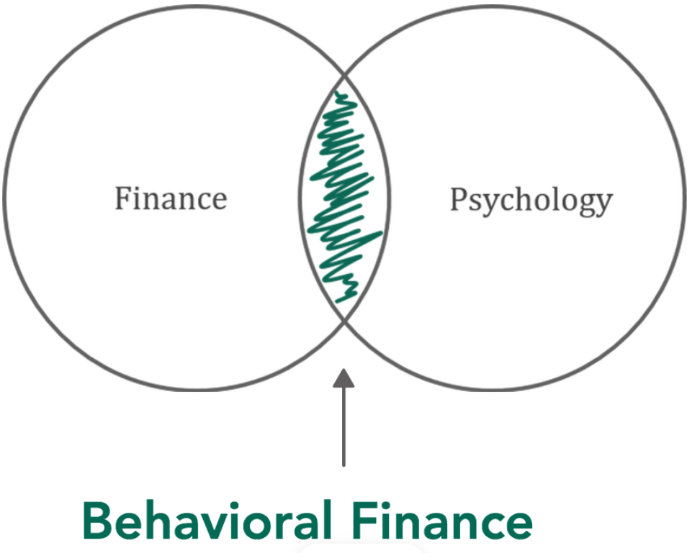

Source: Ali, 2020

Behavioral finance analyzes investor irrationality and the biases that investors are prone to. Investors' inability to foresee market fluctuations produces these cognitive biases, pushing them to make biased investment decisions (Stanovich and West, 2008). An investor must be able to make intelligent investment choices to be considered financially literate. On the other hand, the heuristic bias, the framing effect, cognitive illusions, and herd mentality are all variables that contribute to the formation of behavioral biases, also known as illogical behavior, in the decision-making process (Weixiang, 2022).

The author will now turn to the subject of financial literacy as it is directly related to behavioral finance and the decision-making process.

2 Financial literacy

To research behavioral finance, one must comprehend the crucial role that the act of decision-making is playing, yet is a complicated and complex procedure (Weixiang et al., 2022). In addition to market volatility and the possibility of profit maximization, other factors also affect investors' behavior (Kim and Nofsinger, 2008; Puaschunder, 2021). One of the most important traits that can be traced back through history and used to assess the process of making investment decisions is a person's level of financial literacy (Becchetti et al., 2013; Lusardi and Tufano, 2015). Financial literacy is a comprehension or knowledge of the financial world that may help a person apply and manage money in his life in order to achieve success. Financial literacy will be a factor in a person's decision to make an investment, as seen by how that person handles their finances (Baihaqqy et al., 2020). People can be regarded to have a high level of financial literacy if they can manage and plan their finances for the future. However, there are many people who lack financial literacy, both in terms of fundamental information and more advanced knowledge (Natasya et al., 2022).

According to Lusardi & Mitchell (2014), the relevance of financial literacy has expanded along with the availability of more financial products, their variety, and the significance of household financial product selection. It is assumed that a person will have strong financial literacy while making an investment decision. According to research done by Baihaqqy et al. (2020), financial literacy has a considerable effect on an individual's investing decisions.

The need to improve people's capacity to understand and manage their own money is greater than ever due to the introduction of new financial products, the complexities of the financial markets, and shifting political, demographic, and economic conditions, to name a few (Ahmed et al., 2021). Understanding the global financial system, potential sources of income for investors, and how to manage investments to maximize returns are all components of financial literacy (Giesler and Veresiu, 2014). To gauge a person's level of financial literacy, one might look at their viewpoints, knowledge, and habits regarding various investment vehicles and other monetary issues. Investors who are aware about finances are better equipped to avoid being duped by financial advisors and make wise investment selections. A knowledgeable investor can budget and know their monthly income. Furthermore, every stock market investor must have a thorough understanding of savings, consumption, borrowing, and investment. Competencies make it easier to choose top-notch stocks for long-term and speculative investing (Ganapathi, 2014).

The extent of an investor's financial competency is mostly determined by their financial understanding. An informed investor takes the time to plan, gather, and put information into practice. Additionally, it enables investors to seek out and act on professional advice at the right times, producing greater returns (Hastings et al., 2013). Individuals' involvement into the capital market is encouraged by regulations such as compulsory dematerialization of equities and the requirement that all citizens have a bank account. People are urged to participate in the stock market since it may be profitable. Financial possibilities have played a vital role in the growth of financial markets and the use of financial expertise. Investors need to have the knowledge and a firm understanding of a wide range of financial ideas and facts in order to make wise, risk-free, and profitable decisions. One has to have a thorough understanding of a wide range of financial products in order to reach a certain degree of financial stability. One needs financial literacy to be able to use their knowledge and effectively communicate it in order to make wise decisions (Andriamahery and Qamruzzaman, 2022). The choice of an investor to invest is positively and significantly influenced by financial literacy (Adil et al., 2021).

Conclusion

Traditional finance theory holds that people are rational and make decisions based purely on relevant information (Mittal, 2010). According to the efficient market hypothesis, the stock price always precisely represents all general information, and the stock market is always perfect and efficient (Putri et al., 2021). When making investing decisions, investors always collect the necessary information and maintain objectivity (Gupta and Shrivastava, 2021).

Yet, how are for example bubbles in stock markets possible if there are genuinely efficient markets? Furthermore, how plausible is the EMH's claim that all humans are 100% rational decision makers? A casual investor, or even a rookie investor, should never be able to trade and invest as rationally as a professional trader for an investment bank, according to basic logic, which should disprove this notion. Traditional theory contends that "smart money" investors, or those with the greatest level of knowledge about financial markets, will dampen any noise produced by those who are trading "irrationally" through arbitrage. However, over the last few decades, a significant amount of data has emerged that refutes the notion of total arbitrage (Hammond, 2015).

This study of the evolution from traditional finance to behavioral finance is designed to provide a thorough introduction to the discipline for new readers while also confirming some major notions. The growth of behavioral finance was determined by their efforts to gain acceptance into the mainstream. Both behavioral approaches have been impacted by this need to fight constantly against the prevailing and even orthodox approach. This is because behavioral economics developed as “science, that is harmful” with the primary objective of rejecting explicit and implicit hypotheses put forth by neoclassical economics and traditional finance. Similarly, being part of the mainstream, behavioral finance (at least at this point) ignores numerous crucial concerns such as methodological individualism and complexity. Behavioral finance increases our understanding of the actual world by including humans into its models.

However, when used in investment, behavioral finance can improve judgment and lower the frequency of expensive mistakes. Financial literacy and cognitive estimates may help people choose good stocks in the face of the complexity and uncertainty that typically define investment decisions. Investors' personality types, levels of financial expertise, and investment philosophies may all have an impact on the investments they make (Sukanya and Thimmarayappa, 2015). When it comes to making educated financial decisions, financial literacy is an important factor to consider. Especially as behavioral finance and financial literacy are closely intertwined when it comes to investment decisions.

Bibliography

1. ADIL, Mohd, SINGH, Yogita and ANSARI, Mohd S. How financial literacy moderate the association between behaviour biases and investment decision?, [*Asian Journal of Accounting Research*](https://www.emerald.com/insight/publication/issn/2443-4175)*.* Vol. 7, no. 1, 2022. pp. 17-30. ISSN: 2443-4175. Available at: <https://doi.org/10.1108/AJAR-09-2020-0086>.
2. AHMED, Zaheer, NOREEN, Umara, RAMAKRISHNAN, Suresh A. L. and ABDULLAH, Dewi F. B. What explains the investment decision-making behaviour? The role of financial literacy and financial risk tolerance. Afro Asian J. Finance Account. Vol. 11, no. 1, 2021. pp. 1‑19. ISSN 1751-6447. Available at: https://doi.org/10.1504/AAJFA.2021.111814
3. ALI, Zeshaan. **Behavioral Finance V/s Traditional Finance. *Medium.com*. [online] 22. 8. 2020. [25. 10. 2022].** Available at: <https://medium.com/@zeeshaan2696/behavioral-finance-v-s-traditional-finance-e0b32ed25901>.
4. ANDRIAMAHERY, Anselme and QAMRUZZAMAN, Md. Do Access to Finance, Technical Know-How, and Financial Literacy Offer Women Empowerment Through Women’s Entrepreneurial Development? *Frontiers in Psychology*. Vol. 12, 2022. Available at: https://doi.org/10.3389/fpsyg.2021.776844
5. BAIHAQQY, Mochammad, R. I., DISMAN, Disman, NUGRAHA, Nughara, SARI, Maya, IKHSAN, Sugiyanto. The Effect of Financial Literacy on the Investment Decision. *Budapest International Research and Critics Institute Journal (BIRCI-Journal)*. Vol. 3, no. 4, 2020. pp. 3073–3083. ISSN: 2615-1715. Available at: https://www.bircu-journal.com/index.php/birci/article/view/1333
6. BAKER, Kent H. and RICCIARDI, Victor. Understanding: Behavioral aspects of financial planning and investing. *Journal of Financial Planning*.Vol. 28, no. 3, 2015. pp. 22-26. ISSN 1040-3981. Available at: <https://www.researchgate.net/publication/280086678_Understanding_Behavioral_Aspects_of_Financial_Planning_and_Investing>
7. BARBERIS, Nicholas and THALER, Richard H. A survey of behavioral finance. In: G.M. Constantinides & M. Harris & R. M. Stulz (eds.). *Handbook of the Economics of Finance.* Amsterdam: Elsevier, 2003. pp. 1053-1128. ISSN: 1574-0102.
8. BECCHETTI, Leonardo, CASTRIOTA, Stefano and TORTIA, Ermanno C. Productivity, wages and intrinsic motivations. *Small Business Economics*. Vol. 41, 2013. pp. 379–399. Available at: <https://doi.org/10.1007/s11187-012-9431-2>.
9. BIKAS, Egidijus, JUREVICIENE, Daiva, DUBINSKAS, Petras and NOVICKYTE, Lina. Behavioral Finance: The Emergence and Development Trends. *Procedia - Social and behavioral Sciences.* Vol 82, 2013. pp. 870-876. ISSN: 1877-0428.
10. BIRĂU, Felicia R. The impact of behavioral finance on stock markets. *Annals of the „Constantin Brâncuşi” University of Târgu Jiu, Economy Series.* Issue 3/2012, 2012. pp 45–50. ISSN: 1844 – 7007.
11. EL KASHEF, Noran Naiem. *The eff The effect of beha ect of behavioral biases and gender diff al biases and gender differences on ences on portfolio returns & investment decisions: An experimental approach*. Cairo, 2017. Master's Thesis. American University in Cairo. Available at: https://fount.aucegypt.edu/etds/612/?utm_source=fount.aucegypt.edu%2Fetds%2F612&utm_medium=PDF&utm_campaign=PDFCoverPages
12. FAMA, Eugene. (1965): Random Walks in Stock Market Prices. *Selected Papers.* No. 16, 1965. Available at: <https://www.chicagobooth.edu/~/media/34F68FFD9CC04EF1A76901F6C61C0A76.PDF>.
13. FAMA, Eugene. F., FISHER, Lawrence, JENSEN, Michael C. and ROLL, Richard. The adjustment of stock prices to new information. *International Economic Review.* Vol 10, no. 1, 1969.pp. 1-21. ISSN 0020-6598. Available at: <https://www.evidenceinvestor.com/evidence/adjustment-stock-prices-new-information-2/the-adjustment-of-stock-prices-to-new-information-eugene-f-fama-lawrence-fisher-michael-c-jensen-richard-roll-1969/>
14. FAMA, Eugene F. Efficient Capital Markets: A Review of Theory and Empirical Work. *The Journal of Finance*. Vol. 25, No. 2, 1970. Papers and Proceedings of the Twenty-Eighth Annual Meeting of the American Finance Association New York, N.Y. pp. 383‑417. Available at: <http://efinance.org.cn/cn/fm/Efficient%20Capital%20Markets%20A%20Review%20of%20Theory%20and%20Empirical%20Work.pdf>.
15. FIEGER, Jordan. *Behavioral Finance and Its Impact on Investing*. Lynchburg, Virginia, 2017. Senior Honors Thesis. Liberty University. Available at: https://digitalcommons.liberty.edu/cgi/viewcontent.cgi?article=1747&context=honors
16. GANAPATHY, Bonela. Does inclusive higher education can help for physical disability handicapped people in India? A comparative analysis, *International Journal of Research in Applied, Natural and Social Sciences.* Vol. 2, no. 5, 2014. pp. 1-16. ISSN 2321-8851.
17. GIESLER, Markus and VERESIU, Ela. Creating the Responsible Consumer: Moralistic Governance Regimes and Consumer Subjectivity. Journal of Consumer Research. Vol. 41, no. 3, 2014. p. 840–857, Available at: <https://doi.org/10.1086/677842>
18. GROMB, Denis and VAYANOS, Dimitri. Limits of Arbitrage: The State of the Theory. *NBER Working Paper Series.* No 15821, 2010. Available at: <https://www.nber.org/system/files/working_papers/w15821/w15821.pdf>
19. GUPTA, Shilpi and SHRIVASTAVA, Monica. Impact of Behavioral Biases on Investment Decisions: Moderating Effect of Preferred Sector of Investment. *Ramanujan International Journal of Business and Research.* Vol. 6, 2021. pp37–48. ISSN 2455‑5959
20. HAMMOND, Robert C. *Behavioral finance: Its history and its future, Southeastern University.* Lakeland: 2015. Selected Honors Theses. Southeastern University. Available at: https://firescholars.seu.edu/cgi/viewcontent.cgi?article=1030&context=honors
21. HASTINGS Justine. S., MADRIAN Brigitte. C. and SKIMMYHORN William. L. Financial literacy, financial education, and economic outcomes. *Annual Review of Economics.* Vol 5, 2013. pp. 347-373. ISSN 1941-1391. Available at: <https://www.ncbi.nlm.nih.gov/pmc/articles/PMC3753821/>.
22. HIRSHLEIFER, David. Behavioral finance. *Annual Review of Financial Economics.* Vol. 7, 2015. pp. 133-159. ISSN 1941-1375. Available at: doi:10.1146/annurev-financial-092214-043752
23. HOLDEN, Richard (2015): Economic theories that have changed us: efficient markets and behavioural finance. *The Conversation: academic rigour, journalistic flair.* [online]. 24. 6. 2015. [24. 6. 2022]. Available at: <http://theconversation.com/economic-theories-that-have-changed-us-efficient-markets-and-behavioural-finance-42121>.
24. JORDAN, Bradford, MILLER, Thomas and DOLVIN, Steve. *Fundamentals of investments: Valuation and management*. New York, NY: McGraw-Hill Education, 2015. ISBN: 1259720691.
25. KAHNEMAN, Daniel and TVERSKY, Amos. Prospect theory: An analysis of decision under risk. *Econometrica.* Vol. 47, no. 2, 1979. pp. 263-291. Available at: <https://doi.org/10.2307/1914185>
26. KIM, Kenneth and NOFSINGER, John R. (2008): Behavioral finance in Asia. *Pacific-Basin Finance Journal*. Vol. 16, no. 1, 2008. pp. 1-7. ISSN: 0927-538X. Available at: [10.1016/j.pacfin.2007.04.001](http://dx.doi.org/10.1016/j.pacfin.2007.04.001)
27. LO, Andrew W. Efficient Markets Hypothesis. In: Blume L., Durlauf S. (eds.) *The New Palgrave: A Dictionary of Economics.* London: Palgrave Macmillan Ltd., 2007. ISBN 978-0333786765. Available at: <https://ssrn.com/abstract=991509>
28. LUSARDI, Annamaria and MITCHELL, Olivia S. The Economic Importance of Financial Literacy: Theory and Evidence. *Journal of Economic Literature* Vol. 52, no. 1, 2014. pp. 5-44. ISSN 0022-0515. Available at: <https://doi.org/10.1257/jel.52.1.5>
29. LUSARDI, Annamaria and TUFANO, Peter. Debt literacy, financial experiences, and overindebtedness. *Journal of Pension Economics and Finance.* Vol. 14, no. 4, 2015. pp. 332-368. ISSN 1474-7472. Available at: https://ideas.repec.org/a/cup/jpenef/v14y2015i04p332-368_00.html
30. MALKIEL, Burton G. The Efficient Market Hypothesis and Its Critics. *Journal of Economic Perspectives*. Vol. 17, no. 1, 2003. pp. 59-82 ISSN 0895-3309 Available at: <https://www.aeaweb.org/articles?id=10.1257/089533003321164958>.
31. MARKOWITZ, Harry. Portfolio Selection. *The Journal of Finance*. Vol. 7, No. 1, 1952. pp. 77-91. ISSN 1540-6261. Avaiable at <https://doi.org/10.1111/j.1540-6261.1952.tb01525.x>
32. MITTAL, Manish. Study of differences in behavioral biases in investment decision-making between the salaried and business class investors. *The IUP Journal of Behavioral Finance.* Vol. 7, No. 4, 2010. pp. 20-34. ISSN 0972-9089.
33. NATASYA Natasya, KUSUMASTUTI Dyah H., ALIFIA Widya and LEON Farah M. The Effect Between Behavioral Biases and Investment Decisions Moderated by Financial Literacy on the Millennial Generation in Jakarta. The Accounting Journal of Binaniaga. Vol. 7, no. 1, 2022. pp. 113-126. ISSN 2580-1481. Available at: https://doi.org/10.33062/ajb.v7i1.502
34. NAWROCKI, David and VIOLE, Fred. Behavioral Finance in Financial Market Theory, Utility Theory, Portfolio Theory and the Necessary Statistics: A Review. *Journal of Experimental and Behavioral Finance.* Vol 2, 2014. pp. 10-17. ISSN 2214-6350. Available at: https://doi.org/10.1016/j.jbef.2014.02.005
35. PUASCHUNDER, Julia M. Towards a utility theory of privacy and information sharing and the introduction of hyper-hyperbolic discounting in the digital big data age. In:Information Resources Management Association. Research anthology on privatizing and securing data. Hershey: IGI Global, 2001. pp. 68–111. ISBN 9781799889540. Available at: https://www.igi-global.com/gateway/chapter/280170
36. PUTRI, Linzzy P., CHRISTIANA, Irma, KALSUM, Umi, WIDYA, Widya and JUSTIANTI, Meyyara. The influence of financial literacy on investment decisions during the pandemic. *Journal of International Conference Proceedings* (JICP). Vol. 4, No. 2, 2021. pp. 301-308. ISSN: 2622-0989.
37. SAHI, Shalini K., ARORA, Ashok. P. and DHAMEJA, Nand. An Exploratory Inquiry into the Psychological Biases in Financial Investment Behavior, *Journal of Behavioral Finance*. Vol. 14, no.2, 2013. pp. 94-103. ISSN 1542-7560. DOI: [10.1080/15427560.2013.790387](https://doi.org/10.1080/15427560.2013.790387)
38. SHARPE, William F. and ALEXANDER, Gordon J. *Investments.* New Jersey: Englewood Cliffs, Prentice Hall, 1990. ISBN 9780135043905.
39. SHILLER, Robert J. From efficient markets theory to behavioral finance. *The Journal of Economic Perspectives*. Vol. 17, no. 1, 2003. pp. 83–104. ISSN 0895-3309. DOI:10.1257/089533003321164967
40. SHLEIFER, Andrei. *Inefficient Markets: An introduction to behavioral finance*. Oxford: Oxford University Press, 2000. ISBN 0-19-829228-7. Available at: <https://fernandonogueiracosta.files.wordpress.com/2015/08/shleifer-andrei-inefficient-markets-an-introduction-to-behavioral-finance-oxford-university-press-2000.pdf>,
41. STANOVICH, Keith. E. and WEST, Richard. F. (2008): On the relative independence of thinking biases and cognitive ability. Journal of Personality and Social Psychology. Vol. 94, no. 4, 2008. pp. 672–695. ISSN 0022-3514. Available at: [https://doi.org/10.1037/0022-3514.94.4.672](https://psycnet.apa.org/doi/10.1037/0022-3514.94.4.672)
42. STATMAN, Meir. Behavioral finance: Finance with normal people. *Borsa Istanbul Review*.Vol. 14, no. 2, 2014. pp. 65-73. ISSN: 2214-8450. Available at: http://http//www.elsevier.com/journals/borsa-istanbul-review/2214-8450
43. SUBASH, Rahul. *Role of Behavioral Finance in Portfolio Investment Decisions: Evidence from India*. Praha, 2012. Master thesis. Charles University in Prague, Faculty of Social Sciences, Institute of Economic Studies. Available at: ies.fsv.cuni.cz/default/file/download/id/20803
44. SUKANYA R. and THIMMARAYAPPA R. Impact of behavioural biases in Portfolio investment decision making process. *International Journal of Commerce*, *Business and Management* (IJCBM). Vol. 4, no. 4, 2015. pp. 1278–1289. ISSN 2319–2828.
45. THALER, Richard. H. The end of behavioral finance. *Financial Analysts Journal. Vol.* 55, no. 6, 1999. pp. 12-17. ISSN: 0015-198X. Available at: https://doi.org/10.2469/faj.v55.n6.2310
46. THALER, Richard H. Behavioral economics: Past, present, and future. *American Economic Review.* Vol. 106, no. 7, 2016. pp. 1577-1600. ISSN 0002-8282. Available at: doi:10.1257/aer.106.7.1577
47. VALSOVÁ, Denisa. *Behavioral Finance and Its Practical Implications for Investment Professionals*. Prague, 2016. Bachelor Thesis. State University of New York, Empire State College.
48. WEIXIANG, Sun, QAMRUZZAMAN, Md, RUI, Wang and KLER, Rajnish. An empirical assessment of financial literacy and behavioral biases on investment decision: Fresh evidence from small investor perception. *Frontiers in Psychology.* Vol. 13, 2022. Available at: https://doi.org/10.3389/fpsyg.2022.977444
49. ZHANG, Yu and ZHENG, Xiaosong. A study of the investment behavior based on behavioral finance. *European Journal of Business and Economics.* Vol. 10, no. 1, 2015. ISSN: 1804-5839. Available at: https://ojs.journals.cz/index.php/EJBE/article/view/557

Contact

Bastian Schulz, MBA

Liliencronstraße 89

22149 Hamburg

Germany

([37212@mail.vsfs.cz](mailto:37212@mail.vsfs.cz))

Jiří Slanina  
Analýza statistických závislostí mezi hrubým domácím produktem a mezi trhy autopojištění, pojištění majetku a pojištění odpovědnosti u vybraných evropských zemí

Abstrakt

Cílem tohoto příspěvku bylo ověření statistických vazeb mezi hrubým domácím produktem a mezi trhem autopojištění, pojištění majetku a pojištění odpovědnosti u vybraných evropských zemí. Byla zkoumána data zveřejněná asociací Insurance Europe z roku 2020. Použitou metodou výzkumu byla korelační analýza. Byly zjištěny velmi silné korelace mezi hrubým domácím produktem na obyvatele a hrubým předepsaným pojistným na obyvatele a podílem hrubého předepsaného pojistného na hrubém domácím produktu u trhu neživotního pojištění. Částečně odlišné chování bylo zjištěno u trhů autopojištění.

Klíčová slova

Hrubý domácí produkt, hrubé předepsané pojistné, pojistný trh, Insurance Europe, podíl pojistného na hrubém domácím produktu, pojistné připadající na jednoho obyvatele, regresní a korelační analýza

Klasifikace JEL

G22, E44, C10

Úvod

Tento příspěvek se zaměřuje na zjištění statistických závislostí mezi hrubým domácím produktem a trhem neživotního pojištění ve vybraném vzorku zemí. Vzorek je dán zeměmi zařazenými do evropské federace pojišťoven Insurance Europe. Sledována byla nejnovější dostupná data, tj data za rok 2020. Sledovány byly tři typy pojištění: autopojištění, pojištění majetku a pojištění odpovědnosti. U pojištění byly sledovány následující ukazatele:

* Podíl předepsaného pojistného na hrubém domácím produktu
* Předepsané pojistné na obyvatele

Testováno bude šest pracovních hypotéz:

H1: Existuje pozitivní korelace mezi HDP na obyvatele a mezi podílem předepsaného pojistného autopojištění na HDP.

H2: Existuje pozitivní korelace mezi HDP na obyvatele a mezi podílem předepsaného pojistného pojištění majetku na HDP.

H3: Existuje pozitivní korelace mezi HDP na obyvatele a mezi podílem předepsaného pojistného pojištění odpovědnosti na HDP.

H4: Existuje pozitivní korelace mezi HDP na obyvatele a mezi předepsaným pojistným autopojištění na obyvatele

H5: Existuje pozitivní korelace mezi HDP na obyvatele a mezi předepsaným pojistným pojištění majetku na obyvatele.

H6: Existuje pozitivní korelace mezi HDP na obyvatele a mezi předepsaným pojistným pojištění odpovědnosti na obyvatele.

1 Rešerše literatury

Při hledání souvislostí mezi vývojem makroekonomických veličin a pojistným trhem bylo možné použít rozsáhlou srovnávací studii Outreville (2012), která na základě předchozích prací uvádí seznam faktorů ovlivňujících poptávku po pojištění.

Outreville se domnívá, že existují dva ukazatele, kterými lze hodnotit důležitost pojišťovnictví na celkovou ekonomiku. První z nich je pojistné placené ročně v průměru na jednoho obyvatele v dané zemi přepočteno na americké dolary. V grafu č. 1 je uvedena závislost mezi pojistným na obyvatele a hrubým domácím produktem na obyvatele.

Graf. č. 1: Závislost mezi pojistným na obyvatele a hrubým domácím produktem na obyvatele. Počítáno u 80 zemí jako průměr za roky 2007–2009

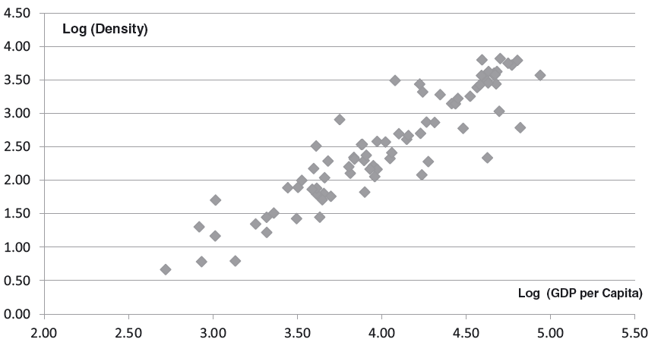

Zdroj: J. Francois Outreville, The relationship between insurance and economic development: 85 empirical papers for a review of the literature.

Druhým ukazatelem je podíl předepsaného pojistného na celkovém hrubém domácím produktu. Outreville uvádí, že až na pár výjimek podíl předpisu pojištění na hrubém domácím produktu (penetrace) u průmyslově vyspělých zemí v roce 2010 přesahoval 5 % a naopak u rozvojových zemí byla penetrace menší než 3 %. Penetrace přitom v rozmezí let 1970 až 2010 výrazně rostla. Nejvýraznější růst byl zaznamenán v Japonsku a Jižní Koreji.

Vztah mezi penetrací pojištění a hrubým domácím produktem na obyvatele je uveden v grafu č. 2. Regresní přímka sice není tímto grafem vedena, ale je zde na první pohled vidět, že s rostoucí vyspělostí země (rostoucí HDP na obyvatele) roste i penetrace pojištění (podíl předpisu na HDP).

Graf. č. 2: Závislost mezi penetrací pojištění a hrubým domácím produktem na obyvatele (v USD). Počítáno u 80 zemí jako průměr za roky 2007–2009

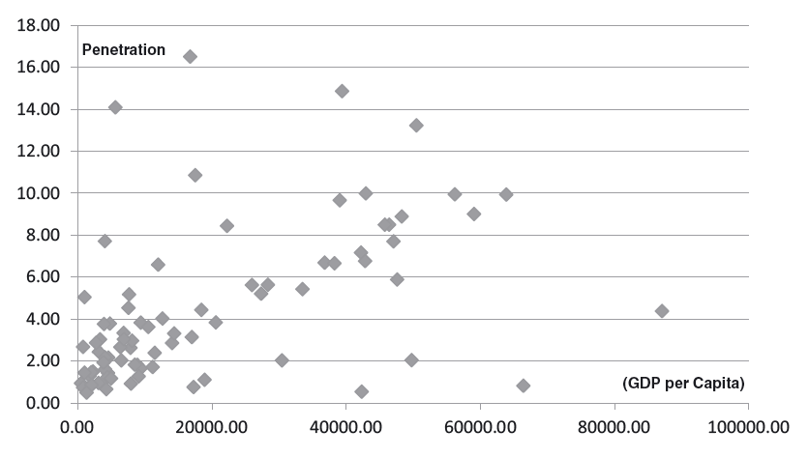

Zdroj: J. Francois Outreville, The relationship between insurance and economic development: 85 empirical papers for a review of the literature.

Outreville uvádí, že vedle toho, jak penetrace pojištění závisí na vyspělosti ekonomiky, tak i pojištění ovlivňuje ekonomický růst. Uvádí přitom několik způsobů, jakými může být tento růst způsoben.

1. Podporou finanční stability domácností i firem,
2. Mobilizací a směřováním úspor k financování investic,
3. Podporou podnikatelské činnosti i sociálních programů,
4. Podporou akumulace kapitálu a jeho efektivní kumulací.

Outreville se odvolává na studii Blum a kol. (2002) dle kterého lze vztahy mezi finančním a reálným sektorem klasifikovat v závislosti na kauzalitě do pěti možných hypotéz:

1. Neexistuje žádný kauzální vztah,
2. Hospodářský růst vede ke zvýšení poptávky po pojištění,
3. Růst pojištění vyvolává hospodářský růst,
4. Negativní příčinná souvislost mezi pojištěním a celkovou ekonomikou,
5. Vzájemná závislost.

Prostudováním již existujících studií Outreville dospívá k závěru, že některé studie preferují kauzalitu od růstu pojištění k růstu celé ekonomiky, jiné preferují kauzalitu od růstu celé ekonomiky k růstu pojištění a třetí skupina studií hovoří o obousměrném ovlivňování.

Pojistným na jednoho obyvatele se zabýval Han (2010). Analyzoval 77 ekonomik z let 1994–2005. Tato studie ukázala, že růst pojistného připadající na obyvatele mělo pozitivní vliv na ekonomický růst. Ve studii vypočítal, že ekonomický růst o 4,781 % byl způsoben zvýšením pojistného na obyvatele o 1 %. Rozlišil rovněž vliv pojištění na ekonomický růst zvlášť u životního a zvlášť u neživotního pojištění. Studie ukázala, že nárůst pojistného životního pojištění na obyvatele o 1 % vedlo k ekonomickému růstu o 1,728 % a nárůst pojistného neživotního pojištění na obyvatele o 1 % vedlo k růstu ekonomiky o 4,180 %. Hanova studie tedy ukázala, že neživotní pojištění mělo mnohem větší vliv na ekonomický vývoj než životní pojištění.

2 Data a metodologie

2.1 Data

K výpočtům byla použita data publikovaná Insurance Europe. Insurance Europe (do března 2012 známá jako Comité Européen des Assurances) je evropská federace pojištění a zajištění, která sdružuje celkem 37 členů, což jsou národní asociace pojišťoven. Členem Insurance Europe za Českou republiku je tedy Česká asociace pojišťoven.

Vstupními daty pro výpočet byly:

Podíl hrubého předepsaného pojistného na celkovém hrubém domácím produktu sledované ekonomiky.

Průměrné hrubé předepsané pojistné připadající na jednoho obyvatele.

Hrubý domácí produkt na jednoho obyvatele.

Podíl hrubého předepsaného pojistného na celkovém hrubém domácím i průměrné hrubé předepsané pojistné připadající na jednoho obyvatele bylo počítáno na datech z roku 2020 u tří typů pojištění: autopojištění, majetkové pojištění a pojištění odpovědnosti. Životní a zdravotní pojištění bylo záměrně vynecháno. Linie mezi sociálním a soukromým pojištěním v rámci mixu pojištění osob může být v rámci jednotlivých států různá a různá může být i metodologie jednotlivých států, co vše zahrne do statistik vykazovaného pojistného za životní a zdravotního pojištění. Pokud je v textu dále uvedeno neživotní pojištění, je myšleno to, které nezahrnuje pojištění osob, tj. je z něj vyloučeno zdravotní a úrazové pojištění.

2.2 Metodologie

Při zkoumání vstupních dat byla použita korelační analýza. Konkrétně byl vypočítáván Pearsonův korelační koeficient. Vlastností Pearsonova korelačního koeficientu je, že lze volně zaměnit vysvětlující a vysvětlovanou veličinu a tento koeficient bude mít v obou případech stejnou hodnotu a nelze tedy stanovit kauzální směr.

3. Výpočty

3.1 Výpočet korelací mezi HDP na obyvatele a podílem pojistného na HDP

Z dat uvedených Insurance Europe byly sestaveny XY grafy, proloženy regresní lineární funkcí a vypočteny Pearsonovy korelační koeficienty.

Graf. č. 3: Závislost mezi podílem pojistného autopojištění na hrubém domácím produktu a hrubým domácím produktem na obyvatele

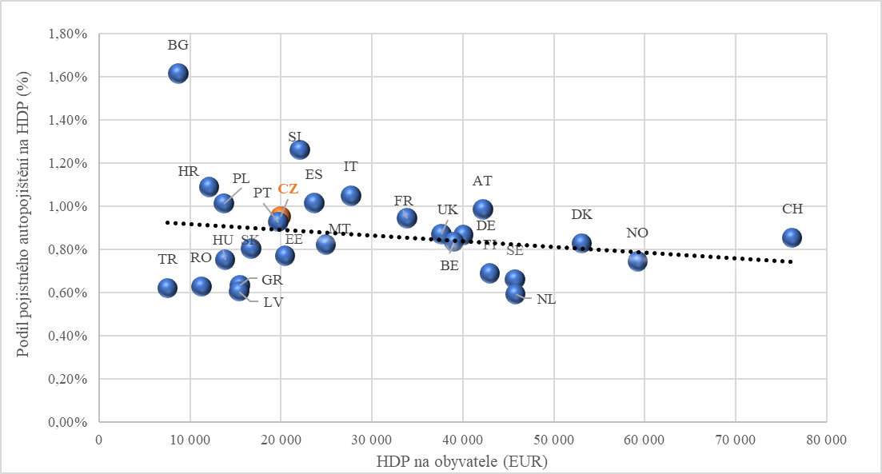

Zdroj: Vlastní výpočty

Pearsonův korelační koeficient byl vypočten ve výši -0,2045. Jedná se tedy o negativní nepříliš těsný vztah.

Graf. č. 4 : Závislost mezi podílem pojistného pojištění majetku na hrubém domácím produktu a hrubým domácím produktem na obyvatele 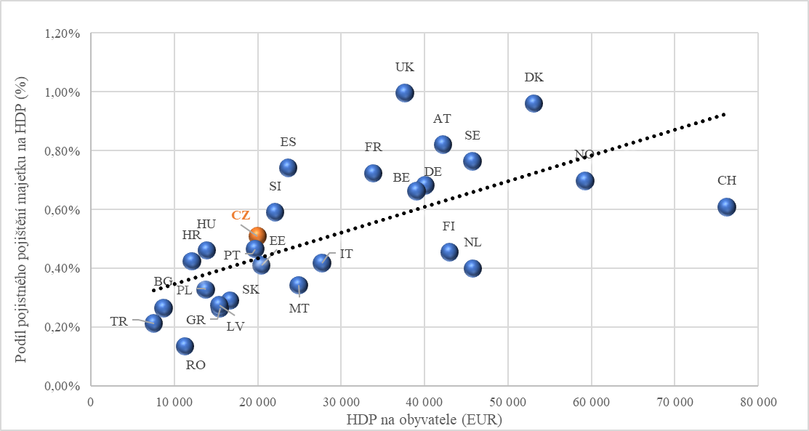

Zdroj: Vlastní výpočty

Pearsonův korelační koeficient byl vypočten ve výši 0,6615. Jedná se tedy o pozitivní středně těsný vztah.

Graf. č. 5: Závislost mezi podílem pojistného pojištění odpovědnosti na hrubém domácím produktu a hrubým domácím produktem na obyvatele

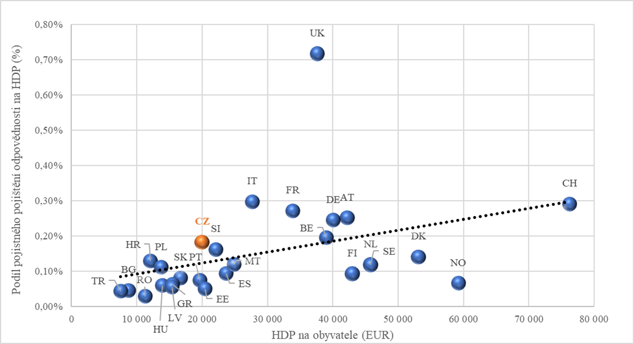

Zdroj: Vlastní výpočty

Pearsonův korelační koeficient byl vypočten ve výši 0,3842. Jedná se tedy o pozitivní nepříliš těsný vztah. Pokud jsou však z výpočtů korelace vypuštěna data za Spojené království, protože je tato hodnota velmi vzdálena od ostatních hodnot, vychází Pearsonův korelační koeficient 0,5272 a jedná se tedy o pozitivní středně těsný vztah.

3.2 Výpočet korelací mezi HDP na obyvatele a pojistným na obyvatele

Graf. č. 6: Závislost mezi pojistným autopojištění na obyvatele a hrubým domácím produktem na obyvatele

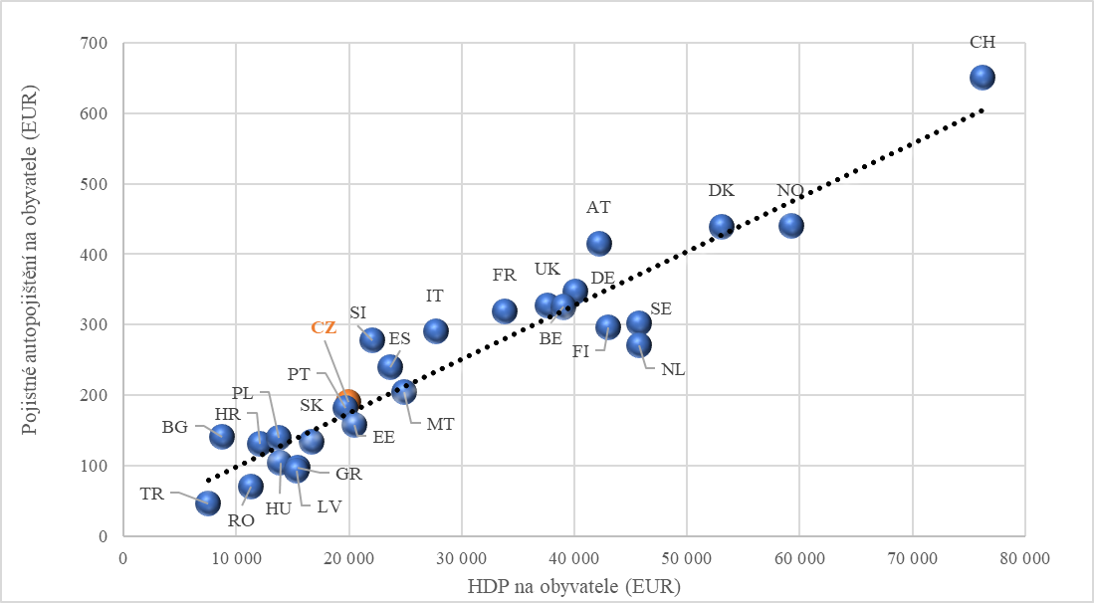

Zdroj: Vlastní výpočty

Pearsonův korelační koeficient byl vypočten ve výši 0,9470. Jedná se tedy o pozitivní extrémně těsný vztah.

Graf. č. 7: Závislost mezi pojistným pojištění majetku na obyvatele a hrubým domácím produktem na obyvatele

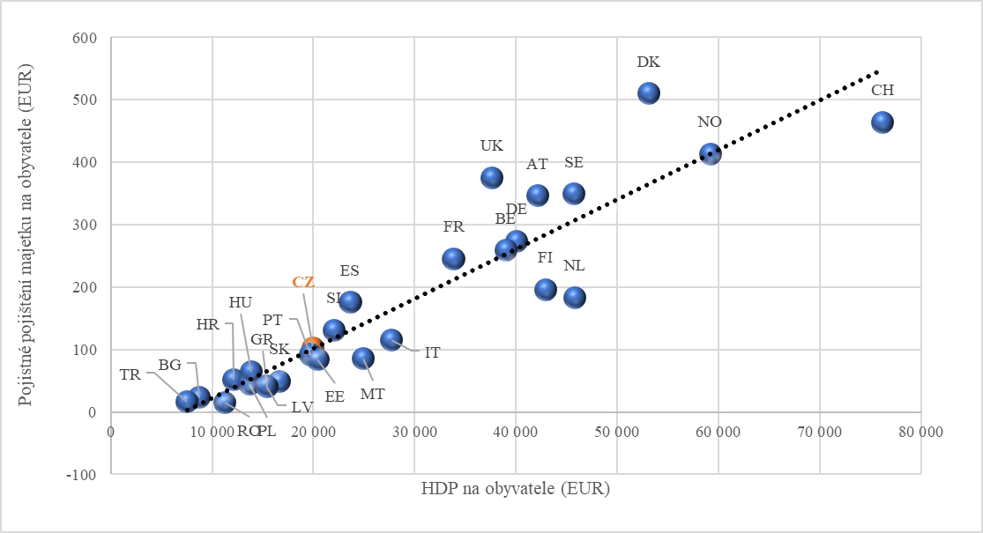

Zdroj: Vlastní výpočty

Pearsonův korelační koeficient byl vypočten ve výši 0,9212. Jedná se tedy o pozitivní extrémně těsný vztah.

Graf. č. 8: Závislost mezi pojistným pojištění odpovědnosti na obyvatele a hrubým domácím produktem na obyvatele

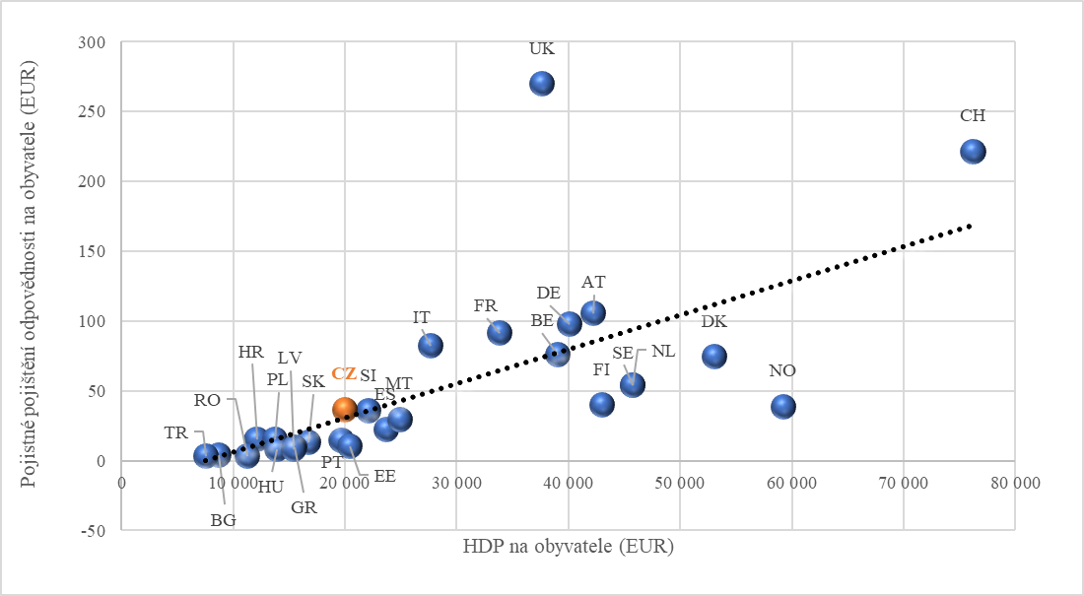

Zdroj: Vlastní výpočty

Pearsonův korelační koeficient byl vypočten ve výši 0,6626. Jedná se tedy o pozitivní středně těsný vztah. Pokud jsou však z výpočtů korelace vypuštěna data za Spojené království, protože je tato hodnota podobně jako i u penetrace pojištění odpovědnosti velmi vzdálena od ostatních hodnot, vychází Pearsonův korelační koeficient 0,8131 a jedná se tedy o pozitivní velmi těsný vztah.

Závěr

Výzkum navázal na předchozí práce a zabýval se výpočty závislostí mezi podílem pojistného na hrubém domácím produktu a hrubým domácím produktem na obyvatele a závislostmi mezi pojistným autopojištění na obyvatele a hrubým domácím produktem na obyvatele.

Cíle tohoto příspěvku se podařilo splnit. S výjimkou korelace mezi hrubým domácím pojistným na obyvatele a mezi podílem předepsaného pojistného autopojištění na hrubém domácím produktu (H1) byly potvrzeny všechny ostatní pracovní hypotézy (H2, H3, H4, H5, H6), tj. že existuje pozitivní korelační závislost mezi sledovanými veličinami. Ekonomicky vyspělejší země mají tedy i vyspělejší trhy neživotního pojištění.

Měření korelace mezi HDP na obyvatele a pojistným na obyvatele lze z interpretačního hlediska považovat za méně zajímavé, protože bylo možné předpokládat, že s růstem HDP na obyvatele poroste i výše výdajů na pojištění vyjádřená v absolutní výši na obyvatele. Zde se lze pouze zaměřit na to, které země se nacházejí dále od regresní křivky (pod ní či nad ní) a vymykají se tedy úrovni, která by odpovídala jejich ekonomické vyspělosti. Nejextrémněji se z tohoto pohledu chovalo Spojené království v případě pojištění odpovědnosti. Zde je pojistné připadající na jednoho obyvatele v absolutní výši nejvyšší a je 3,27 násobně vyšší než odpovídá průměru u všech sledovaných zemí. Naopak pod svým potenciálem daným regresní křivkou je Norsko.

Daleko zajímavější situace byla u podílu pojištění na hrubém domácím produktu. Zde byla měřena závislost mezi podílem hrubého předepsaného pojistného sledovaného druhu pojištění na hrubém domácím produktu a mezi hrubým domácím produktem na obyvatele. U pojištění majetku a odpovědnosti byly zjištěny pozitivní závislosti, tj. bohatší země (s vyšším HDP na obyvatele) vydávaly relativně více na pojištění (relativně myšleno ve vztahu k celkovému HDP). Spojené království a Dánsko například na pojištění majetku vydává až 1 % HDP. Nejmenší podíl pojistného pojištění majetku vůči HDP má naopak Rumunsko s 0,14 %. U pojištění odpovědnosti jsou výdaje na pojištění u nejvyspělejších zemí až 0,3 % (Švýcarsko, Německo, Rakousko, Francie, Itálie), extrémem je pak Spojené království s podílem přesahujícím 0,7 %. Na opačném pólu stojí opět Rumunsko s 0,04% podílem na HDP. Lze tedy konstatovat, že země s vysokým podílem HDP na obyvatele mají i vyspělé pojistné trhy pojištění majetku a odpovědnosti. Zde by určitě stálo pokračovat v dalším výzkumu a zjistit, zda rostoucí míra tohoto typu pojištění nějakým způsobem nesouvisí se strukturou ekonomiky (např. podílu průmyslu na HDP).

U autopojištění však byla zjištěna negativní závislost mezi podílem pojistného na hrubém domácím produktu a hrubým domácím produktem na obyvatele. Bohatší země (s vyšším HDP na obyvatele), tedy vydávali relativně méně na pojištění automobilů. Možné vysvětlení je to, že s růstem ekonomiky již množství aut dále stejným tempem jako růst HDP neroste a pojistné na autopojištění se tedy již dále také stejným tempem nenavyšuje a rostoucí DPH již tedy pouze „ředí“ podíl pojistného na HDP. Rozpětí dosahovaných hodnot podílu pojistného autopojištění na hrubém domácím produktu byla od cca 0,6 % (Nizozemsko, Lotyšsko, Turecko, Rumunsko), až po 1,61 % (Bulharsko).

Při pohledu na země s podobným hrubým domácím produktem na obyvatele jako má Česká republika (Portugalsko a Estonsko) si nešlo nevšimnout, že i jejich pojistné na obyvatele a podíl pojistného na hrubém domácím produktu u všech tří sledovaných druhů pojištění dosahovala podobných hodnot.

Pro další výzkum bych doporučoval zaměřit se u vysvětlující proměnné nejen na celkovou výši hrubého domácího pojistného na obyvatele, ale i na strukturu ekonomiky (např. podíl průmyslové výroby na HDP). Zajímavé by jistě bylo sledovat stejný vzorek zemí v delším časovém období a zjistit, zda se sledované korelace v čase nemění a zda u některých zemí nedochází ke změnám výdajů na pojištění k HDP v čase.

Literatura

1. BLUM, David N., FEDERMAIR, Klaus, FINK, Gerhard, a HAISS, Peter R. The Financial-Real Sector Nexus: Theory and Empirical Evidence. Research Institute for European Affairs, University of Economics and Business Administration Vienna, *IEF Working Paper*. 2002 No. 43. ISSN 1725-3187
2. HAN, Liyan., LI, Donghui, MOSHIRIAN, Fariborz, TIAN, Yanhui. Insurance Development and Economic Growth.2010. *The Geneva Papers on Risk and Insurance - Issues and Practice*. 2010, Vol. 35, April, p. 183-195. ISSN 1018-5895
3. INSURANCE EUROPE. *Statistics*. [online]. 2022. [cit. 11. 7. 2022]. Dostupné z: https://www.insuranceeurope.eu/statistics
4. OUTREVILLE, J. Francois., The Relationship Between Insurance and Economic development: 85 Empirical Papers for a Review of the Literature. Risk *Management and Insurance Review*. 2013, Vol. 16.2013, 1, p. 71-122. ISSN 1098-1616

Kontakt

Ing. Jiří Slanina

Vysoká škola finanční a správní,

Estonská 500/3

101 00 Praha 10

Česká republika

jiri.slanina@uniqa.cz

Moritz Sohns  
Utility indifference pricing in the Heston model: pricing, hedging and shortcomings

Abstract

This paper deals with the Heston model's utility indifference pricing method via the exponential utility function. We illustrate the main properties, review the existing literature and elaborate on the idea behind the pricing method and control. The main results of this paper are a pricing equation for the model, an equation for the optimal hedging strategy in the model, an illustration of why short positions must not appear in practice when applying the utility indifference approach, which is a contradiction to the observed real-world trading and a simulation of the price process, calculation of the corresponding derivative prices and a comparison of the different hedging strategies.

The simulation together with the result about the absence of short positions hints that utility indifference pricing should be treated with caution when applied in practice in the real world.

Keywords

Heston model, stochastic volatility, derivatives pricing, option pricing, pricing simulation

JEL classification

$$C51⋅C52⋅G12⋅G13⋅G17$$

Introduction

The Black-Scholes model has become the standard model for valuing derivatives in industry and academia. The distribution of neither the underlying price process of the stock nor the prices for underlying match the empirical distribution of assets traded in the real world (Rubinstein, 1994; Duan, 1999). One particular drawback of the Black-Scholes model seems to be the assumption of stationary volatility Black; Scholes, 1973 and data shows that the volatility is random (Blattberg et al., 1974, Scott, 1987) and correlated to the underlying price process (Rosenberg, 1972, Black, 1975, Geske, 1979, Beckers, 1980).

In order to remedy these inaccuracies, the Black-Scholes model was generalised to allow stochastic volatility (Scott, 1987; Wiggins, 1987; Hull et al., 1987), and empirical studies show that stochastic volatility improves the performance of the models (Amin et al., 1997; Das et al., 1999; Buraschi et al., 2001).

However, introducing a second source of risk makes pricing more complicated as markets usually become incomplete and hence it is impossible to hedge a claim perfectly. Applying similar methods as Black, Scholes, and Merton did makes it possible to derive a similar PDE. Nevertheless, neither its solution nor any equivalent local martingale in this market is unique, and further assumptions or preferences must be made to obtain a unique price. Several suggestions were made, for example, minimising the risk of the corresponding hedging strategy, pricing via a super-hedging strategy and many more. (A general overview of these methods can be found in Pham, 2000. Its application to stochastic volatility models, for example in Laurent et al., 1999; Biagini et al., 2000; Heath et al., 2001; Pham, 2001; Grandits et al., 2002).

Another approach is to maximise an investor's expected utility by assuming an underlying utility function based on the investor's risk preference, which was introduced in Hodges, 1989 and has become quite popular and well studied, see for example M. H. Davis et al., 1993; Barles et al., 1998; Constantinides et al., 1999; Rouge et al., 2000; Constantinides et al., 2001; Becherer, 2001; Delbaen et al., 2002; Davis, 2006; Monoyios, 2009; Monoyios, 2010; Danilova et al., 2010).

A pricing equation for stochastic volatility models was first calculated by Sircar et al., 2004. Since then, many papers dealt with this problem or the corresponding problem of portfolio optimisation in this model (Kraft, 2005; Benth et al., 2005; Fouque et al., 2015; Boguslavskaya et al., 2016), and the optimisation problem of slightly generalised models such as stochastic interest rate, additional trading of zero bonds, and continuous consumptions has been studied (Li et al., 2009; Noh et al., 2011; Chang et al., 2013; W.-J. Liu et al., 2015; Kim et al., 2015). As the stochastic volatility models are complex and no simple solution can be established for the pricing and hedging of these models, many studies in this area deal more with numerical aspects than analytical and formal investigations of the model (see, for example, Carr et al., 1999; Floc'h et al., 2018).

The aim of the contribution is deriving a pricing equation for the Heston model, similar to the Black-Scholes equation, determining the optimal control, and calculating the residual risk process. Furthermore, potential shortcomings of the model when applied in practice should be investigated. We will show that, an approximated strategy with a positive probability of containing short positions is not the optimal time discrete strategy and hence not the optimal strategy that can be applied in practice. Hence, we put the model to the test, model a stock price process and apply the calculated optimal strategy and the optimal utility indifferent hedging strategy. We compare the results concerning options prices and portfolio wealth with the results we get when applying a delta hedge strategy with respect to the prices from the Black-Scholes model as well as the prices from the closed form solution of the Heston model (Heston, 1993)

1. The model

We assume a market with a stock $S$ and a riskless bond $B$. The price of the stock $S$ is modelled as a diffusion process satisfying

$$\frac{dS_{t}}{S_{t}}=μdt+σ\sqrt{Y_{t}} dW_{t}^{0}, dY_{t}=a\left(t,Y_{t}\right)dt+σ\sqrt{Y_{t}} dW_{t}^{1}$$

with $a\left(t,Y_{t}\right)=κ\left(θ-Y_{t}\right)$ and $μ>0$. The processes $W^{0}$ and $W^{1}$ are standard Brownian motions with $\left\langle W_{t}^{1},W_{t}^{2}\right\rangle =ρt,ρ∈(-1,1)$ defined on a filtered probability space $\left(Ω,F,{\left(F_{s}\right)}_{0≤s≤T},P\right)$ where $F_{s}$ is the $σ$-algebra generated by $W_{s}^{0}$ and $W_{s}^{1}$.

The Bond can be traded, yielding a constant interest rate $r$. For simplicity we assume $r=0$ 
. Furthermore, let $g\left(S_{T}\right)$ be the payoff of a European-style claim.

Consider an agent investing in the stock and the bank account with a self-financing strategy $π_{t}$, where $π_{t}$ denotes the proportion of wealth $X_{t}$ the investor invests in the risky asset. That means, at any time $t$, the investor holds $\frac{π_{t}X_{t}}{S_{t}}$ stocks, and therefore, by the self-financing condition, the wealth process is given by $dX_{t}=\frac{π_{t}X_{t}}{S_{t}} dS_{t}.$

The Heston Model has some advantages over the Black-Scholes model, such as nonlognormal probability distribution (for example, fat tails), mean reverting volatility, leverage effect and many more, but also some disadvantages. Also, the fact that the medium and long-term maturity fits the implied volatility surface of option prices is a huge advantage. The parameters are, for example, arduous to estimate, and these estimations are crucial since the model reacts extremely sensitive to minor variations in the parameters.

Due to the two sources of risk, we cannot perfectly hedge the claim, so it is impossible to determine the price only by no-arbitrage arguments. We formalise this observation:

**Proposition 1** *The market in the Heston model is incomplete.*

Note that the market becomes complete if it is possible to trade an asset with the price process $Y_{t}$. In this case, an equivalent local martingale measure is, by definition, an equivalent probability measure $Q$ only if $S_{t}$ and $Y_{t}$ are local martingales with respect to $Q$, which would not be the case for the probability measures we just constructed in the proof.

Since the no-arbitrage pricing method, as it was applied in the Black-Scholes setting, cannot be applied to incomplete markets, other methods to determine the price of any claim has to be applied in the Heston model. This issue has been studied extensively, and numerous approaches exist.

One possibility is introducing another derivative in the market to complete the market and enable no-arbitrage pricing. For instance, this is the technique described in the articles by Zhu et al., 1998; Romano et al., 1997; Hobson et al., 1998; Davis, 2003. Other papers give a justification requirement for a specific selection of a martingale pricing measure. In the context of continuous-time stochastic volatility models, there are two prevalent criteria for selecting martingale pricing measures: the variance-optimal martingale measures and the minimal entropy martingale measures. There is a relationship between the variance-optimal martingale measures and the quadratic utility functions. Laurent et al., 1999; Biagini et al., 2000; Heath et al., 2001, among others, conducted substantial research on their use. The minimal entropy martingale measure may be related to the option valuation issue under an exponential utility function with constant absolute risk aversion; for instance, see Delbaen et al., 2002; Rheinländer, 2005; D. Hobson, 2004 . Henderson et al., 2008 examined utility-based indifference pricing of contingent claims using stochastic volatility models. Indifference pricing derives from Hodges, 1989 and establishes a seller's/buyer's price such that the seller/buyer is indifferent to whether the claim is sold/bought. An excellent overview of the different pricing methods can be found in Henderson et al., 2008.

This paper will apply the utility indifference pricing method to the Heston model.

2. Pricing equation and hedging strategy

The investor seeks to find an optimal strategy to maximise the expected terminal utility. Therefore let $U$ be a utility function reflecting the personal risk attitude of the investor. A popular choice as utility function is the exponential utility function $$U(x):=-exp⁡(-γx), γ>0.$$

The advantages of this function are not only that it allows for negative wealth but also that the corresponding optimal control will be wealth-independent (see, for example, Grasselli et al., 2004). Wealth independence is crucial for obtaining a 'universal' (as opposed to individual pricing) equation, provided all investors in the market exhibit the same risk preference, which is an advantage over, for example, the power utility function. Note that in the literature, the exponential utility function is very often given as $U(x):=1-\frac{exp⁡(-γx)}{γ}, γ>0$, which yields the same maximising strategies.

We compare the utility of two sets of admissible strategies. The first strategy does not involve the claim at all, and the investor's goal is only to maximise the utility by maximising the expected terminal utility when trading only in the stock and the bank account. Let $Φ$ be the set of admissible strategies, which means self-financing strategies with potentially additional requirements, such as the uniform boundedness of the wealth process from below.

We define

$$J^{(0)}(t,x,y;π):=E\left[U\left(X_{T}\right)∣X_{t}=x,Y_{t}=y\right]$$

with the value function

$$u^{(0)}(t,x,y):=\sup_{π∈Φ} J^{(0)}(t,x,y;π), u^{(0)}(T,x,y)=U(x)$$

We compare these strategies with the strategies involving buying one unit of the claim. In this case, we define

$$J^{(1)}(t,x,y,s;π)=E\left[U\left(X_{T}+g\left(S_{T}\right)\right)∣X_{t}=x,Y_{t}=y,S_{t}=s\right]$$

and so the value function $u^{(0)}(t,x,s)$ is defined by

$$u^{(1)}(t,x,y,s):=\sup_{π∈Φ} J^{(1)}(t,x,y,s;π), u^{(1)}(T,x,y,s)=U(x+g(y)).$$

The functions $u^{(0)}$ and $u^{(0)}$ are solutions of the Hamilton-Jacobi-Bellman equation, which has been studied extensively. A comprehensive treatment can, for example, be found in the textbook by Øksendal, 2010.

Note that $J$ and $u$ also depend on $y$, even though the payoff at time $T$ does not. The reason for doing so is that we do not want to consider the more complex case of partial information: Since $S$ and $Y$ are not perfectly correlated, the $σ$-algebra $A_{t}$ is larger than the $σ$-algebra generated by all sets $\left\{A∈A∣S_{t}=y\right\}$ for $∈R$. And because furthermore $S$ and $Y$ are not independent, we have $E\left[U\left(X_{T}\right)∣X_{t}=x\right]≠E\left[U\left(X_{T}\right)∣A_{t}\right].$

Another advantage of this approach is that it can easily be generalised to the case of claims that depend on $Y_{t}$ such as volatility derivatives.

Now we can define the indifference buy price. Definition 2 The indifference-buy-price $p_{t}(x,s,y)=p(t,x,s,y)$ at time $t$ is defined such that an agent with an initial random endowment is indifferent between doing nothing and buying the claim for that price. That means, for $p_{t}$, we have $u^{(0)}(t,x,y)=u^{(1)}(t,x+p(t,x,s,y),y,s)$.

In a complete market, where a geometric Brownian motion models the stock price, the utility indifference price coincides with the Black-Scholes price (see for example M. H. Davis et al., 1993).

The main result of this paper is the following.

**Theorem 3** *The utility indifference price process $p(t,y,s)$ for the European claim $g\left(S_{T}\right)$ is determined by the PDE*

$$p_{t}+\left(a-μρ-\left(1-ρ^{2}\right)σ^{2}yv_{y}\right)p_{y}+\frac{1}{2}σ^{2}p_{yy}y+σ^{2}yρsp_{ys}=0$$

*with terminal condition $p(T,y,s)=g(s)$, where $v$ is a function which satisfies*

$$-v_{t}+\frac{1}{2}v_{y}^{2}\left(1-ρ^{2}\right)σ^{2}y-\frac{1}{2}v_{yy}σ^{2}y-v_{y}a+v_{y}μρ-\frac{1}{2}\frac{μ^{2}}{σ^{2}y}=0$$

*and $v(T,y)=0$. The optimal hedging strategy is given by*

$$π_{t}X_{t}=ρ\frac{∂p}{y}\left(t,Y_{t},S_{t}\right)+\frac{∂p}{s}\left(t,Y_{t},S_{t}\right).$$

*For an investor holding one claim and trading with the optimal strategy, the residual risk process is given by*

$$\begin{matrix}dR_{t}=( & \frac{μ^{2}}{γσ^{2}Y}+\left(p_{y}-\frac{v_{y}}{γ}\right)ρμ+p_{s}μ-p_{t}-p_{s}Sμ \\ & \left.-p_{y}a-\frac{1}{2}p_{ss}S^{2}σ^{2}Y-\frac{1}{2}p_{yy}σ^{2}Y-p_{ys}σ^{2}ρYS\right)dt-p_{y}σ\sqrt{Y} dW^{1} \\ & +\left(\frac{μ}{γσ\sqrt{Y}}+p_{y}σ\sqrt{Y}ρ-\frac{v_{y}}{γ}ρσ\sqrt{Y}+(1-S)p_{s}σ\sqrt{Y}\right)dW^{0}.\end{matrix}$$

The proof for this statement is given in section 6.1.

If the market is complete, which means $ρ∈\{-1,0,1\}$, the utility-indifferenceprice coincides with the no-arbitrage price. For $ρ=-1,1$ you can see that $E_{Q}\left[g\left(S_{T}\right)∣Y_{t}=y,S_{t}=s\right]$ solves the pricing equation for $Q$ defined by $Q$ by $\frac{dQ}{dP}=E\left(-\frac{μ}{σ\sqrt{Y}}\right)$. - For $ρ=0$, the optimal hedging strategy becomes just a plain delta hedge. If one defines a new probability measure $Q$ the way it was done in definition $2.8$ in Sircar et al., 2004, let $γ$ tend to zero and apply Feynman-Kac, we obtain $E_{Q}\left[g\left(S_{T}\right)∣Y_{t}=y,S_{t}=s\right]$. The martingale measure is called the martin entropy martingale measure. Its importance for pricing theory is well studied. We can derive a connection between certain equivalent local martingale measures and PDEs by comparing our pricing PDE with the one in Sircar et al., 2004. The equations are quite similar, but Sircar and Zariphopoulou expressed the function $v$ in terms of an equivalent local martingale measure.

3. Impossibility of short positions in the utility in- difference approach

As always, when dealing with trading strategies in continuous time, the question arises of whether they are applicable in practice and how they perform when simulated. In the case of an exponential utility function, this is particularly interesting as the utility function becomes very steep for large negative numbers. In particular, the marginal utility drops more than the probability density function, leading to the exclusion of short positions when applying the utility indifference approach in practice. This was already hinted by Gerer et al., 2016. We give here detailed proof in a slightly different setting. As short positions are applied in practice, one can conclude that real-world prices do not arise via the utility indifference method. As continuous trading is impossible in simulation or practice, we must restrict our trading strategies to simple processes, which are often used when defining the stochastic integral.

**Definition 4** A process $H$ is said to be simple if $H$ has a representation

$$H_{t}=H_{0}1_{\{0\}}(t)+\sum_{i=1}^{n}{ }H_{i}1_{\left(t_{i},t_{i+1}\right]}(t)$$

where $0=t_{1}<…<t_{n+1}<∞$ is a finite sequence of real numbers, $H_{i}∈F_{t_{i}}$ with $\left|H_{i}\right|<∞$ a.s., $0≤i≤n$. The collection of simple processes is denoted with $S$.

In continuous trading, a strategy is called admissible when its corresponding value process is bounded from below. As this excludes short positions for simple processes, we will amend this definition slightly. Definition 5 We call a trading strategy $H∈S$ with step-times $t_{0}<t_{1}<…<t_{n}$ 
 simulation admissible if there exists a $B∈R$ such that $H_{t_{i}}=0$ for all $i$ with $t_{i}>t$ for all $t$ with $H⋅S_{t}<=-B$. This means a strategy is admissible if investors stop trading entirely once their wealth process drops beneath a specific value.

**Theorem 6** *Assume a trader wants to maximise the terminal wealth by investing in shares and holding one claim with a bounded payoff . Then the optimal simulation admissible strategy does not involve any short positions in the stock.*

4. Simulation

To test the utility indifference pricing equation, we simulated a stock price process via the Euler-Maruyama method (see, for example, Kloeden et al., 2013).

We use the following set of parameters for our simulation:

$κ=4.3758,θ=0.1505,σ=0.3474,μ=0.0984,ρ=-0.2541,Y_{0}=0.0989,s_{0}=30$,

as these are parameters fitting to the S&P 500 according to Hirsa [36].[13]

As we are particularly interested in claims bounded from above and whose hedging strategy usually consists of holding short positions of the stock, we choose a bull spread containing a long position of a call with strike 30 and a short position of a call with strike 40.

The time interval is divided into 200 equally sized time steps, and we consider five portfolios:

1. Contains a claim priced by the Black-Scholes formula and hedged via simple delta hedging.
2. Contains a claim priced by the explicit Heston formula (Heston [35]) and hedged via simple delta hedging.
3. Contains a claim priced by our utility indifference pricing equation and hedged via simple delta hedging.
4. Contains a claim priced by our utility indifference pricing equation and hedged via the optimal hedging control.
5. Contains a claim priced by our utility indifference pricing equation and hedged via the optimal control for a portfolio consisting of a claim and shares.

Each portfolio starts with zero wealth, and all strategies are self-financing. We used the same value for $μ$ to price the claim via the Black-Scholes formula. However, for the volatility, we used $σ=0.128$ to adapt the volatility of a stock price driven by a geometric Brownian motion to our stock price process. We did 500 simulations in total. The main results are shown in the table below. The values were calculated by the terminal values of the simulations, and $10\%$ stands for the 10 th percentile.

Table No. 1: Terminal values of 500 simulations

|  |  |  |  |  |  |
| --- | --- | --- | --- | --- | --- |
|  | Wealth Mean | Wealth Variance | Wealth $10\%$ | Wealth Median | Wealth $90\%$ |
| Black Scholes | $$0.1724$$ | $$0.4379$$ | $$-0.6643$$ | $$0.1137$$ | $$1.0493$$ |
| Heston Closed Form | $$-0.8407$$ | $$1.4867$$ | $$-2.1616$$ | $$-1.1096$$ | $$0.8922$$ |
| Heston Utility Delta | $$-0.0668$$ | $$0.1643$$ | $$-0.5164$$ | $$-0.1311$$ | $$0.4882$$ |
| Heston Hedging Control | $$0.4547$$ | $$0.9405$$ | $$-0.9401$$ | $$0.6051$$ | $$1.586$$ |
| Heston Optimal | $$5.7941$$ | $$39.2736$$ | $$-2.1486$$ | $$5.4543$$ | $$13.934$$ |

Source: Results from the simulation performed in MATLAB and R

It is not surprising that the Heston Optimal strategy performs best. It is no hedging strategy; its goal is to maximise wealth instead of minimising risk. During the simulations, no short position was held in the stock (even though it got close to zero quite often). Comparing these strategies with a different set of parameters might be interesting. Here the drift of the stock is significantly positive, and the interest rate was set to zero. Hence it seems evident that a strategy comprising going short in the stock and long in the stock performs quite well. The data also shows that the variance in the optimal strategy exhibits a significant variance, and the tenth percentile is significantly lower than the one for three of the four hedging strategies. A somewhat surprising result is the bad performance of a delta hedge in the Heston model, where the price was calculated via the closed-form equation. Moreover, the performance seems even worse when considering longer maturities. The delta-hedged utility indifference claim performs worse on average than the optimal hedge. However, it is the strategy with the most negligible risk apart from the delta-hedged Black-Scholes model. Regarding the calculated option prices, it seems that the Closed Form Heston Model is not as sensitive regarding the maturity as the other two pricing models. There are no essential differences between the Black-Scholes price and the utility indifference price for our set of parameters.

We conclude that the utility indifference pricing and hedging strategies are valid methods. Nevertheless, further tests are necessary to see how these perform for a different set of parameters and to see whether the shortcomings of the Black-Scholes model can be overcome.

Conclusion

This paper examined the popular Heston model for pricing European-style derivatives via the utility indifference method. While it is possible to derive pricing equations and mathematically correct hedging strategies, we found that these strategies should be applied carefully in practice.

One reason is that the formal setting of utility indifference pricing in the Heston model does not allow for short positions in any optimal portfolio. Since short positions frequently happen in practice, this indicates that utility indifference pricing in the Heston model does not explain trading in the real world. Another reason results from the simulation we did in the second part of this paper. This simulation shows that the Heston model's optimal hedging strategy for utility indifference pricing does not perform well when applied in practice. The reasons for this can be manifold; most likely, the strategy and model are susceptible to parameter changes and approximations.

However, our simulation only used one set of parameters. More simulations and research should be performed to support or challenge our findings.

References

1. AMIN, Kaushik I and NG, Victor K. Inferring future volatility from the information in implied volatility in Eurodollar options: A new approach*. The Review of Financial Studies*. Vol. 10, no. 2, 1997. pp. 333-367. ISSN 0893-9454.
2. BARLES, Guy and SONER, Halil Mete. Option pricing with transaction costs and a nonlinear Black-Scholes equation. *Finance and Stochastics.* Vol. 2, no. 4, 1998. pp. 369-397. ISSN 0949-2984.
3. BECHERER, Dirk*. Rational Hedging and Valuation with Utility-Based Preferences.* Berlin, 2001. Dissertation. Technischen Universität Berlin. Available at: DOI: 10.14279/depositonce-311.
4. BECKERS, Stan. The constant elasticity of variance model and its implications for option pricing. *The Journal of Finance*. Vol. 35, no. 3, 1980. pp. 661-673. ISSN 15406261.
5. BENTH, Fred Espen and KARLSEN, Kenneth Hvistendahl. A PDE Representation of the Density of the Minimal Entropy Martingale Measure in Stochastic Volatility Markets. *Stochastics and Stochastics Reports*. Vol. 77, 2005. pp. 109-137. ISSN 10451129.
6. BIAGINI, Francesca, GUASONI, Paolo and PRATELLI, Maurizio. Mean-Variance Hedging for Stochastic Volatility Models. *Mathematical Finance*. Vol. 10, no. 2, 2000. pp. 109-123. ISSN 0960-1627.
7. BLACK, Fischer. Fact and Fantasy in the Use of Options. *Financial Analysts Journal.* Vol. 31, no. 4, 1975. pp. 36-41. ISSN 0015-198X.
8. BLACK, Fischer and SCHOLES, Myron. The Pricing of Options and Corporate Liabilities. *Journal of Political Economy*. Vol. 81, no. 3, 1973. pp. 637-654. ISSN 1537534X.
9. BLATTBERG, Robert C. and GONEDES, Nicholas J. A Comparison of the Stable and Student Distributions as Statistical Models for Stock Prices. *The Journal of Business*. Vol. 47, no. 2, 1974. pp. 244-80. ISSN 0021-9398.
10. BOGUSLAVSKAYA, Elena and MURAVEY, Dmitry. An Explicit Solution for Optimal Investment in Heston Model. *Theory of Probability & Its Applications*. Vol. 60, no. 4, 2016. pp. $679-688$. ISSN $0040-585X$.
11. BURASCHI, Andrea and JACKWERTH, Jens. The price of a smile: Hedging and spanning in option markets. *The Review of Financial Studies*. Vol. 14, no. 2, 2001. pp. 495-527. ISSN 0893-9454.
12. CARR, Peter and MADAN, Dilip. Option valuation using the fast Fourier transform. *Journal of computational finance*. Vol. 2, no. 4, 1999. pp. 61-73. ISSN 1755-2850.
13. CHANG, Hao and RONG, Xi-min. An investment and consumption problem with CIR interest rate and stochastic volatility. *Abstract and Applied Analysis*. Vol. 2013, 2013. ISSN 1085-.3375.
14. CONSTANTINIDES, George M and ZARIPHOPOULOU, Thaleia. Bounds on prices of contingent claims in an intertemporal economy with proportional transaction costs and general preferences. *Finance and Stochastics*. Vol. 3, no. 3, 1999. pp. 345369. ISSN 0949-2984.
15. CONSTANTINIDES, George M and ZARIPHOPOULOU, Thaleia. Bounds on derivative prices in an intertemporal setting with proportional transaction costs and multiple securities. *Mathematical Finance*. Vol. 11, no. 3, 2001. pp. 331-346. ISSN 0960-1627.
16. DANILOVA, Albina and MONOYIOS, Michael; NG, Andrew. Optimal investment with inside information and parameter uncertainty. *Mathematics and Financial Economics*. Vol. 3, no. 1, 2010. pp. 13-38. ISSN 1862-9679.
17. DAS, Sanjiv Ranjan and SUNDARAM, Rangarajan K. Of smiles and smirks: A term structure perspective. *Journal of Financial and Quantitative Analysis*. Vol. 34, no. 2, 1999. pp. 211-239. ISSN 0022-1090.
18. DAVIS, Mark H. A. Optimal Hedging with Basis Risk. In: Kabanov, Yuri, Lipster, Rober, Stoyanov, Jordan (ed.) *From Stochastic Calculus to Mathematical Finance: The Shiryaev Festschrift*. Berlin, Heidelberg: Springer Berlin Heidelberg, 2006. pp. 169-187. ISBN 978-3-540-30788-4.
19. DAVIS, Mark HA. Valuation, hedging and investment in incomplete financial markets. In: HILL, James M. a Ross MOORE (ed.). *Applied Mathematics Entering the 21st Century: Invited Talks from the ICIAM 2003 Congress*. New York: Society for Industrial & Applied Mathematics,U.S., 2004, s. 49-70. ISBN 9780898715590.
20. DAVIS, Mark HA, PANAS, Vassilios G. and ZARIPHOPOULOU, Thaleia. European option pricing with transaction costs. *SIAM Journal on Control and Optimization*. Vol. 31, no. 2, 1993. pp. 470-493. ISSN 0363-0129.
21. DELBAEN, Freddy, GRANDITS, Peter, RHEINLÄNDER, Thorsten, SAMPERI, Dominick, SCHWEIZER, Martin and STRICKER, Christophe. Exponential Hedging and Entropic Penalties. *Mathematical Finance*. Vol. 12, no. 2, 2002. pp. 99 123. ISSN 0960-1627.
22. DRǍGULESCU, Adrian A. and YAKOVENKO, Victor M. Probability distribution of returns in the Heston model with stochastic volatility. *Quantitative Finance*. Vol. 2, no. 6, 2002. pp. 443-453. ISSN $1469-7688$.
23. DUAN, Jin Chuan. Conditionally fat-tailed distributions and the volatility smile in options. Rotman School of Management, University of Toronto, 1999. Working Paper.
24. ELLERSGAARD, Simon and TEGNÉR, Martin. Stochastic volatility for utility maximizers: A martingale approach. *International Journal of Financial Engineering*. Vol. 5, no. 1, 2018. pp. 1850007. ISSN $2424-7863$.
25. FLEMING, Wendell and SONER, Mete. Controlled Markov Processes and Viscosity Solutions. New York: Springer, 2006. ISBN 9780387310718
26. FLOC'H, Le et al. An adaptive Filon quadrature for stochastic volatility models. *Journal of Computational Finance.* Vol. 22, no. 3, 2018. ISSN 1755-2850.
27. FOUQUE, Jean-Pierre, SIRCAR, Ronnie and ZARIPHOPOULOU, Thaleia. Portfolio optimization and stochastic volatility asymptotics. Mathematical Finance, 2015. ISSN 0960-1627.
28. GERER, Johannes and DORFLEITNER, Gregor. A note on utility indifference pricing. *International Journal of Theoretical and Applied Finance*. Vol. 19, no. 06, 2016. pp. 1650037. ISSN 0219-0249.
29. GESKE, Robert. The valuation of compound options. *Journal of financial economics*. Vol. 7, no. 1, 1979. pp. 63-81. ISSN 0304-405X.
30. GRANDITS, Peter and RHEINLÄNDER, Thorsten. On the minimal entropy martingale measure. *Annals of Probability*. Vol. 30, no. 3, 2022. pp. 1003-1038. ISSN 0091-1798.
31. GRASSELLI, Matheus; HURD, Thomas, 2004. Indifference pricing and hedging in stochastic volatility models. *Papers math/0404447, arXiv.org*, 2004.
32. HARRISON, Michael and PLISKA, Stanley R. Martingales and stochastic integrals in the theory of continuous trading. *Stochastic processes and their applications*. Vol. 11, no. 3, 1981. pp. 215-260. ISSN 0304-4149.
33. HARRISON, Michael; PLISKA, Stanley R. A stochastic calculus model of continuous trading: complete markets. *Stochastic processes and their applications*. Vol. 15, no. 3, 1983. pp. 313-316. ISSN 0304-4149.
34. HEATH, David, PLATEN, Eckhard and SCHWEIZER, Martin. A comparison of two quadratic approaches to hedging in incomplete markets. *Mathematical Finance*. Vol. 11, no. 4, 2001. pp. 385-413. ISSN 0960-1627.
35. HENDERSON, Vicky and HOBSON, David. Utility Indifference Pricing: An Overview. In: CARMONA, René (ed.). *Indifference Pricing : Theory and Applications*. Princeton: Princeton University Press, 2008. pp. 44-74. ISBN 9781400833115.
36. HESTON, Steven L. A closed-form solution for options with stochastic volatility with applications to bond and currency options. *The review of financial studies*. Vol. 6, no. 2, 1993. pp. 327-343. ISSN 0893-9454.
37. HIRSA, Ali. Computational Methods in Finance. Florida: CRC Press, 2016. ISBN 9781466576049.
38. HOBSON, David. Stochastic Volatility Models, Correlation, and the q-Optimal Measure. *Mathematical Finance.* Vol. 14, no. 4, 2004. pp. 537-556. ISSN 0960-1627.
39. HOBSON, David G and ROGERS, Leonard CG. Complete models with stochastic volatility. *Mathematical Finance*. Vol. 8, no. 1, 1998. pp. 27-48. ISSN 0960-1627.
40. HODGES, Stewart D. Optimal replication of contingent claims under transaction costs. *The Review of Futures Markets*. Vol. 8, 1989. pp. 223-238. ISSN 0898-011X.
41. HULL, John and WHITE, Allan. The pricing of options on assets with stochastic volatilities. *The journal of finance*. Vol. 42, no. 2, 1987. pp. 281-300. ISSN 1540-6261.
42. KIM, Mi-Hyun, KIM, Jeong-Hoon and YOON, Ji-Hun. Optimal portfolio selection under stochastic volatility and stochastic interest rates. *The Journal of the Korean Society for Industrial and Applied Mathematics.* Vol. 19, no. 4, 2015. pp. 417-428. ISSN $1226-9433$.
43. KLOEDEN, Peter E. and PLATEN, Eckhard. Numerical Solution of Stochastic Differential Equations. Berlin: Springer Berlin Heidelberg, 2013. ISBN 9783662126165.
44. KRAFT, Holger. Optimal portfolios and Heston's stochastic volatility model: an explicit solution for power utility. *Quantitative Finance*. Vol. 5, no. 3, 2005. pp. 303313. ISSN 1469-7696.
45. LAURENT, Jean Paul and PHAM, Huyên. Dynamic programming and meanvariance hedging. *Finance and Stochastics.* Vol. 3, no. 1, 1999. pp. 83-110. ISSN 0949 2984.
46. LI, Jinzhu and WU, Rong. Optimal investment problem with stochastic interest rate and stochastic volatility: Maximizing a power utility. *Applied Stochastic Models in Business and Industry.* Vol. 25, no. 3, 2009. pp. 407-420. ISSN 1526-4025. Available at: DOI: $10.1002/$  asmb $.759$.
47. LIU, Jun and PAN, Jun. Dynamic derivative strategies. *Journal of Financial Economics*. Vol. 69, no. 3, 2003. pp. 401-430. ISSN 0304-405X.
48. LIU, Wei-Jia, FAN, Shun-Hou and CHANG, Hao. Dynamics optimal portfolios with CIR interest rate under a Heston model. *WSEAS Transactions on Systems and Control*. Vol. 10, 2015. pp. 421-429. ISSN 1991-8763.
49. MONOYIOS, Michael. Optimal investment and hedging under partial and inside information. In: ALBRECHER, Hansjörg; RUNGGALDIER, Wolfgang J.; SCHACHERMAYER, Walter (ed.) *Advanced Financial Modelling*. Berlin, New York: De Gruyter, 2009. pp. 371-410. ISBN 9783110213140.
50. MONOYIOS, Michael. Utility-based valuation and hedging of basis risk with partial information. *Applied Mathematical Finance*. Vol. 17, no. 6, 2010. pp. 519-551. ISSN 1350-486X.
51. NOH, Eun-Jung and KIM, Jeong-Hoon. An optimal portfolio model with stochastic volatility and stochastic interest rate. *Journal of Mathematical Analysis and Applications.* Vol. 375, no. 2, 2011. pp. 510-522. ISSN 0022-247X.
52. ØKSENDAL, Bernt. *Stochastic Differential Equations: An Introduction with Applications (Universitext).* Berlin: Springer, 2010. ISBN 9783540047582.
53. PHAM, Huyên. Hedging and Optimization Problems in Continuous-Time Financial Models. In: YOUNG, J.; CONT, R. (eds.). *Mathematical Finance: Theory and Practice*. 2000. Series in Contemporary Applied Mathematics.
54. PHAM, Huyên. Mean-variance hedging for partially observed drift processes. *International Journal of Theoretical and Applied Finance*. Vol. 4, no. 02, 2001. pp. 263‑284. ISSN 0219-0249.
55. PHAM, Huyên. Smooth Solutions to Optimal Investment Models with Stochastic Volatilities and Portfolio Constraints. *Applied Mathematics & Optimization*. Vol. 46, no. 1, 2002. pp. 55-78. ISSN 1432-0606.
56. RHEINLÄNDER, Thorsten. An entropy approach to the Stein and Stein model with correlation. *Finance and Stochastics*. Vol. 9, no. 3, 2005. pp. 399-413. ISSN 09492984.
57. ROGERS, Leonard Christopher Gordon. *Optimal Investment*. Berlin: Springer Berlin Heidelberg, 2013. ISBN 9783642352027.
58. ROMANO, Marc; TOUZI, Nizar. Contingent claims and market completeness in a stochastic volatility model. *Mathematical Finance*. Vol. 7, no. 4, 1997. pp. 399-412. ISSN 0960-1627.
59. ROSENBERG, Barr. *The behavior of random variables with nonstationary variance and the distribution of security prices.* Berkley: University of California, Institute of Business and Economic Research, 1972.
60. ROUGE, Richard and EL KAROUI, Nicole. Pricing via utility maximization and entropy. *Mathematical Finance*. Vol. 10, no. 2, 2000. pp. 259-276. ISSN 0960-1627.
61. RUBINSTEIN, Mark. Implied binomial trees. *The Journal of Finance*. Vol. 49, no. 3, 1994. pp. 771-818. ISSN 1540-6261.
62. SCOTT, Louis O. Option pricing when the variance changes randomly: Theory, estimation, and an application. *Journal of Financial and Quantitative analysis*. Vol. 22, no. 04, 1987. pp. 419-438. ISSN 0022-1090.
63. SIRCAR, Ronnie and ZARIPHOPOULOU, Thaleia. Bounds and asymptotic approximations for utility prices when volatility is random. *SIAM Journal on Control and Optimization*. Vol. 43, no. 4, 2004. pp. 1328-1353. ISSN 0363-0129.
64. WIGGINS, James B. Option values under stochastic volatility: Theory and empirical estimates. *Journal of financial economics*. Vol. 19, no. 2, 1987. pp. 351-372. ISSN 0304-405X.
65. ZHU, Yingzi and AVELLANEDA, Marco. A risk-neutral stochastic volatility model. *International Journal of Theoretical and Applied Finance*. Vol. 1, no. 02, 1998. pp. 289‑310. ISSN 0219-0249.

Contact

Moritz Sohns, MSc

University of Finance and Administration

Estonská 500/3

101 00 Praha 10

Sohns@mokel.science

A. Appendix

Proofs of the results

In this section, the proofs for the results, discussed in the main part, are provided.

**Proposition 7** The market in the Heston model is incomplete.

In the following proof, for stochastic processes $H,X$, we write $H⋅X_{t}$ for the stochastic integral $∫_{0}^{t} H dX_{s}$.

**Proof:** We define $W^{⊥}:=W_{t}^{1}-ρW_{t}^{0}$. Then we have $\left\langle W^{0},W^{⊥}\right\rangle =0$. Now we define a new probability measure $dQ^{λ}$ with $∫_{0}^{T} λ_{t} dt<∞$ by its Radon-Nikodym derivative

$$\frac{dQ}{dP}=E\left(-\frac{μ}{σ\sqrt{Y}}⋅W^{0}+λ⋅W_{t}^{⊥}\right).$$

By Girsanov's Theorem, the process

$$W_{t}^{Q}:=W^{0}-\left\langle \frac{μ}{σ\sqrt{Y}}⋅W_{t}^{0}+λW_{t}^{⊥},W_{t}^{0}\right\rangle =W_{t}^{0}-\frac{μ}{σ\sqrt{Y_{t}}}t$$

is a Brownian Motion with respect to $Q$ and hence

$$\frac{dS_{t}}{S_{t}}=μdt+σ\sqrt{Y_{t}} dW_{t}^{0}=σ\sqrt{Y_{t}}W_{t}^{Q}$$

is a local Martingale for any $λ_{s}$. So there are infinite many equivalent local martingale measures for $S_{t}$, and with the Second Fundamental Theorem of Asset Pricing, which follows if via localisation of the theorems in Harrison et al., 1981; Harrison et al., 1983, we conclude that the market is incomplete. □

The next part of this section provides the proofs for the important Theorem 3. We will split this theorem into smaller parts.

In order to derive a formula for the indifference price we examine $u^{(0)}$ and $u^{(1)}$.

**Theorem 7** *We have*

$$u^{0}(t,x,y)=-exp⁡(-γx-v(t,y))$$

*where $v$ is a function that satisfies*

|  |  |
| --- | --- |
| $$-v_{t}+\frac{1}{2}v_{y}^{2}\left(1-ρ^{2}\right)σ^{2}y-\frac{1}{2}v_{yy}σ^{2}y-v_{y}a+v_{y}μρ-\frac{1}{2}\frac{μ^{2}}{σ^{2}y}=0$$ | (3) |

*and $v(T,y)=0$. The optimal trading strategy is given by*

$$π_{t}^{(0)}X_{t}=\frac{1}{γ}\left(\frac{μ}{σ^{2}Y_{t}}-\frac{∂v}{∂y}\left(t,Y_{t}\right)ρ\right).$$

To keep things short and palatable, we will neither deal with verification of our result nor with technical assumptions such as smoothness or Lipschitz conditions.

The following proof can, for example, be verified with Theorem 11.2.1 from [64], which also states the mild technical assumptions under which a solution of the partial differential equation (4) provides the optimal control. Furthermore, to improve readability, we will omit the indexes in the following calculations, and we write $u_{t}$ for $\frac{∂}{∂t}u$, etcetera.

**Proof:** Throughout this proof, we write $u$ for $u^{0}$. We apply Itô 's Lemma and obtain

$$\begin{matrix}du\left(t,X_{t},Y_{t}\right)= & u_{t}^{0} dt+u_{x} dX+u_{y} dY+\frac{1}{2}u_{xx} d⟨X⟩+\frac{1}{2}u_{yy} d⟨Y⟩+u_{xy} d⟨X,Y⟩ \\ = & u_{t}^{0} dt+u_{x}(πXμ)dt+u_{x}π_{t}X_{t}σ\sqrt{Y_{t}} dW^{0}+u_{y}a dt \\ & +u_{y}σ\sqrt{Y} dW^{1}+\frac{1}{2}u_{xx}(πXσ)^{2}Y dt+\frac{1}{2}u_{yy}σ^{2}Y dt+u_{xy}ρπXσ^{2}Y dt \\ = & \left(u_{t}^{0}+u_{x}(πXμ)+u_{y}a+\frac{1}{2}u_{xx}(πXσ)^{2}Y+\frac{1}{2}Yu_{yy}σ^{2}\right. \\ & \left.+u_{xy}ρπXσ^{2}Y\right)dt+u_{x}πXσ\sqrt{Y} dW^{0}+u_{y}σ\sqrt{Y} dW^{1}.\end{matrix}$$

By the Davis-Varaiya martingale principle of optimal control (see for example Theorem $1.1$ in Rogers [55]), the process $u\left(t,X_{t},Y_{t}\right)$ is a martingale for an optimal process ${\overset{ˆ}{π}}_{t}$. So, we conclude that the drift must be zero for the optimal control $\overset{ˆ}{π}$. Hence, we conclude

|  |  |  |
| --- | --- | --- |
| $$u_{t}^{0}+u_{x}(πxμ)+u_{y}a+\frac{1}{2}u_{xx}(πxσ)^{2}y+\frac{1}{2}yu_{yy}σ^{2}+u_{xy}ρπyσ^{2}=0$$ | (4) |  |

In order to find the optimal control, we differentiate with respect to $π$ and obtain

$$u_{x}xμ+u_{xx}πx^{2}σ^{2}y+u_{xy}ρxyσ^{2}=0.$$

Hence, we have

|  |  |
| --- | --- |
| $$\overset{ˆ}{π}x=-\frac{u_{x}μ-u_{xy}ρyσ^{2}}{u_{xx}σ^{2}y}=-\frac{u_{x}μ}{u_{xx}σ^{2}y}-\frac{u_{xy}ρ}{u_{xx}}.$$ | (5) |

Putting this into equation (4), we get

|  |  |
| --- | --- |
| $$0=u_{t}+\frac{1}{2}u_{yy}σ^{2}Y-\frac{1}{2}\frac{u_{xy}^{2}ρ^{2}σ^{2}Y}{u_{xx}}+au_{y}-\frac{u_{x}u_{xy}μρ}{u_{xx}}-\frac{1}{2}\frac{u_{x}^{2}μ^{2}}{u_{xx}σ^{2}Y}.$$ | (6) |

This is a non-linear PDE, and there is no straightforward way to solve it. In Sircar et al., 2004, T. Zariphopoulou introduced a certain power transformation, a so-called 'distortion power' and obtained a linear PDE. We try a different ansatz here, which goes back to Fleming et al., 2006 and was applied in similar settings for example in Pham, 2002 and Benth et al., 2005. We set

|  |  |
| --- | --- |
| $$u(t,x,y)=-exp⁡(-γx-v(t,y)).$$ | (7) |

Now we get for :

$$u_{t}=-uv_{t}, u_{x}=-γu, u_{xx}=γ^{2}u, u_{y}=-v_{y}u, u_{yy}=uv_{y}^{2}-uv_{yy}, u_{xy}=γv_{y}u$$

So, we obtain for $(6)$

$$0=-v_{t}+\frac{1}{2}v_{y}^{2}\left(1-ρ^{2}\right)σ^{2}y-\frac{1}{2}v_{yy}σ^{2}y-v_{y}a+v_{y}μρ-\frac{1}{2}\frac{μ^{2}}{σ^{2}y}$$

with $v(T,y)=0$

Putting the partial derivatives into (5) yields the optimal strategy. □

Now we have a closer look at $u^{(1)}$.

**Theorem 8** *We have*

$$u^{(1)}(t,x,y,s)=-exp⁡(-γx+γf(t,y,s)-v(t,y))$$

*where $f$ is determined by the PDE*

|  |  |
| --- | --- |
| $$\begin{matrix}0=f_{t} & +\left(a-μρ-\left(1-ρ^{2}\right)σ^{2}yv_{y}\right)f_{y}+\frac{1}{2}σ^{2}f_{yy}y+σ^{2}yρsf_{ys} \\ & +\frac{1}{2}σ^{2}ys^{2}f_{ss}+\frac{1}{2}σ^{2}γ\left(1-ρ^{2}\right)Yf_{y}^{2}\end{matrix}$$ | (8) |

*with $f(T,y,s)=g(s)$ and $v(t,y)$ is the function from Theorem 7. The optimal trading strategy is given by*

$$π_{t}X_{t}=\frac{μ}{γσ^{2}Y_{t}}+\left(\frac{∂f}{∂y}\left(t,Y_{t},S_{t}\right)-\frac{1}{γ}\frac{∂v}{∂y}\left(t,Y_{t}\right)\right)ρ+\frac{∂f}{∂s}\left(t,Y_{t},S_{t}\right).$$

**Proof:** We write again $u$ for $u^{(1)}$ and omit indexes. By applying Itô, we get

|  |  |
| --- | --- |
| $$\begin{matrix}du(t,S,X,Y)= & \left(u_{t}+u_{x}πXμ+\frac{1}{2}u_{xx}π^{2}X^{2}σ^{2}Y+u_{s}Sμ+u_{y}a+\frac{1}{2}u_{ss}S^{2}σ^{2}Y\right. \\ & \left.+u_{xy}ρπXσ^{2}Y+\frac{1}{2}u_{yy}σ^{2}Y+u_{xs}Sσ^{2}YπX+u_{sy}ρσ^{2}YS\right)dt \\ & +M\end{matrix}$$ | (9) |

with $M$ being a local martingale.

So, for the optimal $π$, we have

$$0=u_{x}xμ+u_{xx}πx^{2}σ^{2}y+u_{xy}ρXσ^{2}y+u_{xs}sσ^{2}yx,$$

and we obtain

|  |  |
| --- | --- |
| $${\overset{ˆ}{π}}^{(1)}x=-\frac{u_{x}μ+u_{xy}σ^{2}yρ+u_{xs}sσ^{2}y}{u_{xx}σ^{2}y}$$ | (10) |

By plugging this into equation (9) we get

|  |  |
| --- | --- |
| $$\begin{matrix}0=u_{t} & -\frac{1}{2}\frac{u_{x}^{2}μ^{2}}{u_{xx}σ^{2}y}+au_{y}+μsu_{s}+\frac{1}{2}u_{yy}σ^{2}y+\frac{1}{2}u_{ss}σ^{2}ys^{2} \\ & -\frac{1}{2}\frac{u_{xy}^{2}σ^{2}ρ^{2}y}{u_{xx}}-\frac{1}{2}\frac{u_{xs}^{2}σ^{2}ys^{2}}{u_{xx}}-\frac{u_{x}u_{xy}μρ}{u_{xx}} \\ & -\frac{u_{x}u_{xs}μs}{u_{xx}}-\frac{u_{xy}u_{xs}σ^{2}ρsy}{u_{xx}}+u_{ys}σ^{2}ρsy.\end{matrix}$$ | (11) |

We make a similar ansatz as before and assume

|  |  |
| --- | --- |
| $$u(t,x,y,s)=-exp⁡(-γx+γf(t,y,s)-v(t,y))$$ | (12) |

where $v$ is the function from (3) and $f$ is a function which is, so far, only defined by the PDE. We calculate the partial derivatives for :

$$\begin{matrix}u_{t} & =u\left(γf_{t}-v_{t}\right), u_{x}=-γu, u_{xx}=γ^{2}u \\ u_{y} & =u\left(γf_{y}-v_{y}\right), u_{yy}=u{\left(γf_{y}-v_{y}\right)}^{2}+u\left(γf_{yy}-v_{yy}\right) \\ u_{s} & =uγf_{s}, u_{ss}=uγ^{2}f_{s}^{2}+uγf_{ss}, u_{xy}=-γu\left(γf_{y}-v_{y}\right) \\ u_{xs} & =-γ^{2}uf_{s}, u_{ys}=uγ\left(γf_{y}f_{s}-v_{y}f_{s}+f_{ys}\right),\end{matrix}$$

and by filling them into the partial derivatives in equation (11), we obtain after some reordering

$$\begin{matrix}0=uγ & \left(f_{t}+\frac{1}{2}σ^{2}ys^{2}f_{ss}+\frac{1}{2}yσ^{2}f_{yy}+σ^{2}ρysf_{ys}+af_{y}+\frac{1}{2}σ^{2}γ\left(1-ρ^{2}\right)yf_{y}^{2}\right. \\ & \left.-μρf_{y}-σ^{2}\left(1-ρ^{2}\right)v_{y}yf_{y}\right) \\ & +u\underset{*}{\underbrace{\left(-v_{t}+\frac{1}{2}\left(1-ρ^{2}\right)σ^{2}v_{y}^{2}y-\frac{1}{2}σ^{2}v_{yy}y-av_{y}+μρv_{y}-\frac{1}{2}\frac{μ^{2}}{σ^{2}y}\right)}}.\end{matrix}$$

Note that the term $(*)$ is equal to zero according to Theorem 7. So, since $uγ≠0$, we obtain

$$\begin{matrix}0=f_{t}+ & \frac{1}{2}σ^{2}ys^{2}f_{ss}+\frac{1}{2}yσ^{2}f_{yy}+σ^{2}ρysf_{ys}+af_{y}+\frac{1}{2}σ^{2}γ\left(1-ρ^{2}\right)yf_{y}^{2} \\ & -μρf_{y}-σ^{2}\left(1-ρ^{2}\right)v_{y}yf_{y} \\ =f_{t}+ & \left(a-μρ-\left(1-ρ^{2}\right)σ^{2}yv_{y}\right)f_{y}+\frac{1}{2}σ^{2}f_{yy}y+σ^{2}yρsf_{ys} \\ & +\frac{1}{2}σ^{2}ys^{2}f_{ss}+\frac{1}{2}σ^{2}γ\left(1-ρ^{2}\right)yf_{y}^{2},\end{matrix}$$

which proves equation (8) with the terminal value $f(T,y,s)=g(s)$.

In order to derive the formula for the optimal control, we plug the partial derivatives of $u$ into equation $(10)$, and thus we get

$$\begin{matrix}πx & =-\frac{u_{x}μ+u_{xy}σ^{2}yρ+u_{xs}sσ^{2}y}{u_{xx}σ^{2}y} \\ & =-\frac{-γuμ-γu\left(γf_{y}-v_{y}\right)σ^{2}yρ-γ^{2}uf_{s}sσ^{2}y}{γ^{2}uσ^{2}y} \\ & =\frac{μ+\left(γf_{y}-v_{y}\right)σ^{2}yρ+γf_{s}sσ^{2}y}{γσ^{2}y}=\frac{μ}{γσ^{2}y}+\left(f_{y}-\frac{v_{y}}{γ}\right)ρ+f_{s}s.\end{matrix}$$

Hence the result follows. □

**Corollary 9** *We have $f(t,y,s)=p(t,y,s)$, and hence $p$ is determined by the PDE*

$$p_{t}+\left(a-μρ-\left(1-ρ^{2}\right)σ^{2}yv_{y}\right)p_{y}+\frac{1}{2}σ^{2}p_{yy}y+σ^{2}yρsp_{ys}=0$$

*with terminal condition $p(T,y,s)=g(s)$, and the optimal hedging strategy is given by*

$$π_{t}X_{t}=ρ\frac{∂p}{y}\left(t,Y_{t},S_{t}\right)+\frac{∂p}{s}\left(t,Y_{t},S_{t}\right).$$

**Proof:** The price $p$ is determined by the equation

$$u^{0}(t,x,y)=u^{(1)}(t,x+p(t,y,s),y,s).$$

Using (7) and (12), we obtain

$$-exp⁡(-γx-v(t,y))=-exp⁡(-γ(x+p(t,y,s))+γf(t,y,s)-v(t,y)),$$

and we get the pricing equation.

The hedging strategy follows from $π_{t}=π_{t}^{(1)}-π_{t}^{(0)}$. □

**Theorem 10** *For an investor holding one claim and trading with the optimal strategy, the residual risk process is given by*

$$\begin{matrix}dR_{t}=( & \frac{μ^{2}}{γσ^{2}Y}+\left(p_{y}-\frac{v_{y}}{γ}\right)ρμ+p_{s}μ-p_{t}-p_{s}Sμ \\ & \left.-p_{y}a-\frac{1}{2}p_{ss}S^{2}σ^{2}Y-\frac{1}{2}p_{yy}σ^{2}Y-p_{ys}σ^{2}ρYS\right)dt-p_{y}σ\sqrt{Y} dW^{1} \\ & +\left(\frac{μ}{γσ\sqrt{Y}}+p_{y}σ\sqrt{Y}ρ-\frac{v_{y}}{γ}ρσ\sqrt{Y}+(1-S)p_{s}σ\sqrt{Y}\right)dW^{0}.\end{matrix}$$

**Proof:** By applying the Itô-Formula, we obtain

$$\begin{matrix}dR= & dX-dp(t,Y,S) \\ = & \frac{πX}{S} dS-\left(p_{t} dt+p_{y} dY+p_{s} dS+\frac{1}{2}p_{ss} d⟨S⟩+\frac{1}{2}p_{yy} d⟨Y⟩+p_{ys} d⟨Y,S⟩\right) \\ = & πXμdt+πXσ\sqrt{Y} dW^{0}-\left(p_{t} dt+p_{s}Sμdt+p_{s}Sσ\sqrt{Y} dW^{0}+p_{y}a dt\right. \\ & \left. +p_{y}σ\sqrt{Y} dW^{1}+\frac{1}{2}p_{ss}S^{2}σ^{2}Y dt+\frac{1}{2}p_{yy}σ^{2}Y dt+p_{ys}σ^{2}ρYS dt\right) \\ = & \left(\frac{μ^{2}}{γσ^{2}Y}+\left(p_{y}-\frac{v_{y}}{γ}\right)ρμ+p_{s}μ\right)dt \\ & +\left(\frac{μ}{γσ\sqrt{Y}}+p_{y}σ\sqrt{Y}ρ-\frac{v_{y}}{γ}ρσ\sqrt{Y}+p_{s}Sσ\sqrt{Y}\right)dW^{0} \\ & -\left(p_{t}+p_{s}Sμ+p_{y}a+\frac{1}{2}p_{ss}S^{2}σ^{2}Y+\frac{1}{2}p_{yy}σ^{2}Y+p_{ys}σ^{2}ρYS\right)dt \\ & -p_{s}Sσ\sqrt{Y} dW^{0}-p_{y}σ\sqrt{Y} dW^{1}.\end{matrix}$$

It is also possible to use the pricing equation for further rearrangements. However, this does not simplify the equation any further. □

**Theorem 12** *Assume a trader wants to maximise the terminal wealth by investing in shares and holding one claim with a bounded payoff $C$. Then the optimal simulation admissible strategy does not involve any short positions in the stock.*

In the following proof, for stochastic processes $H,X$, we write again $H∙X_{t}$ for the stochastic integral $∫_{0}^{t} H dX_{s}$.

**Proof:** We show that no simulated admissible strategy with $P\left(minH_{t}<0\right)>0$ is an optimal control.

Let $h>0$ be a real number with $P\left(\min_{t} H_{t}<h\right)>0$ and we define the random variable $b$ as the unique number (possible infinity) for that we have $t_{b}=min\left\{t_{i}∈\right.$ $\left.[0,T]:H_{t_{i}}<-h\right\}$. Furthermore let $x$ be a real number with $x>\frac{M}{h}$ where $M$ is the boundary from definition 5 and $A^{x}:=\left\{ω∈Ω:S_{b+1}-S_{b}-\frac{H⋅S_{τ}}{h}>x\right\}$ . We have $\lim_{x→∞} exp⁡(λx)P\left(A^{x}∣F_{t_{b}}\right)=∞$, which can be seen with the equation (44) from Drăgulescu et al., 2002 which gives an expression for the asymptotic distribution of the returns in the Heston model.

First, we note that we have $S_{b+1}-S_{b}≥0$ for all $ω∈A^{x}$. Assume $S_{b+1}-S_{b}<0$, then we have of all $ω∈A^{x}$

$$-h\left(S_{b+1}-S_{b}\right)+H⋅S_{t_{b}}<-hx<-M.$$

Hence, we have

$$H⋅S_{t_{b}}<-h\left(S_{b+1}-S_{b}\right)<-M.$$

Since $S$ is continuous, $H∙S$ is also continuous and there exists a $t<t_{b}$ with $⋅S_{t}<$ $-M$, and thus we have $H_{t}=0$ for all $t≥t_{b}$ because $H$ is admissible. This contradicts the definition of $t_{b}$ and hence we conclude $S_{b+1}-S_{b}≥0$.

Now we see that we have $H_{t}=0$ for all $t>=t_{b+1}$ for all $ω∈A^{x}$, which is a direct consequence of $H$ being admissible:

$$\begin{matrix}H⋅S_{b+1} & =H_{b}\left(S_{b+1}-S_{b}\right)+H⋅S_{t_{b}}≤-h\left(S_{b+1}-S_{b}\right)+H⋅S_{t_{b}} \\ & ≤-M+H⋅S_{t_{b}}-H⋅S_{t_{b}}=-M.\end{matrix}$$

Hence, we derive for all $∈A^{x}$:

$$\begin{matrix}H⋅S_{T}+C & =H_{b}\left(S_{b+1}-S_{b}\right)+C+H⋅S_{t_{b}}≤-h\left(S_{b+1}-S_{b}\right)+C+H⋅S_{t_{b}} \\ & ≤-h\left(S_{b+1}-S_{b}\right)+s{ }C+H⋅S_{t_{b}}≤-hx+s{ }C.\end{matrix}$$

Since the function $f(x)=max(-U(x),0)=max(exp⁡(-γx),0)=(U(x))^{-}$ is decreasing, we have

$$\begin{matrix}E\left[f(H⋅S+C)∣F_{t_{b}}\right] & ≥E\left[1_{A^{x}}f(H⋅S+C)∣F_{t_{b}}\right]≥E\left[1_{A^{x}}f(-hx+s{ }C)∣F_{t_{b}}\right] \\ & =f(-hx+s{ }C)E\left[1_{A^{x}}∣F_{t_{b}}\right]=f(-hx+s{ }C)P\left(A^{x}∣F_{t_{b}}\right)\end{matrix}$$

Now we can complete the proof. The definition of a random variable $Y$ is defined as $E[max(Y,0)]-E[max(-Y,0)]$ with the condition that at least one of these two expectations is finite. Thus, by showing $E\left[max\left(-U\left(H⋅S_{T}+C\right),0\right]=∞\right.$, we can conclude $E\left[U\left(S⋅X_{T}+C\right)\right]=-∞$, which means that $H$ is no optimal control.

We calculate

$$\begin{matrix}E\left[-U\left(H⋅S_{T}+C\right)\right] & =E\left[E\left[f\left(H⋅S_{T}\right)∣F_{t_{b}}\right]\right]≤E\left[f(-hx+s{ }C)P\left(A^{x}∣F_{t_{b}}\right)\right] \\ & =exp⁡(-γs{ }C)E\left[exp⁡(γhx)P\left(A^{x}∣F_{t_{b}}\right)\right]\end{matrix}$$

By letting $x$ tend to infinity and interchanging integral and limit (which we justify by dominated convergence), we get the desired result. □

Katrin Steyer  
Public finances in Germany since 2010 – Analysis of the debt ratio

Abstract

The state sets the framework for the democratic coexistence of citizens and provides services that secure their existence. State finances also support the German economy. State measures and the financing of social systems mitigate economic consequences and damages triggered by crises or unforeseen events such as the corona pandemic or wars. First, a literature review describes the theory of public debt. Then is followed by an analysis of the development of public finances in Germany. The analysis aims to analyse unemployment as a lever. A regression analysis with R explains the development of the debt ratio through the unemployment rate. Subsequently, recommendations on reducing unemployment and the unemployment system should lead to a political discussion.

Keywords

Public finances, unemployment, financial sustainability, Germany

JEL classification

J64, H12, G28

Introduction

Many industrialised countries, including the European Union member states (EU), have high public debt levels. According to Kronberger Kreis, the risk of insolvency has risen sharply in countries such as Greece, Portugal and Spain (Kronberger Kreis, 2010). The development of public finances in Germany has been the focus of policy. Public finances in Germany have been heavily troubled after the global financial crisis (from 2007) and the subsequent euro crisis in 2009. The German debt ratio was at this time at an all-time high. Politicians were forced to act to stabilise the economy on the one hand and to stabilise public finances following the Maastricht Treaty. The author focuses on analysing the impact of unemployment on public finances. For this, it is necessary to know the two financing systems of unemployment benefits.

On the one hand, the unemployed and employers are supported by one of the five significant social security funds. The unemployment costs from this insurance are not visible in the public finances. Public finances support unemployed people who are not entitled to unemployment insurance benefits (basic social security). Since unemployment is generally considered as a whole, coming from both jurisdictions (unemployment insurance and basic security), the influence on public finances must be analysed.

According to the analysis, unemployment presents itself as a lever. Therefore, the author develops recommendations to stabilise public finances in the future. The volatile environment shows that crises will not be avoided in the future. It is, therefore, essential to bring these levers into a political discussion.

1 Material and Methods

1.1 Literature Review

1.1.1 State growth and Wagner’s law

Blankart explains that the scholar Adolf Wagner that he established the “law of growing government spending” (Blankart, 2017). As a driving factor, Blankart suggests that the decisive institutions influence the growth of government spending. There are players, such as political representatives and opponents, such as institutional rules. For Germany, the debt brake is cited as an example.

In this work, the influence of population growth is not further deepened, which Blankert describes as neutrality (Blankart, 2017).

Priesmeier (2012 and 2013) and Köster investigated the question of the end of the growth of government spending. These examined the reciprocal adjustments between sovereign debt and the economy.

Government spending has risen in Germany over the last 100 years. Historically, the above authors found a correlation between GDP income growth and an increase in government finances. Crises and historical events such as the reunification of East and West Germany led to state action to keep state finances financeable.

Particular drivers of finances are political interest groups, which drive up public finances with programs such as the German scrappage bonus.

1.1.2 Cost of government debt

According to Blankart (Blankart, 2017), interest is the price of government debt. Accordingly, the interest price is determined by individuals’ savings decisions and by companies’ investment decisions.

(State) loans lead to spending money today and only paying it off later. Blankart explains that the scarcity of financial resources must lead to careful handling so that loans, interest and other government debts, such as pensions and other legally guaranteed benefits, can be paid to citizens and companies on time.

In Germany, the debt brake has been anchored. This is intended to prevent the government from pursuing an offensive, vote-induced spending policy.

Budgetary imbalances resulting from recession deficits and booms’ surpluses balance each other. The so-called automatic stabilisers support the sustainability of finances (Blankart, 2017). Spending on additional costs as a result of shocks, such as the corona pandemic and other extreme events, such as the Russian war of aggression, leads to higher deficits. To this end, Germany undertakes to draw up repayment plans.

1.1.3 Analysis with the help of national accounts

National accounts give information to analyse economies’ structure and development over time.

The primary aggregates of GDP report an overview of the most important economic developments.

General government gross debt is one of the most critical indicators. The indicator is defined (in the Maastricht Treaty). Net borrowing relative to nominal GDP is a second key debt indicator used to identify the presence of a fiscal crisis or emergency. Eurostat data sources from the European Commission, data from the Federal Ministry of Finance, or data from Statista are used for the analysis.

1.2 Analysis Approach

Fiscal statistics reflect the general government budget’s revenue, expenditure and debt and provide a detailed picture of the entire public finance sector (European Commission, 2021).

The author uses linear regression analysis to analyse the development of public finances in Germany from 2010 to 2021 to explain the gross public debt. The indicator is defined (in the Maastricht Treaty) as the consolidated gross debt of the general government at nominal value (face value).

The author examines the influence of the favourable labour market situation and the unemployment rate on the debt ratio (gross debt). The unemployment rate is the share of unemployed persons in the labour force. The labour force is the sum of employed and unemployed persons. Unemployed persons include all persons aged 15 to 74 (a) who were unemployed, (b) who were available to the labour market, (c) who were actively seeking work. The Statistical Office of the European Union (Eurostat) and the European Commission provide the data used.

2 Results

The global financial crisis in 2009 left a gap in public finances. The banks’ financing problems are spilling over into the real economy. In 2010, Germany reported a net borrowing deficit of ‑4.4% of GDP. Compared to the European Union (27 states), public finances stabilised as early as 2012. From there, Germany accounts for a government surplus as the net borrowing of the entire government sector according to the concept of national accounts according to the Maastricht Treaty.

Figure no. 1.1: Development of the german debt ratio since 2010 compared to the European Union

|  |
| --- |
| Figure no. 1.2: Development of the debt level of the German government since 2010 compared to the European Union |

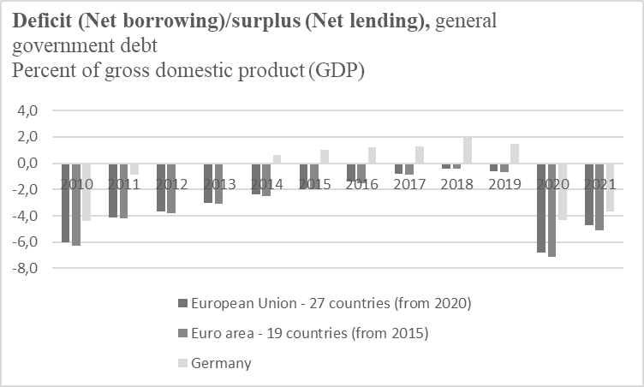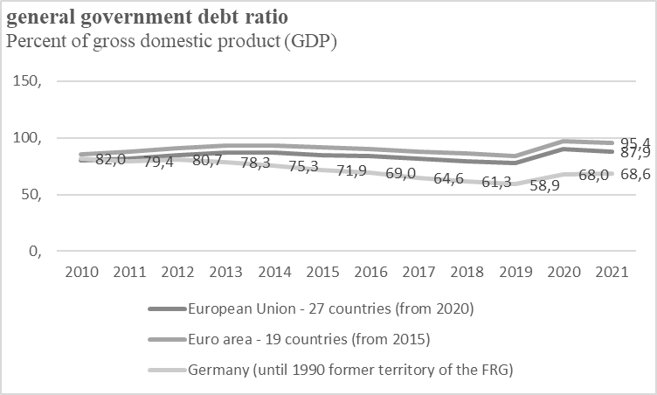

Source (both): Statistics Service of Eurostat ([Datenbank - Eurostat (europa.eu)](https://ec.europa.eu/eurostat/de/web/main/data/database)), own presentation

The positive economic development of recent years has been the starting point for the positive effect of public finances in Germany since 2010. The corona pandemic abruptly stopped this positive development (net credit deficit of -3,7% of GDP). The corona pandemic has led to significant expenses.

Figure no. 2: Expenditure of the most extensive five ministries in the federal budget by the department from 2017 to 2021 (values in billions of euros)

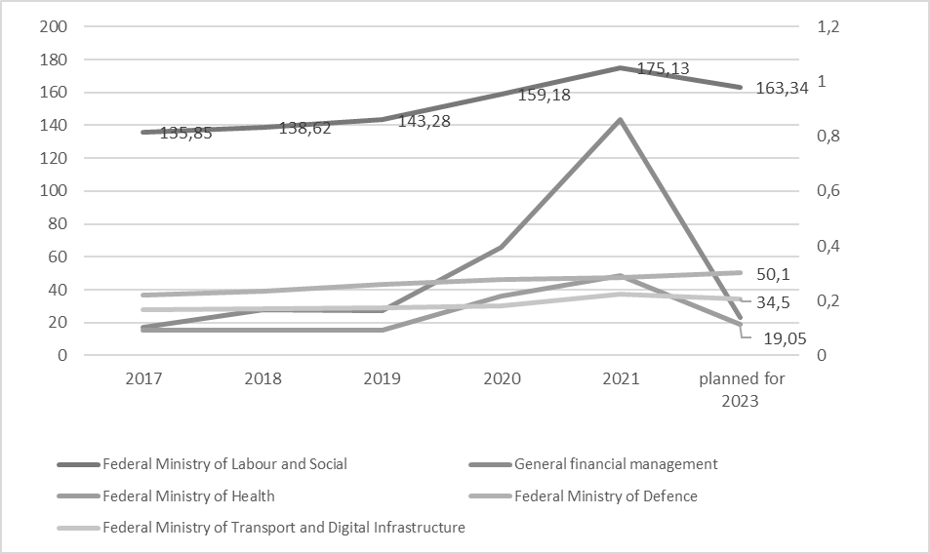

Source: Federal Ministry of Finance [Bundeshaushalt - Bundeshaushalt digital](https://www.bundeshaushalt.de/DE/Bundeshaushalt-digital/bundeshaushalt-digital.html), own presentation

The rash in the Ministry of General financial management line is very clearly due to Corona Business support (support is called “Corona Soforthilfen” and “Corona Überbrückungshilfen”). Another essential financial item under this line is the Energy and Climate Fund allocation. The focus below is on the ministry with the highest expenditure.

Before Corona and during Corona, the most significant expenditure was attributed to the Ministry of Labour and Social Affairs. However, most of the expenses went to Pension insurance and were subsidies for primary security in old age and the event of reduced earning capacity (72.5%). 26.29% of the ministry’s expenditure was on benefits under the Second and Third Books of the Social Code and similar benefits. That is financing the unemployed, who do not receive unemployment insurance benefits. This so-called basic security is different from the other unemployment system - unemployment insurance. Unemployment insurance is one of the social insurance. Contributions from employees and employers finance unemployment insurance. That means that support for the unemployed from this insurance is not visible in public finances. The Ministry of Labour and Social Affairs finances unemployment benefit II and active labour market policy services for this group. The Ministry of Labour and Social Affairs also subsidised the Federal Employment Agency during the Corona Crisis.

After the development of costs, the analysis of unemployment has been carried out since 2010. The unemployment rate has been declining since 2010 until the onset of the corona pandemic.

Figure no. 3: Development of gross public debt/per cent of gross domestic product (GDP) and unemployment rate in Germany as of 2010

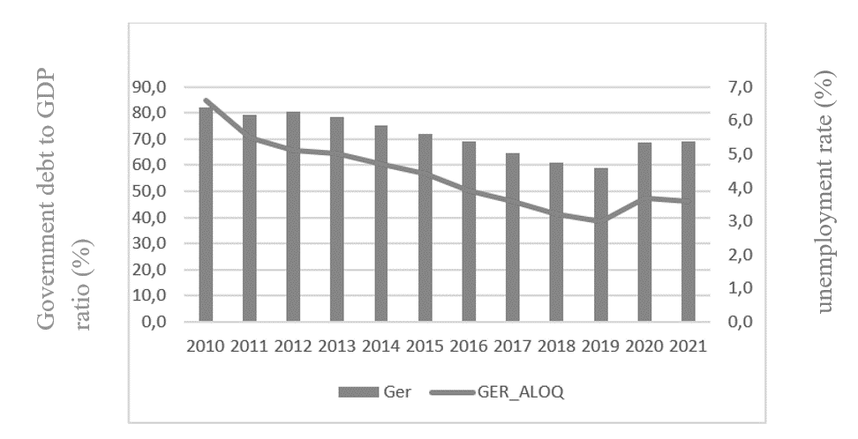

Source: Statistics Service of Eurostat, own presentation

The next step is to check whether the regression analysis model makes an explanatory contribution between the two parameters.

Figure no. 4: Explanation of the dependent variable “government debt/per cent of gross domestic product (GDP)” by the “Unemployment rate in Germany” as of 2010

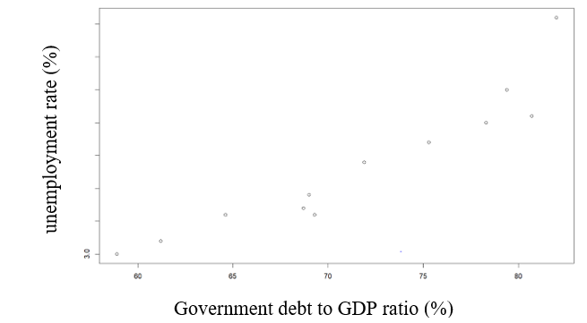

Source: Statistics Service of Eurostat, own presentation

The result of the analysis is that it can be proven that the development of unemployment explains the government debt of the state of Germany. That means when unemployment increases, the level of debt increases.

The IAB, Institute for Employment Research has published an article from the IAB Forum 12/2021. It analysed the costs of unemployment in 2020.

Figure no. 5: Impact of unemployment on overall fiscal costs- Total fiscal costs of unemployment in 2020 in Germany

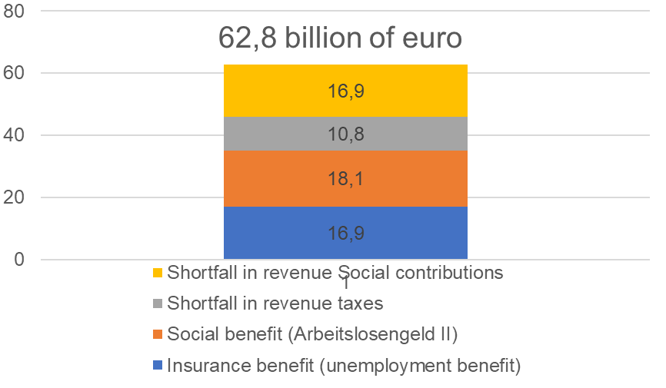

Source: Hausner et al.: Total fiscal costs of unemployment in 2021 in Germany, IAB-Forum 12/2021, own illustration

Of course, it has been proven that unemployment causes costs, but not insignificant is the loss of taxes and social security contributions. This shortfall leads to a lack of state revenue to balance the national budget - while at the same time, expenditure on support for the unemployed is rising.

Therefore, combating unemployment is and remains one of the most critical goals to positively influence public finances’ stability.

Recommendation and Conclusion

Recommendation related to unemployment

1.) Zika et al. identify risks for unemployment due to the energy crisis (Zika et al., 2022). The contribution rate is 2.4%; from 1 January 2023, the contribution rate will be back at 2.6%, and the Federal Agency plans to retain reserves of 2 billion euros from 2023 – these would not be sufficient if the energy crisis increases unemployment as estimated by the IAB. In this case, the Federal Agency will require a loan or grant that is attributed to public finances. The contribution rate for unemployment insurance should therefore be discussed politically.

2.) The lever is to reduce unemployment and hidden unemployment to reduce shortfalls in taxes and social security contributions. Indeed, the cost savings of reducing unemployment are becoming more and more difficult. Reducing the unemployment rate to 0% is theoretically possible but rather unlikely. Nevertheless, there are still starting points here, e.g. reducing the unemployment of particular groups of people, e.g. women after family periods or long-term unemployed women.

3.) Risk management is necessary to avoid unemployment. Active labour promotion develops anti-cyclically and stabilises the economy and the labour market (Hausner et al., 2021). That also includes the instrument of short-time work. However, the short-time allowance does not help in all crises (Weber et al., 2022). Another solution must be considered here, such as training and further education.

Related to the overall system

1.) Compliance with the debt brake is necessary after overcoming the crises, while at the same time, the composition of German government spending must be tested (Werding et al., 2020).

A system comparison with another European country Czech Republic, which has low unemployment, shows that the conditions for unemployment to support the unemployed differ in both the amount and duration of financial support: after the labour market is characterised by a shortage of skilled workers and peaks in vacancies, the duration of unemployment benefits should be put to the test.

2.) A comparison of the data from Eurostat “Government expenditure by function 2020 (% of total or GDP) shows that Germany has a higher share for social function than the EU or the Czech Republic, which means that the share is lower, e.g. for environmental protection, which is a risk for the Green Deal.

3.) by far, the most significant cost factor is pensions and essential security expenditure in old age – which approaches are available were not examined.

Conclusion

The state sets the framework conditions for the democratic coexistence of citizens and provides subsistence services. The development of unemployment explains the gross debt of the state of Germany. Further efforts are needed to ensure the stability of public finances. Compliance with the debt brake is necessary after overcoming the crises, while at the same time, the composition of German government spending must be put to the test (Werding et al., 2020). The recommendations on reducing unemployment and on the unemployment system can be a starting point for political discussion.

Literature

1. BAUER, Anja and WEBER, Enzo. COVID-19: how much unemployment was caused by the shutdown in Germany? *Applied Economics Letters.* Vol. 28, no.12, 2021. pp. 1053-1058. ISSN 1350-4851. Available at: https://doi.org/10.1080/13504851.2020.1789544
2. BLANKART, Charles B. *Öffentliche Finanzen in der Demokratie.* *Eine Einführung in die Finanzwissenschaft.* München: Vahlens Handbücher der Wirtschafts- und Sozialwissenschaften, 2017. ISBN: 978-3-8006-5347-8
3. Deutsche Bundesbank. 73. Jahrgang Nr. 5. *Monatsbericht Mai 2021*[online]. Deutsche Bundesbank, May 2021. [cit. 2022-09-23]. Available at: <https://www.bundesbank.de/resource/blob/866780/738ffabd4954debc0191af80ac21a468/mL/2021-05-oeffentliche-finanzen-data.pdf>
4. DONGES, Juergen B., EEKHOFF, Johann, FELD, Lars P., MÖWCHEL, Wernhard, NEUMANN, Manfred J. M. *Öffentliche Finanzen dauerhaft sanieren - in Deutschland und Europa*. Berlin: Stiftung Marktwirtschaft, 2010. ISBN 3-89015-111-6.
5. EUROPEAN COMMISSION. *European Economic Forecast: Spring 2021*. Luxembourg: Publications Office of the European Union, 2021. ISBN: 978-92-76-29720-8.
6. PRIESMEIER, Christoph. *Dynamic interactions between public finances and economic activity in Germany: time series perspectives on the sustainability, cyclicality, sensitivity and economic impact of fiscal policy*. Baden-Baden:Nomos, 2015. ISBN 978-3-8452-5198-1
7. WEBER, Enzo, a Karl Heinz ENGELHARD. Die Kosten der Arbeitslosigkeit sind 2020 um 11,5 Milliarden Euro gestiegen. *AIB-Forum: Das Magazin des Instituts für Arbeitsmarkt- und Berufsforschung* [online]. 28. 12. 2021. Available at: https://www.iab-forum.de/die-kosten-der-arbeitslosigkeit-sind-2020-um-115-milliarden-euro-gestiegen/
8. WEBER, Enzo and YILMAZ, Yasemin. Designing short-time work for mass use. *IAB-Forschungsbericht.* No. 202210, 2022. ISSN 2195-2655. Available at: DOI:10.48720/IAB.FB.2210EN
9. WERDING, Martin, GRÜNDLER, Klaus, LÄPPLE, Benjamin, LEHMANN, Robert, MOSLER, Martin and POTRAFKE, Niklas. Tragfähigkeit der öffentlichen Finanzen. Spielt sie noch eine Rolle? *Ifo-Schnelldienst.* Vol. 73, iss. 09, 2020. pp. 53-58. Available at: <https://www.ifo.de/DocDL/sd-2020-09-werding-etal-tragfaehigkeit.pdf>.
10. ZIKA, Gerd, SCHNEEMANN, Christian, WEBER, Enzo, ZENK, Johanna, KALINOWSKI, Michael, MAIER, Tobias and WOLTER, Marc Ingo. Die Folgen des Kriegs in der Ukraine und der Energiekrise für Wirtschaft und Arbeitsmarkt in Deutschland*.*  *IAB-Forschungsbericht.* No. 202211, 2022. ISSN 2195-2655. Available at: DOI:10.48720/IAB.FB.2211

Contact

Katrin Steyer

University of Finance and Administration

Siedlung 16a, 08340 Schwarzenberg

Germany

e-mail: katrin.steyer.szb@gmail.com

Dennis C. Tale  
A comparison of the pension systems of Germany and Austria

Abstract

A comparison of the pension systems in Germany and Austria can be interesting for Czech academics and politicians who want to push through a fundamental pension reform. In Germany and Austria, the governments initiated a trend towards later retirement with the measures they introduced at the beginning of the century. Despite the drastic reduction in the benefits of their public pension systems since the early 2000s, Germany and Austria support later retirement to maintain the viability of their pension systems. This paper focuses on the basic structure of these two interesting pension systems and their main parameters that influence their adequacy and sustainability.

Keywords

Pension system, Austria, Germany, Pensioners

JEL Classifications

H55, J26

Introduction

Many welfare states in Europe have changed their policies from permitting and encouraging older workers to retire before the mandatory retirement age to decreasing the incentives to do so by enacting different policy measures (Hinrichs, 2000; Ebbinghaus, 2011). This policy reform, which mostly came into force in the 1980s, is the product of evolving sociocultural conditions. Austrian labor market policies forced older workers to retire early in order to reduce pressure on the labor market after facing greater unemployment as a result of the oil crisis in the 1970s (Obinger and Talos, 2010). Welfare states face a difficulty in reforming their pension systems to endure demographic ageing and remain sustainable over the long term due to a rising number of older persons aged 50 and above in the populations of industrialized nations, low labor market participation rates, and low fertility rates (Schmidthuber et al,. 2016). This is addressed by a variety of measures, from changes to the statutory retirement age, the elimination of early retirement options, and the reduction of public pension benefits to active labor market policies that encourage firms to take on older employees (Hofäcker and Naumann, 2015); (Christl and Kucsera, 2016). Lower pension benefits, unusual kinds of labor, and gaps between jobs all have an impact on income in old age, according to the literature (Mayrhuber et al., 2019; Möhring, 2015; Bäcker, 2018; OECD, 2019). Since the early 2000s, Germany and Austria have experienced an increase in the proportion of persons working over the age of 65 (Eurostat 2020, 2022).

Germany and Austria are more than just neighboring nations. The economic and social structures of both counties are similar. The pension system is among these similarities. In both nations, a public, pay-as-you-go social insurance system is at the heart of old-age support, with benefits reflecting previous life pathways, particularly working lives (Blank et al., 2021).

The Austrian laws that are in effect there have frequently been mentioned in recent years discussions about German pension policy (Haan and Schaller, 2021; Geyer et al., 2021). Comparing the two nations can aid in determining what can be achieved using social insurance as a tool, as well as identifying potential for reform and political scope for action. Comparing the two nations can also assist put alleged limitations into perspective and examine and reflect on presumptions about what is fair and proper and what functions in each country. The comparison may also be used as a form of experimental setup. For example, what would happen if one adjustment screw was moved in either direction (Blank et al., 2021)?

The comparison between the two nations is particularly fascinating since it demonstrates that one need not reinvent one's pension system from scratch when learning from one's neighbor. By comparing the two, it is possible to find methods to improve the current system. It is particularly relevant from a German viewpoint to observe that a much more efficient pension system is conceivable without causing an adverse impact on the economy (Blank et al., 2016).

1. German pension system

The existing multi-pillar concept is the foundation of the German pension system and is shown below.

Table no. 1 - German Pension Pillars and Tiers

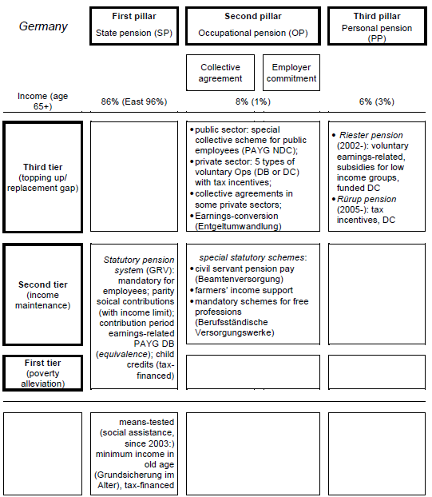

Source: Mayer, 2020

The approach focuses on individual retirement savings plans, with the state pension (first pillar) acting as a mechanism to reduce poverty (Ebbinghaus et al., 2011). The German state pension accounts for around 86% of retirement income, as stated above in Table 1. The state pension has been increased to include new professions as well as individuals who work only a few hours per week, dubbed "mini-jobbers" (Bäcker, 2018). 83,8% of the whole work force that was dependant was covered by the statutory pension in 2018. Benefits have been reduced over the last 20 years, leaving the gross ratio at 46% of lifetime earnings (Bäcker, 2018). The decreased earning capacity pension criteria have been strengthened, while others have been altered. Old age pension for extended insurance periods can be utilized from 63 years but only with deductions, for example) (Bäcker, 2018). As long as insurance-legal conditions are met, the insured may choose to retire from the statutory pension either early with deductions or at the usual retirement age, which will eventually rise to 67 years old by 2029 (Schmitz-Kießler, 2019). There are not just deductions when using early retirement, but there is also an earnings restriction. Another option for retiring early was provided in 2017 with the flexibilization of the transition into retirement by receiving a portion of the pension benefits, the so-called partial pension, before the statutory retirement age while remaining in the job market (Bäcker, 2018). There are no adverse impacts on an individual's public pension benefits by working above the statutory retirement age, and there are no further earnings caps (Schmitz-Kießler, 2019).

For those with a decreased earning ability, the German statutory pension system offers two pension routes, which are the full and partial earning capacity pensions (Bäcker, 2018). These have extra earnings constraints as well (Schmitz-Kießler, 2019).

Occupational pensions have grown massively in the twenty-first century. Employers who implement an occupational pension program, for example, enjoy tax breaks. The vesting time for employees to switch firms and maintain their accrued pension benefits has been steadily eliminated. Employees who have worked for the same firm for three years and are at least 21 years old can now transfer their accrued occupational pension benefit to a new employer (ibid).

Private pension systems such as the Riester and Rürup pensions have been improved to make them more consumer friendly (ibid.). Deferred compensation, for example, is now permanent. The cost of switching private pension plans is capped at 150€. (ibid.). Additionally, the Riester pension can be tapped for accumulated funds for real estate investment (ibid.).

After taking a short look at the history of the pension, more specifically the latest policy changes and status quo in Germany the author will now focus on Austria as Austria is quite often discussed as a role model for Germany.

Minimum pension levels have been reduced since the millenium, with the objective of maintaining contribution rates around 20% until 2020 (Mayer, 2020). Following the archetypal Riester reform, subsequent changes have focused on early retirement (Hofäcker and Naumann, 2015). Starting in July 2005, the minimum age for receiving an old age pension owing to unemployment was raised from 60 to 63 years old (Bäcker, 2018). The statutory regular pensionable age was raised in 2012 (Bäcker, 2018). The mandatory retirement age will increase to 67 years old in 2029. Deductions of up to 14.4% have been granted to all early retirement programs (Bäcker, 2018). Additionally, the minimum retirement age for those with lengthy contribution histories has been raised to 63 years (Bäcker, 2018). Beneficiaries who are 50 years of age or older can contribute more to the public pension as of 2017 (Bäcker, 2018).

Furthermore, Germany has established policies to boost employment in old age (50+ years), such as offering additional training allowances for older persons and awarding incentives to enterprises who hire previously jobless older adults (Bäcker, 2018).

Since 2001, there are now two different pension entitlements for people receiving invalidity benefits.

1. For individuals who are unable to work three hours per day (full pension due to diminished earning capacity)
2. For individuals who can work three to six hours per day (pension for half of one's earning capacity) (Bäcker, 2018).

In 2012, the minimum age to be eligible was raised from 63 to 65 without deductions. Utilizing this retirement option prior to turning 65 entails maximum 10.8% withdrawals from the individual pension (Bäcker, 2018).

Germany implemented a new retirement route in 2017 (Bundesministerium für Arbeit und Soziales, 2020) to make the transition from productive job to retirement simpler. This new retirement option allows recipients to cut their work hours before reaching the statutory pension age and earn a portion of their pension payments early. Additionally, voluntary occupational pensions have undergone change (Mayer, 2020).

As of 2002, beneficiaries had to have worked for a single employer (30 years of age) for a minimum of 5 years before their occupational pension rights become vested (Bäcker, 2018). As of 2005, pension benefits might be transferred to a new employer (Bäcker, 2018). This has been changed such that a person's benefits now vest after three years with the same job and a minimum age of 21. (Bäcker, 2018).

2. Austrian pension system

The existing multi-pillar concept is the basis of the Austrian pension system and is presented below.

Table no 2 - Austrian Pension Pillars and Tiers

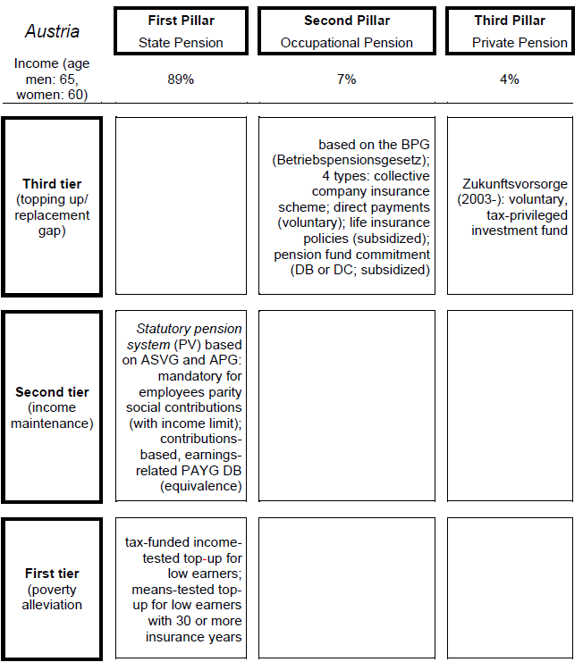

Source: Mayer, 2020

In Austria, the state pension system is by far the most significant source of retirement income for older people. As shown in table 2, the public pension accounts for around 89% of retirees income. Yet income from occupational and private pensions accounts for less than 10%. Currently, the public pension attempts to provide a fair quality of living from wages earned throughout one's working life. Due to its generosity, the Austrian pension system perfectly illustrates how state pensions swamp out alternative sources of pension earnings (Mayer, 2020).

Following the FPÖ-ÖVP partnership, a new Grand Coalition took office and implemented a minimum wage and a means-tested basic income. In order to better safeguard residents who work in new occupations, such as quasi-freelancing, pension benefits were increased once again (Bundeskanzleramt, 2007).

The decision to let the Langzeitversichertenrente (a route to early retirement based on a long insurance record) expire in 2017 was made in 2016 (BMASK, 2016). Prior to that, eligibility requirements were strengthened. This gradually raised the earliest retirement age for males from 60 to 62 and for females from 57 to 62. (BMASK, 2016).

Prior credited periods for the personal pension account were transformed in 2014 to become a beginning credit for all pension accounts. This was done to simplify and make public pension calculations more transparent for the general public.

Additionally, the eligibility requirements for invalidity payments have been strengthened. The right to pay for rehabilitative measures has taken the role of the temporary invalidity pension retirement path, which has expired. However, the indefinite invalidity pension is still in place.

Currently, the Austrian pension system uses a personal pension account and complies with the General Pensions Act. Own pensions and survivor's pensions are the two main categories of pension benefits offered by the Austrian public pension system. Only the personal pensions will be discussed in further depth below.

According to BMAGSK (2018), own pensions include the standard old-age pension, early retirement pension based on long-term insurance contributions, corridor pensions, manual labor pensions, and invalidity or occupational disability pensions (Mayer, 2020).

When a person reaches the statutory pension age, which is 65 for males and 60 for females, they are eligible to receive regular old-age benefits. Starting in 2024, the retirement age for women will be gradually raised to 65, reaching 65 in 2033. The minimum number of contribution months required to qualify for pension benefits is 180, or 15 years, according to the Ministry of Social Affairs (Mayer, 2020). 7 of these 15 years must be spent in productive employment. The General Pensions Act, which offers the personal pensions account, is applicable to claimants born after January 1, 1955. Additionally, times of unpaid caregiving labor can be taken into account when calculating pension contributions, and periods of education can be purchased and used toward a voluntary pension plan's contribution periods (Mayer, 2020).

Men who have gathered 45 contribution years can request early retirement on the basis of long-term insurance contributions (Hacklerregelung), which allows them to retire at the age of 62 without abductions. Women are exempt from this.

According to the theory behind corridor pensions (Korridorpensionen), claimants (male) are eligible for an early retirement at age 62 if they have amassed at least 40 years of insurance. Deductions amount to 5.1% each year of early retirement or 0.425% per month. Deductions are subject to a 15.3% maximum (Mayer, 2020). Women are exempt from this.

Workers who undertake physically difficult work can retire at the age of 60 thanks to manual labor pensions (Schwerarbeiterrente). A minimum of 10 of the previous 20 years must have been spent in physically demanding job, with a minimum insurance duration of 45 years. Deductions range from 4.2% each year to 13.8% at most (Mayer, 2020).

Only when a person is determined to have a permanent handicap or be unable of working is the new invalidity pension plan (Invaliditätsrente) granted. This kind of public pension intends to lower the number of invalidity pensions and aid workers who are experiencing health problems in returning to the workforce. Regional health insurance funds will pay for medical care and rehabilitation for those who are temporarily critically ill (BMAGSK, 2018).

3. Comparsion

After comparing the German and the Austrian pension systems, it can be seen that the structure of the pillars and tiers is the same. However, differences arise in the retirement age, benefits, occupational pensions as well as possibilities for private old-age provision.

In Germany, the first pillar includes, within the framework of the state pension, benefits for income protection and poverty reduction. In addition, the second pillar covers supplementary or replacement pensions under occupational pensions, additional benefits through collective agreement or employer commitment by employees. Furthermore, the second pillar covers some pensions for income maintenance on the second floor. Finally, private pensions can be built up in the third pillar with the Riester pension or Rürup pension.

The Austrian pension system, on the other hand, offers separate benefits for income security and poverty reduction in the first pillar of the state pension. There are no collective agreements or employer commitments for the supplementary occupational pension. There are also no separate pensions in the second pillar compared to Germany.

If one looks at recent developments in the pension systems, it becomes clear that the retirement age and pension level have essentially been harmonised.

With regard to the actual pension benefits, the comparison shows that the Austrian pension insurance provides considerably more benefits than the German pension insurance. This becomes clear when comparing the average pension payments. The following two tables show the gross payment amounts of the German and Austrian pension insurance pensions for non-self-employed persons in 2019. Table 3 shows the average gross monthly pensions in Germany and Austria in 2019 for existing pensioners, while Table 4 shows the average gross monthly pensions in Germany and Austria in 2019 for new, additional pensioners. As there are 14 pension payments per year in Austria, the amounts are converted to 12 months so that a comparison with Germany is possible. The two tables are broken down in euros by pension type and gender.

Table no. 3 - Average gross monthly pensions in Germany and Austria in 2019 - Existing Pensioners

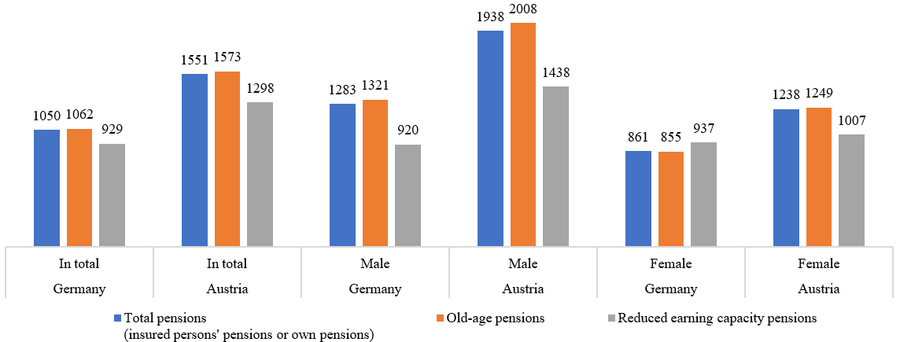

Source: Blank et al., 2021

Table no. 4 - Average gross monthly pensions in Germany and Austria in 2019 - New Pensioners

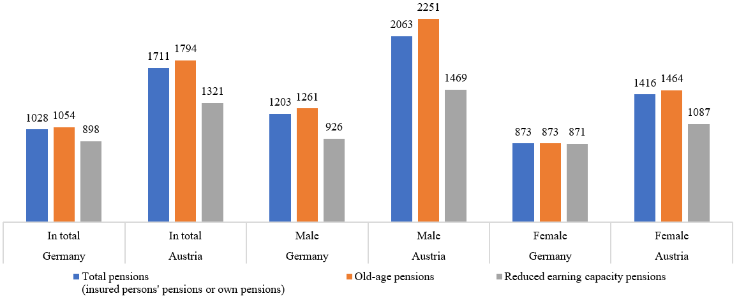

Source: Blank et al., 2021

The two tables do, however, also highlight a similarity between the two nations. Men enjoy much greater benefits than women. This reflects the historical and ongoing division of labor, which results in different rates of labor force participation between the sexes, with men's labor force integration in both countries being significantly better and associated with higher contribution payments and longer contribution payment phases (Dessimirova and Bustamante 2019).

There are clear disparities across nations in present pension payouts. OECD projections, which use the current legal position as a starting point for evaluating future benefits for persons with comparable job histories, indicate that the Austrian system is far more generous (OECD 2019). Under the current legislative framework, these forecasts also imply a further decline in the benefit level of the German pension insurance system in the future. For more differentiated and up-to-date comparisons, the OECD estimates can serve as the foundation (Blank/Türk 2021).

The outcome of calculations using the OECD models is shown in Figure 1. The gross replacement rates for persons entering the labor market in 2063 are displayed here with half, one and one and a half times average earnings. What becomes visible here is not only that the public system in Austria offers significantly higher replacement rates, but also the effect of the equivalence principle. This leads to largely uniform replacement rates across income groups within countries (Blank et al.,2021).

Figure no. 1 - Projected gross replacement rates as a percentage at the start of the 2018 occupation

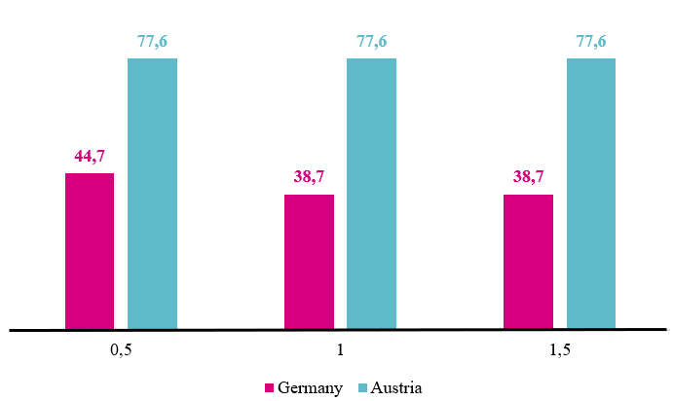

Source: Blank et al., 2021

Finally, a comparison of ratios reflecting the system's benefit core shows that Austria has a significant advantage. If, as in Austria, we examine what pension flows from contributions (relative pension entitlements), we discover that this entitlement is much larger in 2018 in the Austrian pension account system, at 1.72 percent of gross income, than in Germany, at 0.99 percent (Blank et al., 2021). If the OECD's estimate of diminishing pension levels is implemented, the entitlement in Germany, for individuals who start a career in 2018 decreases to 0.86 percent (Blank et al. 2021). In other words, a contribution payment on a contributed yearly income of 30,000 euros in Austria leads in a monthly pension entitlement of roughly 43 euros, whereas the entitlement in Germany is just around 25 euros, and this value still reduces to just under 22 euros per month over time (Blank et al. 2021).

4. Conclusion

The Austrian pension system makes a compelling case for being adopted by Germany. The Austrian system, like the German one, is the outcome of a decades-long series of individual choices, some of which have been overturned, as well as cutbacks. The Austrian transition to an employment insurance system, for example, is the culmination of a process that began in the postwar period. Many elements influence the respective evolution, including various party-political power linkages and state-association interactions.

Proposals for transfer should include consider system flaws and contentious issues in both systems. As a result of the equivalence principle, both nations have a significant gender pension discrepancy.

The warning against directly transferring the Austrian system is not intended to imply that there are no lessons to be learned for Germany, especially since demands for employment insurance, strengthening the statutory pension, and improved minimum security have long been raised in the political arena. And, following careful consideration and prioritization of pension policy goals, the Austrian system may, of course, contribute to further develop the German system's aims as well as its means.

First and foremost, the comparison demonstrates the options and room that may be exploited especially with the social insurance instrument. This includes, but is not limited to, the amount of benefits. If approved, pension insurance can give higher benefits than in Germany!

The analogy might also prompt thought about one's personal views on justice. Performance equity was a major topic of discussion during the basic pension debate in Germany. The basic pension is meant to help people who, despite putting in a lot of time at work, only earn a little income when calculated in terms of periods of pensionable service. They shouldn't, however, fare any better than others who have worked more diligently. The Austrian equalization supplement is not very equitable in this regard as it raises low (pension) incomes to a flat rate regardless of how well the prior work was done.

Bibliography

1. BÄCKER, Gerhard.Alterssicherung in Deutschland. In. Schroeter, Klaus R., Vogel Claudia and Harald Künemund (ed). *Handbuch Soziologie des Alter(n)s.* Wiesbaden: Springer Fachmedien Wiesbaden, 2018. ISBN: 978-3-658-09486-7.
2. BLANK, Florian and TÜRK, Erik. Altersrenten und sozialer Ausgleich in Deutschland und Österreich – Ein Vergleich anhand von Modellrechnungen. *Sozialer Fortschritt.* Vol. 71, iss. 2, 2022. pp. 139–163. ISSN 1865-5386. Available at: https://doi.org/10.3790/sfo.71.2.139
3. BLANK, Florian, LOGEAY, Camille, TÜRK, Erik, WÖSS, Josef and ZWIENER, Rudolf . Renten in Deutschland und Österreich: Fragen und Antworten. *WSI Policy Brief.* Vol. 64, 2021. ISSN 2366-9527
4. BUNDESKANZLERAMT. Regierungsprogramm 2007 - 2010. Regierungsprogramm für die XXIII. Gesetzgebungsperiode. Wien, 2007.
5. Teilrente In: *Rentenlexikon* [online]. Bundesministerium Für Arbeit und Soziales, 2020. [cit. 2022-10-26] Available at: <https://www.bmas.de/DE/Themen/Rente/Rentenlexikon/Functions/glossar.html;jsessionid=A0290D41021A4F2780ECCC8E38FB1F47?cms_lv2=75204&cms_lv3=85896#glossar85896>
6. CHRISTL, Michael and KUCSERA, Dénes.Actuarial neutrality and financial incentives for early retirement in the Austrian pension system. *Agenda Austria Working Paper*, No. 01, 2016.
7. DESSIMIROVA, Denisa and BUSTAMENTE, Maria A.*The Gender Gap in Pensions in the EU* [online]. Policy Department for Economic, Scientific and Quality of Life Policies Directorate-General for Internal Policies, 2019. [cit. 2022-10-26]. Available at: https://www.europarl.europa.eu/RegData/etudes/BRIE/2019/631033/IPOL_BRI(2019)631033_EN.pdf.
8. EBBINGHAUS, Bernhard.*The varieties of pension governance. Pension privatization in Europe.* Oxford: Oxford University Press, 2011. ISBN: 9780199586028
9. EUROSTAT*. Ageing Europe - statistics on pensions, income and expenditure: The risk of poverty among older people.* [online] 2020. [cit. 2022-10-26]. Available at: <https://ec.europa.eu/eurostat/statistics-explained/index.php?title=Ageing_Europe_-_statistics_on_pensions,_income_and_expenditure#Pensions>.
10. EUROSTAT**.** *Employment rates by sex, age and citizenship (%).*[online]. 2022. [cit. 2022-10-26]. Available at: <http://appsso.eurostat.ec.europa.eu/nui/show.do?dataset=lfsa_ergan&lang=en>.
11. FEDERAL MINISTRY OF LABOUR, SOCIAL AFFAIRS AND CONSUMER PROTECTION (BMASK). *The Austrian welfare state. Benefits, expenditure and financing 2016*. Vienna, 2016.
12. FEDERAL MINISTRY OF LABOUR, SOCIAL AFFAIRS, HEALTH, AND CONSUMER PROTECTION (BMAGSK).*Fundamentals of the Austrian Pensions System. For 2018 - Summary*. Vienna, 2018.
13. GEYER, Johannes, HAAN, Peter and LUDWIG, Alexander.Mindestrente: Absicherung gegen Altersarmut und notwendiger Baustein für weitere Reformen. *DIW aktuell.* No. 72, 2021. Deutsches Institut für Wirtschaftsforschung (DIW), Berlin.
14. HAAN, Peter and SCHALLER, Maximilian. *Heterogene Lebenserwartung*. Berlin: Deutsches Institut für Wirtschaftsforschung (DIW), 2021. ISBN 978-3-946417-62-0.
15. HINRICHS, Karl. Elephants on the move. Patterns of public pension reform in OECD countries. *European Review Cambridge University Press.* Vol. 8, no. 3, 2000. pp. 353-378. Available at: DOI: 10.1017/S1062798700004956
16. HOFÄCKER, Dirk and NAUMANN, Elias.The emerging trend of work beyond retirement age in Germany: Increasing social inequality? Zeitschrift für Gerontologie und Geriatrie. Vol. 48, no. 5, 2015. pp.473‑479. ISSN: 0948-6704. Available at: [https://doi.org/10.1007/s00391-014-0669-y](https://psycnet.apa.org/doi/10.1007/s00391-014-0669-y).
17. MAYER, Thomas*.**Who works beyond the retirement age and why?**A comparison between Austria and Germany with a focus on pension levels and institutional early retirement incentives.* Finland, 2020. Tampere University.
18. MAYRHUBER, Christine, BADELT, Christoph and BRUNNER, Anna.Durchrechnung in der Pensionsversicherung: Langfristige Implikationen. *Wirtschaft und Gesellschaft - WuG.* Vol. 45, no. 3, 2019. pp. 349-366. ISSN 0378-5130.
19. MÖHRING, Katja. Employment Histories and Pension Incomes in Europe: A multilevel analysis of the role of institutional factors. *European Societies*. Vol. 17 no. 1, 2015. pp. 3-26. Available at: DOI: 10.1080/14616696.2014.934874
20. OBINGER, Herbert and TALOS, Emmerich.Janus-Faced Developments in a Prototypical Bismarckian Welfare State: Welfare Reforms in Austria since the 1970s. In Palier, Bruno (ed.). *A long goodbye to Bismarck? the politics of welfare reforms in continental Europe. Changing welfare states*. Amsterdam: Amsterdam University Press, 2010.  
    ISBN 908964234X
21. OECD.*Pensions at a glance 2019: Key findings for Germany*. [online] 2019‑11‑27. [cit. 2022-10-26]. Available at: https://www.oecd.org/germany/PAG2019-DEU.pdf
22. SCHMIDTHUBER, Lisa, SCHRÖDER, Heike and PANZENBÖCK, Edmund.Retirement Determinants in Austria: An Aging Society but a Hesitant Policymaker!? In Hofäcker, Dirk, Hess, Moritz and König, Stefanie (ed.) *Delaying retirement: progress and challenges of active ageing in Europe, the United States and Japan*. London: Palgrave Macmillan, 2016. ISBN 978-1-137-56696-6
23. SCHMITZ-KIESSLER, Jutta.*Erwerbstätigkeit trotz Rente? Zum Bestand, den Motiven, und der sozialpolitischen Einordnung von erwerbstätigen Rentnerinnen und Rentnern*. Duisburg, 2019. Dissertation. Universität Duisburg-Essen.

Contact

Dennis C. Tale, LL.M.

Söby 22

24364 Holzdorf

Germany

Dennis.Tale@web.de

Jan Vogt  
Peculiarities in Accounting: The difficulties between recording past transactions and forward looking estimates and the transmission of value through IFRS balance sheets

Abstract

This paper discusses the relevance of accounting from the investor's perspective focusing on "value". It first explains the key basic concepts of accounting - fair value accounting vs. historical cost - and thus frames the conflict between recording past transactions reliably vs. providing fair values based on future estimates. Based on the differences of market and book values of equity in combination with (at least in parts) inconsistent rules in accounting, challenges regarding systemic transparency on value are discussed. Accounting lost significant ground regarding the relevance of information in the context of decision-making for investors mostly because defining significant value sitting in intangibles as out of scope.

Keywords

Accounting, Valuation, Book Value, Market Value, Fair Value

JEL classification

M41, G30, G32

Introduction

The earliest “commercial recordkeeping” dates back to roughly 5,000 to 7,000 years ago and can be located in the valley of Mesopotamia (Keister, 1963), while the first and most influential text on today’s double-entry bookkeeping[14] was published by the Franciscan monk and mathematician Pacioli in 1494 (Carruthers and Espeland, 1991). Therewith, accountants would fulfill the role Damodaran a.k.a. “Wallstreet’s Dean of Valuation” (CNBC, 2017) concedes them: Check transactions, record them in a consistent manner and report the results in a standardized form. Accordingly, financial statements should answer the following three key questions (Damodaran, 2020):

* What do you own?
* What do you owe?
* How much money did you make?

Performing financial accounting in that direction, associations of public accountants that certified “qualified” accountants were formed in the UK in the late 1800s which spread internationally (Richardson, 2017). After the first world war a distinct discipline evolved: Management accounting. Reflecting the importance of operational efficiency management accounting focuses on the decision needs of managers (Richardson, 2017).

Already in the year 1949, Coleman stated in his article regarding the role of accounting in management that “[t]he historic cost figure of an asset often bears little relation to its current value and hence is of limited use to management.” (Coleman, 1949).

Accordingly, in 1962 with the publication of so called Accounting Research Study 3 (ARS3) issued by the Accounting Principles Board (APB)[15] a modern era of accounting that considers changes in the value of assets (amongst others by price level changes) was born (Emerson et al., 2010).

To deal with either “recording transactions”, or reflecting changes in value and thus portraying “up-to-date information”, accounting offers two fundamentally different concepts: Historical cost accounting (HCA) where the book value of an asset is determined by historical transactions and a defined depreciation mechanics, or fair value accounting (FVA) where current prices determine the book value of an asset. In case quoted prices in an active market are available those determine the book value of an asset, otherwise it is determined by substitutes like prices of inactive markets or model-based prices that take actual market information into account (Laux and Leuz, 2009). Conceptually the decision between HCA and FVA is a positioning between reliance and relevance (Laux and Leuz, 2009).

The standard setter in the US, the FASB focuses within its mission on “investors and other users of financial reports“ (FASB, 2020) while the international standard setter, the IASB, defines in its conceptual framework the primary users of financial statements as ‘present and potential investors, lenders and other creditors’ – opposed to an earlier version that additionally included customers, governments and their agencies and the public (IFRS Foundation, 2022C).

Focusing on the investing community, the path of relevance and thus, fair value accounting had been followed. Financial reporting became more future-oriented and investor focused. Thereby, assumptions underlying budgeting and operational planning have become inputs to financial accounting policies and estimates. Management accounting and financial accounting lost their borderline (Richardson, 2017).

In result, a complex accounting regime evolved that does not consistently apply certain rules for the valuation of assets or liabilities. It rather requires to put assets and liabilities in boxes for which varying accounting mechanics apply. Regarding IFRS, a mix of old Internal Accounting Standards (IAS) and new International Financial Reporting Standards (IFRS) is existent. Taking it altogether, it is at least questionable whether the respective rules and regulations fulfill the objectives that the IASB defines in its mission statement: Transparency, accountability and efficiency [10,11]. Accordingly, the IFRS foundation published on its website that “[t]he notes in financial statements sometimes include too little relevant information, too much irrelevant information and information disclosed ineffectively. Stakeholders say this typically occurs when the requirements in IFRS Standards are treated like a checklist without applying effective judgement.” (IFRS Foundation, 2022).

To address those points the IASB has developed an Exposure Draft “Disclosure Requirements in IFRS Standards – A Pilot Approach” that was open for comment until 12 January, 2022. Basically, that new approach (that was tested on two standards IFRS 13 Fair Value Measurement and IAS 19 Employee Benefits) gives greater prominence to the objective of disclosure requirements and requires companies to apply judgement and provide information to meet described investor needs. The disclosure requirements of particular items is minimized to help companies to focus on material information (IFRS Foundation, 2022).

Whether that approach helps or not is to be seen. Particularly for regulators that need information foremost in critical situations, this new reporting approach might be tricky, as managers might have a tendency not to report if the situation is really bad (Gebhardt and Novotny-Farkas, 2011; Baker & Wurgler, 2013).

Given the opacity, the lacking coherence and the complexity of current accounting mechanics, the aim of the contribution is to highlight conspicuous features of IFRS rules and regulations that determine value and its transmission through accounting balance sheets when consecutive ownership structures are considered.

1 Systemic transparency on value

As first starting point on the topic whether accounting balances[16] reflect fair value the equity value is considered. On the one hand side, the accounting interpretation of equity value, the book value of equity, as the resulting position of assets and liabilities encompasses the measurement effects of all line items. On the other hand side, for publicly listed companies capital markets provide a reasonable benchmark, the market value of equity (market capitalization).

This approach can further be justified, as IFRS (and US-GAAP) define fair value in the following way: “Quoted prices (unadjusted) in active markets for identical assets or liabilities that the entity can access at the measurement date” represent so called “Level 1 inputs” according to IFRS 13-76, while “inputs other than quoted prices included within level 1 that are observable for the asset or liability either directly or indirectly” are labelled Level 2 inputs (IFRS 13-81), and unobservable inputs that “should reflect the assumptions that market participants would use when pricing the asset or liability […]” are named Level 3 inputs (IFRS 13-86,87). As fair value the best input following the “fair value hierarchy” – i.e. Level 1 inputs are preferred to level 2 and Level 2 are preferred to Level 3 inputs – according to IFRS 13-72 have to be used.

Comparing the market value of equity to the book value of equity (Price-to-Book ratio, a.k.a. Market-to-Book ratio) a strongly skewed distribution towards higher ratios is obtained (see Appendix), indicating that either markets significantly overestimate equity values and/or that book values – although IFRS/USGAAP strived for fair value – underestimate fair values, at least in the aggregate all-encompassing equity position.

For all publicly listed firms in Europe (20,696) an analysis by industry reveals that in January 2022 only 9 out of 96 industries reflecting 597 firms exhibit an average Price-to-Book ratio (PTB) of below 1.0 (see Appendix). The largest average industry PTB in Europe of 17.9 (based on 21 companies) is obtained for semiconductor equipment, while for the U.S. computer/peripherals reveal 26.3 as largest industry PTB. Other very high PTBs can be found in software, information services, recreation, health care, and environmental related industries. For those industries intangible assets are key that – as it will be seen later on – might not fully be reflected in balance sheets on a fair value basis.

A hand-selected analysis of the most valuable companies from the capital market’s perspective for the selective industries technology, automotive, banks and insurance betrays similar findings (see Figure 1): “Hot companies”, i.e. technology firms exhibit very large PTBs. SAP as Germany’s most valuable tech company accounts for 5.1, Meta/Facebook 7.4, Alphabet/Google 8.7, Microsoft 14.3, Amazon 26.6 and Apple for 38.3. Not less remarkable Tesla with 30.0, while all other top automotive firms exhibit a bandwidth of PTBs between 0.8 and 1.3. In general, the market capitalization of financial service firms is relative to “hot companies” much closer to the book value of equity, although particularly in Insurance there are players that exhibit a PTB of 2.4 (Anthem) and 4.7 (United Health), respectively.

Interesting to note is the ratio of goodwill to equity on a book value basis. Among the selected companies, United Health shows a goodwill that is even 4% above its equity value, followed by SAP with 92%, as the firm with the second largest share of goodwill to equity. Besides Volkswagen the top automotive firms do not possess significant goodwill in their balance sheets, while the tech firms do so. However, Apple as most valuable company overall and Tesla as most valuable company in automotive do materially contain no goodwill in their balance sheets. The diverging situation of value and goodwill leads to the question what information regarding value is contained in goodwill. Particularly, since “companies are allowed only to recognize goodwill from acquisitions; internally generated goodwill may not be recognized because it is considered to be too difficult to identify and to measure [.Further] Goodwill from acquisitions is an important balance sheet item; in many cases it is the single largest item on companies’ balance sheets” (Boennen, 2014).

It can be summarized that it is at least somehow justifiable when Damodaran is challenging the accounting perspective on “fair value” by provokingly stating (Damodaran, 2015): “*A new world order: Accountants as the final arbiters of value!! There are some (accountants, theorists and others) who believe that it is possible to replace the current accountant balance sheet with one that reflects the true value of the company. In their vision, investors would not look at the market to assess the fair value of a company but at accounting statements.”*

He further brings up three ways of thinking about fair value accounting (Damodaran, 2015), that will be picked up and assessed in the summary of this paper:

* *The Dreamer: To make accounting value (book value) a reasonable measure of the true value of a company.*
* *The Pragmatist: If we mark assets up to fair value, investors will have a better idea of what a firm is worth and there should be therefore less uncertainty about the true value and lower variance in that value.*
* *The Marginalist: Fair value accounting, even if imperfect and noisy, will provide investors with useful additional information which they can use to estimate value in a company or assess its risk.*

Besides the measurement of (economic) value, the diffusion process of value through balance sheets of firms within an economy is key for systematic transparency on value. Figure 2 displays how changes in economic value of a publicly listed, stylized firm (investee) affect the balance sheets of firms that are invested (investor) based on their respective business model and stake. The situation in which the investor controls the investee (IFRS 10-2,5-7) that results in consolidated financial statements (IFRS 10-1) is not regarded.[17] At the initial stage it is assumed that the book value of assets (100.0) and equity (30.0) as well as debt (70.0) are in line with the respective market values. Further it is assumed that the “true economic value” is reflected in market values. In a second stage a positive (negative) event occurs that changes the market value of total assets to 120 (80), the respective value market value of equity to 49 (25) and debt to 71(55). According to IFRS 9-4.1.4 financial assets “shall be measured at fair value through profit or loss unless […] measured at amortised cost in accordance with paragraph 4.1.2 or at fair value through other comprehensive income in accordance with paragraph 4.1.2A”. Thereby, equity investments have to be measured at fair value since IFRS 9-4.1.2 excludes only financial assets with “contractual terms [that] give rise on specified dates to cash flows that are solely payments of principal and interest […]” that are “held within a business model whose objective is to hold financial assets in order to collect contractual cash flows”, while IFRS 9-4.1.2A excludes also those that are “held within a business model whose objective is achieved by both collecting contractual cash flows and selling financial assets”. However, for equity investments in joint ventures according to IFRS 11-16 and investments in associates (IAS 28-3) as investments with significant influence assumed at “20 per cent or more of the voting power of the investee [… ]unless it can be clearly demonstrated that this is not the case.” (IAS 28-5), the equity method[18] shall be applied (IAS 28-16). Thus, those investments are “recognized at cost, and the carrying amount is increased or decreased to recognize the investor’s share of the profit or loss of the investee after the date of the acquisition” (IAS 28-10). Regarding fixed income investments (bonds) the above mentioned paragraphs of IFRS 9-4.1.2 and 9-4.1.2A define that those are recognized at amortized cost and fair value through other comprehensive income (OCI)[19], respectively. In result, the case of the positive event impacts the investors equity value[20] depending on its business model and share in the investee in one of the following ways: +3, +4 (thereof one setting with +1 in OCI), +19, +20 (thereof one setting with +1 in OCI).

Figure no. 1: Goodwill and market value of equity (EQ_MV) relative to book value of equity (EQ_BV) for most valuable companies as of 05.02.2022 in selective industries.

Top 5 firm selection of each industry based on [www.companiesmarketcap.com](http://www.companiesmarketcap.com); companies that do not provide audited financial statements in IFRS or US-GAAP have been excluded (Toyota, AIA and BYD) and replaced by subsequently ranked firms. This top 5 is extended by the following largest German firm of the respective industry. For the derived firms the last available annual report or 10K-form with the market value of equity (Source: [www.yahoo.finance.com](http://www.yahoo.finance.com)) as of the corresponding reporting date is being taken into account.

For the negative event the investor’s equity values are impacted by -20 (thereof one setting with -15 in OCI) and -16 (thereof one setting with -15 in OCI).[21]

In addition to the described set of various outcomes regarding the financial position that represent the diffusion process of value, the various outcomes with respect to the impact on profit and loss are worth to note.

In summary, investors and their investments are allocated to categories for which different rules apply. Thus, the effects on book value of equity on the investor side resulting of fluctuations in market values of acquired bonds and stocks are opaque or at least complex.

Figure no. *2*: The diffusion process of value through balance sheets based on accounting (IFRS) mechanics.

Ein Bild, das Tisch enthält.

For a stylized investee with publicly listed equity and debt, the upper (lower) section of the chart describes the balance sheet and profit and loss impact on the investor side, in case the business condition change in a (un)favorable manner. According to IFRS 9-4 the impact on the investor’s balance sheet and profit and loss statement is separately depicted for the various potential business models (“cash collection”, “cash collection and selling of financial assets”, and “other”) of the investor. Holdings that require consolidation are excluded, while the particularities implied by different levels of control according to IAS 28 (indicated by the equity share as proxy for voting rights and control) including the specifics of investment entities according to IFRS 10 are reflected in separated rows. The charts represents the general rules of the relevant IFRS, i.e. discretionary options for the investor are not displayed. The numbers are arbitrarily and for illustration purpose only (e.g. for the rows with an investor share ≥20% and <50% the investor’s share of profit or loss, i.e. +3 and -1 as fraction of the total economic value change in equity of +19 and -5).

2 Summary conclusion and outlook

“Financial accounting data are neither inherently right nor wrong. They are only more or less useful for the questions that people want answered.” Having this statement of Hulten & Charles (2008) in mind, this paper tried to shed some light in the peculiarities of accounting from the perspective of an investor.

The difficulties between recording past transactions and providing forward looking information became obvious, and therewith the trade-off of accounting’s two major concepts: Historical cost accounting vs. fair value accounting. Based on current market valuation of key players in addition to broad market data, it was demonstrated that market valuations significantly and systematically differ from book values of equity. It was shown that current accounting mechanics established a complex and at least in parts inconsistent process of how “value” is processed through the balance sheets of companies with consecutive holdings (“diffusion process of value”).

The current IFRS framework states that the “[g]eneral purpose financial reports are not designed to show the value of a reporting entity; but they provide information to help existing and potential investors, lenders and other creditors to estimate the value of the reporting entity” (1-7 in IFRS, 2018). Hence, the spirit of IFRS is to provide fair value information for selective items, but not for the entire company or its equity. Paragraph 13 of the previous framework[22] accordingly says: “financial statement do not provide all the information that users may need to make economic decisions since they largely portray the financial effects of past events and do not necessarily provide non-financial information.” Altogether the standard setters seem to have a realistic perception regarding fair value information.[23]

However, the relevance of accounting information for investors has significantly decreased as Gu&Lev [20] demonstrate based on an extensive empirical data set. The “single most widely followed measure of firm performance”, reported earnings, has lost dramatically in importance within the last 30 years (67%!) as the shift of investments from tangible to intangible assets is not reflected in the scope of accounting.

Going forward accounting will still or even further face the challenge to balance between the qualitative characteristics[24]: Understandability, relevance, reliability and comparability. May be with adapted priorities…

Literature

1. BAKER, Malcom and WURGLER, Jeffrey. Behavioral corporate finance: An updated survey. In: Constantinides, George, Harris, Milton, Stulz Rene (ed.) *Handbook of the Economics of Finance*. Amsterdam: Elsevier, 2013. ISBN 978-0-444-53594-8.
2. BECKER, Julia. Kritik an IFRS reißt nicht ab. *FINANCE Magazin* [Online]. 20.07.2015. [cit. 20.02.2022]. Available at: <https://www.finance-magazin.de/finanzabteilung/bilanzierung/kritik-an-ifrs-reisst-nicht-ab-29782/>
3. BOENNEN, Sascha and GLAUM, Martin. Goodwill Accounting: A review of the literature. *Working Paper*. 2014. pp. 1-58. Available at: https://papers.ssrn.com/sol3/papers.cfm?abstract_id=2462516
4. CARRUTHERS, Bruce G. and ESPELAND, Wendy Nelson. Accounting for Rationality: Double-Entry Bookkeeping and the Rhetoric of Economic Rationality. *American Journal of Sociology.* Vol. 97, no. 1, 1991. pp. 31–69. ISSN 0002-9602.
5. CNBC. Wall Street’s Dean of Valuation has some interesting advice for Apple: Do nothing. *CNBC – FINANCE.* [Online]. 02.05.2017. [cit. 20.02.2022]. Available at: [https://www.cnbc.com/2017/05/02/wall-streets-dean-of-valuation-has-some-interesting-advice-for-apple-do-nothing.htm](https://www.cnbc.com/2017/05/02/wall-streets-dean-of-valuation-has-some-interesting-advice-for-apple-do-nothing.html)
6. COLEMAN, R.W. The Role of Accounting in Management, *The Accounting Review.* Vol. 24, no. 2, 1949. pp. 179–183. ISSN 0001-4826.
7. DAMODARAN, Aswath. *Fair value accounting: Visionary thinking or oxymoron?* [Online]. 30.08.2015. [cit. 20.02.2022]. Available at: [pages.stern.nyu.edu/~adamodar/pdfiles/country/fairvalueaccounting.pdf](http://pages.stern.nyu.edu/~adamodar/pdfiles/country/fairvalueaccounting.pdf)
8. DAMODARAN, Aswath. Session 1: The Financial Statements - An Overview. *Youtube.* [Online]. 2020. [cit. 20.02.2022]. Available at: <https://www.youtube.com/watch?v=7rW7lpQZpqY&list=PLUkh9m2BorqmKaLrNBjKtFDhpdFdi8f7C&index=2>
9. EMERSON, David J., KARIM, Khondkar E. and RUTLEDGE, Robert W. Fair Value Accounting: A Historical Review Of The Most Controversial Accounting Issue In Decades. *Journal of Business & Economics Research.* Vol. 8, no. 4, 2010. pp. 77-86. ISSN 1542-4448.
10. Financial Accounting Standards Board*.* *FASB mission*. [Online]. 07.2020. [cit. 20.02.2022]. Available at: <https://www.fasb.org/Page/ShowPdf?path=About_the_FASB_(7-20).pdf>
11. GEBHARDT, Günther and NOVOTNY-FARKAS, Zoltan. Mandatory IFRS Adoption and Accounting Quality of European Banks. *Journal of Business Finance & Accounting*. Vol. 38, no. 3&4, 2011. pp. 289–333. ISSN 1468-5957.
12. GU, Feng and LEV Baruch. Time to Change Your Investment Model. *Financial Analysts Journal.* Vol. 73, no. 4, 2017. pp. 23-33. ISSN 0015-198X.
13. HULTEN, Charles. What is a company really worth? Intangible Capital and the ‘Market to Book Value Puzzle’. *NBER Working Papers*. No.14548, 2008.
14. IFRS FOUNDATION. Connectivity, core work and convergence – what next for IFRS Accounting Standards? *International Financial Reporting Standards Foundation* [Online]*.* 07.12.2021. [cit. 20.02.2022]. Available at: <https://www.ifrs.org/news-and-events/news/2021/12/connectivity-core-work-and-convergence/>
15. IFRS FOUNDATION. IFRS Standards Navigator. *International Financial Reporting Standards Foundation* [Online]*.* 2022. [cit. 20.02.2022]. Available at: <https://www.ifrs.org/issued-standards/list-of-standards/>
16. IFRS FOUNDATION. Exposure Draft and comment letters: Disclosure Requirements in IFRS Standards – A Pilot Approach. *International Financial Reporting Standards Foundation* [Online]*.* [cit. 20.02.2022]. Available at: <https://www.ifrs.org/projects/work-plan/standards-level-review-of-disclosures/exposure-draft-and-comment-letters/>
17. IFRS FOUNDATION. Working in the Public Interest: The IFRS Foundation and the IASB [Online]. [cit. 20.02.2022]. Available at: <https://www.ifrs.org/content/dam/ifrs/about-us/who-we-are/working-in-the-public-interest.pdf>
18. KEISTER, Orville R. Commercial Record Keeping in Ancient Mesopotamia, *The Accounting Review.* Vol. 38, no. 2, 1963. pp. 371–376. ISSN 0001-4826.
19. LAUX, Christian and LEUZ, Christian. The crisis of fair-value accounting: Making sense of the recent debate. *Accounting, Organizations and Society*. Vol. 34, 2009. pp. 826‑834. ISSN 0361-3682.
20. RICHARDSON, Allen J. The Relationship between Management and Financial Accounting as Professions and Technologies of Practice. In: GORETZKI, Lukas and STRAUSS, Erik (ed.). *The Role of the Management Accountant.* London: Routledge, 2017. ISBN 9781315673738.

Contact

Dipl.-Wi.-Ing. Jan Vogt, CFA

University of Finance and Administration

Estonská 500/3

10100 Praha 10

Czech Republic

38217@mail.vsfs.cz

Appendix

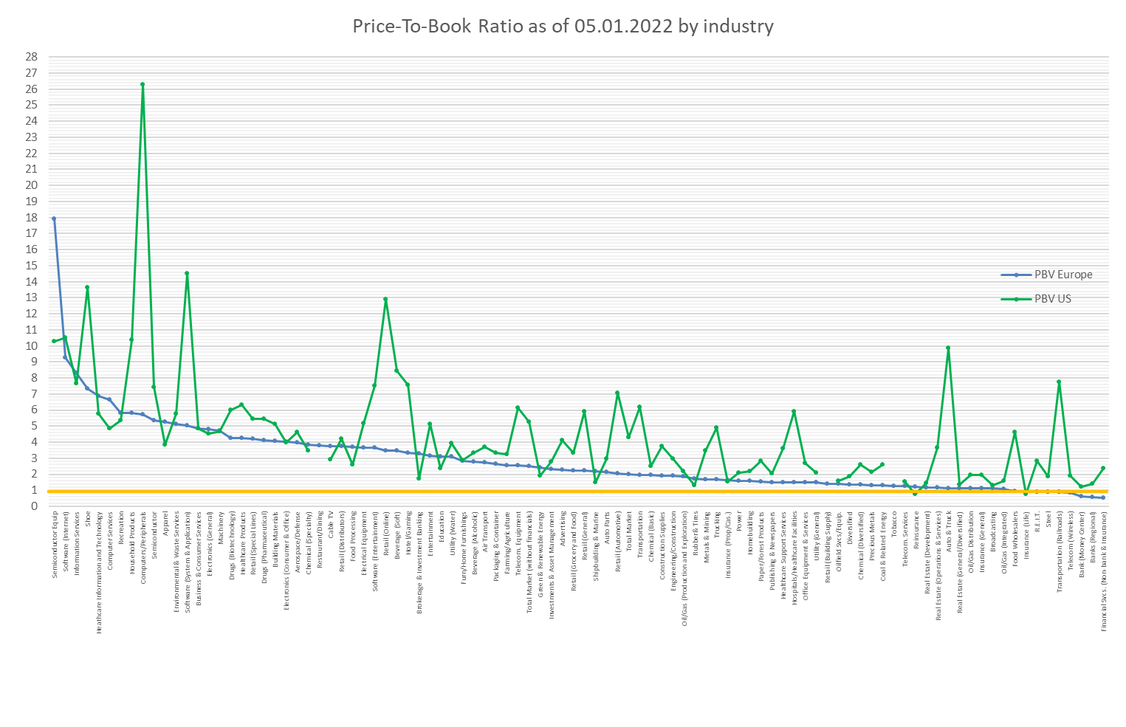

Source: Damodaran-Online (<https://pages.stern.nyu.edu/~adamodar/>), 05.01.2022

1. Takto základní zásady správy daní vnímá například Ústavní soud, který již v 90. letech v nálezu ze dne 11. 12. 1996, sp. zn. I. ÚS 116/96 judikoval: „Základní zásady daňového řízení tedy určují, že daňová politika státu má sice odpovídat jeho zájmům a že jejím cílem je správné stanovení a vybírání daně, avšak vyplývá z nich, že tato politika nemůže mít pouze jednostranný charakter.“
2. Klíčovou podmínkou tak je identifikovatelnost (srov. rozsudek Nejvyššího soudu ze dne 12. 10. 2006, sp. zn. 30 Cdo 2232/2006).
3. Srov. usnesení Nejvyššího soudu ze dne 25.1.2017, sp. zn. 4 Tdo 8/2017.
4. Srov. Automatická kontrola vozidel. Dostupné z: <https://www.policie.cz/clanek/automaticka-kontrola-vozidel.aspx>.
5. Srov. rozsudek Nejvyššího správního soudu ze dne 25. 10. 2016, č. j. 4 Afs 177/2016-35.
6. Předně jde o rozsudek Nejvyššího správního soudu ze dne 2. 8. 2017, č. j. 4 Afs 58/2017 - 78.
7. S tímto důkazním postupem jsem se pak doposud ani nesetkal v rámci mé vlastní praxe daňového poradce.
8. Srov. GDPR a osobní údaje. Dostupné z: <https://edalnice.cz/gdpr-a-osobni-udaje/index.html>
9. Srov. Zásady zpracování osobních údajů. Dostupné z: <https://www.parkujvklidu.cz/wp-content/uploads/2021/09/2021-09-01_Zasady-zpracovani-osobnich-udaju_TSK_ZPS.pdf>
10. Z anglického Negative Interest Rate Policy.
11. Dostupné na https://www.ecb.europa.eu/stats/monetary/rates/html/index.en.html.
12. V grafu uvedeno jako časová řada „Euro area“.
13. It should be noted that several empirical studies of the Heston model exist, and the parameter estimations differ. For example, Ellersgaard et al., 2018 assume a much higher mean-reversion speed. The values estimated by $J$. Liu et al., 2003 are similar to ours.
14. A technique to record a transaction as credit and debit developed by Italian merchants.
15. The former authoritative body of the American Institute of Certified Public Accountants (AICPA) that

    was replaced in 1973 by the Financial Accounting Standards Board (FASB).
16. Although there have been significant efforts of the standard setters Financial Accounting Standards Board (FASB) and International Accounting Standards Board (IASB) towards harmonization or convergence of accounting standards between 2002 and 2011 [15,16] the gap between IFRS and USGAAP starts to grow again as stated by global audit firms.

    (<https://www.iasplus.com/en/projects/completed/other/iasb-fasb-convergence>; <https://assets.kpmg/content/dam/kpmg/xx/pdf/2020/03/ifrs-us-gaap-2020.pdf>).

    Although, the key challenges addressed in this paper are prevalent to both accounting frameworks, the focus will be on IFRS.
17. The situation in which an investor represents an “investment entity” according to IFRS 10-27 and thus “shall not consolidate its subsidiaries [but] measure an investment in a subsidiary at fair value through profit and loss […]” (IFRS 10-31) is considered. Further, discretionary options or eligible exemptions such as referenced by IFRS 4‑3 for insurers are not considered.
18. IAS 28-17 defines exemptions that are not relevant in the defined setting.
19. According to IAS1-106 OCI is part of shareholder’s equity.
20. For the sake of simplicity, i.e. to identify the differences in value, the book values for the different investor groups are kept at the level inline with the investees’ values.
21. The depicted figures for the book values of bonds represent the amortized costs that differ from the gross carrying amounts by the expected credit loss component.
22. approved by the IASC Board in April 1989 for publication in July 1989, and adopted by the IASB in April 2001, published by the Commission of the European Communities in November 2003.
23. The role “pragmatist” or “marginalist” opposed to “dreamer” as mentioned by Damodaran [18] is assumed; The Dreamer: To make accounting value (book value) a reasonable measure of the true value of a company; The Pragmatist: If we mark assets up to fair value, investors will have a better idea of what a firm is worth and there should be therefore less uncertainty about the true value and lower variance in that value.; The Marginalist: Fair value accounting, even if imperfect and noisy, will provide investors with useful additional information which they can use to estimate value in a company or assess its risk.
24. According to the framework approved by the IASC Board in April 1989 for publication in July 1989, and adopted by the IASB in April 2001, published by the Commission of the European Communities in November 2003.